**LOAD**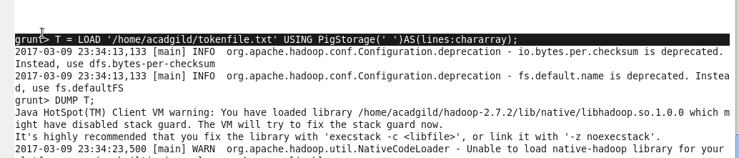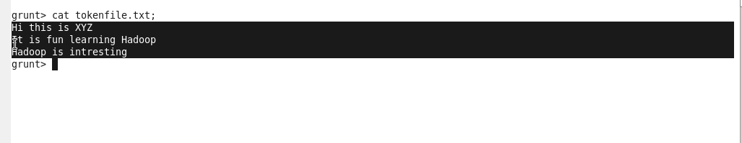

**TOKENIZER**

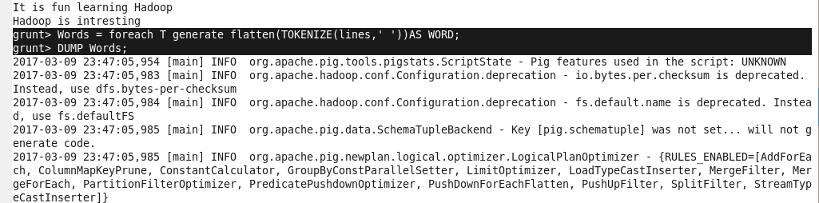

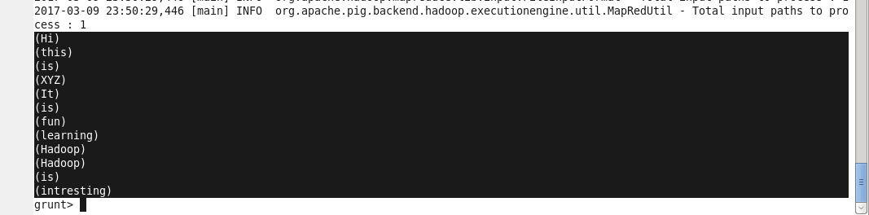

**GROUP**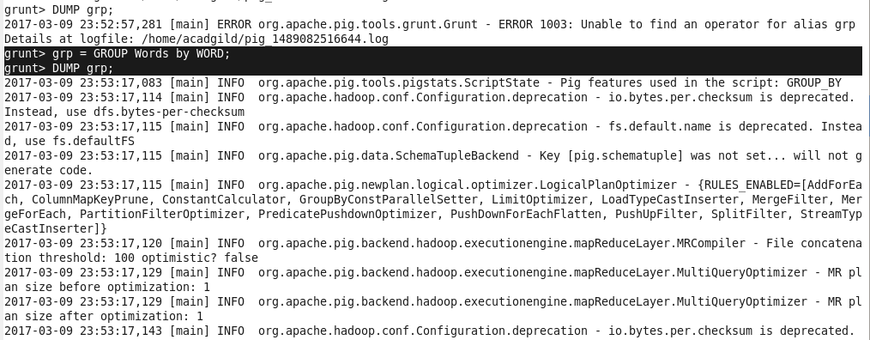

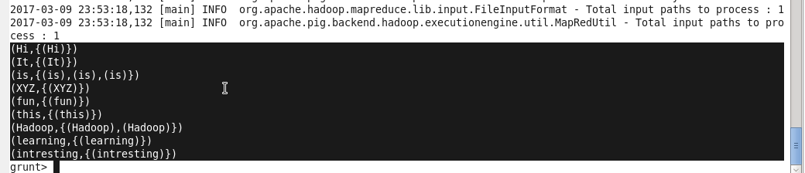

**WORD COUNT**

