EGERTON UNIVERSITY

FACULTY OF SCIENCE

DEPARTMENT OF COMPUTER SCIENCE

COMP 493 :- COMPUTER SYSTEM PROJECT

USER MANUAL FOR:-

ONLINE EMPLOYEE RECRUITMENT MANAGEMENT SYSTEM

NAME: SALOME WANJIKU GITHINJI

REG NO: S13/02332/19

COORDINATOR:- MR KABIRA

TABLE OF CONTENT

1.0 SYSTEM OVERVIEW 2

1.1 AUTHORISED USE PERMISSION 2

1.2 POINT OF CONTACT 2

2.0 SYSTEM FEATURES 2

2.1 LOGIN 2

2.1.1 LOGIN AS JOBSEEKER 2

2.1.2 LOGIN AS EMPLOYER 5

2.1 SIGN-UP 8

2.2 ADMIN VIEW 9

3.0 SYSTEM SUPPORT 12

# 1.0 SYSTEM OVERVIEW

The Employee Recruitment System (ERS) allows job seekers to register online and view available job openings. It provides global access to recruitment help and streamlines the recruitment process. Candidates can upload their CVs and apply for suitable jobs, while organisations can post their staffing needs and view interested candidate profiles. The manual recruitment process has been replaced by this efficient system, which not only reduces paperwork but also contributes to a company's marketing and sales activities. Managers have access to crucial information for human resources management, staffing, and planning. The primary goal of ERS is to optimise the recruitment process for organisations and provide qualified applicants.The system can enable managers to sort qualified applicants based on their qualifications and the organisation's requirements.

# AUTHORISED USE PERMISSION

The 4IQ TECHNOLOGIES Employee Recruitment Portal is available to the public. Every job seeker that adopts this platform will however be required to cutomise their profiles by providing some information about themselves.

# 1.2 POINT OF CONTACT

For additional information, please contact the developer through the contacts below:

Email – sallygithinji72@gmail.com

Phone Number – 0742466933

WhatsApp – 0742466933

# 2.0 SYSTEM FEATURES

## 2.1 LOGIN

### 2.1.1 LOGIN AS JOBSEEKER

Logging in is not a requirement to access the platform. However not logging in limits the functionalities that someone can access. To login:

1. Open web browser and navigate to the 4IQ TECHNOLOGIES Employee Recruitment management system.

2. Click on the login menu

3. A log in form appears as shown below

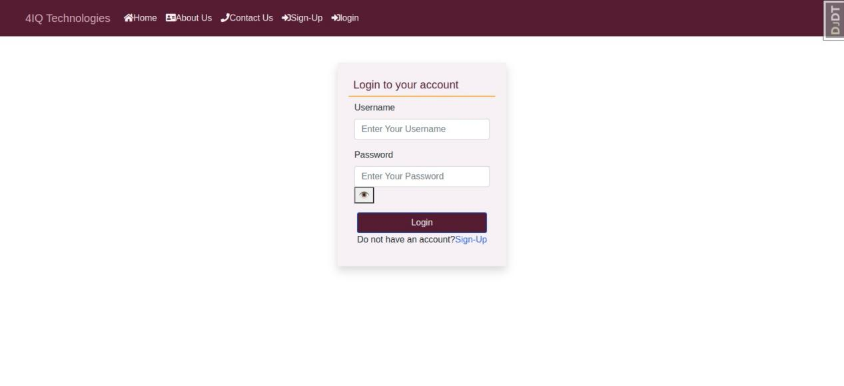

1. Enter the username and password and click the LOGIN button. Users create passwords during registration.

#### 2.1.1.1 Unregistered user view

5. Unregistered users landing page looks like this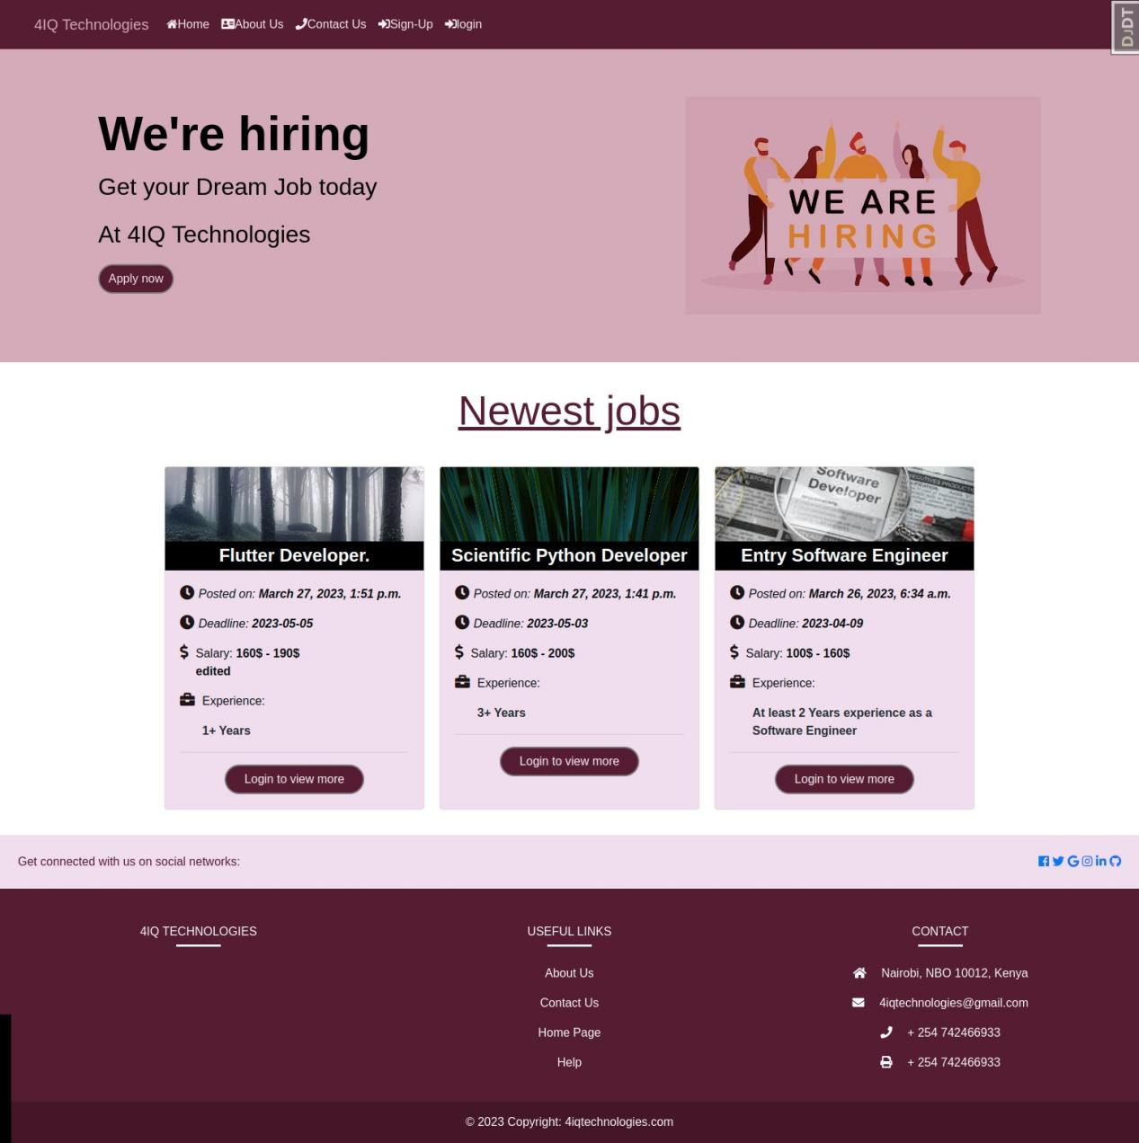

1. You cannot view more details about the job unless you are logged in.Once logged in the landing page will look like this.

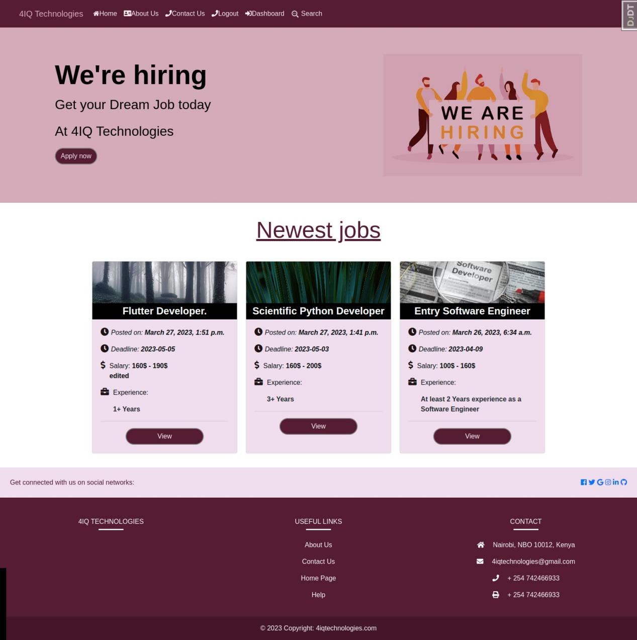

1. Once logged in and you select the job to view the job detail.The job details will lokk like this.

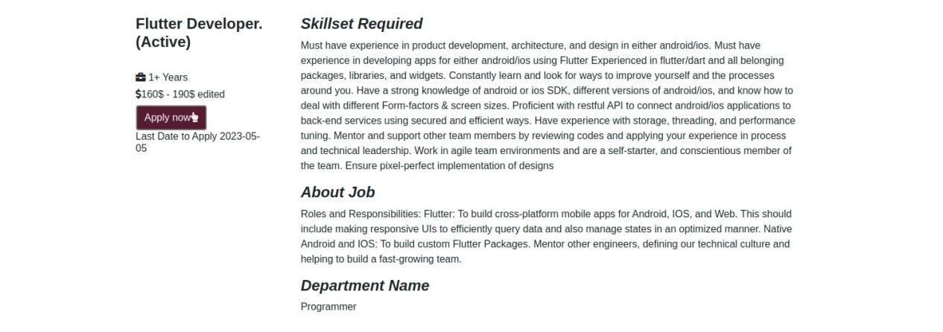

1. Pressing the Apply now ,you’ll be directed to a form that allows you to fill your personal details.

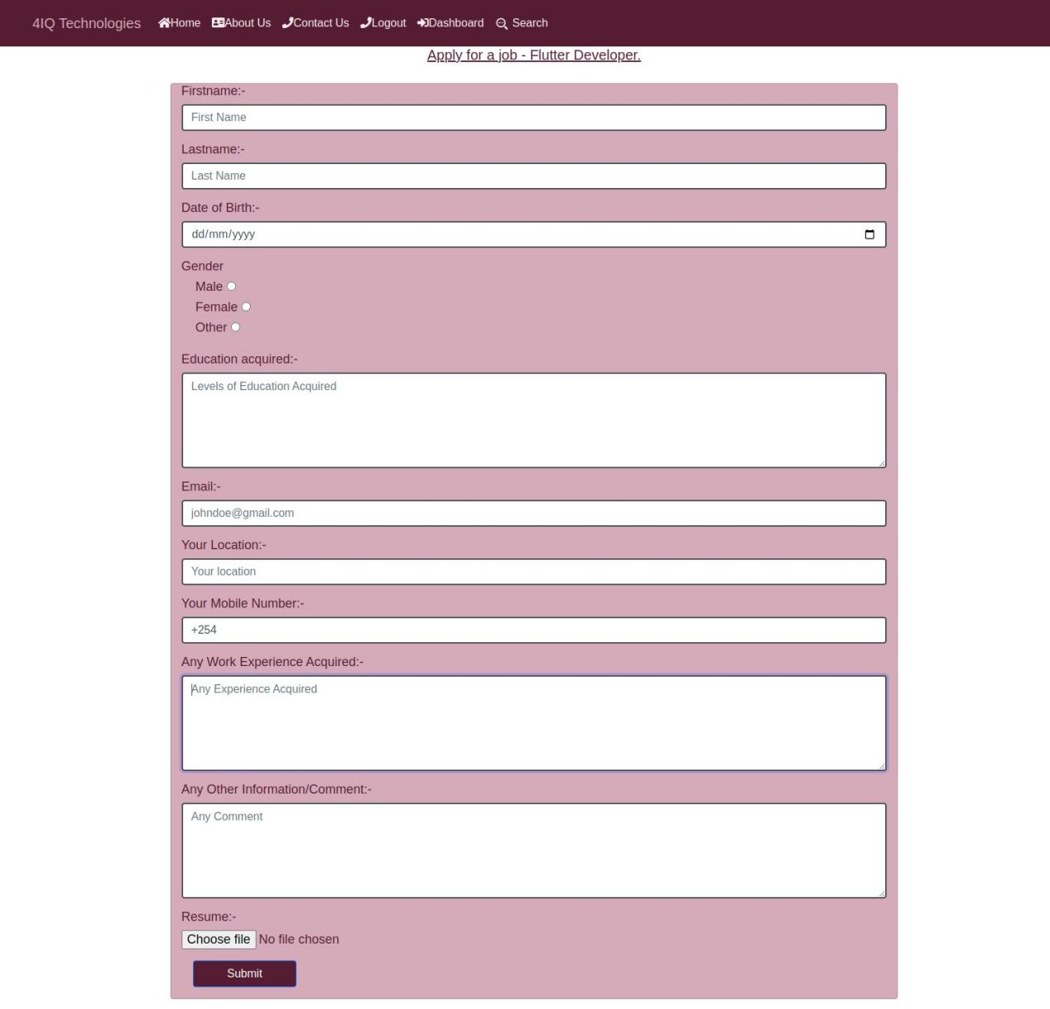

1. Once you complete filling in the form correctly you will be directed to the dash board where you can see you application details.

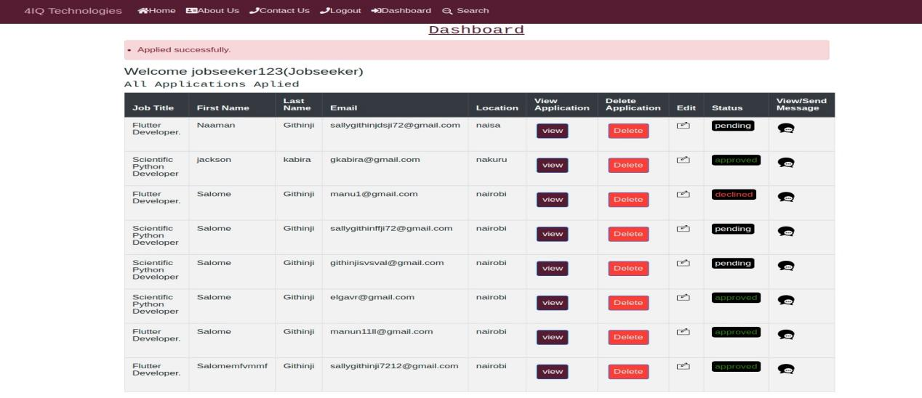

1. In the Dashboard you can see the new Application has a pending status.Once an employer approves/disapproves the status changes to either approved or declined.

### 2.1.2 LOGIN AS EMPLOYER

10. Once you are logged in as an Employer ,you can go to the dashboard to see the already added jobs.

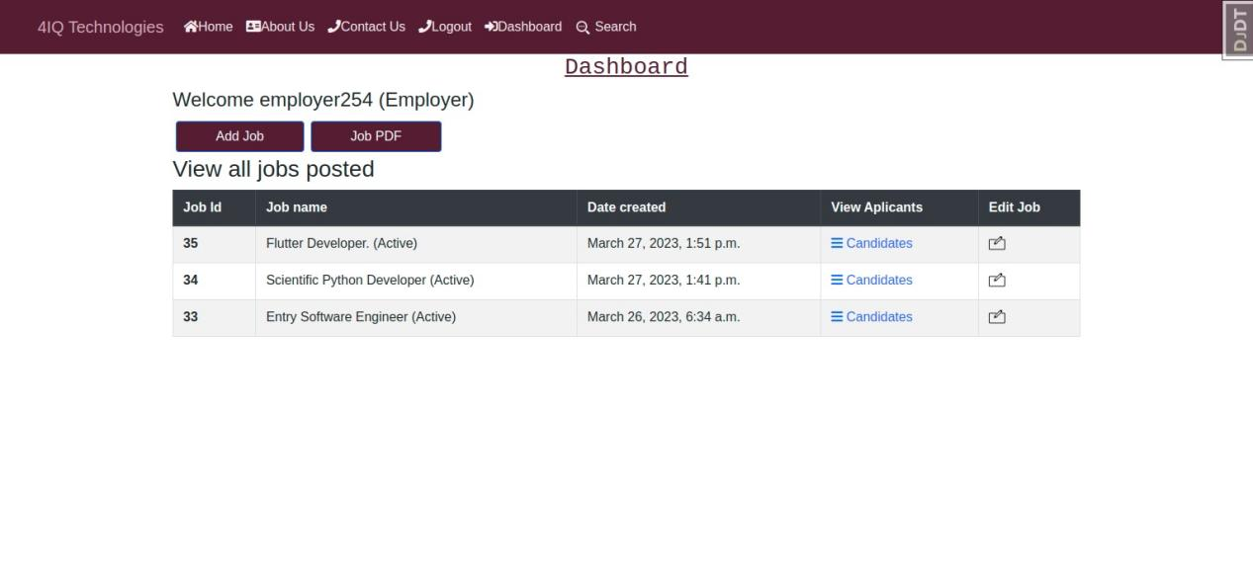

11.Press Add Job button.It Directs you to a form to add the job details to be viewed on the landing page.

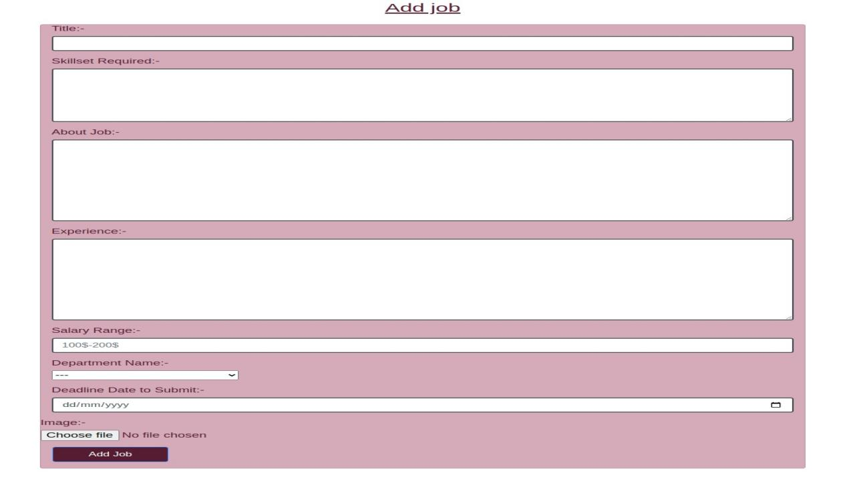

1. The Employer can view the job details of the job he/she has entered

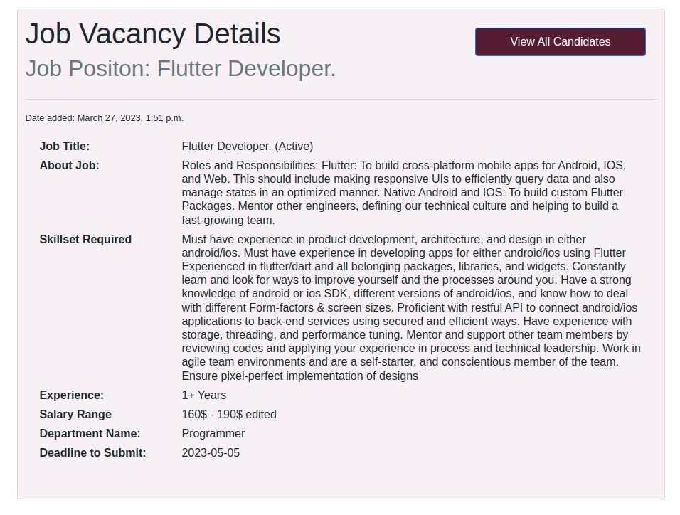

1. The Employer can view all candidates who applied for the job job posted

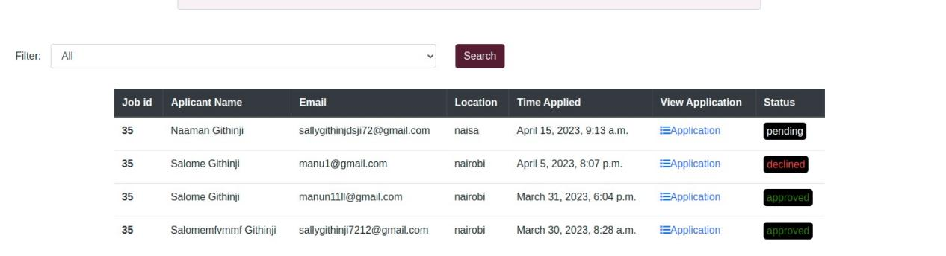

1. The employer can view each individual application and either approve or decline the application.

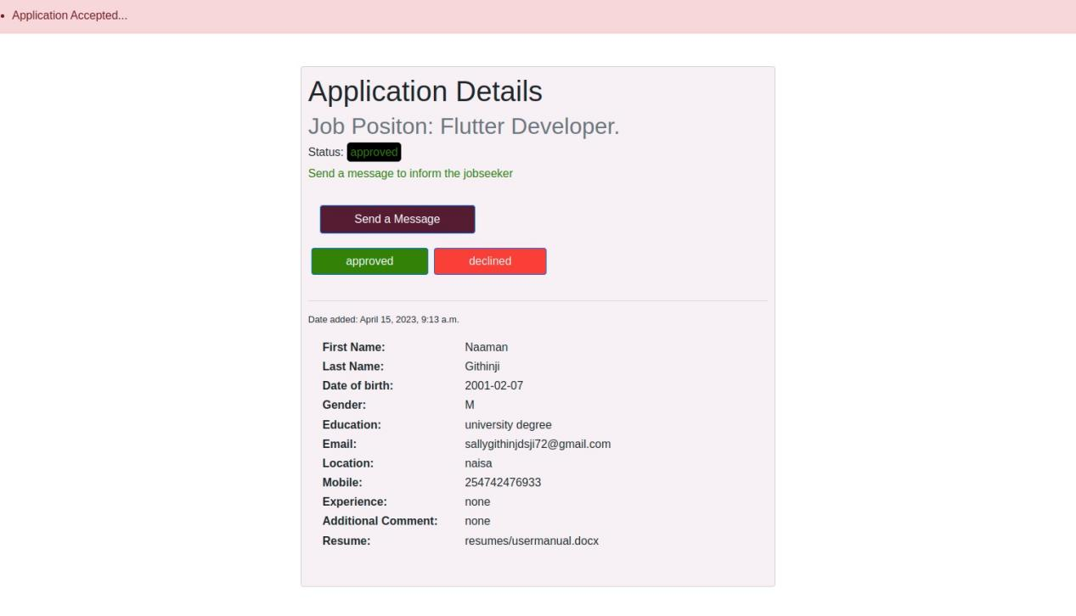

1. The employer can send a message to the job seeker based on the viewed application.

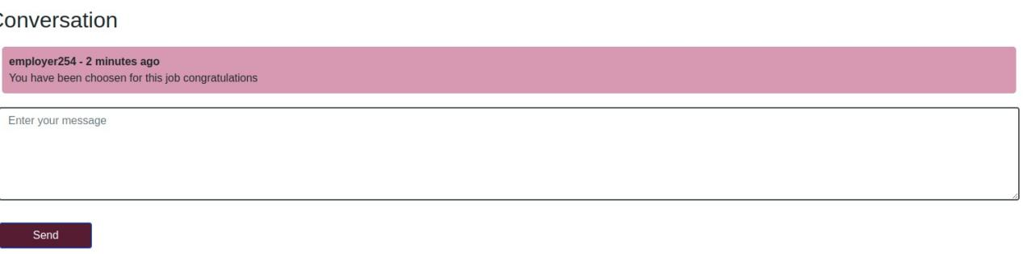

## 2.1 SIGN-UP

1. To sign up click on sign up button on navigation bar



1. Fill in the user details including the first-name, username, email,password and the type of account you are creating either job seeker or employer.

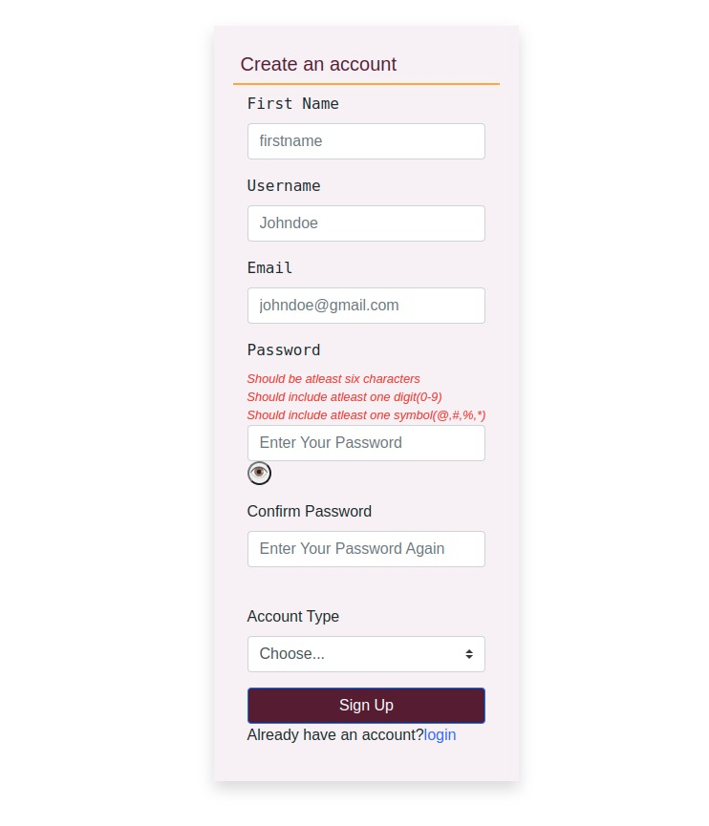

1. Once signed up you are directed to the login page.

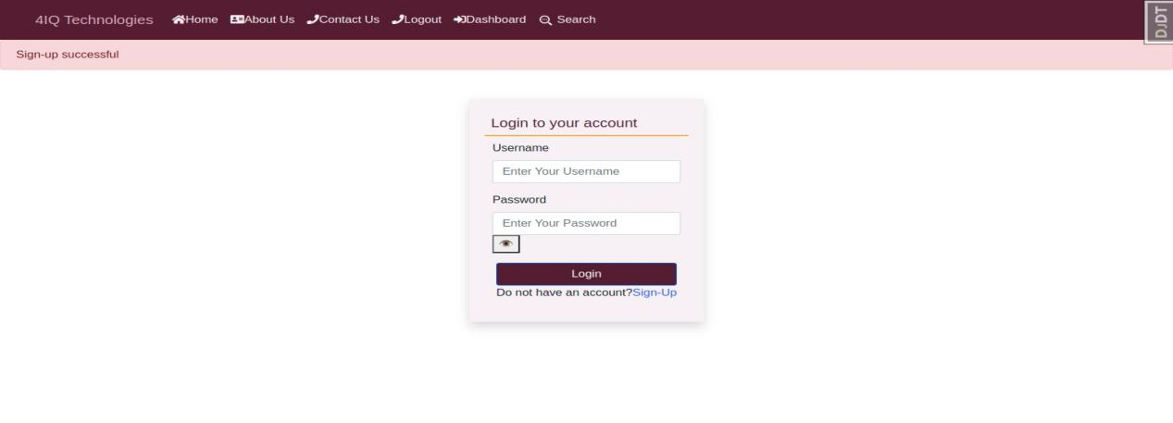

## 2.2 ADMIN VIEW

1. The admin dashboard

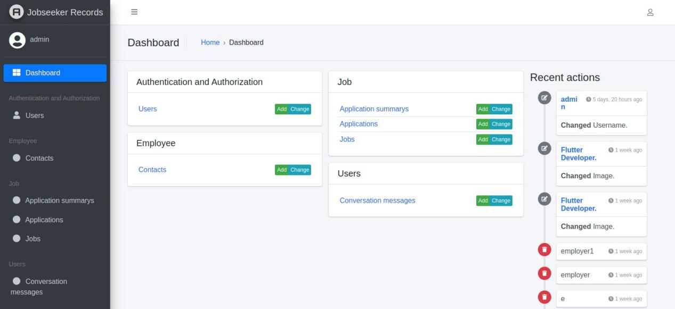

1. In authentication and Authorization press Users to view the list of users logged in the site

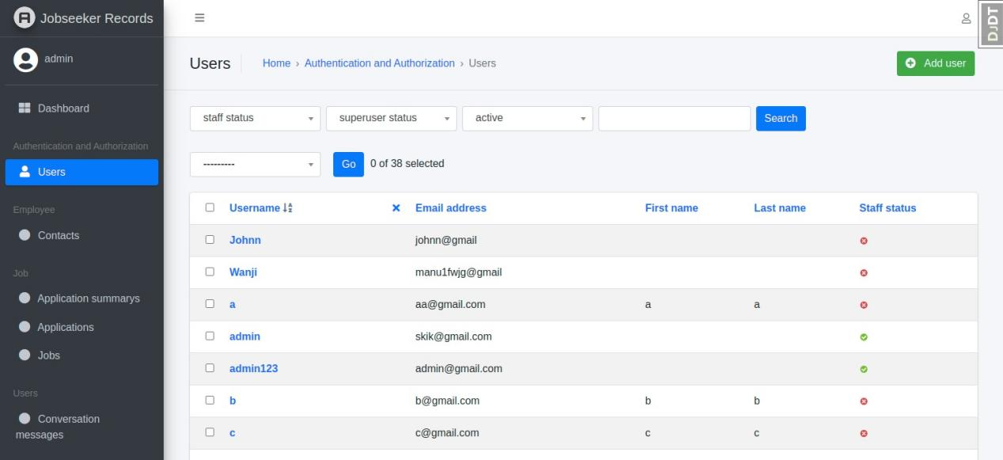

1. In Employee press contacts to see all the messages written in the contact us form

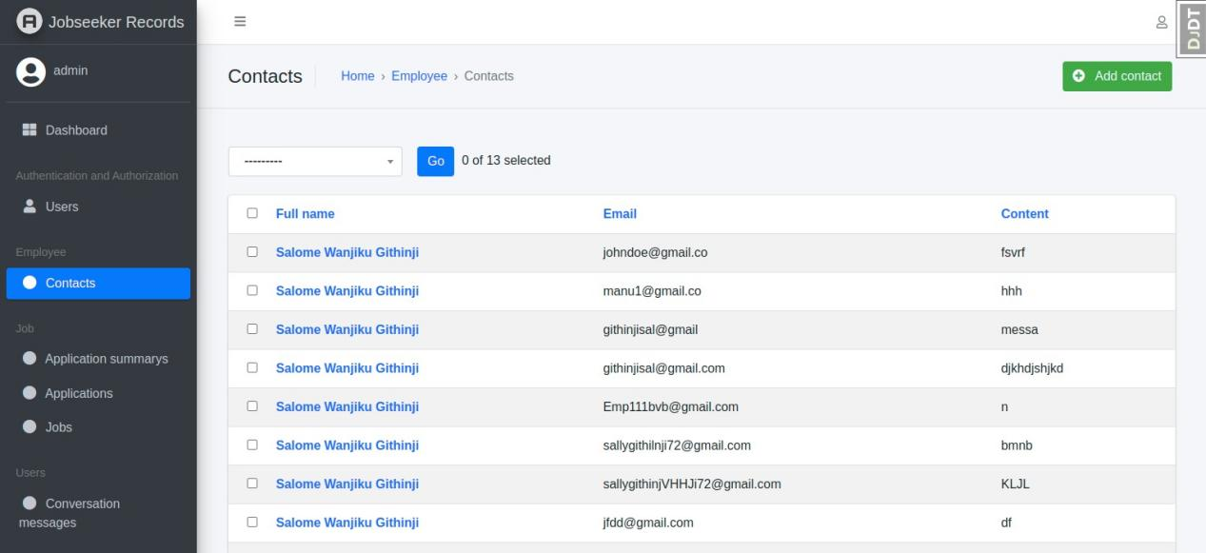

1. Click on Application summarys on the dashboard to view a report of all applications

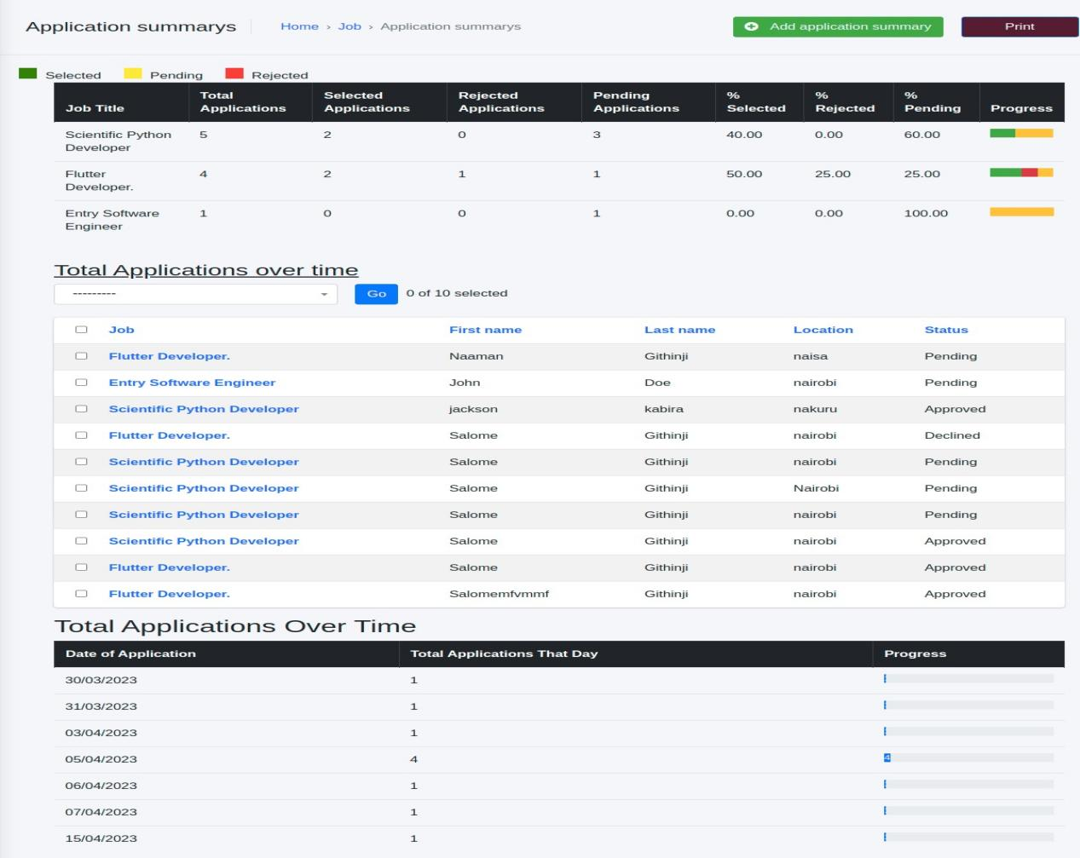

1. Click on Applications on the dashboard to see all applications done by all job seekers in the site.

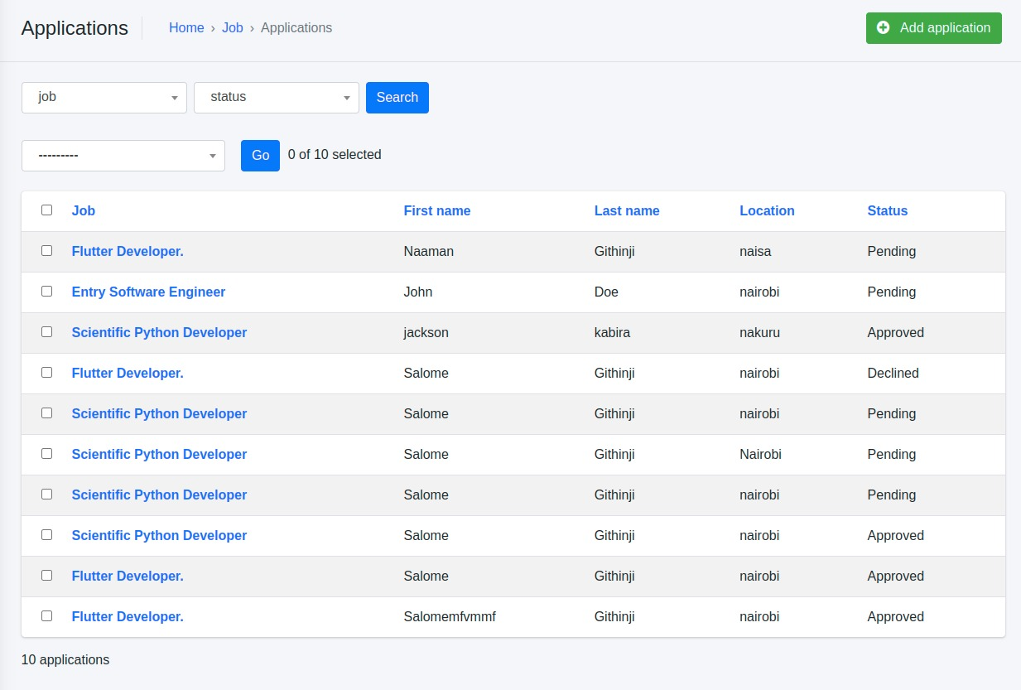

1. Click on jobs in the dashboard to view all jobs posted by all employers.

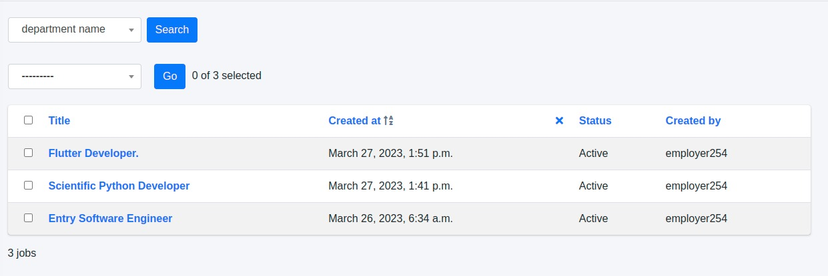

1. Click on conversations to see all the conversations between the employee an job seekers.

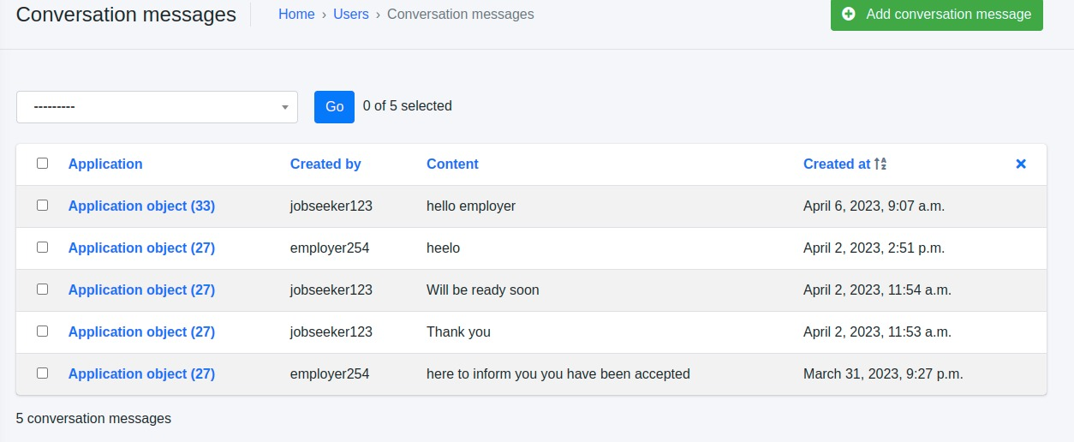

# 3.0 SYSTEM SUPPORT

1. About Us page : Click about on the navigation bar to lead you to the about us page



1. Contact us page : Click contact us on the navigation bar to lead you to the contact us page

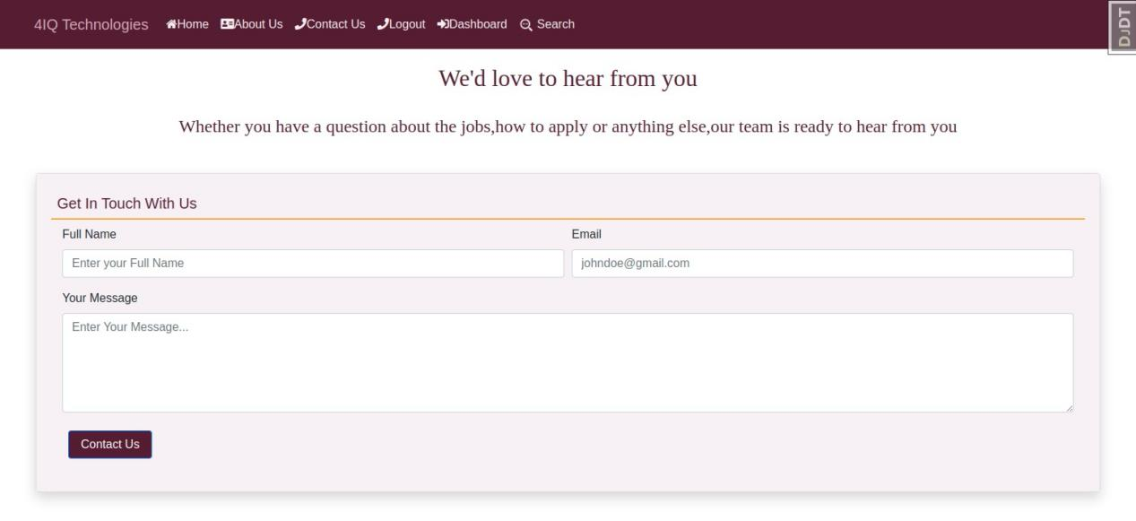

1. Help page : Click on the help on the navigation bar to lead you to the help page

