**Guidelines to Seminar Presentation**

**Introduction**

These guidelines are meant to guide you realize a good seminar presentation. Kaufmann et al. (2011) developed the following guidelines;

1. Pick a good topic

In the introduction section, you were advised to choose a topic that is of interest to you and of general interest as well. This is because a seminar is really a story, and giving a good seminar is the same thing as telling a good story. Therefore, selecting a topic that will make a good story is a big first step toward making your seminar a good one. It can be about a technology, a model/algorithm or any other subject. But as stated earlier that irrespective of the specific topic, seminars which tell a good story and have a clear take-home message are the memorable ones (memorable for the right reasons) Kaufmann, et al. (2011).

You have the topic√

2. Know your audience

It is important to understand how much your audience is likely to know in advance about your seminar topic. This will determine the amount of time you need to spend on the various portions of your talk.

You need to decide if the tone of your seminar should be serious or informal. Is a touch of humor acceptable? How much is too much? How should you dress? For most seminars at Egerton university, department of computer science, presenters dress well - more on the formal side than the casual side.

Familiarize yourself in advance with the room where you will give your talk and with any equipment that you plan to use. Not only should this make you more comfortable, but it may also help you avoid unexpected technological problems—ask your supervisor about any areas of concern or expectations.

You know them [your lecturer-examiners]√

3. Begin with a title slide and show a brief outline or list of topics to be covered

Use text slides to designate the beginnings of individual sections of your talk or to introduce a major topic shift. Usually a prominent title in bold letters is adequate. Text slides can be important and very helpful to you and your audience. They demonstrate your organizational skills, help audience members to follow your talk more easily, and let them know where you're headed. They also help to keep you on track and focused during your talk.

- first slide to present your name [select a good design theme]

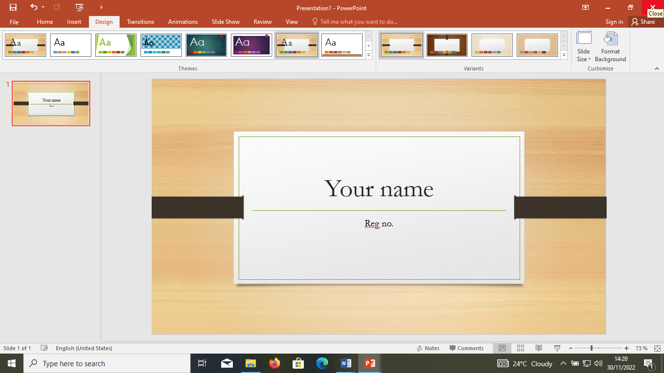

-second slide to indicate your title/topic

[consider guideline number 3]

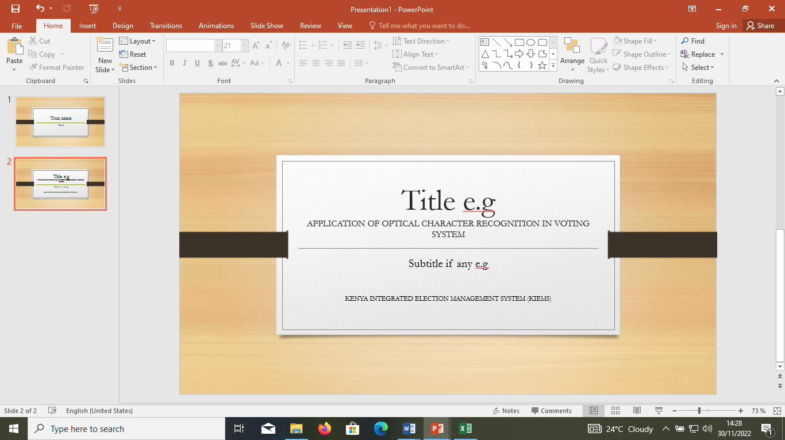

Note:

Some of us have titles with subtitles e.g APPLICATION OF OPTICAL CHARACTER RECOGNITION IN VOTING SYSTEM: KENYA INTEGRATED ELECTION MANAGEMENT SYSTEM (KIEMS).

In this case, both on the front page and title slide, indicate the first part of the title using larger font size e.g 14 then the next part, small size e.g 12

4. The next slide will be introduction

* Introduce your topic well

- Your introduction will vary in length and detail, depending on the length of your talk, your topic, and the level of sophistication of your audience.

- Give the necessary information but be careful not to include large amounts of extraneous material. E.g

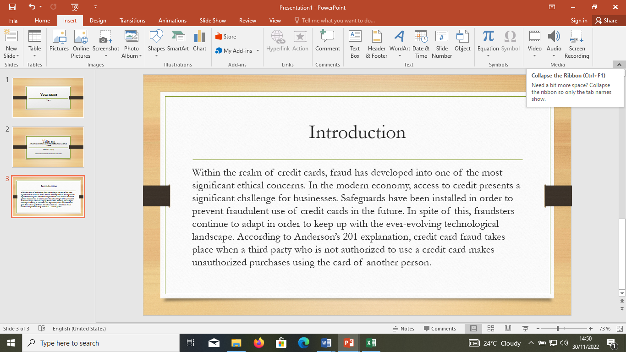

You can limit this e.g

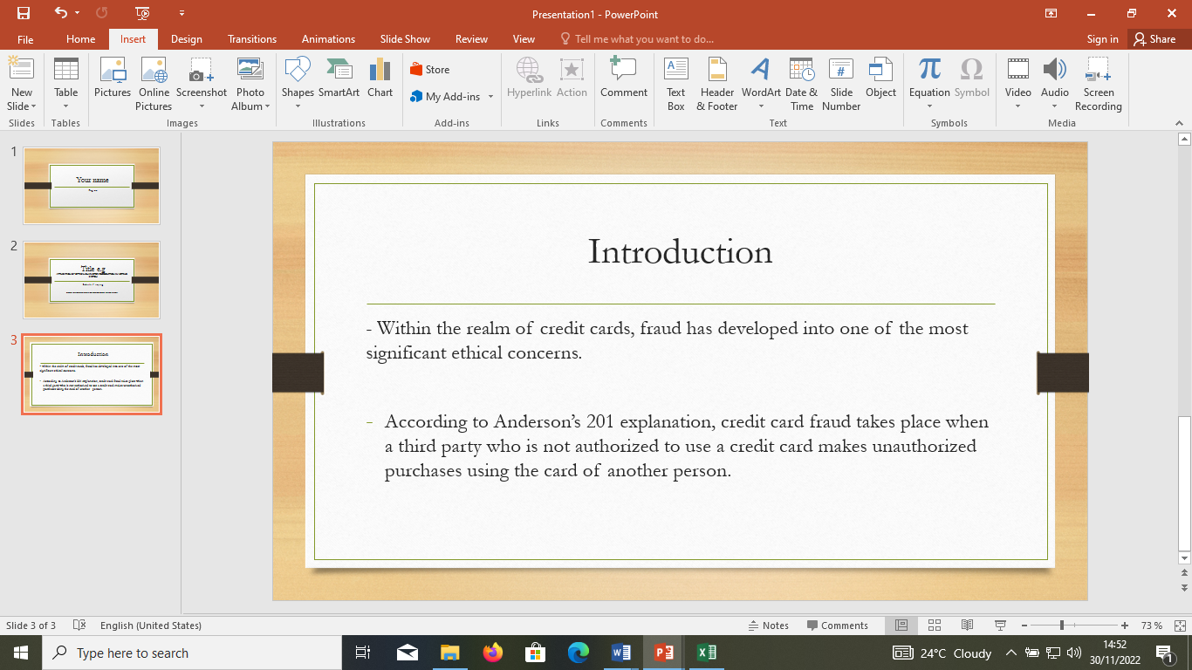

Use the little to explain the rest. In this case, know your material well without reading. See Don’ts number 3

- Visual aids are particularly important here to grab your audience's attention. If you have a snappy photo, and interesting thought or catchy phrase, use it here.

-Remember you can just use a catchy photo without text to explain a concept

The point of the introduction is to catch your audience, let them know what you'll be talking about, get them enthused about the topic, and let them know why your topic is interesting and exciting.

-Other slides will follow (brief/summarized)

5. Presentation is the heart of a successful talk

- Use the best graphics available but be careful not to distract your audience by making the artwork more interesting than the information. You should be especially careful in choosing how to present your data. Watch your color and pattern combinations. Don't waste your time trying to make the prettiest or the coolest slides. Focus on content and clarity. Some pizzazz is fine, but don't go to extremes.

- Limit your use of animation. Too much can be distracting and reduce the impact of your talk. This is one of the most common problems encountered in students’ seminars.

- Make your presentation visually appealing by using variations in color and texture. Color can be used to unite items related to a single topic, emphasize points and generally enhance the audience’s ability to understand your subject.

6. Answer questions thoroughly and thoughtfully

-Remain relaxed during the question period. Remember, you're the expert on this subject, and this is your chance to demonstrate (but not show off) your expertise in the topic.

-The question period is not designed to allow the audience to harass you. Your audience is supportive and interested, and they truly want to know more about your topic or they would have gone somewhere else instead.

-No one is out to get you! When answering questions, take your time, compose yourself, make sure you understand the question clearly and think before you answer. If the question is unclear or doesn't make sense to you, ask politely for clarification.

-Prior to your talk, think carefully about your presentation and you may be able to anticipate major questions. If you suspect that something in particular will come up, prepare an answer. If you have additional slides ready to answer that query, put them in your presentation after your final planned slide and use them as appropriate.

- If you don't know the answer to a question, try to say something useful and relevant. If you really don't know, "I don't know" is perfectly acceptable, but not for every question.

**SEMINAR PRESENTATION PRACTICAL DO'S AND DON'TS**

**DO:**

1. Practice

2. Look professional

3. Preview your slides

4. Clearly state your objectives and goals

5. Speak clearly and at a good pace. Rule of thumb: About 1 slide per minute

6. Always identify your axes, define all technical terms and spend time on your data (graphs, tables)—where applicable

7. Quote appropriate references and distinguish your work from literature sources

8. Make a lot of eye contact with your audience

9. Conclude your talk with statements that address your objectives and finish your story

**DON'T:**

1. Wait until the last minute to prepare

2. Make slides that are impossible to read or understand, e.g. complicated figures, large tables, Picasso-like graphs.

3. Read your talk verbatim, either from notes or from your slides!! Know your material well without reading.

4. Make distracting gestures when you talk (play with a pointer, rock back and forth, play with your hair, pick your nose, etc.).

5. Speak too rapidly, too slowly, too quietly or too loudly. Don't speak in a monotone and try not to mumble.

6. Talk to one person or the screen.

7. Panic. Staying calm and focused is very important, especially if you hate speaking publicly.

8. Try to be too funny. Humor has its place in your seminar, but use it judiciously.

ALL THE BEST IN YOUR PRESENTATION!!