For this lab, we use the same tests that are available in Alphagrader.

### Example 1 - Play ball?

### Weka tool solution:

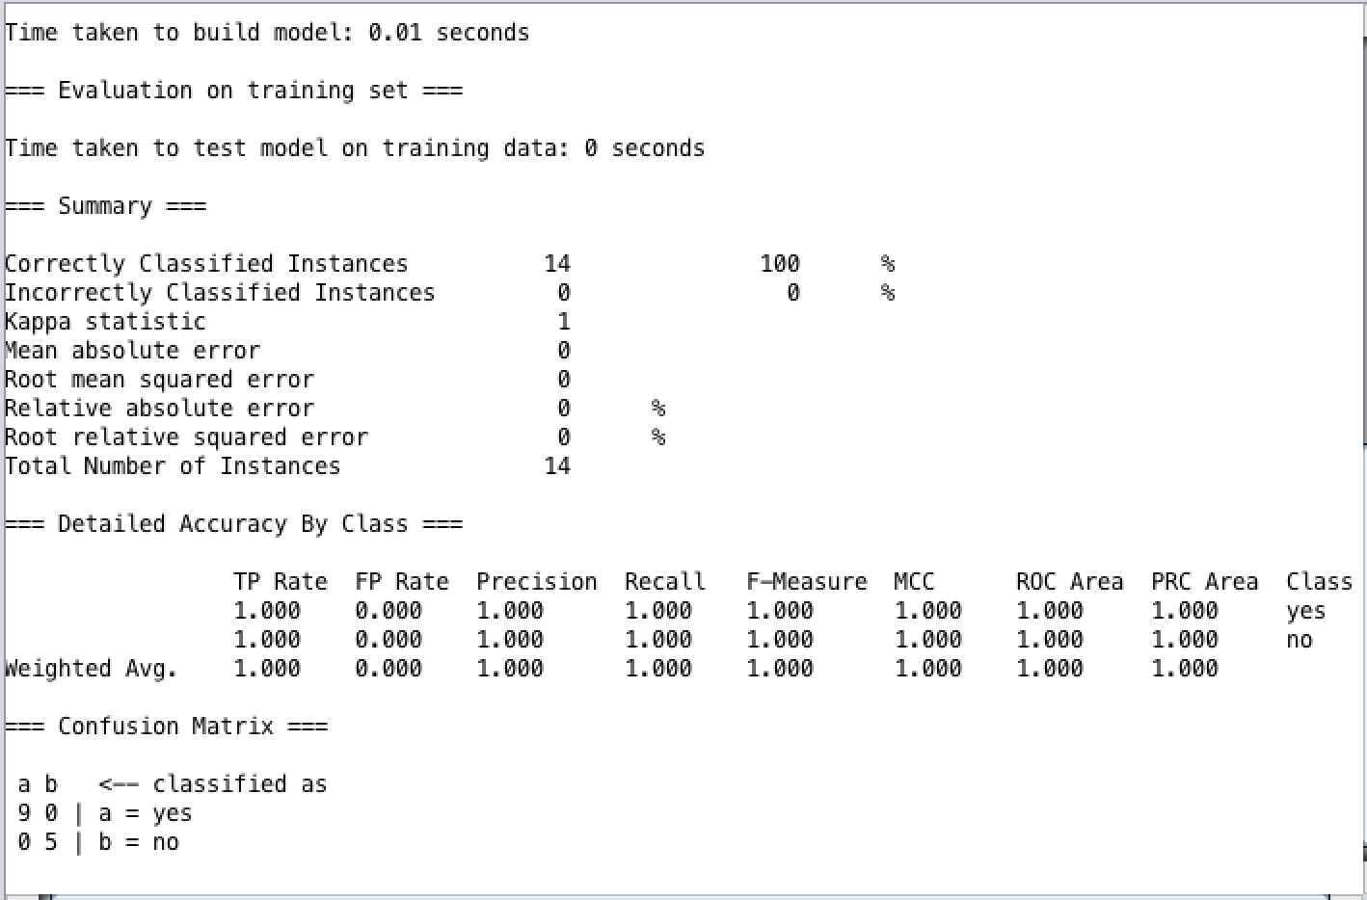

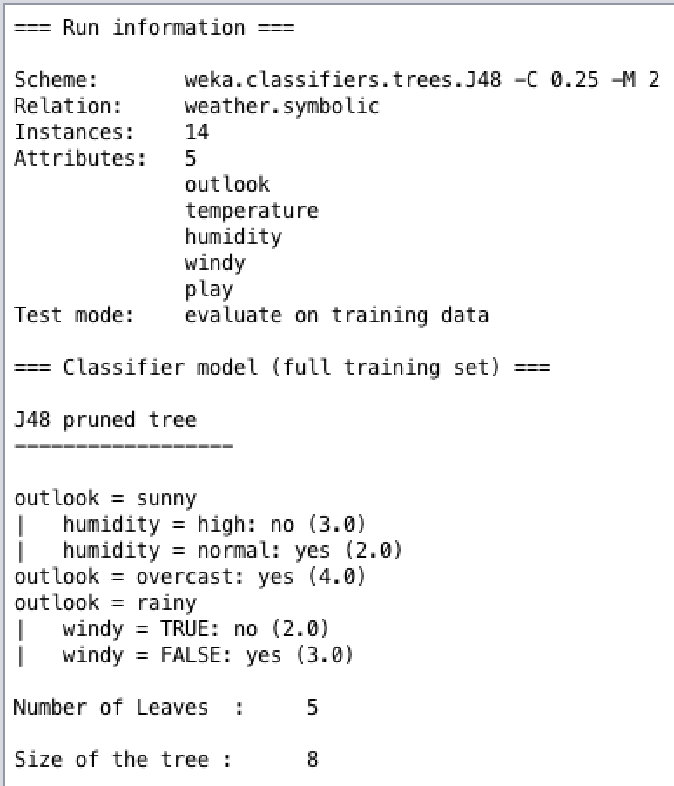

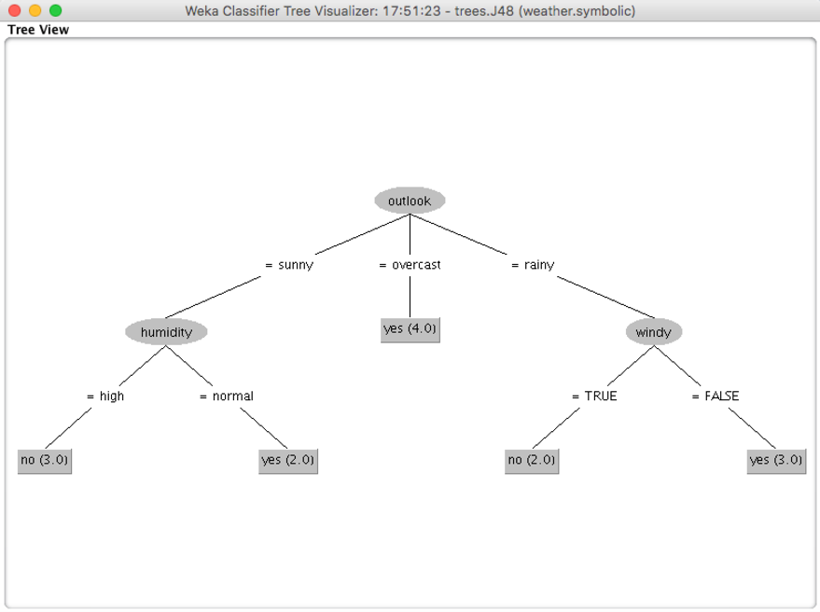

Our solution:

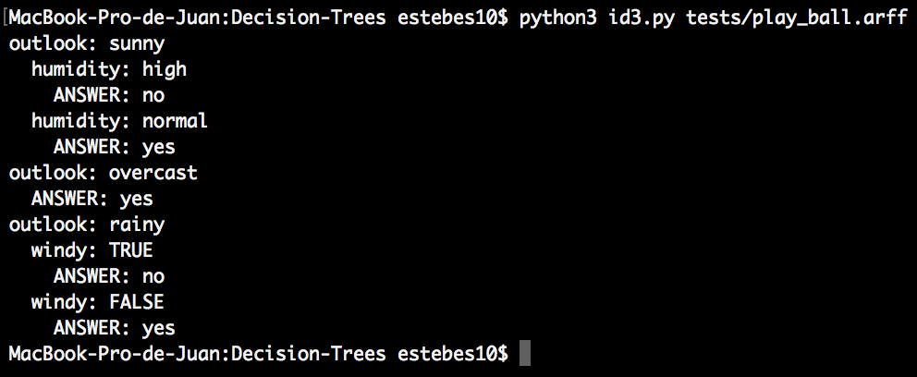

### Example 2 - Contact lenses

Weka tool solution:

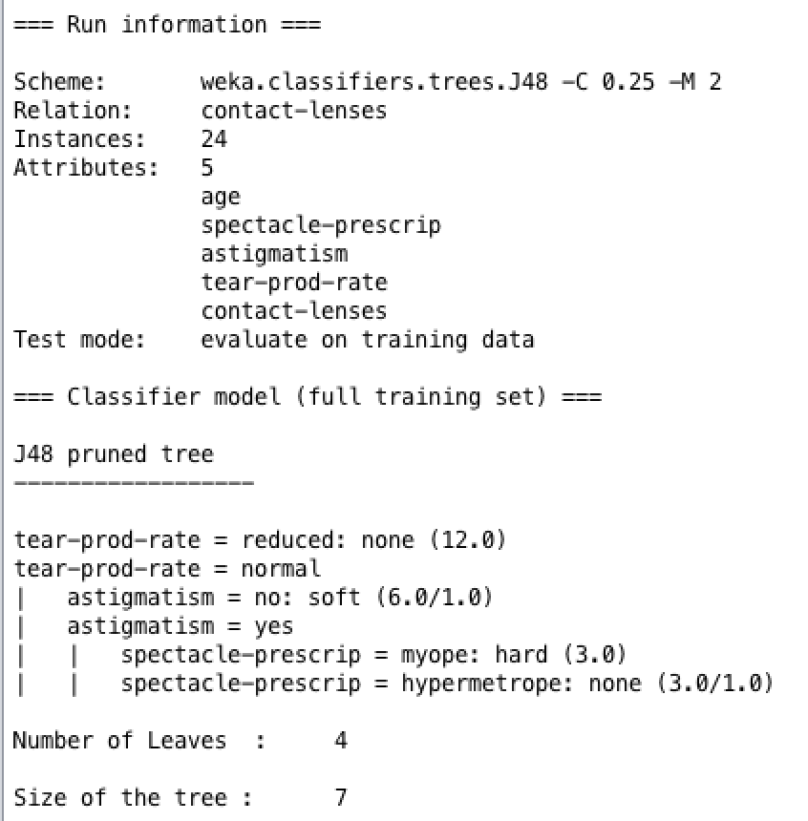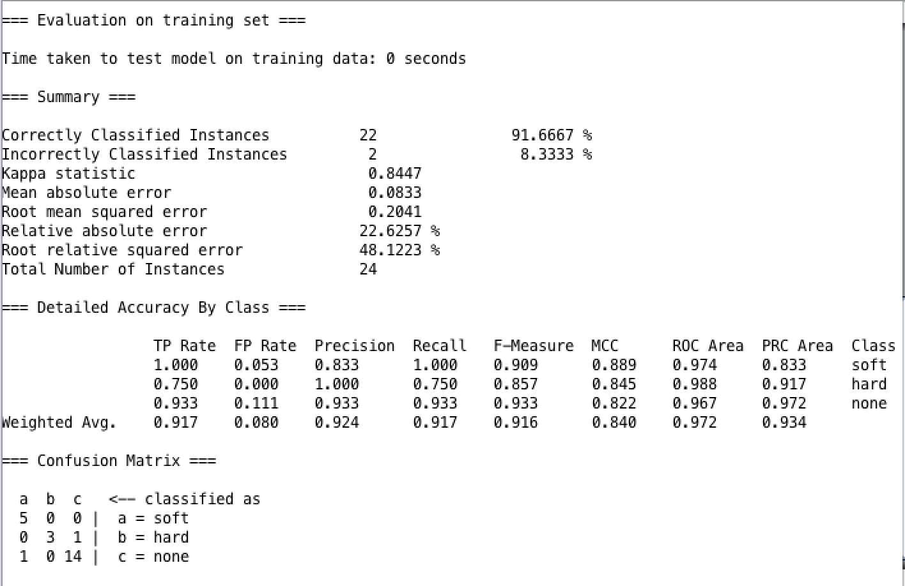

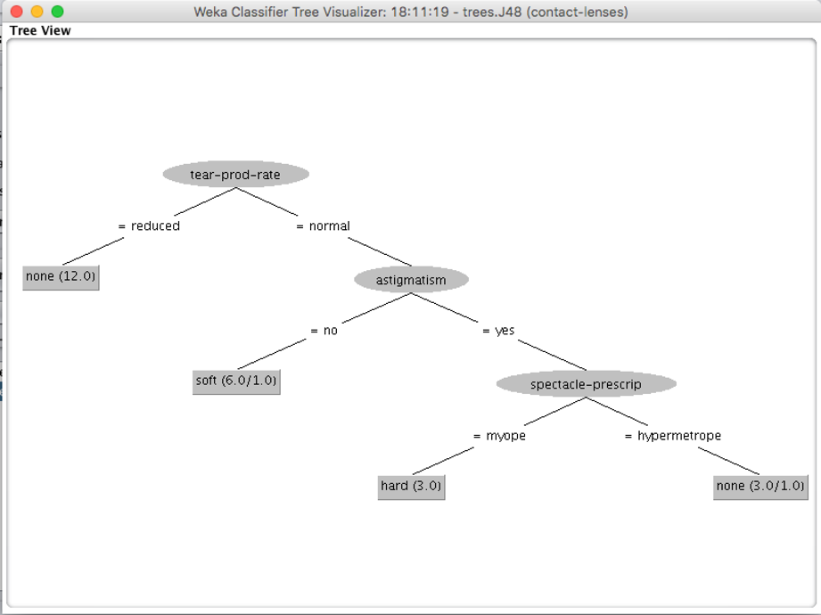

Out solution:

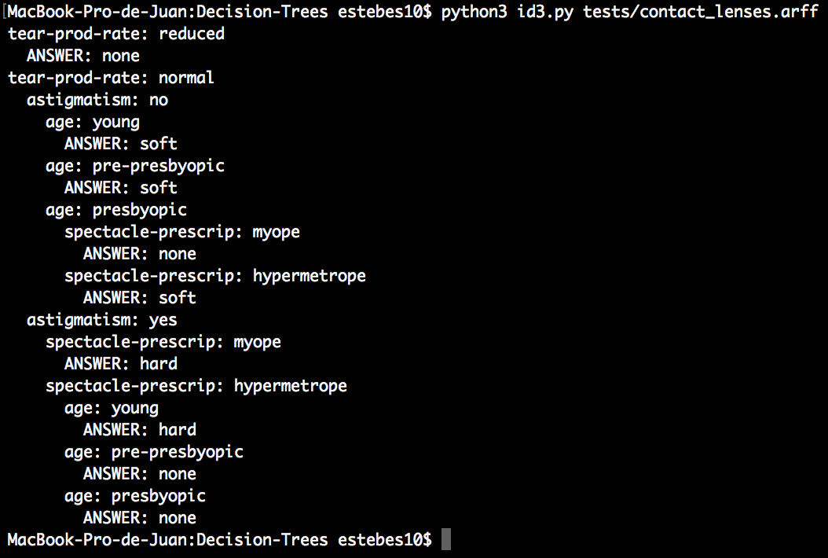

### Example 3 - OR function

### Weka tool solution:

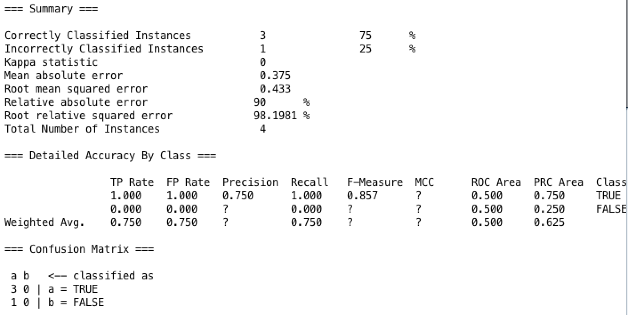

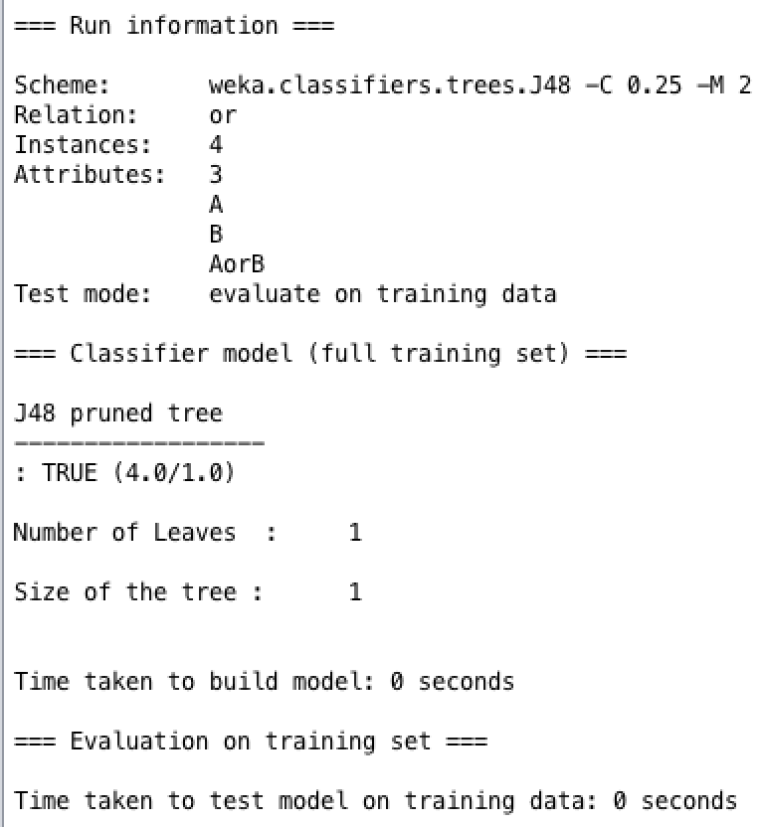

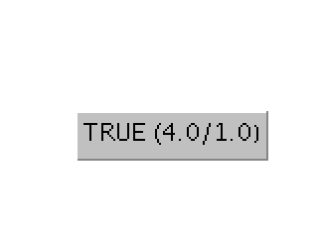

Our solution:

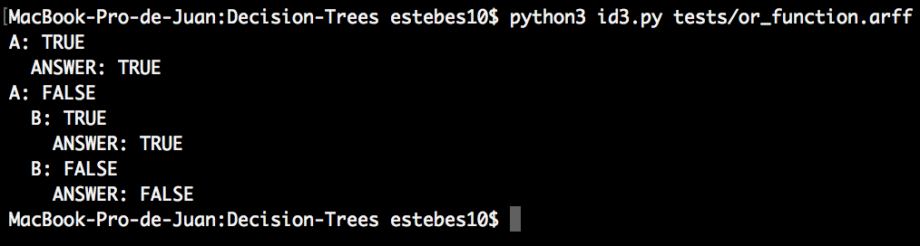

As conclusion doing this lab, both implementations provides a solution for decision trees problems, however, implement our own program give us the chance to understand how Decision Trees algorithms work and if we have to modify the algorithm to adapt it to others problems, we know how it is implemented and we can make necessary changes without complications, however, WEKA tool provides a good visual representation of the tree created and it is easier for users to understand how decisions are represented, due to this, our solution requires a user interface more suitable for users. On the other hand, WEKA also gives values for each leaf node and not just the result.

As we said before, to compare results between our implementation and Weka tool, we use the same tests available in Alphagrader platform, however in the algorithm that we use, we implement create a node with its corresponding information, a method to calculate the entropy for each node and a function to calculate the gain per node and for the total gain, then we just create a simple visual representation. By the way, there was little difference in the last test, because Weka just shows the result node of the solution and not the whole tree.

Based on we learned about Decision Trees, we could use them in problems to make predictions, accept or reject a proposal given some information and goals, increase or not the production capacity for a company, probability of success of an advertising campaign, minimize costs, etc. Finally, we can say that decision trees are useful for problems where alternatives or actions are well defined, if uncertainties can be quantified and the goals are clear.