- https://onlinelibrary.wiley.com/doi/10.1111/resp.14582
  - Most straightforward but only shows lipid class in figure, done on human lung tissue
  - 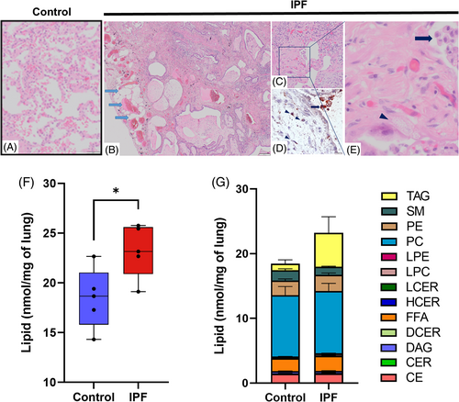
  - 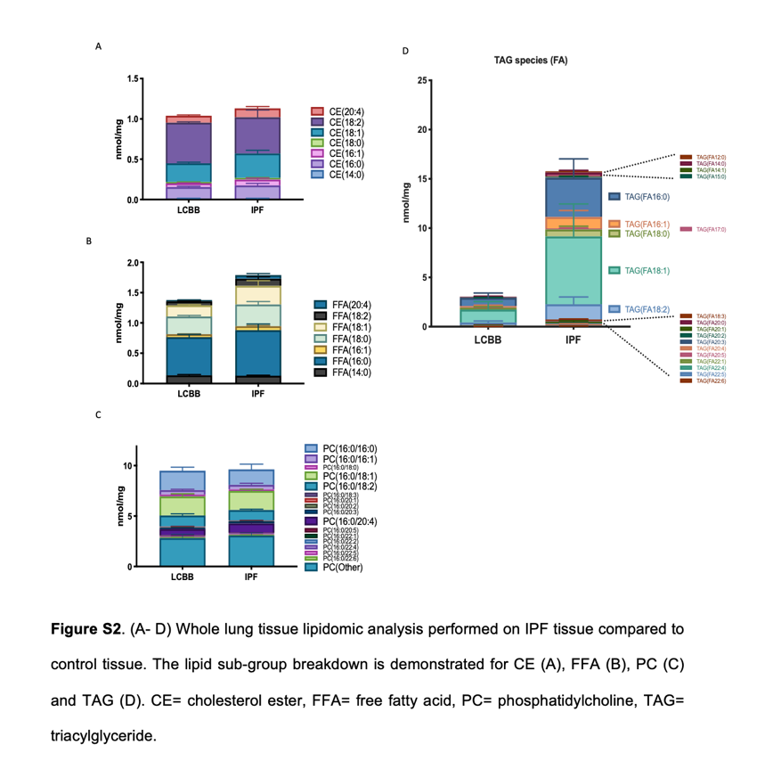
- https://link.springer.com/article/10.1007/s11306-025-02355-8#Sec7
  - This study mainly looked at Metabolomics but there are Lipids in here too
  - But COPD is there control: 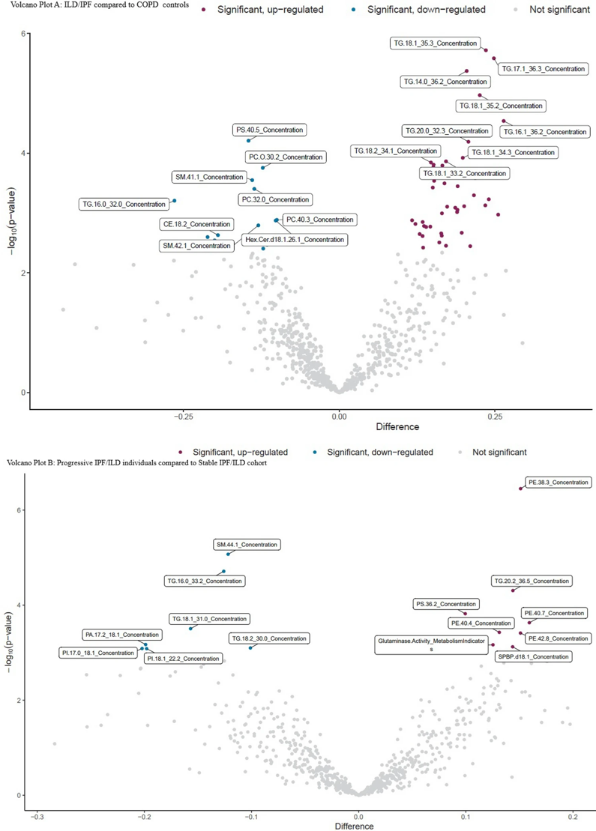
- https://link.springer.com/article/10.1186/s12890-017-0513-4
  - There is another study that found the most lipid “biomarkers” but it is from serum.
  - “Finally, 6 out of 62 discriminating lipids were selected as the potential biomarkers, which are able to differentiate between IPF disease and controls with ROC analysis. “
No. | Gender/P-value | Smoking/P-value | Disease status/P-value |  | VIP | Trenda | Accepted Description | LipidIon | Element | Lipid class | P-Value
R7 | 0.92 | 0.92 | 0.65 | 666.618 | 14.64 | 3.39521 | ↑ | Stigmasteryl ester(16:1) | M + H,M + NH4,M + K,2 M + NH4,2 M + Na | C45H76O2 | Stero lipids | 7.79E-08***
R9 | 0.51 | 0.51 | 0.91 | 369.352 | 14.65 | 3.00377 | ↑ | (E,E)-3,7,11-Trimethyl-2, | M + H-2H2O | C27H48O2 | Fatty acids | 7.31E-08***
R13 | 0.81 | 0.16 | 0.17 | 603.535 | 15.07 | 2.44092 | ↑ | DG(O-16:0/18:1) | M + Na | C37H72O4 | Glycerolipids | 7.02E-08***
R16 | 0.4 | 0.4 | 0.84 | 369.352 | 15 | 2.27907 | ↑ | 3-Deoxyvitamin D3 | M + H,M + NH4,2 M + H | C27H44 | Stero lipids | 7.31E-08***
R17 | 0.85 | 0.43 | 0.3 | 925.796 | 14.55 | 2.1151 | ↑ | TG(18:4/20:3/22:0)[iso6] | M + H-2H2O | C63H108O6 | Glycerolipids | 7.86E-08***
R21 | 0.96 | 0.17 | 0.15 | 603.532 | 14.82 | 1.64593 | ↑ | DG(18:0/18:2/0:0)[iso2] | M + H-H2O | C39H72O5 | Glycerolipids | 7.53E-08***

Reviews:

https://pmc.ncbi.nlm.nih.gov/articles/PMC9954511/#:~:text=The%20disease%20occasionally%20exacerbates%20acutely,in%20the%20treatment%20of%20IPF.

https://pmc.ncbi.nlm.nih.gov/articles/PMC7352853/#sec5-ijms-21-04257

