./

Report

on

Train Information System

SF ID : 104426



Version Number:

Team Members :

Team No:

Module: Model Based System Engineering

|  |  |  |  |  |  |
| --- | --- | --- | --- | --- | --- |
| **Ver. Rel. No.** | **Release Date** | **Prepared. By** | **Reviewed By** | **Approved By** | **Remarks/Revision Details** |
| 1.0 |  | Hamsini Hariprasad |  |  |  |
|  |  |  |  |  |  |
|  |  |  |  |  |  |
|  |  |  |  |  |  |
|  |  |  |  |  |  |

**Document History**

Table of Contents

1.INTRODUCTION 2

1.1 TOPIC 3

1.2 PURPOSE 3

1.3 OBJECTIVES 3

2. REQUIREMENTS 3

2.1. INTERACTIVE MENU 3

2.2 TRAIN LISTING 3

2.3 TRAIN SEARCH 3

3. DESIGN 4

3.1. INTERACTIVE MENU 4

3.2 TRAIN LISTING 4

3.3 TRAIN SEARCH 4

4.CONCLUSION 5

**List of figures**

FIGURE 1: INTERACTIVE MENU DISPLAY 4

FIGURE 2: TRAIN LISTING DISPLAY 4

FIGURE 3: TRAIN SEARCH DISPLAY 5

FIGURE 4: EXAMPLE FOR TRAIN SEARCH DISPLAY 5

# 1.INTRODUCTION

1.1 TOPIC- Train Information System in Indian Railways System.

1.2 PURPOSE- Transportation is one of the most important need in current day world. Because of this there is a strong bond and communication being established among places. When considered the means, we can see Railways is one of the biggest means of transportation in India.

There are many numbers of train across the country. In order to get the information about the Trains, one has to travel to the railway station and get it, which is a tedious job. In order to make the job easy, the project gives the required information on trains where one can access just by sitting at home.

## 1.3 OBJECTIVES

* To give basic information about the trains in Indian Railways.
* To give information on Train names, Source, destination and numbers.
* To be Understood by Lay man and user friendly.
* To be simple and legible.

# 2. REQUIREMENTS

## 2.1. INTERACTIVE MENU

* A menu is being displayed which gives the user to select the particular option.
* Based on the option it takes further to that particular information.

## 2.2 TRAIN LISTING

* The listing will have options to see train details with a particular information.
* This will have a menu to select by which form the train has to be listed (E.g.- All trains, timings etc.).

## 2.3 TRAIN SEARCH

* This asks the user to search for trains according to their choice. Based on the choice that particular information is being is displayed.

# 3. DESIGN

## 3.1. INTERACTIVE MENU

As per the requirements, this gives the user to enter their choice for the information. This menu contains the options (FIG 1) such as All trains, Trains from particular source, trains from particular destination. After going to a particular choice, the user will be able to return to the original menu.

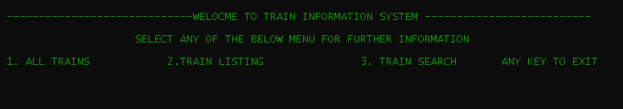

### FIGURE 1: INTERACTIVE MENU DISPLAY

## 3.2 TRAIN LISTING

This menu helps the user to get information with more choice. Train information can be viewed through alphabetical order, only by source or destination and also based on timings. FIG 2 shows the way it is being displayed.

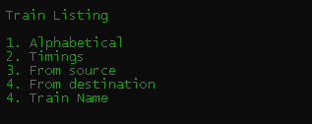

### FIGURE 2: TRAIN LISTING DISPLAY

## 3.3 TRAIN SEARCH

The search menu helps to find about a particular information. Like to find only about trains starting at particular time or particular source. This has further choice to find according to user choice. When a particular choice is selected, it is being displayed as shown in FIG 4

* According to train name.
* According to timings
* According to Source/destination.

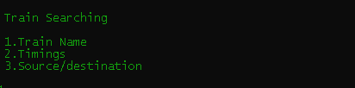

### FIGURE 3: TRAIN SEARCH DISPLAY

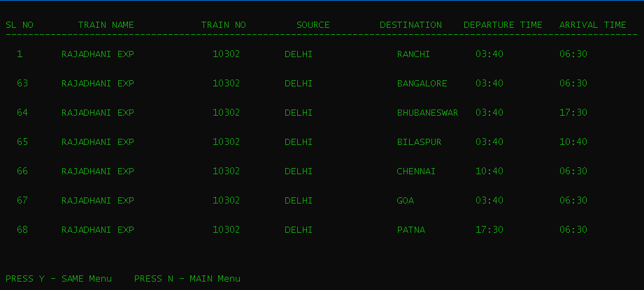

### FIGURE 4: EXAMPLE FOR TRAIN SEARCH DISPLAY

# 4.CONCLUSION

As per the requirements the proper code has been designed. The program can be used to find about the trains and their related information.