Vivek Yadav
IT Department, AITR
RGPV Bhopal, India
vivekshrinathyadav@gmail.com

Roshan Gorakhpuriya
IT Department, AITR
RGPV Bhopal, India
roshangorakhpuriya@gmail.com

Vishal Patidar
IT Department, AITR
RGPV Bhopal, India
vishalpatidar0102@gmail.com

Abstract - The TrackIT system is a role-based academic web platform developed to streamline and digitize campus-related activities by providing distinct dashboards for students, faculty, and administrators. This centralized platform facilitates seamless academic communication, attendance tracking, assignment submission, result display, and faculty-student engagement. The paper highlights the motivation behind the system, its design, and the anticipated impact on academic efficiency. TrackIT aims to simplify administrative processes while improving transparency and accessibility in academic operations.
Keywords – TrackIT, Academic portal, Role-based access control, Student management system, Faculty dashboard, Admin panel, Attendance tracking system, Assignment submission portal, Internal marks management, JSP web application, MySQL database, Real-time academic system, Education technology, Cloud deployment in education, Academic process automation, Faculty-student interaction, Personalized dashboards, Education data management, Digital transformation in education, Responsive academic portal, Secure login, Academic performance monitoring, Paperless academic system, Institutional efficiency, Student engagement tools, Smart education system, Online grading system.

Yashwardhan Sharma
IT Department, AITR
RGPV Bhopal, India
Yash.sharma.indr@gmail.com

Shahida Khan
IT Department, AITR
RGPV Bhopal, India
shahidakhan@acropolis.in

- Introduction

- Background:
Managing academic records and communication is a challenge in traditional educational systems. Manual handling of attendance, results, and assignments often leads to inefficiencies and lack of transparency. With the digital shift in education, institutions require a unified system that facilitates streamlined management of academic activities and communication among stakeholders.

- Problem Statement:
Current academic systems are either too generalized or fragmented, making it difficult for students and faculty to access essential academic services in a single interface. There is a need for a platform that clearly distinguishes roles and responsibilities while providing essential tools for academic tracking and engagement.

- Objective:
TrackIT aims to provide a centralized, role-based system where students, faculty, and administrators can log in to personalized dashboards tailored to their specific roles. The platform will manage attendance, assignments, internal marks, and faculty-student interactions with transparency and accessibility.

- Literature Review

- Current Systems:
Existing academic management systems either focus solely on administrative records or lack interactivity and scalability. Some institutions use third-party solutions that do not integrate well with internal processes. These tools often lack personalization and specific modules needed for internal assessments or communication.

- Research on Alumni Networks:
Research supports that customized, role-specific systems improve engagement and efficiency in educational institutions. Role-based access control enhances security while simplifying user interfaces for different users. It also supports better analytics and insights into academic performance and administration.

- Previous Work:
Platforms like Moodle or Blackboard provide learning management features but are often overly complex and not tailored to the academic workflows of many Indian institutions. TrackIT focuses on simplicity and relevance by offering exactly what students, faculty, and admins need without unnecessary clutter.

- System Design and Features

- Overview:
TrackIT consists of three main dashboards – Student, Faculty, and Admin. Each dashboard has a distinct set of features built using HTML, CSS, JSP, and backed by a MySQL database. The system ensures secure login, data segregation, and real-time information updates.

- User Roles:
- Students: View attendance, check internal marks, download assignments, upload submissions, and receive announcements.
- Faculty: Upload assignments, mark attendance, manage internal marks, and communicate with students.
- Administrators: Manage users, oversee system activity, monitor faculty inputs, and ensure data integrity.
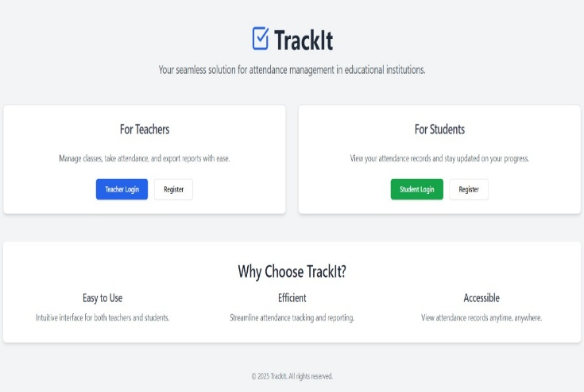
Fig. Home page of TrackIT website

- Key Features:
- Role-Based Dashboards: TrackIT provides separate dashboards for students, faculty, and administrators. Each user sees only the information relevant to their role, ensuring clarity, privacy, and efficient navigation. Students can view their attendance, assignments, and marks, faculty can manage records and communicate with students, and admins have full control over the system’s operations.
- Attendance Management: Faculty can digitally record student attendance on a daily or subject-wise basis. Students can view their current attendance percentages, while the system highlights shortages and tracks regularity. This reduces manual errors and increases accountability.
- Assignment Upload and Submission: Faculty can upload assignments with deadlines, and students can download and submit them online. The platform tracks submission status and timing, helping faculty with timely evaluations and students with structured deadlines.
- Real-Time Notifications: Admins and faculty can send important announcements like timetable changes, assignment uploads, or academic notices. These alerts appear directly on the user’s dashboard, ensuring students stay informed without the need for external apps.
- Secure Authentication: Each user logs in with a unique ID and password. The system uses secure authentication techniques to protect personal and academic data, while admins can manage user credentials and monitor access.
- Admin Control Panel: Admins have powerful tools to add or remove users, view reports, track academic data, and manage the entire platform. This centralized control ensures smooth operation and oversight of institutional processes.
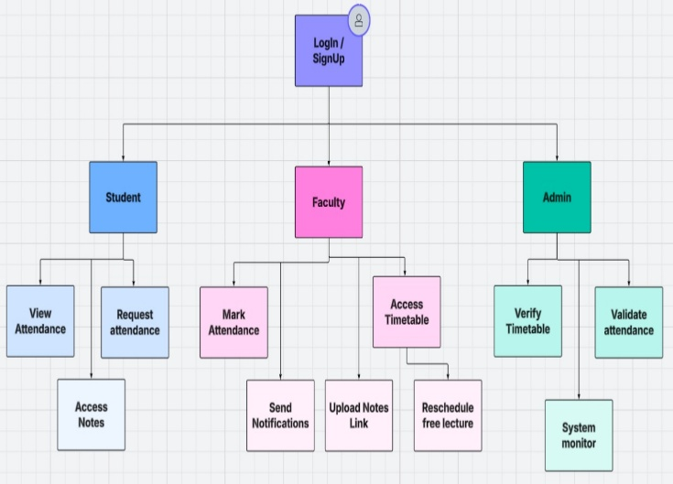
Fig. Flow diagram of TrackIT

- Implementation

- Technologies Used:
- Frontend: The frontend is built using HTML and CSS for responsive design, while JSP (Java Server Pages) is used for dynamic content rendering based on user roles.
- Backend: The backend is developed using Java and JDBC to connect with the database.
- Database: MySQL is used as the database system to store all records including users, attendance, assignments, marks, and notifications.
- Authentication: Session-based authentication using Java

- Challenges Faced:
- Session Management: Ensuring secure access and role-specific data visibility.
- Database Consistency: Maintaining consistent data flow between the three roles.
- Scalability: Planning for institutional-level deployment with thousands of users.

- Solutions:
- Secure Sessions: Implemented JSP session validation for user control and privacy.
- Optimized Queries: Designed relational schema and optimized SQL queries for better performance.
- Responsive UI: Used Bootstrap to ensure a clean, intuitive interface across devices.

- Impact and Evaluation
- Student Feedback: Students appreciated centralized access to academic data and assignment submissions.
- Faculty Benefits: Faculty found it easier to manage marks and communicate with students.
- Admin Efficiency: Administrators could easily monitor academic progress and system usage.

- Expected Outcomes:
- Improved Academic Monitoring: Instant access to marks and attendance.
- Streamlined Administration: Reduced paperwork and centralized control.
- Transparency: Students can track their performance in real-time, reducing ambiguity.

- Future Scope:
- Creating an Android/iOS mobile app version of TrackIT to improve accessibility and allow students and faculty to use the system on the go.
- Integration with university ERP systems.
- SMS/Email notifications for assignments or attendance alerts.
- Analytics dashboard for faculty performance and student progress.
- AI-based feedback system for performance improvement suggestions.

- Conclusion
TrackIT is a practical and effective solution to bridge the communication and operational gaps in educational institutions. By offering tailored interfaces for students, faculty, and admins, the platform ensures accessibility, transparency, and improved academic management. Its implementation promises to enhance institutional efficiency while supporting student success.

References
- Al-Azawei, A., Serenelli, F., & Lundqvist, K. (2016). Universal Design for Learning (UDL): A Content Analysis of Peer-Reviewed Journal Papers from 2012 to 2015. Journal of the Scholarship of Teaching and Learning, 16(3), 39–56. https://doi.org/10.14434/josotl.v16i3.19295
- Kumar, V., & Sharma, N. (2020). A Role-Based Access Control System for Web Applications Using Java. International Journal of Computer Applications, 176(18), 1–5. https://doi.org/10.5120/ijca2020920729
- Singh, A., & Sudarshan, S. (2019). Effective Data Handling in Web Applications Using MySQL and JDBC. Proceedings of the International Conference on Computing and Communication Technologies (ICCCT), IEEE. https://doi.org/10.1109/ICCCT2.2019.8824906
- Aljawarneh, S. (2017). Design and Implementation of a Role-Based Access Control for e-learning Systems. International Journal of Information and Education Technology, 7(9), 655–660. https://doi.org/10.18178/ijiet.2017.7.9.947
- Dawson, S. (2006). A Study of the Relationship Between Student Communication Interaction and Sense of Community. The Internet and Higher Education, 9(3), 153–162. https://doi.org/10.1016/j.iheduc.2006.06.007
- Moodle Documentation. (2024). Learning Management System Features. https://docs.moodle.org
- Kaur, P., & Chana, I. (2014). Cloud Based Intelligent System for Delivering e-Learning Services. Computer Applications in Engineering Education, 22(1), 183–193. https://doi.org/10.1002/cae.20445
- Oracle. (2024). Java EE Documentation. https://docs.oracle.com/javaee/
- W3Schools. (2024). JSP Tutorial. https://www.w3schools.com/jsp/
- MySQL Documentation. (2024). MySQL Reference Manual. https://dev.mysql.com/doc/
- “User-Centered Design and Role-Based UI” – Human-Computer Interaction Conference Proceedings, 2018
- “Role-Based Access Control Models” by Sandhu, R., & Samarati, P. ACM Transactions on Information and System Security, 1994
- “Software Engineering” by Ian Sommerville, 10th Edition
- “Web Application Architecture” by Leon Shklar and Richard Rosen
- “Database Systems: The Complete Book” by Hector Garcia-Molina, Jeff Ullman

