**ACROPOLIS INSTITUTE OF TECHNOLOGY AND**

**RESEARCH**

**Department of IT, CSE (DS), CSE (IoT)**

**Synopsis**

on

***CheckIT : Smarter tools for smarter campuses.***

1. **Introduction**
   1. Overview

The **CheckIT** is a web-based **ERP solution** designed to streamline and automate the attendance tracking process for **students of IT Department**. The traditional method of maintaining attendance records using paper registers or Excel sheets is inefficient, error-prone, and time-consuming. This project integrates **Google Forms API** to collect attendance data, which is then stored in a centralized database for easy retrieval and analysis. Faculty members can manage their subjects, lecture schedules, and attendance records, while students receive notifications regarding their attendance status. The system enhances transparency, reduces manual effort, and ensures timely tracking of attendance.

Additionally, the system includes a Task Management and Reminder Module. Students and faculty can create personal to-do lists and set custom reminders. Admins can also assign tasks to both faculty and students and track their completion status, improving productivity and academic coordination. Faculty members can also share study materials and notes with students through the portal and generate notices or announcements related to classes, assignments, or academic updates.

* 1. Purpose

The primary goal of this project is to automate the attendance process and ensure seamless management of student records.

Key benefits include:

* Reducing manual errors in attendance tracking.
* Automating notifications for faculty (lecture reminders) and students (low attendance alerts).
* Generating attendance reports for academic evaluation.
* Providing real-time access to attendance records for faculty and students.
* Enhancing data security and role-based access control.
* Offering task tracking and reminder features to improve time management for all users.
* Allowing faculty to share notes and issue notices efficiently within the system.

1. **Literature Survey**
   1. Existing Problem

**TABLE I**

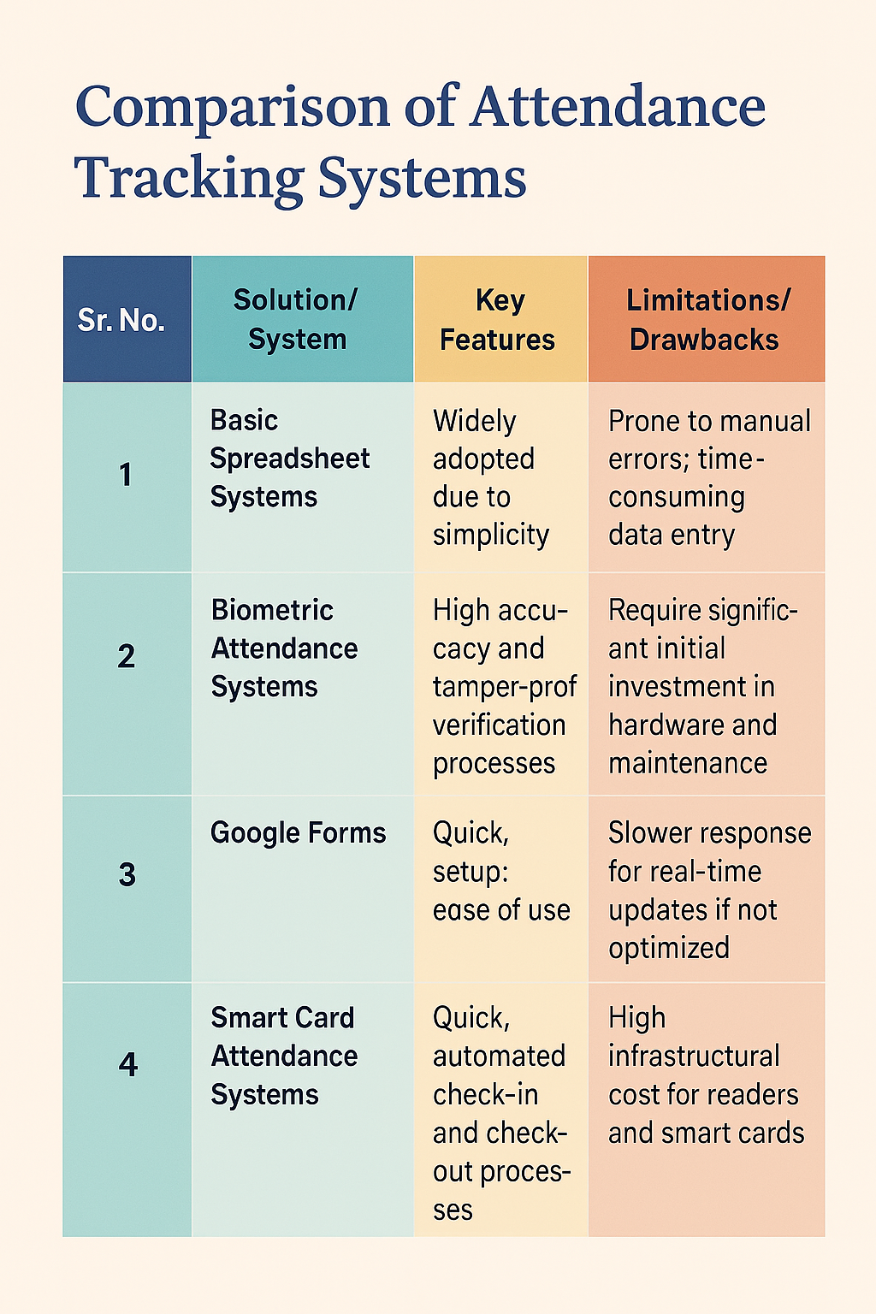 **LITERATURE SURVEY**

* 1. Proposed Solution

The proposed CheckIT overcomes these issues by:

* Integrating Google Forms API for easy attendance collection.
* Providing real-time analytics on student attendance trends.
* Automating alerts for faculty (lecture reminders) and students (low attendance warnings).
* Enhancing accessibility through a web-based portal with role-based authentication.
* Allowing report generation in multiple formats (PDF, Excel, CSV).
* Introducing task assignment and reminder features to streamline academic and administrative activities.
* Supporting faculty in uploading notes and creating notices, enhancing academic communication.

1. **Theoretical Analysis**
   1. 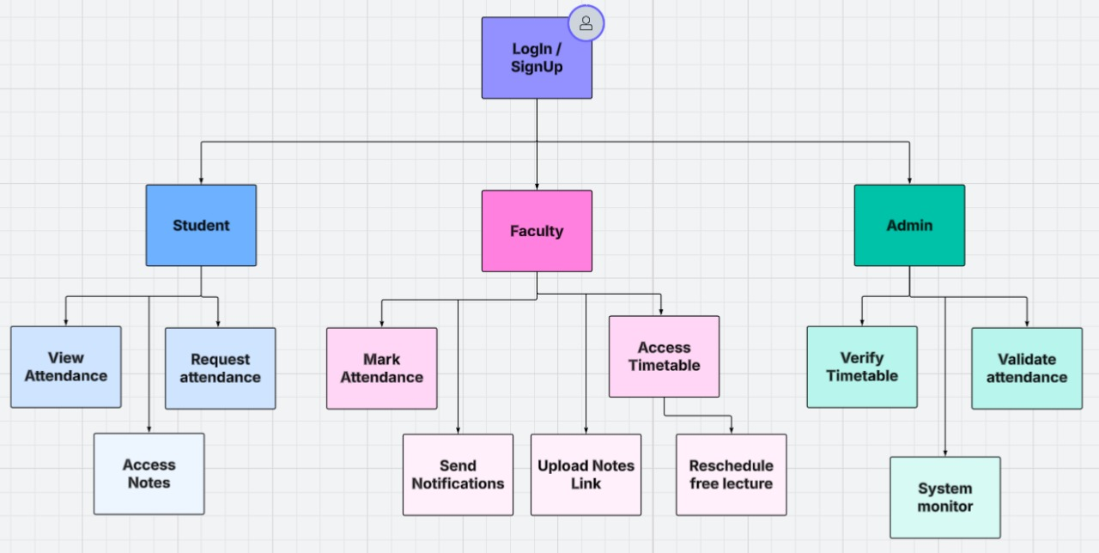 Flow Diagram

Fig.1. Flow Diagram

* 1. Hardware/Software Designing

3.2.1 Hardware Requirements:

* Basic Computer or Laptop (For development and usage)
* Internet Access (For using web-based services like Google Forms)
* Web Server Hosting (Shared hosting or cloud server like Render or Hostinger)

3.2.2 Software Requirements:

* **Frontend:** HTML, CSS, JavaScript (with Bootstrap for UI design)
* **Backend:** Java (Servlets, JSP or Spring Boot)
* **Database:** MySQL
* **Google Integration:** Google Forms and Google Sheets
* **Notification System:** Email Notifications via JavaMail API
* **IDE:** Eclipse / IntelliJ IDEA
* **Deployment Platform:** Apache Tomcat Server / Localhost (XAMPP or WAMP for testing)

1. **Applications**

This system can be applied in various fields, including:

* **Educational Institutions** – Colleges and universities for managing student attendance efficiently.
* **Corporate Training Programs** – Tracking attendance of employees during training sessions.
* **Coaching Centers** – Monitoring attendance of students in private coaching institutes.
* **Remote Learning Platforms** – Ensuring participation in online classes.
* **HR & Workplace Monitoring** – Tracking employee attendance in workplaces.
* **Academic Task Management** – Facilitating personal and administrative task assignment with reminders.
* **Notes Distribution and Notice Management** – Enhancing faculty-student communication.

**REFERENCES**

1. International Journal of Computer Applications. (2021). Web Based Attendance Management System. Available: https://www.ijcaonline.org/
2. Journal of Emerging Technologies and Innovative Research. (2022). Automated Attendance System Using Web Technologies. Available: https://www.jetir.org/
3. ResearchGate. (2020). Smart Attendance Management System Using ERP. Available: <https://www.researchgate.net/>

**Guided By: Group Members:**

Prof. Shahida Khan Kratika Jain (0827IT221079)

Pratham Bothra (0827IT221112)

Saloni Jain (0827IT221128)

Urvashi Yadav (0827IT221147)