Worksheet 2
Student Name: Saloni Kumari UID: 25MCA20087
Branch: MCA (General) Section/Group: 25MCA-2A
Semester: 3rd Date of Performance: 03-08-2026
Subject Name: Backend Technologies Subject Code: 25CAP-706

Aim/Overview of the practical:
To develop a Signup Page using NodeJS and store the user-entered data into a file.
Objectives:
- To design a Signup and Login page using HTML and Node.js.
- To create an HTTP server using Node.js.
- To handle HTTP GET and POST requests.
- To validate username, email, password, and confirm password.
- To ensure that the username starts with a capital letter.
- To verify the user's email using a 6-digit OTP.
- To implement OTP expiration for 5 minutes.
- To prevent duplicate usernames and email addresses.
- To store registered user data in a text file.
- To hash passwords before storing them.
- To authenticate users during login.
- To understand the use of Node.js core modules such as http, fs, querystring, and crypto.
Software Require:
- NodeJS Installed
- VS Code
- Web Browser
- Terminal
Project Structure:
SignupProject/
│
├── server.js
│
└── users.txt

FlowChart:
START
↓
Open Signup Page
↓
Enter Username, Email, Password & Confirm Password
↓
Validate User Input
┌───────┴────────┐
Invalid Valid
↓ ↓
Show Error Check Duplicate
┌──────┴──────┐
Exists Not Exists
↓ ↓
Show Error Generate OTP
↓
Display OTP
↓
Enter OTP
┌────────┴────────┐
Invalid Valid
↓ ↓
Show Error Hash Password
↓
Save User in users.txt
↓
Signup Successful
↓
Login Page
↓
Enter Email & Password
↓
Verify Credentials
┌────────┴────────┐
Invalid Valid
↓ ↓
Show Error Welcome Page
↓
END

Code/Output:
Import Required Modules
const http = require("http");
const fs = require("fs");
const querystring = require("querystring");
const crypto = require("crypto");
Create HTTP Server
const server = http.createServer((req, res) => {
const url = req.url.split("?")[0];
// Request handling code
});
Signup Page
<form method="POST" action="/" autocomplete="off">
<input
type="text"
name="username"
placeholder="Example: Saloni"
required>

<input
type="email"
name="email"
placeholder="Enter Email"
required>

<input
type="password"
name="password"
placeholder="Enter Password"
required>

<input
type="password"
name="confirmPassword"
placeholder="Confirm Password"
required>

<input
type="checkbox"
name="terms"
required>

<button type="submit">
Sign Up
</button>

</form>

Username Validation
const usernamePattern =
/^[A-Z][A-Za-z0-9_]{2,19}$/;

if (!usernamePattern.test(username)) {

// Show invalid username message

return;
}
Email Validation
const emailPattern =
/^[^\s@]+@[^\s@]+\.[^\s@]+$/;

if (!emailPattern.test(email)) {

// Show invalid email message

return;
}
Password Validation
const passwordPattern =
/^(?=.*[a-z])(?=.*[A-Z])(?=.*\d)(?=.*[@$!%*?&]).{8,}$/;

if (!passwordPattern.test(password)) {

// Show password error
return;
}
Confirm Password
if (password !== confirmPassword) {

// Show password mismatch
return;
}
Generate OTP
const otp =
crypto.randomInt(
100000,
1000000
).toString();
Store User Data
const user = `
Username : ${storedData.username}
Email : ${email}
Password Hash : ${hashedPassword}
Email Verified : YES
Registration Date : ${new Date().toLocaleString()}
`;
fs.appendFile(
"users.txt",
user,
(err) => {
// Handle result
}
);
Login Page
<form method="POST" action="/login">

<label>Email</label>
<input
type="email"
name="email"
required>

<label>Password</label>

<input
type="password"
name="password"
required>

<button type="submit">
Login
</button>
</form>
Login Authentication
const hashedPassword =
crypto
.createHash("sha256")
.update(password)
.digest("hex");

fs.readFile(
"users.txt",
"utf8",
(err, fileData) => {

// Search for matching
// email and password hash

}
);

Output:
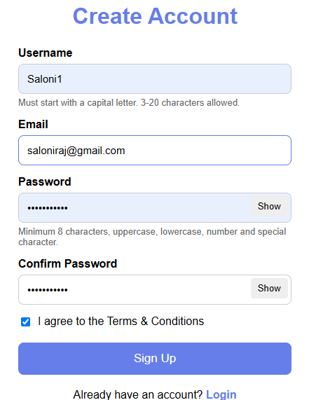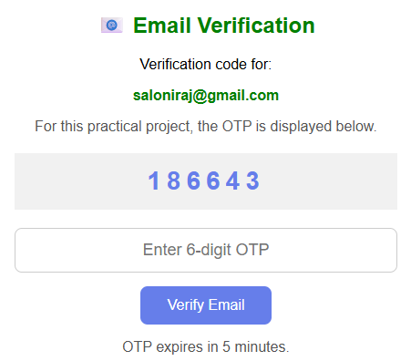
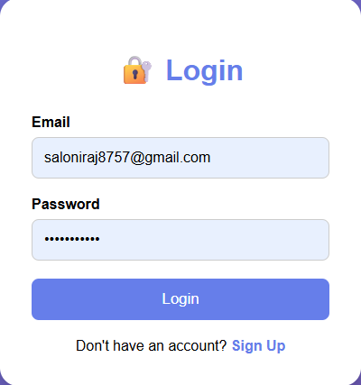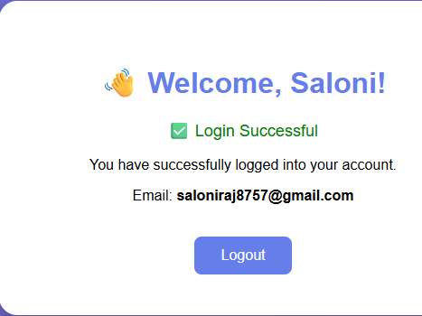
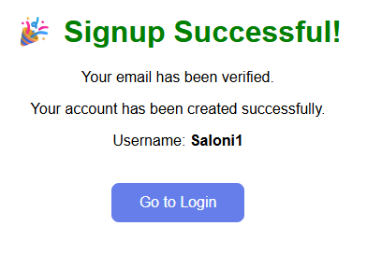
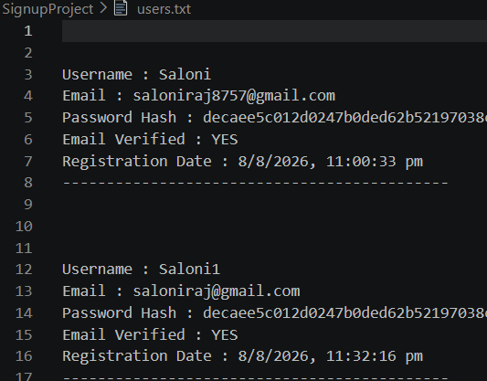
Learning Outcomes:
- Understand the basics of backend development using Node.js.
- Create Signup and Login pages using HTML and Node.js.
- Handle HTTP GET and POST requests.
- Read and process user input from web forms.
- Generate and verify OTPs.
- Implement email-verification logic using OTP.
- Validate usernames, emails, and passwords.
- Hash passwords before storing them.
- Store and retrieve user data using the Node.js File System module.

