Assignment : 4 (Bootstrap)

1. What are the advantages of Bootstrap?

* Easy to prevent repetitions among multiple projects
* Responsiveness
* Maintaining consistency among projects when using multiple developer teams
* Quick design of prototypes
* Cross-browser compatibility

1. What is a Bootstrap Container, and how does it work?

Containers are the most basic layout element in Bootstrap and are ****required when using our default grid system****.

Bootstrap comes with three different containers:

* .container, which sets a max-width at each responsive breakpoint
* .container-fluid, which is width: 100% at all breakpoints
* .container-{breakpoint}, which is width: 100% until the specified breakpoint

1. What are the default Bootstrap text settings?

Bootstrap styles HTML headings (<h1> to <h6>)  with a bolder font-weight and an increased font-size:

# h1 Bootstrap heading

## h2 Bootstrap heading

### h3 Bootstrap heading

#### h4 Bootstrap heading

##### h5 Bootstrap heading

###### h6 Bootstrap heading

Display headings are used to stand out more than normal headings (larger font-size and lighter font-weight), and there are four classes to choose from: .display-1, .display-2, .display-3, .display-4

1. What do you know about the Bootstrap Grid System?

Bootstrap’s grid system uses a series of containers, rows, and columns to layout and align content. It’s built with [flexbox](https://developer.mozilla.org/en-US/docs/Web/CSS/CSS_Flexible_Box_Layout/Using_CSS_flexible_boxes) and is fully responsive

Example,

<div class="container">

<div class="row">

<div class="col-sm">

One of three columns

</div>

<div class="col-sm">

One of three columns

</div>

<div class="col-sm">

One of three columns

</div>

</div></div>

1. What is the difference between Bootstrap 4 and Bootstrap 5?

* brand new look and fed in bootstrap5.
* Brand new logo in bootstrap 5.
* New typography added in bootstrap 5.
* No jquery required anymore in bootstrap 5.
* Enhanced grid (multiple changes including addition of xxl)

1. What is a Button Group, and what is the class for a basic Button Group?

“Button Groups” in Bootstrap is a class of name “btn-group” which is used to create series of buttons in groups (without spaces) vertically or horizontally.

This is the basic syntax of the button group class where each button has its own class of “btn”.

<div class="btn-group">

<button type="button" class="btn">Click</button>

</div>

1. How can you use Bootstrap to make thumbnails?

<!DOCTYPE html>

<html lang="en">

<head>

    <title>Bootstrap Example</title>

    <meta charset="utf-8">

    <meta name="viewport" content="width=device-width, initial-scale=1">

    <link rel="stylesheet" href="https://maxcdn.bootstrapcdn.com/bootstrap/3.4.1/css/bootstrap.min.css">

    <script src="https://ajax.googleapis.com/ajax/libs/jquery/3.6.0/jquery.min.js"></script>

    <script src="https://maxcdn.bootstrapcdn.com/bootstrap/3.4.1/js/bootstrap.min.js"></script>

</head>

<body>

    <div class="container">

        <h2>Thumbnail</h2>

        <img src="img/myphoto.JPG" class="img-thumbnail" alt="Cinque Terre" width="304" height="236">

    </div>

</body>

</html>

Output:

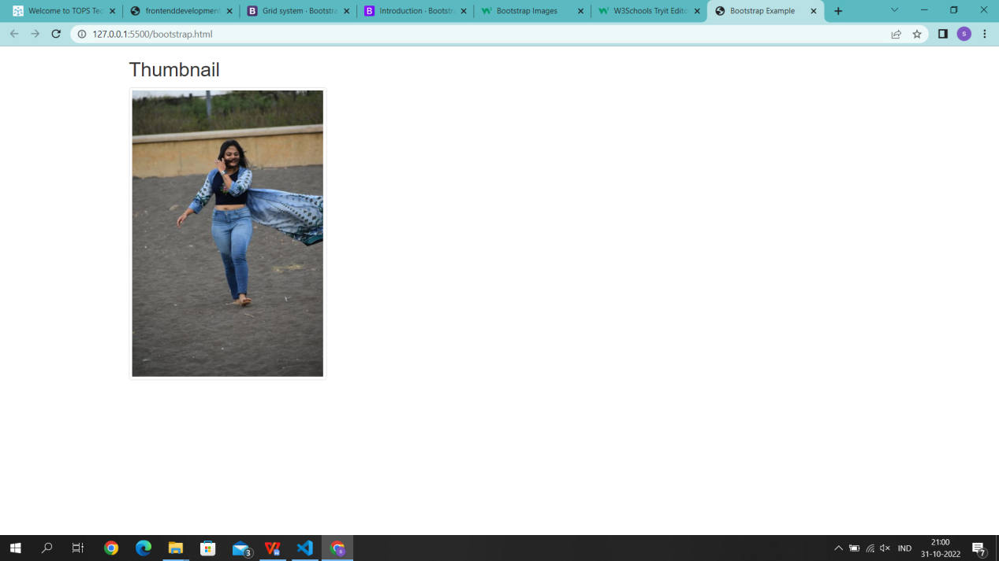

1. In Bootstrap 4, what is flexbox?

The Flexible Box Layout Module, makes it easier to design flexible responsive layout structure without using float or positioning.

1. • How can one create an alert in Bootstrap?

Alerts are created with the .alert class, followed by one of the four contextual classes .alert-success, .alert-info, .alert-warning or .alert-danger

1. how would you create one?

<!DOCTYPE html>

<html lang="en">

<head>

    <title>Bootstrap Example</title>

    <meta charset="utf-8">

    <meta name="viewport" content="width=device-width, initial-scale=1">

    <link rel="stylesheet" href="https://maxcdn.bootstrapcdn.com/bootstrap/3.4.1/css/bootstrap.min.css">

    <script src="https://ajax.googleapis.com/ajax/libs/jquery/3.6.0/jquery.min.js"></script>

    <script src="https://maxcdn.bootstrapcdn.com/bootstrap/3.4.1/js/bootstrap.min.js"></script>

</head>

<body>

    <div class="card" style="width: 330px; border: 1px solid blue;">

        <img src="img/myphoto.JPG" class="card-img-top">

        <div class="card-body">

            <h2 class="card-title">saloni patel</h2>

            <p class="card-text">Some quick example text </p>

            <a href="#" class="btn btn-primary">click here</a>

        </div>

    </div>

</body>

</html>