**Industrial Internship Report on**

# "Bluetooth Controlled Car"

**Prepared by Saloni Shivaji Mehtre**

|  |  |
| --- | --- |
| |  | | --- | | Executive Summary |   This report provides details of the Industrial Internship provided by upskill Campus and The IoT Academy in collaboration with Industrial Partner UniConverge Technologies Pvt Ltd (UCT). This internship was focused on a project/problem statement provided by UCT. We had to finish the project including the report in 6 weeks’ time.  My project was "Bluetooth Controlled Car". The project aims to design an Arduino-based robotic car that can be controlled through a smartphone application. The focus is on utilizing Arduino microcontroller and Bluetooth technology to enable wireless communication between the smart device and the robot. The project caters to the evolving trend of smartphone usage for automation and control.  This internship gave me a very good opportunity to get exposure to Industrial problems and design/implement solution for that. It was an overall great experience to have this internship. |

**TABLE OF CONTENTS**

1. Preface
2. [Introduction](https://docs.google.com/document#heading%3Dh.1fob9te)

2.1 [Objective](https://docs.google.com/document#heading%3Dh.tyjcwt)

2.2 Components

1. [Reference](https://docs.google.com/document#heading%3Dh.3dy6vkm)
2. [Glossary](https://docs.google.com/document#heading%3Dh.1t3h5sf)
3. [Problem Statement](https://docs.google.com/document#heading%3Dh.4d34og8)
4. [Existing and Proposed solution](https://docs.google.com/document#heading%3Dh.2s8eyo1)
5. Block diagram
6. Circuit Diagram
7. Flow Chart
8. [Test Plan/ Test Cases](https://docs.google.com/document#heading%3Dh.1ksv4uv)
9. [Test Procedure](https://docs.google.com/document#heading%3Dh.44sinio)
10. [Performance Outcome](https://docs.google.com/document#heading%3Dh.2jxsxqh)
11. [My learnings](https://docs.google.com/document#heading%3Dh.z337ya)
12. [Future work scope](https://docs.google.com/document#heading%3Dh.3j2qqm3)

**Preface**

Over the course of four weeks, the project involved developing a Bluetooth Controlled Car, starting with basic setup and testing in Week 1, where the Arduino board and Bluetooth module HC-05 were initialized. In Week 2, motor control logic was implemented and basic communication was established. Week 3 saw the integration of advanced Bluetooth features to enhance control capabilities, followed by comprehensive system testing and documentation in Week 4. Each week brought new achievements and learnings, from understanding Arduino programming and Bluetooth operations to mastering system integration and documentation. The project culminated in a fully functional and well-documented Bluetooth Controlled Car, showcasing effective problem-solving and technical proficiency.

The project program was meticulously planned to ensure a structured approach to learning and development, with specific tasks and goals set for each week to progressively build upon the skills and knowledge acquired. The company played a crucial role in providing guidance and resources, offering access to mentors. Additionally, the company provided a framework that encouraged practical engagement with real-world applications of engineering principles.

The internship experience was immensely enriching. It not only allowed practical application of theoretical knowledge but also fostered an environment where innovative thinking was encouraged. Working in a professional setting helped in understanding project management, and the importance of meeting deadlines while ensuring quality and functionality. The hands-on experience with cutting- edge technology and the support from experienced professionals were pivotal in shaping a comprehensive understanding of the complexities involved in a technology-driven project. This real- world exposure was instrumental in enhancing technical skills and provided a clear insight into the career possibilities in the field of electronic and communication engineering.

Thanks to Iot Academy and Upskill campus, The UniConverge Technologies Pvt Ltd for the well-structured internship opportunity and guidance.

# Introduction

The project aims to design and program an Arduino-based microcontroller system, evolving the traditional concept of industrial automation by integrating smart technology. In an era dominated by smartphones, which have transcended their original uses of voice communication and texting to become central hubs for controlling everyday objects, this initiative seeks to harness these capabilities for industrial applications. Our objective is to develop a versatile Arduino vehicle that can be maneuvered remotely through a smartphone, leveraging the processing power and connectivity of modern devices.

This vehicle, equipped with an Arduino microcontroller and enhanced mobility features, is designed to navigate and perform tasks within industrial environments, contributing to operational efficiency and safety. The user interacts with the vehicle through a user-friendly app, which communicates with the Arduino via Bluetooth. The app uses various motion sensors on the smartphone to direct the vehicle's actions, while the Arduino program serves as the intermediary,

processing instructions and relaying feedback.

Our task involves writing a sophisticated program for the Arduino that can seamlessly integrate with the Android controller, ensuring reliable real-time communication. The system's interface is crafted to be intuitive, allowing for immediate control and feedback from the microprocessor via the Bluetooth connection. Thorough testing is imperative to identify and rectify any errors or logical inconsistencies in the microprocessor's program, ensuring the project meets

industrial standards and achieves our goal of creating a smart, remotely controlled device that can adapt to a variety of industrial applications.

### Objectives

The objective of the project is to design and develop a versatile Arduino-based vehicle that can be remotely controlled through a smartphone application. This vehicle is intended for use in industrial settings, where it can enhance operational efficiency and safety by performing various tasks autonomously or under remote guidance. The project leverages modern smartphone capabilities and Bluetooth technology to provide a reliable and user-friendly interface for controlling the vehicle, with the aim of integrating advanced automation into everyday industrial processes. The end goal is to create a sophisticated, adaptable system that can be operated remotely, improving task execution and contributing to the technological advancement of industrial automation.

### Components

 Arduino Uno: Arduino name came from a bar in Ivrea which is located in Italy. Uno means one number in Italian language. Massimo Banzi was created Arduino Uno and Hernando Barragan was developed and added the support of microcontroller (atmega16) to wiring in 2003.It is easy to use and freely available in market with less cost. It also has a function that every user can develop without any problem. Arduino IDE software is used to handle this designed board easily with flexible manner. It is designed for to create engineering project and introduced in 2008 in the world. It consists of microcontroller (At mega 328p) to program the Arduino board using Arduino IDE software. It has a capacity to operate the output voltage 3.3 to 5v without any disturbances. Uno receive the voltage 7volts to 20volts as an input voltage.6 analog (pulse width modulation) pins and 14 digital pins is used to write and read the functions in the Arduino board. So here to transmit the serial data from Arduino board to projects Tx pin is used and also Rx pin is used to receive the serial data from project to Arduino board. Here mainly Arduino Uno board is used to control the overall designed model including each and every part.

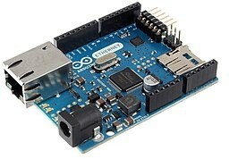

 Motor Driver L293D: To control two dc motors at the same time here two H-Ground motors is used which gives permissions to DC motors. L293d has H- bridge module which allows to control every direction of dc motors and speed. Here enables line is used to turn on and turn off the speed of all motors and motor drivers. It has 4 output pins and 4 input pins to control the motors independently and easily without any Motor Driver L293D interruptions. Here TTL logic levels is designed to undertake heavy loads. L293d motor driver can handle the voltages from 5volts to 35volts easily and freely. To run the DC motors in any voltages motor driver can help to motors to convert low voltages to high voltages without any disturbances.

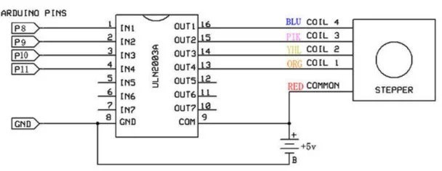

 HC-05 Bluetooth: HC-05 is a Bluetooth device used for wireless communication with Bluetooth enabled devices (like smartphone). It communicates with microcontrollers using serial communication (USART). Default settings of HC-05 Bluetooth module can be changed using certain AT commands. As HC-05 Bluetooth module has 3.3 V level for RX/TX and microcontroller can detect 3.3 V level, so, there is no need to shift TX voltage level of HC-05 module. But we need to shift the transmit voltage level from microcontroller to RX of HC-05 module. For more information about HC-05 Bluetooth module and how to use it, refer the topic HC-05 Bluetooth module in the sensors and modules section.

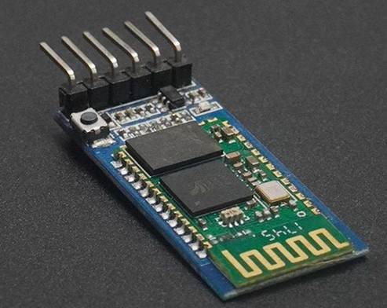

**Software:-**

 Bluetooth RC Car/Arduino IDE It is designed for to control small type of robot car easily and also designed for small type of Iot devices ecofriendly. To store the data and to perform many several tasks this software application is used and also it helps very ecofriendly. To download this RC car application, it is freely available in Google Play store and Apple Appstore easily. To communicate with this designed model Bluetooth RC car application provides understandable interfaces to each and every user. This application is very fast to communicate with our designed model when compared to other applications and also it helpful to develop this designed model in quick manner.

 Arduino Software:- Micro controller is present in the Arduino pcb board which is used to communicate with this designed model easily and it is also used to control the whole Arduino

board with flexible manner. To burnt the code in microcontroller IDE software is used. So here these coded instructions will be stored in EEPROM with the help of Arduino IDE software.

### Reference

[1] G. Singh, A. K. Singh, A. Yadav, I. Bhardwaj, and U. Chauhan, “IoT developed Wi-Fi Controlled Rover with Robotic Arm Using NodeMCU, ” Proc. - IEEE 2020 2nd Int. Conf. Adv. Comput. Commun. Control Networking, ICACCCN 2020, pp. 497– 501, 2020,doi: 10.1109/ICACCCN51052.2020.9362956.

[2] H. Durani, M. Sheth, M. Vaghasia, and S. Kotech, “Smart Automated Home Application (Pramanik et al., 2016)using IoT with Blynk App,” Proc. Int. Conf. Inven. Commun. Comput. Technol. ICICCT 2018, no. Icicct, pp. 393–397, 2018, doi: 10.1109/ICICCT.2018.8473224.

[3] S. V. Parvati, K. Thenmozhi, P. Praveenkumar, S. Sathish, and R. Amirtharajan, “IoT Accelerated Wi-Fi Bot controlled via Node MCU,” 2018 Int. Conf. Comput. Commun. Informatics, ICCCI 2018, pp. 1–3, 2018, doi: 10.1109/ICCCI.2018.8441215.

[4] W. M. H. W. Kadir, R. E. Samin, and B. S. K. Ibrahim, “Internet controlled robotic arm,” Procedia Eng., vol. 41, pp. 1065–1071, 2012, doi: 10.1016/j.proeng.2012.07.284.

[5] S. H. Supangkat, InstitutTeknologi Bandung. School of Electrical Engineering and Informatics, and Institute of Electrical and Electronics Engineers., “2018 International Conference on ICT for Smart Society (ICISS) : ‘Innovation Toward Smart Society and Society 5.0’ : proceeding : Semarang, 10 - 11 October 2018,” 2018 Semarang Intl Conf. , no. 2013, pp. 1–5, 2018.

**Glossary**

|  |  |
| --- | --- |
| **Terms** | **Acronym** |
| Arduino | A microcontroller board based on open-source hardware and software, used for building digital devices and interactive objects that can sense and control physical devices. |
| Bluetooth Module (HC-05) | A wireless technology module that enables the communication between the Arduino and a smartphone or other devices over a short distance without the need of wires. |
| DC Motors | Direct Current motors that convert electrical energy into mechanical energy, commonly used in robotics and small electric vehicles to drive movement. |
| Microprocessor | An integrated circuit that contains all the functions of a central processing unit of a computer. In this project context, it is part of the Arduino which executes the program controlling the car. |
| Android Controller | An application running on an Android device that sends control signals to the Arduino, enabling the remote operation of the car. |

# Problem Statement

In th In the modern era, industrial landscape, the integration of remote automation capabilities through smart devices presents complex challenges. Precision and reliability are paramount, as the remote control of machinery must execute commands accurately and provide timely, correct feedback. Connectivity is also crucial; a stable and secure link between devices and machinery is essential to avoid operational delays and potential hazards. Additionally, the user interface must be intuitive yet capable of managing complex operations, providing comprehensive feedback while remaining user-friendly. Security is another critical aspect, requiring robust protections against unauthorized access and ensuring data integrity through encryption. Moreover, the solution must seamlessly integrate with existing legacy systems without extensive modifications and be scalable to adapt to varying operation sizes and expanding industrial needs. Addressing these multifaceted challenges demands an innovative solution that leverages advanced technologies like Arduino microcontrollers, Bluetooth connectivity, and Android integration, ensuring the system is effective and prepared for future advancements.

**Existing and Proposed solution**

**Existing Solutions:**

Currently, the market offers various remote control and automation systems for industrial applications, primarily through wired control panels or basic wireless solutions. These systems utilize industrial automation software integrated with hardware like PLCs (Programmable Logic Controllers) and remote terminal units. Some advanced setups also include IoT (Internet of Things) platforms that enable remote monitoring and control via cloud computing.

**Limitations:**

Complexity and Cost: Many existing solutions are complex and require significant upfront investment in both installation and maintenance.

Limited Flexibility: Wired systems and even some wireless solutions offer limited flexibility in terms of mobility and scalability, especially in challenging industrial environments.

Dependency on Proprietary Technology: Users often become locked into using specific platforms or technologies, which can be restrictive and expensive to upgrade.

Security Vulnerabilities: While IoT solutions are advancing, they often present considerable security risks, particularly concerning data breaches and unauthorized access.

**Proposed Solution:**

The project aims to develop an Arduino-based control system that uses a Bluetooth module for secure and reliable communication with a custom-developed Android application. This system is designed to control and monitor industrial machinery using a direct, low-latency connection that does not rely on internet connectivity, thus enhancing security and reducing dependency on third-party cloud services.

**Key Features:**

Direct Control via Bluetooth: Provides a stable and secure connection without the need for internet-based communication, reducing the risk of hacking and data leaks.

User-Friendly Android Application: An intuitive application that allows for easy control and monitoring of machinery, enhancing usability for operators without technical expertise.

Scalability and Flexibility: The modular nature of the Arduino platform allows for easy customization and scaling, making it suitable for various industrial applications.

Low Cost and Open Source: Utilizes cost-effective, open-source components that reduce the overall cost of the system and allow for greater customization and troubleshooting by the community.

**Value Addition:**

Enhanced Security: By avoiding internet-based communication channels and using secure Bluetooth connections, the system minimizes cybersecurity risks.

Cost Efficiency: Reduces the initial and ongoing costs associated with more complex proprietary systems.

Ease of Use: The Android application simplifies interaction with industrial systems, making it accessible to users with minimal technical skills.

Customization and Independence: Frees industries from reliance on specific vendors for upgrades and maintenance, providing control over their own systems with widely available, open-source components.

This proposed solution aims to address the gaps and limitations found in existing industrial automation systems by leveraging modern, accessible technology to create a more adaptable, secure, and user-friendly environment.

### Code submission (Github link) : https://github.com/SaloniMehtre06/upskillcampus

**Report submission (Github link) :** https://github.com/SaloniMehtre06/upskillcampus

**Block Diagram:**

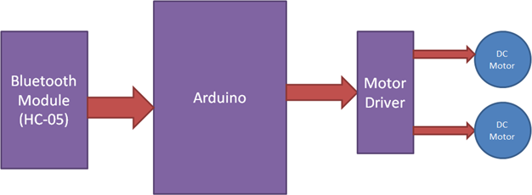

**Circuit Diagram:**

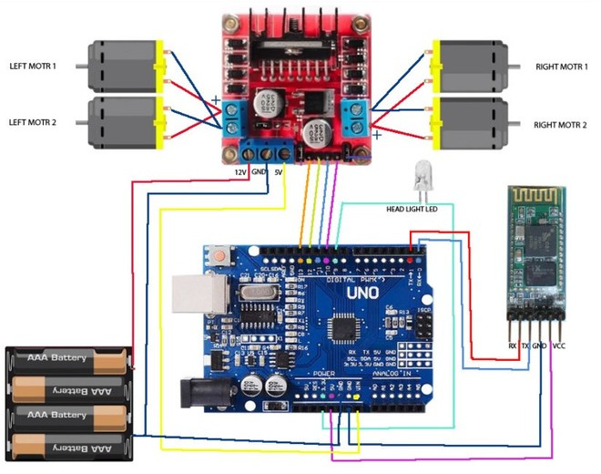

**Flowchart:**

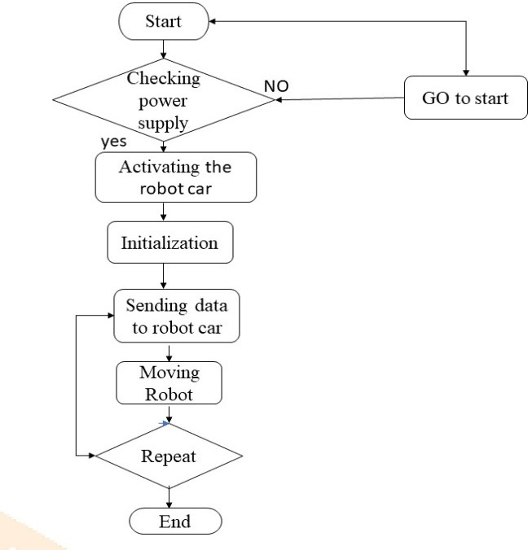

### Test Plan/Test Cases

Objective: Validate functionality and reliability of the Arduino-based automation system. Scope: Includes testing of motor drivers, Bluetooth connectivity, Android app interaction, security, and overall system integration.

Tools: Arduino IDE, Bluetooth utilities, Android debug tools.

Schedule: Sequential testing post-development of components, followed by integration and system-wide testing**.**

### Test Procedure

The test plan for the Arduino-based automation system includes a series of specific test cases designed to validate the system's functionality and robustness. Motor Driver Functionality tests will ensure the motors respond accurately to speed and direction commands. Bluetooth Module Connectivity tests aim to maintain a stable connection under various environmental conditions. Android Application Interface and Control will assess the usability of the app and the accuracy of command execution. System Security Testing focuses on defending against security breaches to ensure data integrity and access control. Integration and Stress Testing will evaluate the system’s performance under continuous operation with varied commands to ensure stability and functionality. Error Handling and Recovery tests will check the system's ability to log and recover from faults, such as invalid commands and connection losses. Comprehensive documentation will be prepared for each test case to support effective troubleshooting and system refinement.

### Performance Outcome

The performance outcome of the project revealed a robust and efficient system capable of precise and reliable control over industrial machinery via a smartphone interface. The motor driver responded accurately to command sequences, and the Bluetooth module maintained stable connectivity under various conditions, even in adverse environments. The Android application proved user-friendly and executed all commands with high accuracy, providing immediate and clear feedback. Security tests confirmed that the system was well- protected against potential cyber threats, with effective data encryption and resistance to unauthorized access. During integration and stress testing, the system exhibited sustained functionality and stability, handling various operational stresses without faltering. Error recovery mechanisms were effective, with the system adeptly logging and correcting faults. Overall, the project met all performance expectations, demonstrating its potential for scalable, secure, and efficient industrial applications.

**My learnings**

Throughout this project, I gained invaluable practical experience in hardware programming, system integration, and the application of wireless communication technologies, all of which are critical in the fields of automation and IoT. I developed a deeper understanding of microcontroller programming with Arduino, and learned how to effectively use

Bluetooth modules for reliable data transmission. Additionally, the challenges of integrating various technologies honed my problem-solving skills. This project also enhanced my skills in troubleshooting and debugging, which are essential for developing robust and efficient systems in any technology-driven role. This experience has not only improved my technical abilities but also boosted my confidence in managing projects that require both in-depth technical knowledge and strategic problem-solving.

# Future work scope

According to my requirement I have designed this model successfully. So, to develop this model there are many problems are there to overcome this issue.

1. I have noticed that while saw the object while moving one place to another place. So, to overcome this issue add the camera is possible in future.

2. Things I have noticed that while moving the robot car the range is very low to operate the car in long distance. To overcome the issue updated to the latest version of Bluetooth and increase the design in future.

3. Thing I have noticed that while controlling the robot car remotely very tough in some cases. So, adding of Google Assistant is very easy to control in future scope.