|  |
| --- |
| Edwisor.com |
| **CAB FARE PREDICTION** |
| **PREDICTION OF FARE AMOUNT FOR A CAB RIDE IN THE CITY** |
|  |
| **Saloni Mishra** |
| **11/29/2019** |

|  |
| --- |
| This Case study is to predict the fare amount for a cab ride in the city based on historical data from a pilot project. |



|  |  |
| --- | --- |
| **OVERVIEW** | **2** |
| **CHAPTER 1: INTRODUCTION** | **2** |
| **1.1 PROBLEM STATEMENT** |  |
| **1.2 DATA** |  |
| **CHAPTER 2: METHODOLOGY FOLLOWED** | **3** |
| **2.1 PRE-PROCESSING** |  |
| **2.2 MODELLING** |  |
| **2.3 MODEL SELECTION** |  |
| **CHAPTER 3: PRE-PROCESSING** | **4** |
| **3.1 DATA EXPLORATION & CLEANING (MISSING VALUES &** |  |
| **OUTLIERS)** |  |
| **3.2 CREATING NEW VARIABLES FROM GIVEN VARIABLES** |  |
| **3.3 SELECTION OF VARIABLES** |  |
| **3.4 SOME MORE DATA EXPLORATION** |  |
| **3.5 FEATURE SCALING** |  |
| **CHAPTER 4: MODELLING** | **9** |
| **4.1 LINEAR REGRESSION** |  |
| **4.2 DECISION TREE** |  |
| **4.3 RANDOM FOREST** |  |
| **4.4 GRADIENT BOOSTING** |  |
| **4.5 HYPER PARAMETERS TUNINGS FOR OPTIMIZING THE** |  |
| **RESULTS** |  |
| **CHAPTER 5**: **CONCLUSION** | **17** |
| **5.1 MODEL EVALUATION** |  |
| **5.2 MODEL SELECTION** |  |
| **5.3 PREDICTOR VS PREDICED VARIABLES** |  |
| **REFERENCES** | **22** |
| **APPENDEX** | **23** |

1

**OVERVIEW**

Now a day’s cab rental services are increasing at exponential rates. The flexibility and ease of using the service, gives customers a great experience at affordable prices.

**CHAPTER 1: INTRODUCTION**

**1.1 PROBLEM STATEMENT**

The objective of this Case is Predication of fare amount for a cab ride in the city.

The prediction is based on a successfully run pilot project and the historical data from your pilot project is being used to apply analytics for fare prediction.

**1.2 DATA**

Understanding data is the first and most important step to find solutions to any business problem.

Here in our case we have a data set with following features

* we need to go through each and every variable of it to understand and for better functioning.

Below mentioned is a list of all the variable names with their meanings:

|  |  |
| --- | --- |
| ***Variables*** | ***Description*** |
| ***Fare_Amount*** | ***Fare Amount*** |
| *Pickup_Datetime* | *Cab Pickup Date With Time* |
| *Pickup_Longitude* | *Pickup Location Longitude* |
| *Pickup_Latitude* | *Pickup Location Latitude* |
| *Dropoff_Longitude* | *Drop Location Longitude* |
| *Dropoff_Latitude* | *Drop Location Latitude* |
| *Passenger_Count* | *Number Of Passengers Sitting In The Cab* |
|  | **Table 1- Dataset variables** |

**Size of Dataset:** - 16067 rows, 7 Columns (includes dependent variable)

**Missing Values:** Yes

**Outliers Present:** Yes

**Sample data:**

|  |  |  |  |  |  |  |
| --- | --- | --- | --- | --- | --- | --- |
| fare_amount | pickup_datetime | pickup_longitude | pickup_latitude | dropoff_longitude | dropoff_latitude | passenger_count |
| 4.5 | 2009-06-15 17:26:21 UTC | -73.844311 | 40.721319 | -73.84161 | 40.712278 | 1 |
| 16.9 | 2010-01-05 16:52:16 UTC | -74.016048 | 40.711303 | -73.979268 | 40.782004 | 1 |
| 5.7 | 2011-08-18 00:35:00 UTC | -73.982738 | 40.76127 | -73.991242 | 40.750562 | 2 |
| 7.7 | 2012-04-21 04:30:42 UTC | -73.98713 | 40.733143 | -73.991567 | 40.758092 | 1 |
| 5.3 | 2010-03-09 07:51:00 UTC | -73.968095 | 40.768008 | -73.956655 | 40.783762 | 1 |

**Table 2- Sample Data**

2

**CHAPTER 2: METHODOLOGY FOLLOWED**

**2.1 PRE-PROCESSING**

For a predictive model, before modelling the data should be checked and manipulated under ***Exploratory Data Analysis***. It includes following steps:

1. Data exploration and Cleaning
2. Missing values treatment
3. Outlier Analysis
4. Feature Selection
5. Features Scaling
   * Skewness and Log transformation
6. Visualization

**2.2 MODELLING**

After Pre-Processing the next step is modelling. Modelling helps to find out the good inferences from the data.

Choice of models depends upon the problem statement and data set. Based on our problem statement and dataset, following models are tested on our pre-processed data:

1. Linear regression
2. Decision Tree
3. Random forest,
4. Gradient Boosting

Post comparison of the output results we select the best suitable model for our problem.

We have also used hyper parameter tunings to check the parameters on which our model runs best. Following are two techniques of hyper parameter tuning we have used:

1. Random Search CV
2. Grid Search CV

**2.3 MODEL SELECTION**

The final step of our methodology is Model Selection.

It is based on the outputs and results shown by different models. Multiple parameters are also studied to further scrutinize the model feasibility for the problem statement.

3

**CHAPTER 3: PRE-PROCESSING**

**3.1 DATA EXPLORATION & CLEANING (MISSING VALUES & OUTLIERS)**

Following are the steps followed to explore and clean the data we have:

1. Combined variable separation.
2. Negative values in fare amount to be removed.
3. Passenger count cannot exceed 6 (SUV vehicle), the rows having passengers counts more than 6 and less than 1 to be removed.
4. Outlier figures in the fare (like top 3 values) to be removed.
5. Latitudes range from -90 to 90. Longitudes range from -180 to 180. To remove the rows beyond above ranges.

**3.2 CREATING NEW VARIABLES FROM GIVEN VARIABLES**

Here in our data set our variable name pickup_datetime contains date and

time for pickup. So we tried to extract some important data in form of

variables from pickup_datetime:

1. Year
2. Month
3. Date
4. Day of Week
5. Hour
6. Minute

Using the haversine formula we tried to find out the distance: ***HAVERSINE FORMULA*** determines the great-circle distance betweentwo points on a sphere given their longitudes and latitudes. Important in navigation, it is a special case of a more general formula in spherical trigonometry, the law of haversines, that relates the sides and angles of spherical triangles.

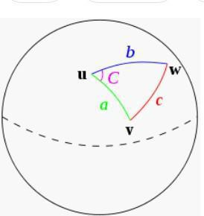

4

So our new extracted variables are:

1. fare_amount
2. pickup_datetime
3. pickup_longitude
4. pickup_latitude
5. dropoff_longitude
6. dropoff_latitude
7. passenger_count
8. year
9. Month

10. Date

11. Day of Week

12. Hour

13. Minute

14. Distance

**3.3 SELECTION OF VARIABLES**

Now as we know that all above variables are of now use so we will drop the redundant variables:

1. pickup_datetime
2. pickup_longitude
3. pickup_latitude
4. dropoff_longitude
5. dropoff_latitude
6. Minute

Below is the data being used after removing not useful variables:

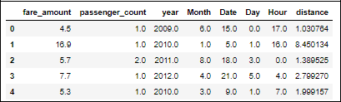

**Table 3 - Data after removing redundant variables**

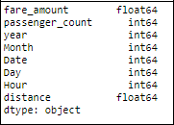

*Table 4 - Data types of the variables*

5

**3.4 SOME MORE DATA EXPLORATION**

In this report we are trying to predict the fare prices of a cab rental company. So here we have a data set of 16067 observations with 8 variables including one dependent variable.

**Below are the names of Independent variables:**

passenger_count, year, Month, Date, Day of Week, Hour, distance Our Dependent variable is: **fare_amount**

**3.4.1 Uniqueness in Variable**

We need to look at the unique number in the variables which help us to decide whether the variable is categorical or numeric. So, by using python script ‘nunique’ we tried to find out the unique values in each variable. We have also added the table below:

|  |  |
| --- | --- |
| **Variable Name** | **Unique Counts** |
| fare_amount | 450 |
| passenger_count | 7 |
| year | 7 |
| Month | 12 |
| Date | 31 |
| Day of Week | 7 |
| Hour | 24 |
| distance | 15424 |

*Table 5- Unique elements*

**3.4.2 Dividing the variables into two categories basis their data types:**

Continuous variables - 'fare_amount', 'distance'.

Categorical Variables - 'year', 'Month', 'Date', 'Day of Week', 'Hour', 'passenger_count'

**3.5 FEATURE SCALING**

**Skewness** is asymmetry in a statistical distribution, in which the curveappears distorted or skewed either to the left or to the right.

Skewness can be quantified to define the extent to which a distribution differs from a normal distribution. Here by using **log transform** technique we tried to reduce the skewness of the same.

6

Below mentioned graphs shows the probability distribution plot to check distribution before log transformation:

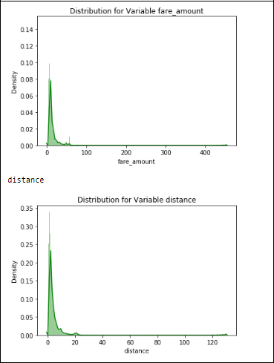

**Figure 1 - Probability distribution before log transformation**

7

Below mentioned graphs shows the probability distribution plot to check distribution after log transformation:

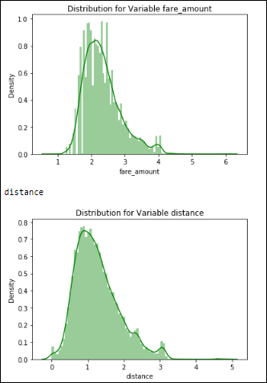

***Figure 2-Probability distribution after log transformation***

As our continuous variables appears to be normally distributed so we don’t need to use feature scaling techniques like normalization and standardization for the same.

8

**CHAPTER 4: MODELLING**

After a thorough pre-processing, we will use some regression models on our processed data to predict the target variable.

Following are the models which we have built: – Linear Regression

Decision Tree

Random Forest

Gradient Boosting

**Note :** Before running any model, we will split our data into two partswhich is train and test data. Here in our case we have taken 80% of the data as our train data. Below is the snipped image of the split of train test.

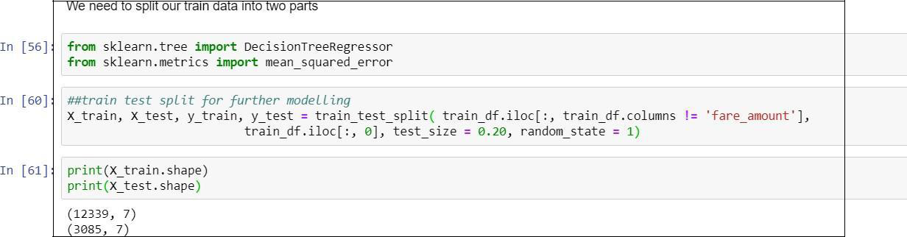

**Figure 3- Code snippet**

9

**4.1 LINEAR REGRESSION**

Multiple regression is an extension of simple linear regression. It is used as a predictive analysis, when we want to predict the value of a variable based on the value of two or more other variables. The variable we want to predict is called the dependent variable (or sometimes, the outcome, target or criterion variable).

Below is the screenshot of the query we executed and the result shown

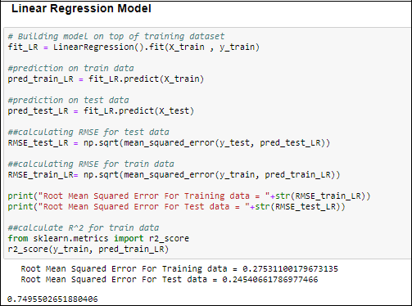

**Figure 4- Linear regression**

10

**4.2 DECISION TREE**

A tree has many analogies in real life, and turns out that it has influenced a wide area of machine learning, covering both classification and regression. In decision analysis, a decision tree can be used to visually and explicitly represent decisions and decision making. As the name goes, it uses a tree-like model of decisions.

Below is the screenshot of the query we executed and the result shown

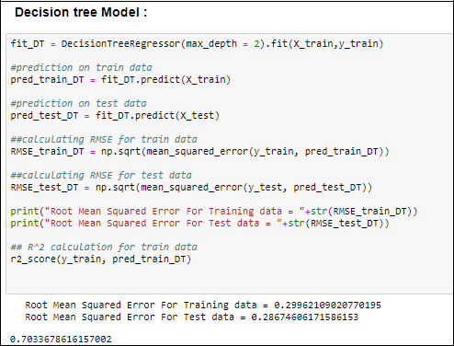

**Figure 5- Decision tree**

11

**4.3 RANDOM FOREST**

Random forests or random decision forests are an ensemble learning method for classification, regression and other task, that operate by constructing a multitude of decision trees at training time and outputting the class that is the mode of the classes (classification) or mean prediction (regression) of the individual trees.

Random decision forests correct for decision trees' habit of overfitting to their training set.

**To say it in simple words: Random forest builds multiple decision trees and merges them together to get a more accurate and stable prediction.**

Below is a screenshot of the model we build and its output:

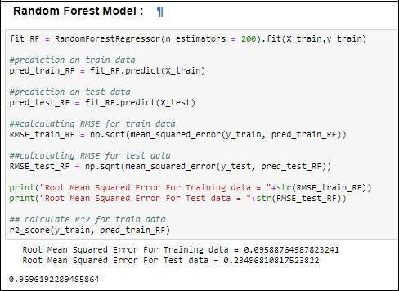

**Figure 6- Random forest**

12

**4.4 GRADIENT BOOSTING**

Gradient boosting is a machine learning technique for regression and classification problems, which produces a prediction model in the form of an ensemble of weak prediction models, typically decision trees. It builds the model in a stage-wise fashion like other boosting methods do, and it generalizes them by allowing optimization of an arbitrary differentiable loss function.

Below is a screenshot of the model we build and its output:

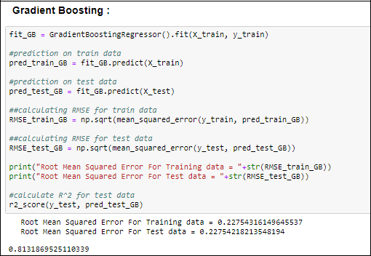

13

**4.5 HYPER PARAMETERS TUNINGS FOR OPTIMIZING THE RESULTS**

Model hyperparameters are set by the data scientist ahead of training and control implementation aspects of the model. The weights learned during training of a linear regression model are parameters while the number of trees in a random forest is a model hyperparameter because this is set by the data scientist.

Hyperparameters can be thought of as model settings. These settings need to be tuned for each problem because the best model hyperparameters for one particular dataset will not be the best across all datasets. The process of hyperparameter tuning (also called hyperparameter optimization) means finding the combination of hyperparameter values for a machine learning model that performs the best - as measured on a validation dataset - for a problem.

Here we have used two hyper parameters tuning techniques

1. **Random Search CV**: This algorithm set up a grid of hyperparametervalues and select random combinations to train the model and score. The number of search iterations is set based on time/resources.
2. **Grid Search CV**: This algorithm set up a grid of hyperparameter valuesand for each combination, train a model and score on the validation data. In this approach, every single combination of hyperparameters values is tried which can be very inefficient.

14

Check results after using Random Search CV on Random forest and gradient boosting model.

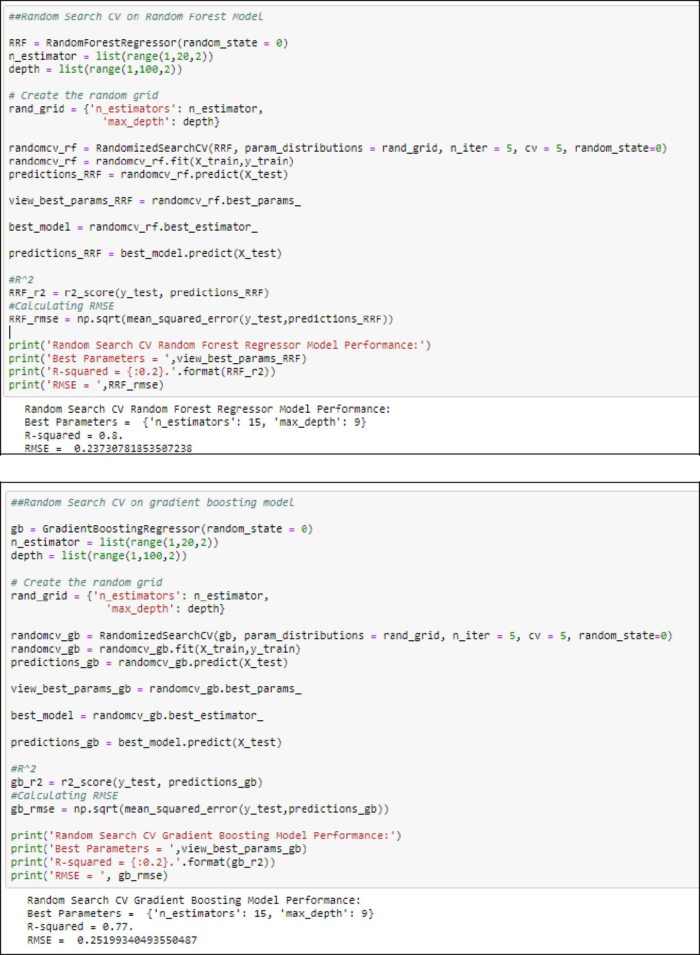

15

Check results on using Grid Search CV on Random forest and gradient boosting model:

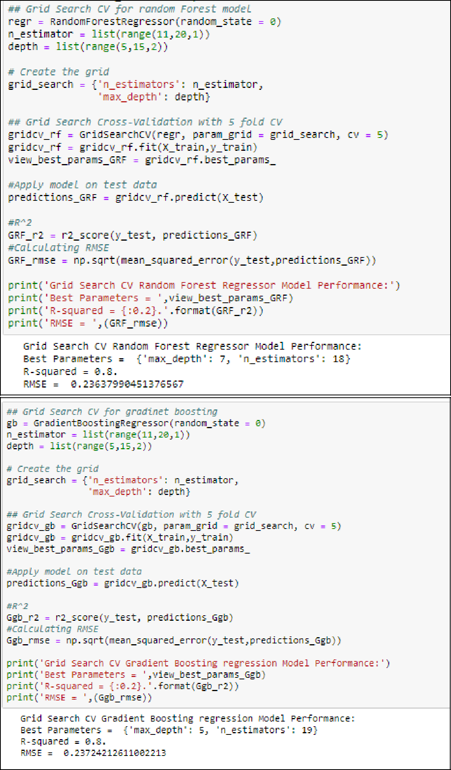

16

**CHAPTER 5**: **CONCLUSION**

**5.1 Model Evaluation**

The main concept is residuals or difference between our predictions f(x[I,]) and actual outcomes y[i].

In general, we scientists use two methods to evaluate the performance of the model:

**5.1.1 RMSE** (Root Mean Square Error): It is a frequently used measure ofthe difference between values predicted by a model and the values actually observed from the environment that is being modelled.

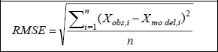

**5.1.2 R Squared(R^2):** It is a statistical measure of how close the data areto the fitted regression line. It is also known as the coefficient of determination, or the coefficient of multiple determination for multiple regression. In other words, we can say it explains as to how much of the variance of the target variable is explained.

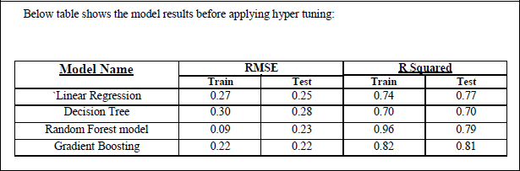

**Table 6- Pre Hyper tuning**

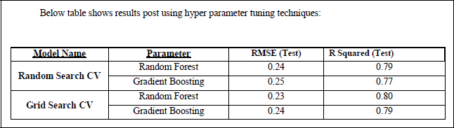

**Table 7- Post Hyper tuning**

17

Above table shows the results after tuning the parameters of our two best suited models i.e. Random Forest and Gradient Boosting. For tuning the parameters, we have used Random Search CV and Grid Search CV under which we have given the range of n_estimators, depth and CV folds.

**5.2 MODEL SELECTION**

So, from above tables we can see:

* Both the models- Gradient Boosting Default and Random Forest perform comparatively well while comparing their RMSE and R-Squared value.
* After this, I chose Random Forest CV and Grid Search CV to apply cross validation technique and see changes brought about by that.
* After applying tunings Random forest model shows best results compared to gradient boosting.
* So finally, we can say that Random forest model is the best method to make prediction for this project with highest explained variance of the target variables and lowest error chances with parameter tuning technique Grid Search CV.

Finally, I used **RANDOM FOREST MODEL** method to predict the target variable for the test data file shared in the problem statement.

**5.3 PREDICTOR VS PREDICED VARIABLES**

**5.3.1 Passengers VS Fare**

Single passengers are the most frequent travellers, and the highest fare payers too.

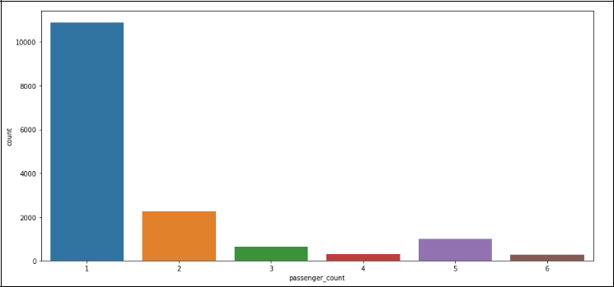

**Figure 7-Passenger vs No. Of Passengers**

18

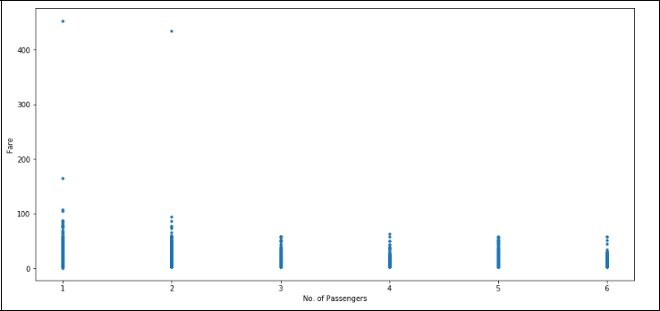

**Figure 8-Passenger vs Fare**

**5.3.2 Date Of Month VS Fares**

The fares throughout the month mostly seem uniform.

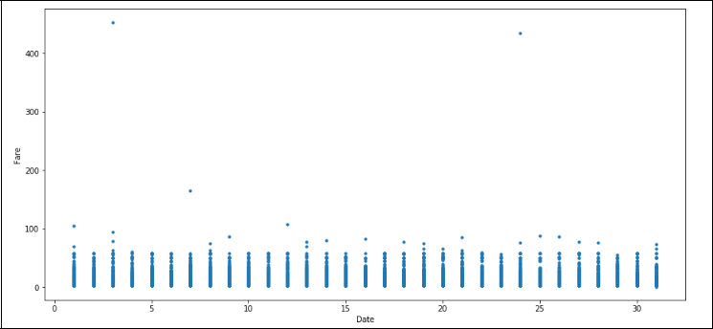

**Figure 9- Date vs Fare**

19

**5.3.3 Hours VS Fares // Hours VS Frequency**

* During hours 6 PM to 11PM the frequency of cab boarding is very due to peak hours
* Fare prices during 2PM to 8PM is bit high compared to all other time might be due to high demands.

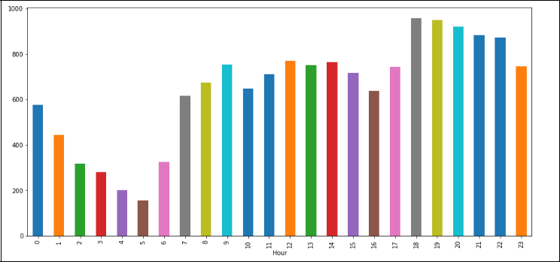

**Figure 10- Hours Vs Frequency**

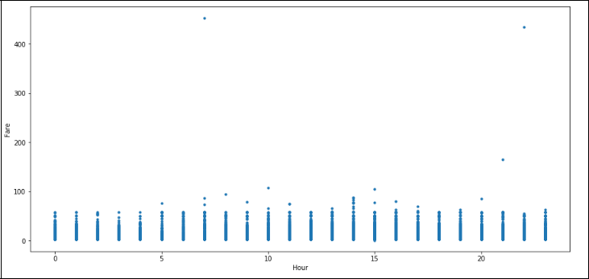

**Figure 111- Hours Vs Fare**

20

**5.3.4 Week Day VS Fare // Week Day VS Frequency**

>Cab fare is high on Friday, Saturday and Monday, may be during weekend and first day of the working day they charge high fares because of high demands of cabs.

>The day of the week does not seem to have much influence on the number of cabs ride

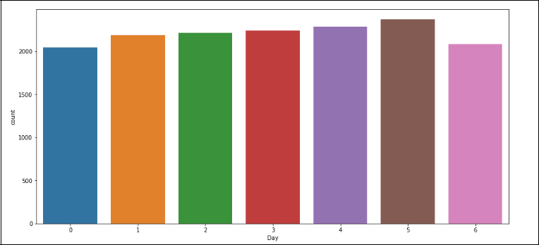

**Figure 12-Week Day VS Frequency**

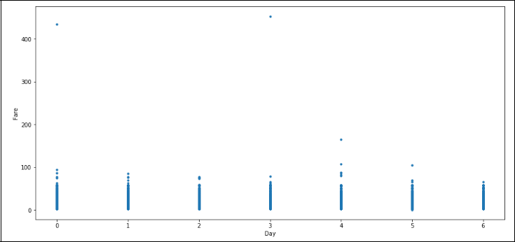

**Figure 13- Week Day VS Fare**

21

**REFERENCES**

1. For Data Cleaning and Model Development - https://edwisor.com/career-data-scientist
2. For other code related queries - https://www.analyticsvidhya.com/blog/2016/03/practical-guide-principal-component-analysis- python/
3. For Visualization –

https://www.udemy.com/python-for-data-science-and-machine-learning-bootcamp/

1. https://towardsdatascience.com/
2. https://stackoverflow.com/
3. Google searches and Wikipedia pages for Theoretical basics
4. Python and R documentation
5. Online project reference

22

**APPENDEX**

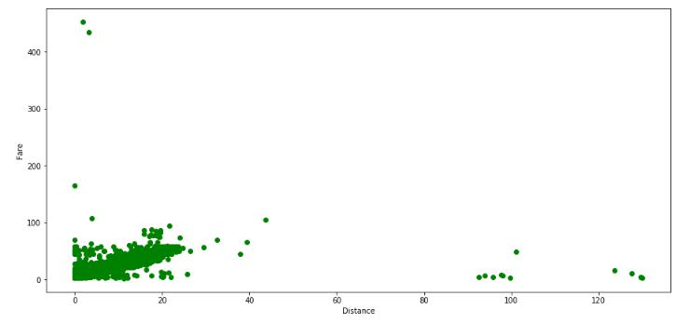

***14 - DISTANCE VS FARE***

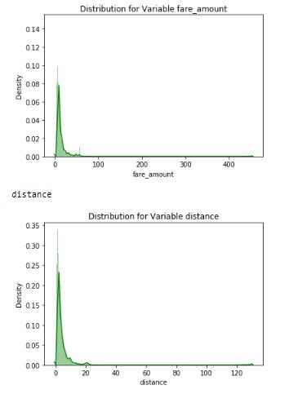

***15 - FARE VS DENSITY AND FARE VS DISTANCE***

23