**Mastering the HTML <table> Tag: Create Stunning Data Tables for Your Web Interface!**

Are you struggling to find a clear and concise way to display data on your web interface that's formatted like an Excel sheet? Don't worry, we've got you covered!

The HTML <table> tag is the perfect solution to showcase your data in a professional and organized way. By using this tag, you can easily replicate the tabular format of Excel sheets on your web pages. We'll dive deep into the different aspects of the table tag so you can create stunning data tables that will impress your audience.

The <table> tag is the first and foremost tag while creating a table in HTML. With this mandatory tag, you can organize your data into rows and columns, making it easy for your visitors to navigate and understand your information. So why wait? Start using the <table> tag today and take your web interface to the next level!

Example:

<table>

Content of the table….

</table>

As a table consists of rows and columns, how can we incorporate them into our table?  
<tr></tr>: This tag represents a table row.

<td></td>: This tag represents a table cell.

Now the <table> tag consists of three subparts:

* <thead></thead>: This element consists of the heading of the table and is always represented in bold for representing as a heading for that particular column. It is represented as <thead></thead> as well as <th></th>.
* <tbody></tbody>: As the name suggests this tag consists of the whole body content of a table.
* <tfoot></tfoot>: Usually this represents the footer of the table.

Now For Example:  
 <table>

<tr>

<th>Name</th>

<th>Place</th>

<th>Role</th>

<th>Status</th>

</tr>

<tr>

<td>Saloni</td>

<td>Mumbai</td>

<td>Student</td>

<td>Interested</td>

</tr>

</table>

Output:



The above output is of the basic table head in bold and the other elements in a lighter shade.

Another Example:

<!DOCTYPE html>

<html lang="en">

<head>

<meta charset="UTF-8" />

<meta name="viewport" content="width=device-width, initial-scale=1.0" />

<title>Document</title>

</head>

<body>

<table>

<thead>

<tr>

<th>Name</th>

<th>Contact</th>

<th>Email</th>

<th>Course</th>

</tr>

</thead>

<tbody>

<tr>

<td>Saloni</td>

<td>9123456780</td>

<td className="p-2.5">saloni@gmail.com</td>

<td>Maths</td>

</tr>

</tbody>

</table>

</body>

</html>

Output:



Now this table lacks some styling so for that we will use the different css styles in the <table></table> itself.

Example:

<table border="1" width="50%" cellspacing="10" cellpadding="5" align="center" summary="Sample Table">

<thead>

<tr>

<th>Name</th>

<th>Contact</th>

<th>Email</th>

<th>Course</th>

</tr>

</thead>

<tbody>

<tr>

<td>Saloni</td>

<td>9123456780</td>

<td className="p-2.5">saloni@gmail.com</td>

<td>Maths</td>

</tr>

</tbody>

</table>

So in the above code: The border is mentioned and the table width to be half i.e. 50% then a cell spacing of 10 with a cell padding which is like aligning the elements from inside is called padding. Align the center to make the table appear in the centre.

Thus the output is:  
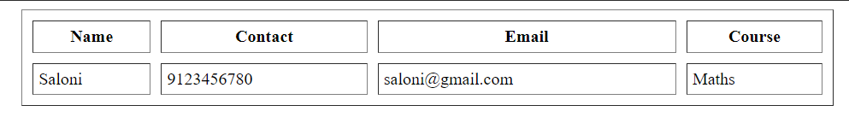

This table is more organized and looks more systematic :)

Let's have some colour to our columns in order for them to appear more stylish

For this, we will use:

<colgroup></colgroup> tag in which we define the <colstyle></colstyle> for each column

The Example that is mentioned showcases different background colours for different columns as mentioned:

<table

border="1"

width="50%"

cellspacing="10"

cellpadding="5"

align="center"

summary="Sample Table"

>

<thead>

<tr>

<th>Name</th>

<th>Contact</th>

<th>Email</th>

<th>Course</th>

</tr>

</thead>

<tbody>

<tr>

<colgroup>

<col style="background-color: yellow" />

<col style="background-color: green" />

<col style="background-color: lightsalmon" />

<col style="background-color: lightblue" />

</colgroup>

<td>Saloni</td>

<td>9123456780</td>

<td className="p-2.5">saloni@gmail.com</td>

<td>Maths</td>

</tr>

</tbody>

</table>

Output:

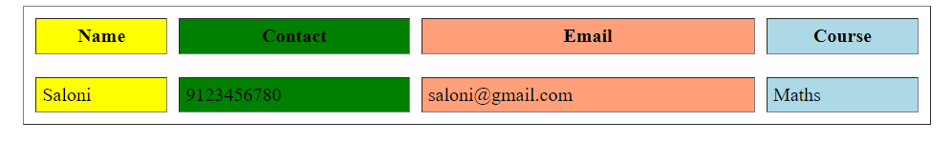

In conclusion, the HTML <table> tag is a powerful tool that can help you create stunning data tables for your web interface. Now that you know how to use it, you can take advantage of this amazing feature and create beautiful tables that will impress your audience.

Remember, the <table> tag is just the beginning of the many possibilities that HTML offers. So keep exploring and experimenting with different features to take your web design skills to the next level!