IBM SkillsBuild Internship
House Price Prediction
using Machine Learning (Python Backend + Streamlit Frontend)
Project Report
Submitted by: Your Name
Program: IBM SkillsBuild Internship
Date: October 2026

Table of Contents
1. Abstract
2. Introduction
3. Dataset Description
4. Tools and Technologies
5. System Architecture
6. Methodology
7. Results and Evaluation
8. Frontend Application (Streamlit)
9. How to Run the Project
10. Conclusion
11. References

1. Abstract
This project builds a machine-learning system that estimates the price of a house from seven property attributes. A dataset of 1,000 houses was analysed, cleaned, explored visually and used to train six regression algorithms. The best model, a tuned Ridge Regression, achieved an R² of 0.9984 with a mean absolute error of 8,175 on unseen data. The model is deployed through an interactive Streamlit web application written entirely in Python, where users can enter house details and instantly receive a price estimate, explore the data and review model performance.

2. Introduction
Pricing a house correctly is important for buyers, sellers, banks and real-estate agents. Manual valuation is slow and subjective. Machine learning can learn the relationship between house characteristics and sale price from historical data and give fast, consistent estimates.

2.1 Problem Statement
Given the characteristics of a house (area, rooms, age, lot size, garage and neighbourhood quality), predict its price. This is a supervised regression problem.

2.2 Objectives
- Understand and validate the quality of the house-price dataset.
- Perform exploratory data analysis to find the factors that influence price.
- Build, compare and tune several regression models.
- Evaluate the final model with standard regression metrics.
- Develop a user-friendly Python frontend for real-time prediction.

3. Dataset Description
The dataset (house_price_regression_dataset.csv) contains 1,000 records and 8 columns. There are no missing values and no duplicate rows. All columns are numeric.
Column | Description | Range
Square_Footage | Built-up area (sq ft) | 503 – 4,999
Num_Bedrooms | Number of bedrooms | 1 – 5
Num_Bathrooms | Number of bathrooms | 1 – 3
Year_Built | Year of construction | 1950 – 2022
Lot_Size | Plot size (acres) | 0.51 – 4.99
Garage_Size | Garage spaces | 0 – 2
Neighborhood_Quality | Neighbourhood rating | 1 – 10
House_Price (target) | Price of the house | 111,627 – 1,108,237

4. Tools and Technologies
Category | Technology
Programming language | Python 3
Data processing | pandas, NumPy
Machine learning | scikit-learn
Visualisation | Matplotlib, Seaborn
Model persistence | joblib
Frontend | Streamlit
Development | VS Code, Jupyter Notebook

5. System Architecture
The project follows a simple two-tier design written fully in Python:
- Backend: data loading, preprocessing, feature engineering, model training and prediction logic (pandas + scikit-learn). The trained pipeline is stored as models/house_price_model.joblib.
- Frontend: a Streamlit application (app.py) that loads the saved model, collects user input through widgets, calls the model and renders results and charts with Matplotlib/Seaborn.
Workflow: Dataset → Data checks → EDA → Feature engineering → Train/Test split → Model training & tuning → Evaluation → Save model → Streamlit app → Predicted price.

6. Methodology

6.1 Data Quality Check
The dataset was checked for null values, duplicates and data types. No cleaning was required.

6.2 Exploratory Data Analysis
The average house price is 618,861 and the distribution is almost symmetric (skewness ≈ −0.06), so no target transformation was needed.
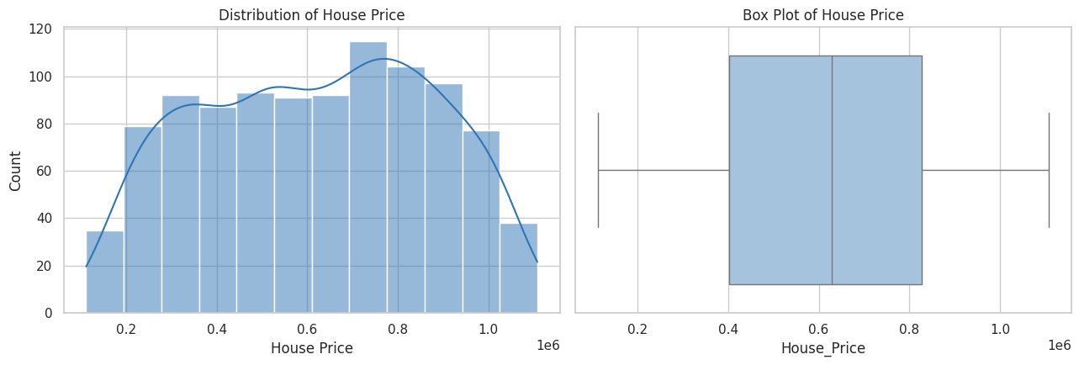
Figure 1: Distribution of house prices
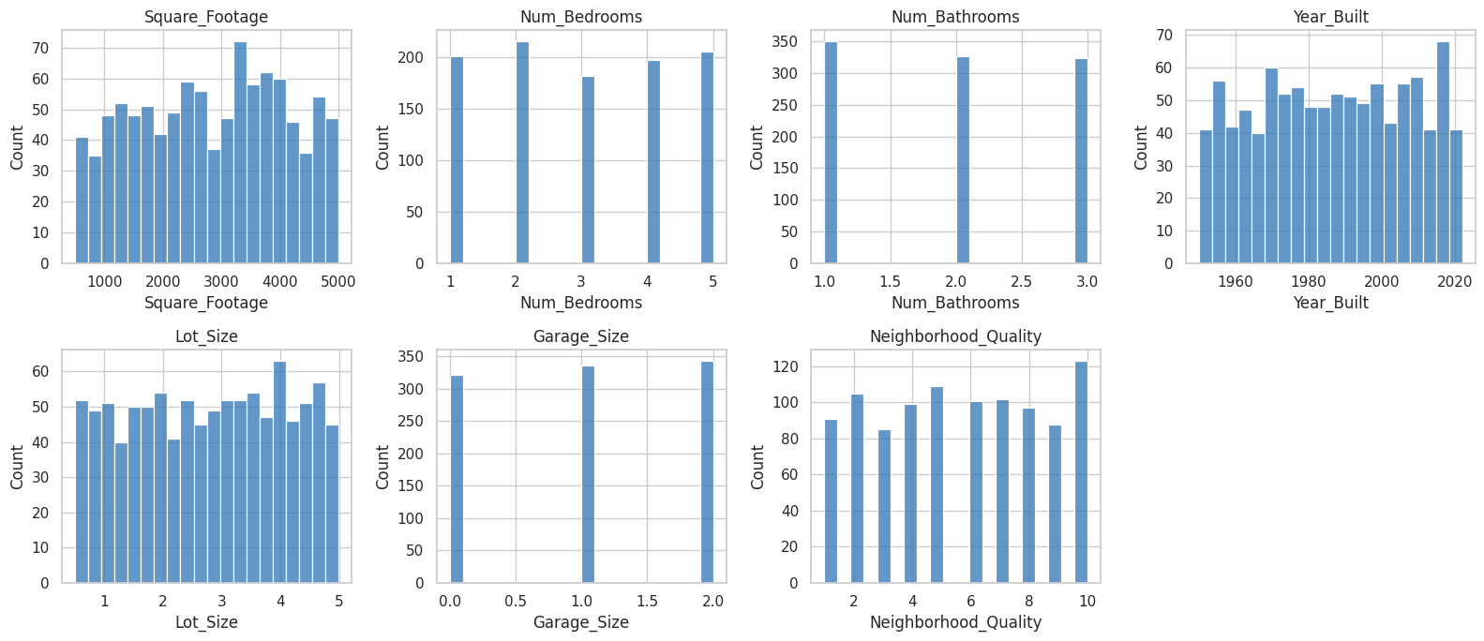
Figure 2: Distribution of input features
Correlation: Square_Footage shows a correlation of about 0.99 with House_Price, making it the dominant factor. Lot_Size has a weak positive correlation (0.16); the remaining features have very low individual correlation.
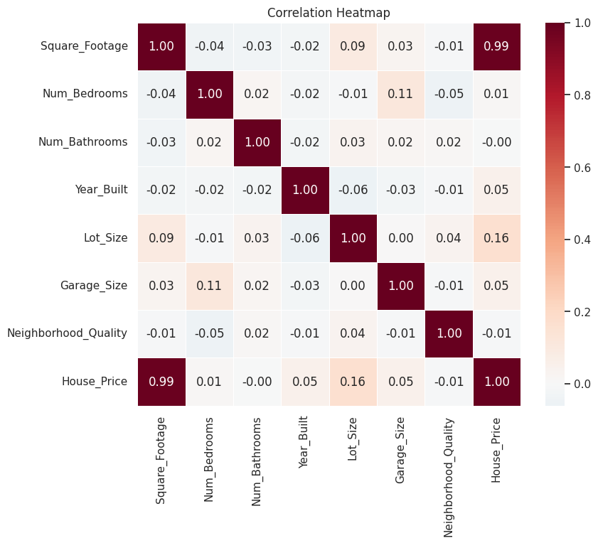
Figure 3: Correlation heatmap
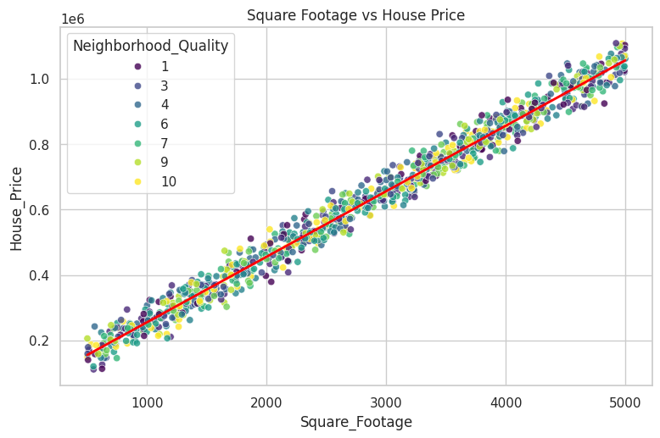
Figure 4: Square footage versus price
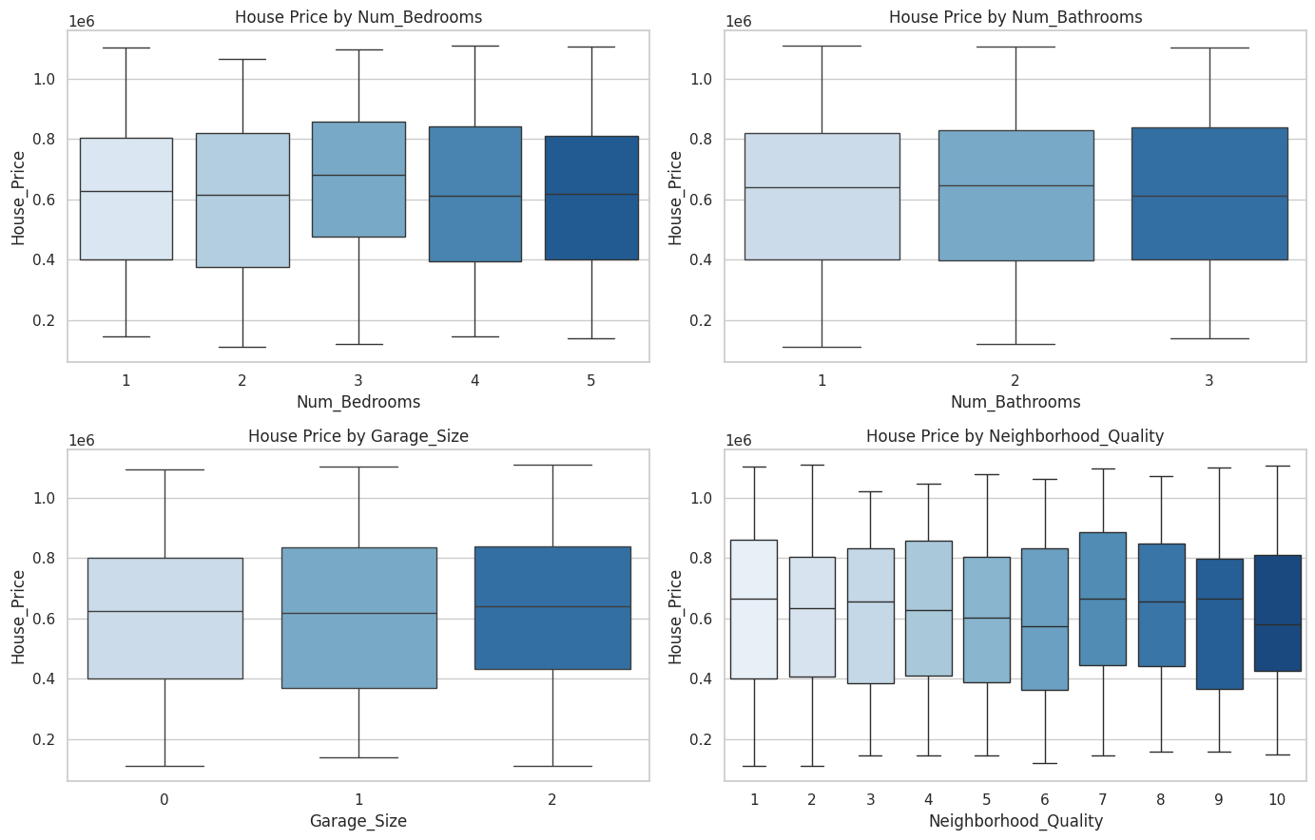
Figure 5: Price across bedrooms, bathrooms, garage and neighbourhood quality

6.3 Feature Engineering and Preprocessing
- Created House_Age = 2026 − Year_Built and removed Year_Built.
- Split data into 80% training (800 rows) and 20% testing (200 rows) with random_state = 42.
- Standardised features with StandardScaler inside a scikit-learn Pipeline to avoid data leakage.

6.4 Model Building
Six regression algorithms were trained and compared using 5-fold cross-validation and the hold-out test set: Linear Regression, Ridge, Lasso, Decision Tree, Random Forest and Gradient Boosting.

6.5 Hyper-parameter Tuning
GridSearchCV (5-fold) tuned the regularisation strength of Ridge Regression and the number of trees, learning rate and depth of Gradient Boosting. The best Ridge model had alpha = 0.01.

7. Results and Evaluation

7.1 Model Comparison
Model | CV R² | Test R² | Test MAE | Test RMSE
Linear Regression | 0.9985 | 0.9984 | 8,175 | 10,071
Lasso Regression | 0.9985 | 0.9984 | 8,175 | 10,072
Ridge Regression | 0.9985 | 0.9984 | 8,242 | 10,123
Gradient Boosting | 0.9963 | 0.9970 | 11,402 | 14,019
Random Forest | 0.9922 | 0.9940 | 16,071 | 19,729
Decision Tree | 0.9835 | 0.9849 | 24,911 | 31,228

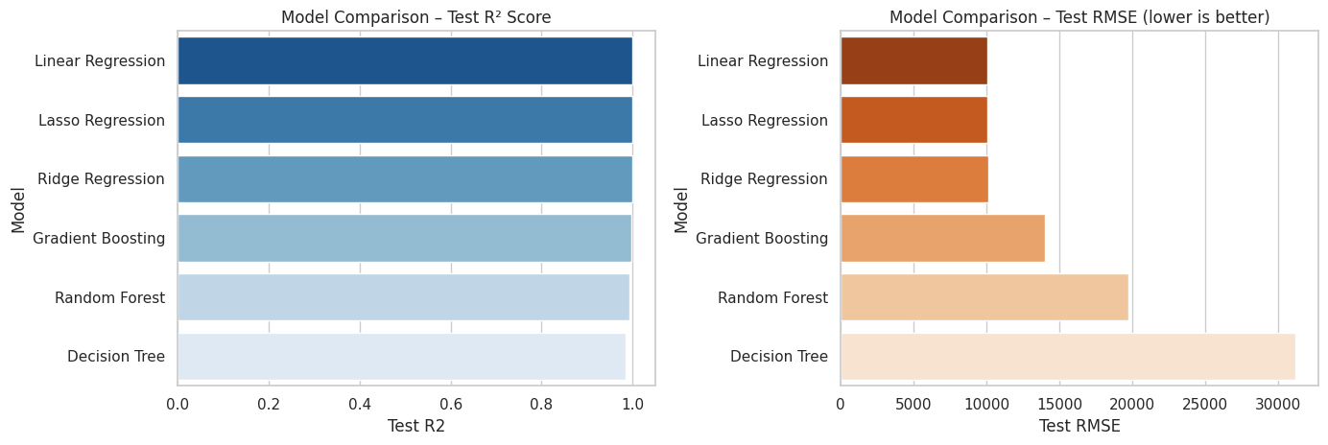
Figure 6: Comparison of models
Linear-family models perform best, because house price in this dataset is almost a linear function of square footage. Tree-based models approximate a straight line with steps and therefore have larger errors.

7.2 Final Model Performance
Metric | Value
Final model | Ridge Regression (tuned)
R² score | 0.9984
Mean Absolute Error (MAE) | 8,175
Root Mean Squared Error (RMSE) | 10,072
Training / test samples | 800 / 200

The model explains about 99.8% of the variance in house prices. The average prediction error is 8,175, roughly 1.3% of the average price.
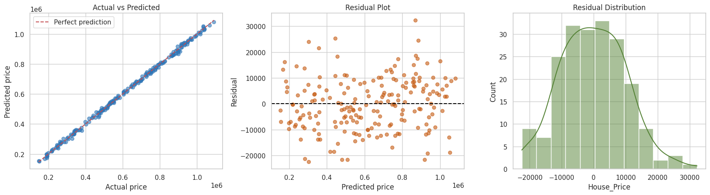
Figure 7: Actual vs predicted values and residual analysis
Predictions lie close to the diagonal line and residuals are centred around zero without a visible pattern, indicating that the model assumptions hold.

7.3 Feature Importance
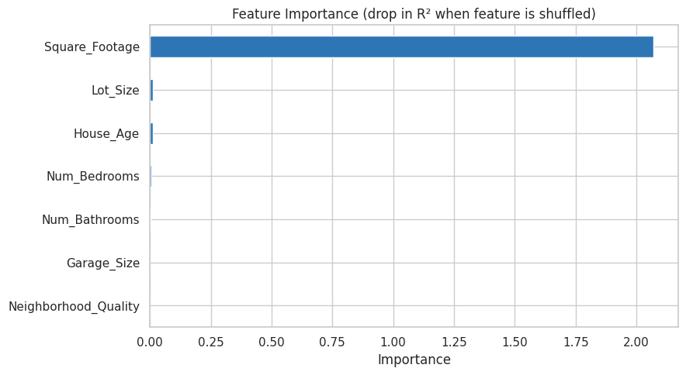
Figure 8: Permutation feature importance
Square_Footage is overwhelmingly the most important feature. Lot_Size, House_Age and Num_Bedrooms add small contributions.

8. Frontend Application (Streamlit)
The web interface is launched with the command streamlit run app.py and contains four pages:
- Predict Price: input widgets for all house features; shows the estimated price, a likely range (±RMSE), price per square foot, comparison with the dataset average and a size-sensitivity chart.
- Data Explorer: data table, summary statistics, distributions, correlation heatmap and scatter plots.
- Model Performance: R², MAE, RMSE, model comparison, feature importance and actual-vs-predicted plot.
- About: short project description.

8.1 Application Screenshots
[Paste screenshots of the Predict Price, Data Explorer and Model Performance pages here after running the app.]

9. How to Run the Project
- Extract the ZIP and open the folder in VS Code.
- Create and activate a virtual environment, then run: pip install -r requirements.txt
- Open the notebook, select the Python kernel and click Run All.
- Run streamlit run app.py in the terminal to open the web app at http://localhost:8501.

10. Conclusion
The project successfully predicts house prices with high accuracy (R² = 0.9984). The analysis shows that the size of the house is the principal price determinant in this dataset and that regularised linear models are the most suitable. The Streamlit interface makes the model accessible to non-technical users.

10.1 Limitations
- The dataset is small (1,000 rows) and has a very strong linear relationship, so the same accuracy should not be expected on real market data.
- Location (city, ZIP code) and house condition are not included.

10.2 Future Scope
- Use larger real-world datasets with location and amenity features.
- Add prediction confidence intervals and model explainability (e.g., SHAP).
- Deploy the app on Streamlit Community Cloud or as a REST API.

11. References
- scikit-learn documentation – https://scikit-learn.org
- pandas documentation – https://pandas.pydata.org
- Streamlit documentation – https://docs.streamlit.io
- Matplotlib and Seaborn documentation – https://matplotlib.org , https://seaborn.pydata.org
- IBM SkillsBuild – https://skillsbuild.org

