# Settings اعدادات النظام

## Lookup Parameters

|  |  |  |  |
| --- | --- | --- | --- |
| Lookup Name | Values | DB Table | DB Lookup Type |
| Countries  البلاد | User Defined  Set HAS_CHILD_FLAG = 1 in table SYS_LOOKUP_TYPES= WHERE LOOKUP_TYPE = ’COUNTRIES’ |  | COUNTRIES |
| Cities  المدن | User Defined  Set LOOKUP_TYPE_PARENT in table SYS_LOOKUP_TYPES=’COUNTRIES’  LOOKUP_TYPE = CITIES |  | CITIES |
| Currency  العملات | User Defined |  | CURRENCY |
| Payment Method  طريقة الدفع | 1-Cash  2-Visa فيزا  3-Cheque شيك  4-Bank transfer تحويل بنكى  5-Credit  6-other  System defines |  | PAYMENT_METHODS |
| Partner Types  انواع الشركاء | 1. Vendor 2. Customer   System Defined |  | PARTNER_TYPES |
| Customer or Vendor Types  انواع العملاء او الموردين | 1-persons افراد  2-Companies شركات  User Defined |  |  |
| Partner Person types  انواع الاشخاص | 1-managers.  2-contact Persons  System Defined |  |  |
| Document Types  انواع الوثائق | User defines |  | Document_TYPES |

## Customers

### Interface Design

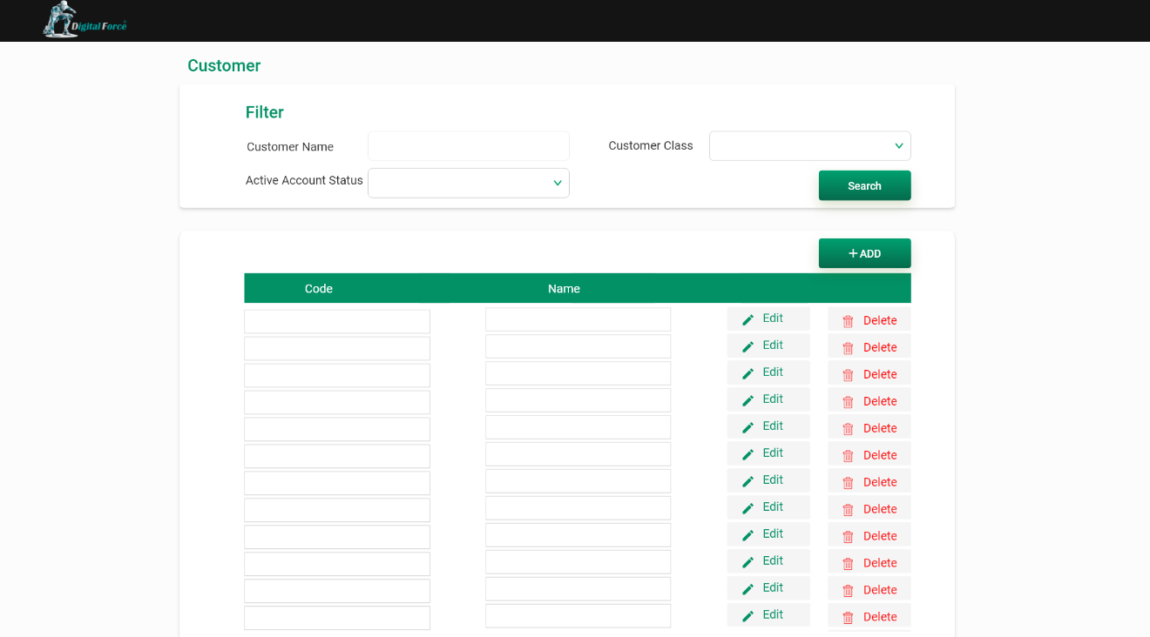

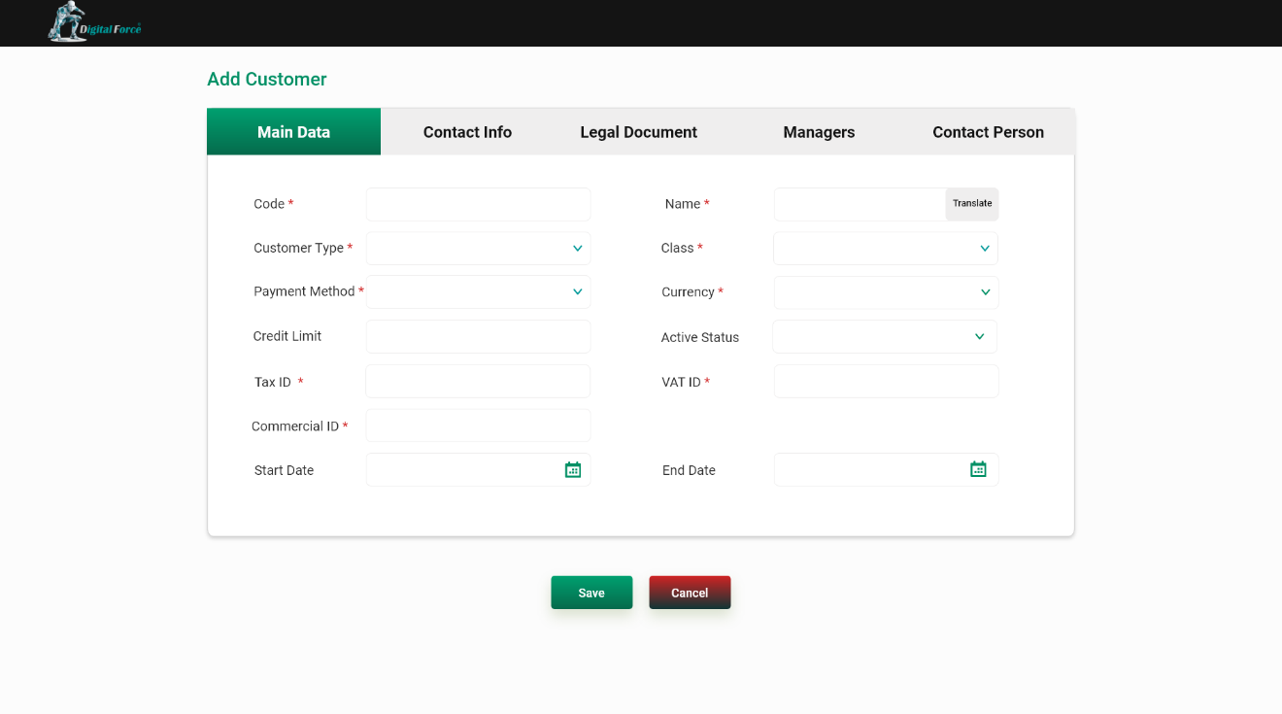

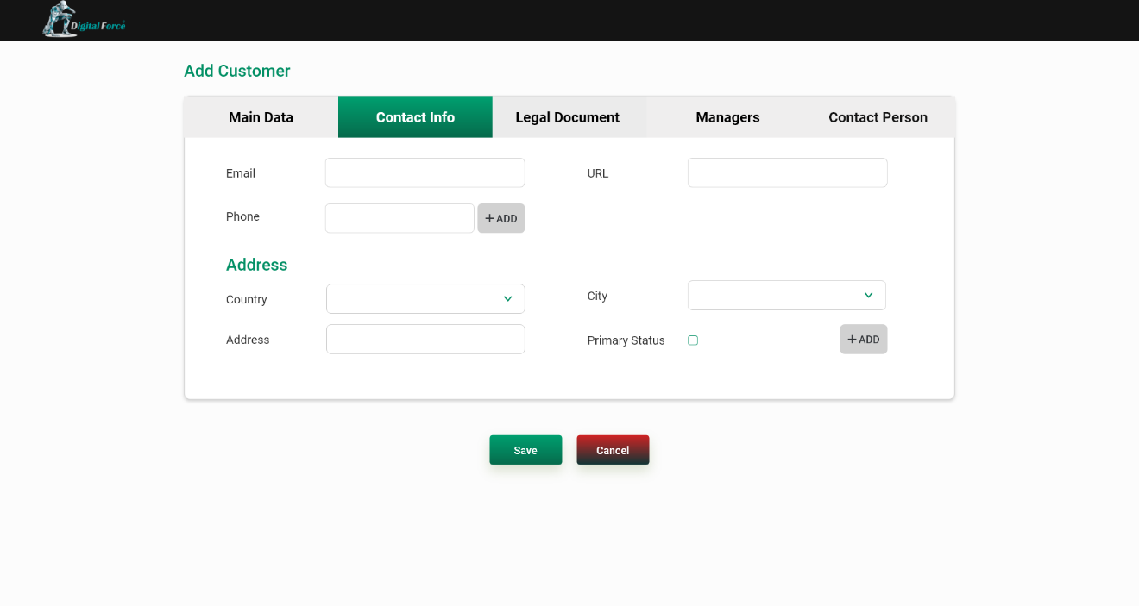

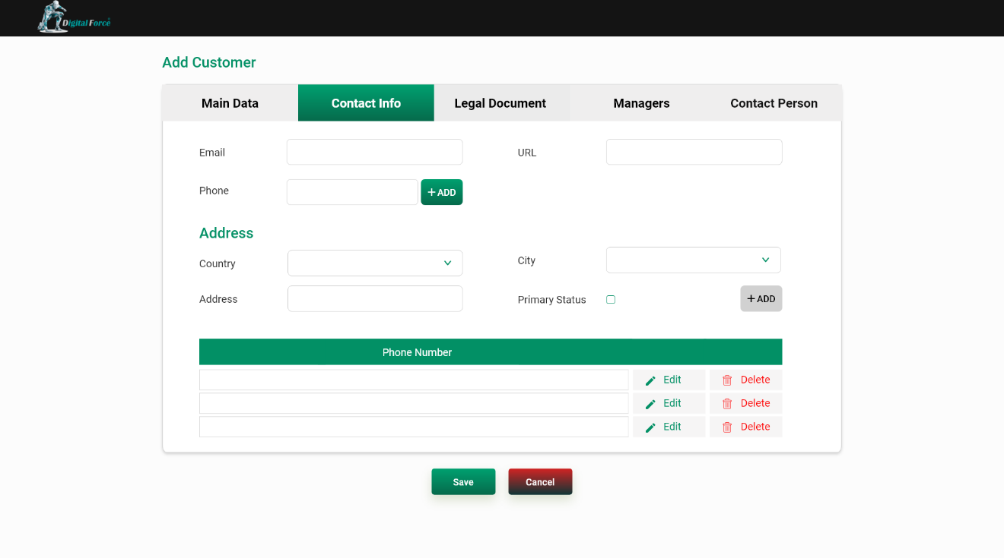

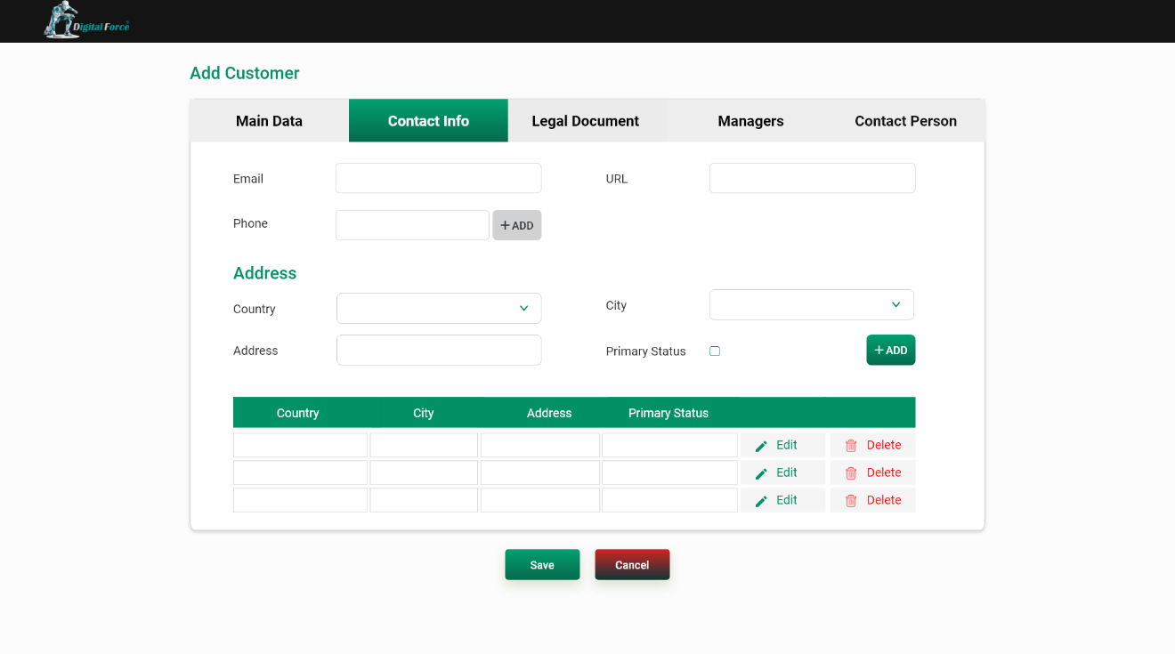

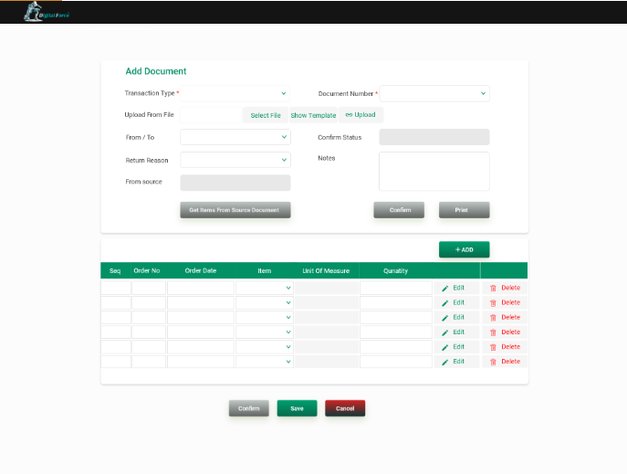

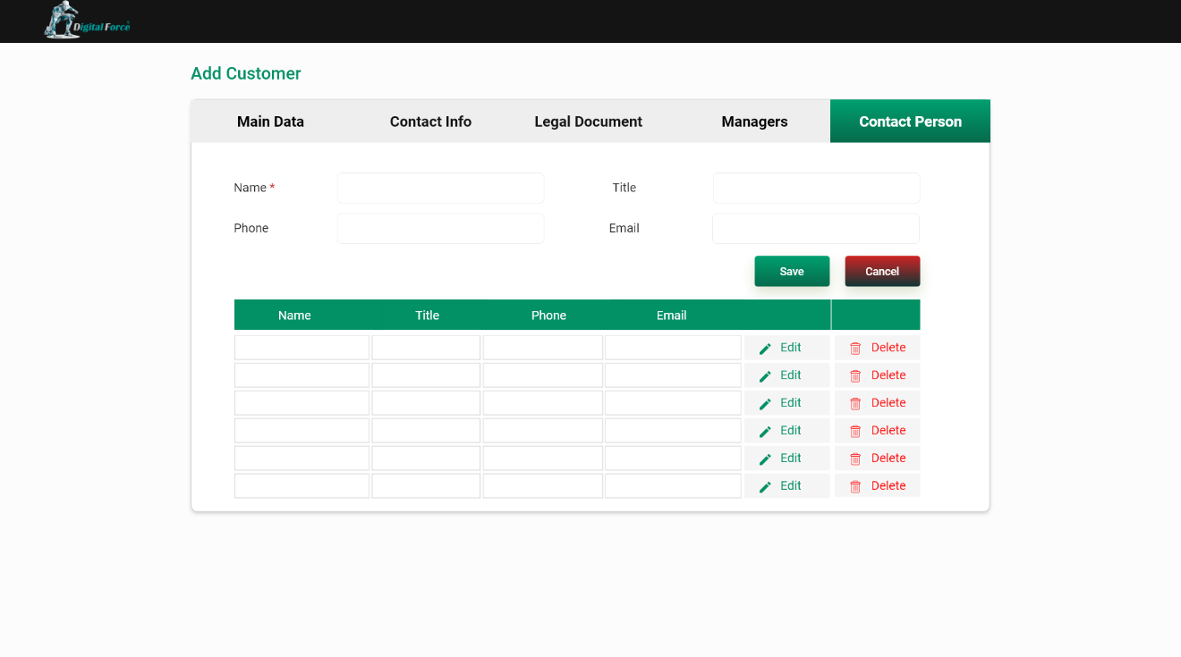



### Screen Attributes and Behavior

|  |  |  |  |
| --- | --- | --- | --- |
| Attribute | Description | DB Table | DB Column |
| Code  كود | Unique Display value max+1.  Required: yes. | SAL_CUSTOMERS | CUSTOMER_CODE |
| Name  الاسم | Unique.  Input value  Required :yes | SAL_CUSTOMERS | FULL_NAME |
| Class  الفئة | Input value select name from partner classes language list where class type = 1(customer) and language parameter.  Required: yes | SAL_CUSTOMERS | PARTNER_CLASS_ID |
| Currency  العملة | Display currency from ERP_PARTNER_CLASSES_LANG where id = class id entered previous and user can modify when modify select name from lookup values list where lookup type = currency and language parameter.  Required: yes | SAL_CUSTOMERS | CURRENCY_ID |
| Payment Method  طريقة الدفع | Display payment method from ERP_PARTNER_CLASSES_LANG where id = class id entered previous and user can modify when modify select name from lookup values list where lookup type = payment_methods and language parameter.  Required: yes | SAL_CUSTOMERS | PAYMENT_METHOD_ID |
| Tax File Number  رقم الملف الضريبى | Unique.  Input value.  Required :No | SAL_CUSTOMERS | TAX_FILE_NO |
| Tax VAT  رقم البطاقة الضريبية | Unique.  Input value.  Required :No | SAL_CUSTOMERS | TAX_CARD_NO |
| Tax Registration ID  السجل التجارى | Unique.  Input value.  Required :No | SAL_CUSTOMERS | COMM_RECORD |
| email | Input value in email format.  Required: no. | SAL_CUSTOMERS | EMAIL |
| Fax Number | Input value.  Required :No | SAL_CUSTOMERS | FAX_NO |
| URL | Input value.  Required :No | SAL_CUSTOMERS | URL |
| Active Account Status  فعال | Input list value select it from lookup values.  Default 1 active.  Required: Yes. | SAL_CUSTOMERS | CUSTOMER_Account_Status |

**Phones**

|  |  |  |  |
| --- | --- | --- | --- |
| Attribute | Description | DB Table | DB Column |
| Phone | Specifies the phone of Organization.  Input value.  Required :no. | SAL_CUSTOMER_PHONS | PHON_NO |

**Address**

|  |  |  |  |
| --- | --- | --- | --- |
| Attribute | Description | DB Table | DB Column |
| Country | Input value select name from lookup values list where language parameter and lookup type = Countries.  Required: yes | SAL_CUSTOMER_ADDRESS | COUNTRY_ID |
| City | Input value select name from lookup values list where language parameter and lookup type = CITIES list according to country_id selected before.  Required: No | SAL_CUSTOMER_ADDRESS | CITY_ID |
| Address | Input value  Required: No. | SAL_CUSTOMER_ADDRESS | ADDRESS |
| Primary  رئيسي | Input check box  Required: No. | SAL_CUSTOMER_ADDRESS | PRIMARY_FLAG |

**Managers**

|  |  |  |  |
| --- | --- | --- | --- |
| Attribute | Description | DB Table | DB Column |
| Name | Input value  Required: yes | SAL_CUSTOMER_PERSONS | FULL_NAME |
| title | Input value  Required: No | SAL_CUSTOMER_PERSONS | TITLE |
| Phone | Input value  Required: No. | SAL_CUSTOMER_PERSONS | PHON_NO |
| EMAIL  رئيسي | Input check box  Required: No. | SAL_CUSTOMER_PERSONS | EMAIL |

Set person_type_id=1 manager

**Contact persons**

|  |  |  |  |
| --- | --- | --- | --- |
| Attribute | Description | DB Table | DB Column |
| Name | Input value  Required: yes | SAL_CUSTOMER_PERSONS | FULL_NAME |
| title | Input value  Required: No | SAL_CUSTOMER_PERSONS | TITLE |
| Phone | Input value  Required: No. | SAL_CUSTOMER_PERSONS | PHON_NO |
| EMAIL  رئيسي | Input check box  Required: No. | SAL_CUSTOMER_PERSONS | EMAIL |

set person_type_id=2 contact persons

**Documents الوثائق**

|  |  |  |  |
| --- | --- | --- | --- |
| Attribute | Description | DB Table | DB Column |
| Document Type  نوع الوثيقة | Input value select it from lookup list.  Required: No | SAL_CUSTOMER_DOCUMENTS | DOCUMENT_TYPE_ID |
| Issuing Country  دولة الاصدار | Input value select it from lookup list.  Required: No | SAL_CUSTOMER_DOCUMENTS | LK_COUNTRY_ID |
| Issuing Date  تاريخ الاصدار | Input value in date format dd/mm/yyyy.  Required: No | SAL_CUSTOMER_DOCUMENTS | ISSUE_DATE |
| Issuing End Date  تاريخ انتهاء | Input value in date format dd/mm/yyyy.  Required: No | SAL_CUSTOMER_DOCUMENTS | ISSUE_END_DATE |
| Add Picture  اضافة صورة | When pressing button display Hard Disk to choose image and display path in item & display photo in photo item.  Required: No | SAL_CUSTOMER_DOCUMENTS | DOCUMENT_PHOTO_PATH |
| Remarks  ملاحظات | Input text.  Required: No. | SAL_CUSTOMER_DOCUMENTS | REMARKS |

**Tables**:

|  |  |  |  |  |
| --- | --- | --- | --- | --- |
| Table name | Insert | Update | Delete | select |
| SAL_CUSTOMERS | Yes | Yes | Yes | Yes |
| SAL_CUSTOMERS _LANG | Yes | Yes | Yes | Yes |
| SAL_CUSTOMER_PHONES | Yes | Yes | Yes | Yes |
| SAL_CUSTOMER_DOCUMENTS | Yes | Yes | Yes | Yes |
| SAL_CUSTOMER_PERSONS | Yes | Yes | Yes | Yes |
| SAL_CUSTOMER_ADDRESS | Yes | Yes | Yes | Yes |
| SYS_LOOKUP_VALUES_LANG | No | No | No | Yes |
| ERP_TAX_SCHEDULES_LANG | No | No | No | Yes |

### Screen Buttons

**Add- إضافة:** Pressing this button should insert a new line.

**Delete- حذف:** Pressing this button shouldreturn a message confirming the deletion action & upon confirming the action, the selected line should be deleted.

**Save- حفظ:** Pressing this button should:

* Check that all mandatory fields have been filled.
* Check that all entered values are valid according to the field format & input mask.
* If missing/incorrect data found, a stop message should be retrieved to user specifying the error reason.
* If no errors found, save the entered data in DB.
* When customer add account from online orders system and admin modify account status from pending to active then add new row in table SYS_USERS and send user and password to customer by email and send notification to him.

**Cancel- إلغاء:** Pressing this button should return a message confirming that the entered/ edited data will not be saved & upon confirming the action, user should be moved to home page**.**

**Translate- ترجمة:** Pressing this button should retrieve from table SAL_CUSTOMERS_LANG