**Lab 5: Network Centrality and Prestige**

For this lab we will import a sociomatrix, examine individual network centrality and centralization within the network, symmetrize the network, and examine centrality in the symmetrized network.

Complete all tasks and answer all questions for full credit.

**NOTE:** Before starting, make sure UCINET shows that your default directory is set to “C:\Users\Desktop\” (on the bottom of the window). If not, click on the file folder and select “Desktop” to set it.

**Dataset:**

For this exercise, you will be working with the friendship data from a single school in the Add Health study (Class 81). This school was made up of 7th through 11th grade students. The dataset for the exercise consists of the 66 students who participated.

**Task 1.** Calculate directed centrality measures using Ucinetwith **Class81**

a) Open **Class81** in Ucinet.

b) In UCINET calculate multiple measures of centrality for the individuals in the class using:

Network ->Centrality->Multiple measures

**Questions:**

1. **Which individuals name the highest number of classmates as friends?**

52

1. **Which individuals are named most often by their classmates as friends?**

62

c) In UCINET examine the degree centralization for the entire network using:

Network ->Whole networks and cohesion->Multiple whole network

measures

1. **What is the in-degree centralization of the network?**

0.106

1. **What is the out-degree centralization of the network?**

0.090

1. **Explain why the in-degree centralization is greater than the out-degree centralization for this class based on the in-degree and out-degree distributions.**

there are some extreme indegree counts for some people in the network. There are few people who have a lot of indegree and some has 0. So there is more dispersion.

**Task 2.** Symmetrize Class81 with the maximum value rule. Examine the symmetrized network’s centrality using UCINET and NetDraw.

1. In UCINET determine the following measures of centrality in the symmetrized network using

Network -> Centrality->Multiple Measures:  
 Degree

Betweenness

Eigenvector

1. Using Netdraw visualization (Analysis->Centrality measures), compare the various centrality measures.

**Questions:**

1. **Which actors have the largest degree centrality in the symmetrized network?**

25

1. **Which actors have the largest betweenness centrality in the symmetrized network?**

44

1. **How does betweenness centrality vary across the network compared to Eigenvector centrality?**

eigen -> degree + degree of those who you are connected to (being connected to others who are well connected)  
The people within the most well-connected subgroup have higher eigenvector centrality. But betweenness centrality is not like that. We see high betweenness of the nodes who connect different subgroups by lying in their shortest paths. That’s why we see in the network that high betweenness nodes are those who connects the network subgroups, not the densely connected ones.

**Task 3.** Compare the profile of actor 44 with actor 62 across all centrality measures.

**Questions:**

1. **What are the differences in centrality between actor 44 and actor 62?**

betweenness: 725.297, eigen: 0.128 (44)

bet: 125.925, eigen: 0.323 (62)

1. **Interpret these results.**

**44 lies in a critical position to keep the network connected and that’s why it has high betweenness centrality. But 62 has low betweenness. But 62 is in a densely connected part of the network and have a high eigenvector centrality. Also, 62 has higher degree compared to 44.**

**Task 4.** Compare actor 44 to actor 60 across all centrality measures.

**Questions:**

1. **What are the differences in centrality between actor 44 and actor 60?**

betweenness: 320.387, eigen: 0.000 (60)

betweenness: 725.297, eigen: 0.128 (44)

1. **Why is actor 60 so much lower on eigenvector centrality?**

60 is situated in a loosely connected place and the nodes with which 60 is connected are not much highly connected ones. That’s why it has a very low eigenventor centrality.

**Task 5.** Import the **Class81Attr** attribute file in Ucinet.

1. Attach **Class81Attr** to the Class81 matrix data in NetDraw.
2. Using NetDraw, color the nodes based on different attributes (e.g., gender, race, clubs/sports, alcohol/tobacco use, close_school, part_school, happy_school) and size the nodes based on at least three different centrality measures.

**Questions:**

1. **What patterns do you see** **among the node attributes and** centrality/position in the network?

betweenness is higher among female students.

another interesting thing is eigenvector is higher between the grade 11 and 10 students.

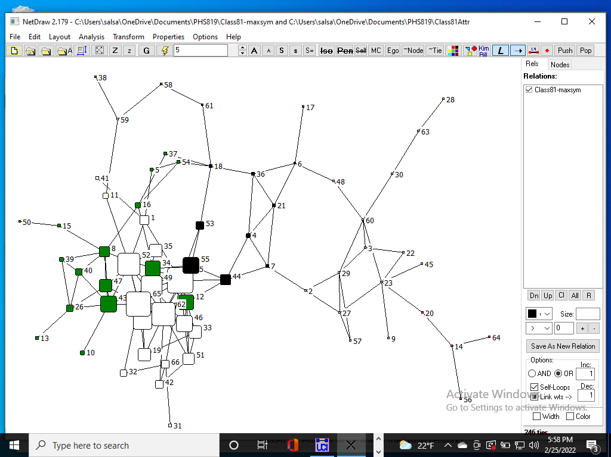

Closeness is higher among 10th grade students.

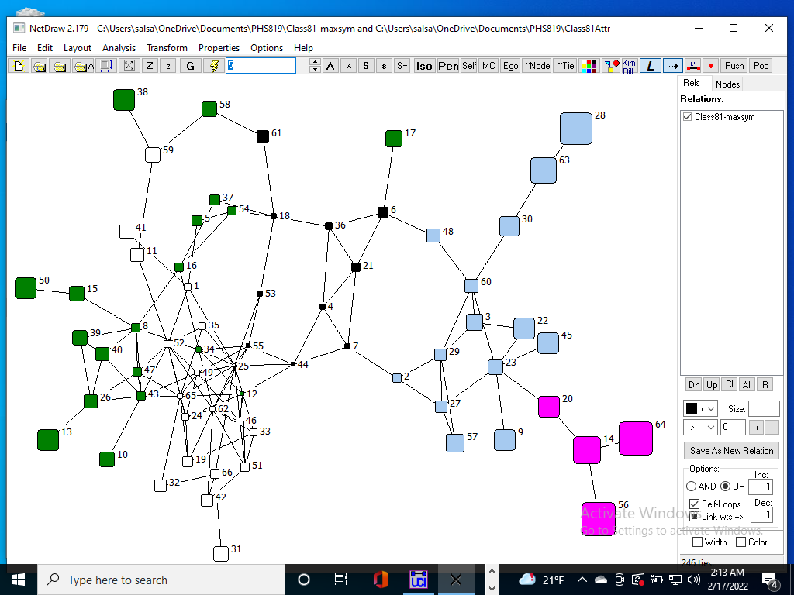

1. **How are the attributes close_school, part_school, and happy_school** related to centrality in the school friendship network?

Eigenvector is higher among those who agree that they feel close to school. however, peripheral people are not feeling close to the school. Even though 44 is in a critical position having high betweenness, it does not feel connected to the school.

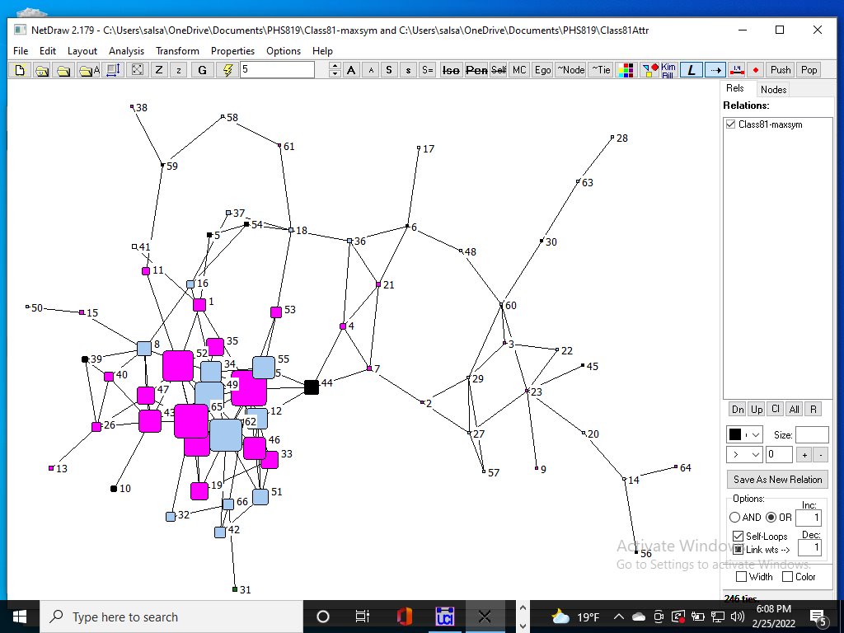

people having high closeness are mostly happy being at the school.

**Task 6.** Summary write-up

Write up a short description of your SNA analysis of centrality observed among students in the Class81 dataset. Illustrate your findings with graphs. Suggest directions for future research.

From the analysis, I have seen that people with high closeness are mostly happy being at the school. So we can further test if closeness with friends make people more happy in the school.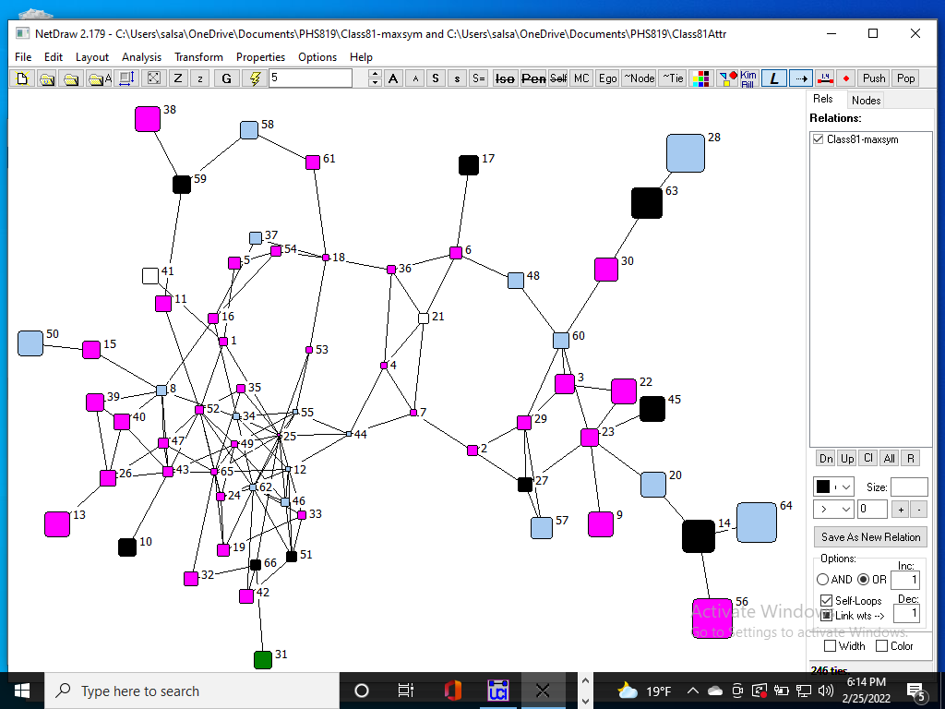

Another interesting observation is that, peripheral people are not feeling that close to the school even though they are bridging many people in the graph. Most likely that’s why they are connecting different group of people as they themselves mix with different group and are not solely into any particular school group.

