**Lab 6: Block-Modeling** **Work Roles**

Introduction. This lab focuses on profiling clinic staff roles and positions using the block-modeling functions in Ucinet.

Complete all tasks and answer all questions for full credit.

Set-up. The data used here are from a sociometric survey of clinicians and staff at a single primary care clinic.

There are 2 network matrices (F2FNet and EHRNet) which represent frequency of communication about patient care between staff members, either face-to-face or through secure messaging in the clinic’s Electronic Health Records system.

The networks are asymmetric, valued networks representing typical daily communication over the past 6 months. The coding for the dyadic ties is given by:

5=Multiple times per day

4=Once a day

3=A few times a week

2=Once per week

1=1-2 times per month

0=Less than 1-2 times per month

There is also an attribute file (ClinAttr) which provides some characteristics of the staff members.

MD: physician MA - medical assistant

ClinAttr contains a number of node characteristics, including:

1. Job_Category - (1-MD, 2-RN, 3-MA, 4-Office, 5-Lab)

2. MD/RN/MA/Office/Lab- binary indicators for job category

3. Years_Clinic – number of years working at this clinic

4. FTE- Percent of full-time/part-time employment

5. Female – employee gender (1=female, 0=male)

6. Job_Satisfaction – job satisfaction scale score (a 10-item scaled score, with

values ranging from worst possible job satisfaction=10 to best possible job satisfaction=70)

**Task 1:** Import to the data into Ucinet datasets for the 3 data files. Note: F2FNet and EHRNet are DL files; ClinAttr is a raw text file with column headings. Visualize the network for F2FNet using NetDraw.

**Questions:**

**1: Why does your network graph have so many ties between clinic staff members?**

It’s due to the way data was collected. If they pick anything other than 0 connection, it will add an arrow in the connection.

**Task 2:** In Netdraw, use Properties->Lines->Multi-relational selection to change the graph to only show communication ties that are daily or more frequent (Click on F2FNet relations, change the > indicator to 3, then click Next).

**Task 3:** Examine the centrality of the nodes in the network by sizing nodes according to eigenvector and betweenness centrality (Analysis->Centrality measures->Set Node Sizes by).

**Questions:**

**2. Which nodes are most central in the face-to-face network?**

betweenness - 2007

eigenvector - 2014, 2016, 2012, 2013, 2001

**Task 4:** We will now begin to group individuals who have similar types of network connections. Return to Ucinet and use Network->Roles and Positions-> Structural->

Profile to create a structural equivalence matrix for the F2F network. The procedure will create a new file SE that contains information about the degree of structural equivalence between any 2 individuals.

**Questions:**

**3. What are the ID numbers for the two clinic members who have the highest structural equivalence (Hierarchical Clustering output displays a bar graph of the degree of structural equivalence; the highest points on the graph indicate the highest equivalence)? What are the job titles for those 2 clinic members?**

2019 and 2003

2003 - 1(MD - Doctor or Physician)

2019 - 1(MD)

**Task 5:** Use Tools->Cluster Analysis->Hierarchical on the SE matrix to create a hierarchical partitioning of the network into groups. The procedure will create a partition matrix Part.

**Task 6:** The Cluster Analysis command created a partition matrix Part which indicates the optimal grouping for a given number of within-clinic groups. Use Data->Display and choose Part to examine the optimal partitions for the clinic members into groups.

**Questions:**

**4. How many groups does the 11th partition divide the clinic into? Which clinic members are in each group?**

8 groups.

1 - 2004

2 - 2010

3 - 2007, 2011

4 - 2001, 2013

5 - 2005, 2009, 2015

6 - 2002, 2008, 2018

7 - 2003, 2019, 2020

8 - 2012, 2014, 2016, 2021

**Task 7:** Display the Block model for the 11th partition of the clinic (Transform->Aggregate (includes CSS)->Block. Choose F2FNet for the matrix, Method=Average, and Part Col 11 for the Row and Column Partition).

**Questions:**

**5. What patterns do you notice from the Block model of Face-to-Face communication in the clinic network?**

2019, 2003, 2020 never interact f2f with 2004, 2010. They do it with 2012, 2016, 2014, 2021.

black, green - medical staff have most face-to-face interaction.

**Task 8:** We will now return to Netdraw. Close any open Netdraw programs. Reopen Netdraw, open the F2F network, and open the Part file as an attribute file. Collapse the groups by the 11th partition (Transform->Collapse Nodes by attribute. Choose 11 for the Attribute and Average for Method of Calculating Tie Values). Use Properties->Lines->Multi-relational selection to set the graph to only represent average ties >4.

**Questions:**

**6. Which group receives incoming communications from five of the other groups?**

8.00 which consist of medical assistant and nurses

**7. The following classifications are often useful for describing positions in networks: (a) isolates: nodes with neither indegree nor outdegree; (b) transmitters: nodes with only outdegree; (c) receivers: nodes with only indegree; and (d) carriers or ordinary points: nodes with both indegree and outdegree. Which groups of clinic employees are transmitters? Which are receivers?**

1, 6 - transmitter (office and lab)

receiver - 7,8,5, 2

**Task 9:** Repeat the above steps for the EHRNet communication data.

**Questions:**

**8. What are the structurally equivalent groups for the EHR communication network? Are they the same as the face-to-face groups? Hypothesize why the groupings may differ between face-to-face and electronic communication.**

From the structural equivalence matrix, we see that 2021 and2007 has the highest structural equivalence.

Theyboth have job title RN (registered nurse I guess).

The 11 partition shows that both 2021 and 2007 are in the same group 8.

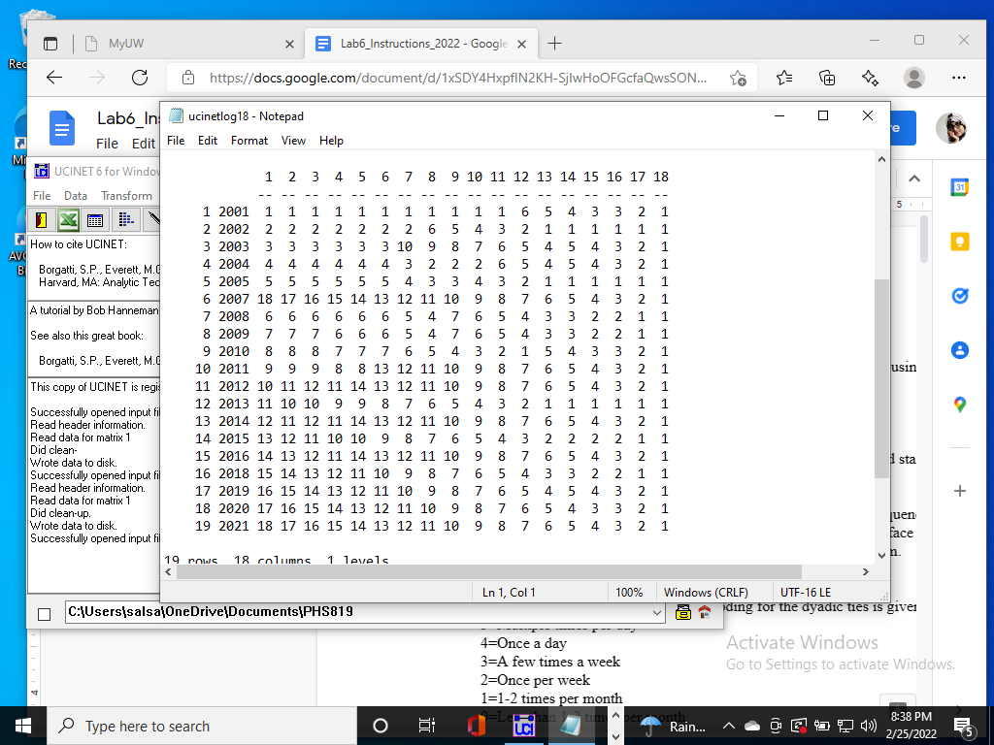

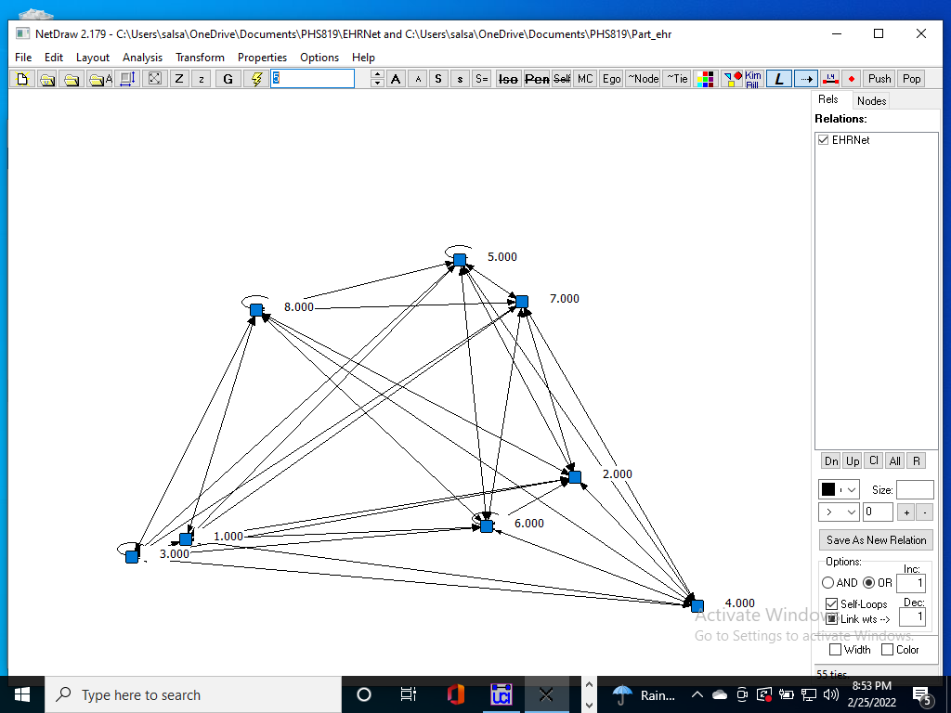

**There is no transmitter in the network.**

**Receiver: 2, 5**

**Task 10:** Summary write-up. Write up a short description of your SNA analysis of block models and work roles observed among the participants in the clinic network dataset. Illustrate your findings with graphs. Suggest directions for future research.

In the face to face network, we see that highest receiver was group 8 which consists of medical assistants and nurses. But for electronic communication, the highest number of receiver is node 2 which is office which indicates in this case, the people who work in office play an important role in this case.