**Lab 7: 2-Mode Affiliation Networks**

Introduction. This lab focuses on displaying and analyzing 2-mode affiliation networks in Ucinet.

**Set-up.** The data used here are from a survey of primary care clinic patients about the clinic staff members whom they considered to be part of their “primary care team”. The data are from a single primary care clinic.

The data were collected by surveying patients about their primary care team in June 2015. The data represent 84 patient reports of primary care teams at a single primary care clinic. Patients were given surveys with pictures of all physicians and staff at the clinic and asked to circle staff members whom they considered to be a part of their care team. The staff list included 7 office support personnel (front desk staff and administration), 8 clinical support staff (RNs, medical assistants), 1 nurse practitioner, 3 physicians, and 4 lab/radiology technicians.

The result is a patient-by-staff matrix (84-by-23) that indicates whether the patient listed the staff member as part of the care team (CareTeam.txt).

PtDemographics.txt contains a number of node characteristics for the patients, including:

1. Age

2. Male (1=Male, 0=Female)

3. Education (1= <HS, 2=HS, 3=Some college, 4=College degree, 5=Graduate degree)

4. ClinicYears (1= <1 year, 2=1, 3=2, 4=3, 5=4, 6=5, 7=6-10 years, 8= >10 years)

5. Visits in Past Year (1=First, 2=2 total, 3=3, 4=4, 5=5, 6=6, 7=More than 5 other)

6. Health (1=Excellent, 2=Very good, 3=Good, 4=Fair, 5=Poor)

7. Satisfaction with Care (1=Rarely, 2=Occasionally, 3=Sometime, 4=Most of the time, 5=Always)

**Task 1:** Create a Ucinet dataset for CareTeam.txt and visualize your network using NetDraw.The data file contains row labels and columns labels (check the appropriate boxes in the Raw matrix textfile reader) and be sure to change the matrix size to 84 rows and 23 columns.

**Questions:**

**1. How does NetDraw distinguish between patients and clinic staff members in the 2-mode network? What staff member clustering occurs in the graph?**

**using color of the nodes, red - patients, blue - staff**

**Care team members cluster together who are dealing with the same patients. Maybe, people visit same labs in a regular basis that’s why the primary care giver is dealing more with the patient.**

**Task 2:** Go back to Ucinet and convert the two-mode data to 2 separate one-mode datasets, one for rows and one for columns. Data -> Affiliations (2-mode to 1-mode) -> Rows/Columns.

**Task 3:** Extract the diagonal from the CareTeamRows and CareTeamColumns matrices (Data->Filter/Extract->Main Diagonal).

**Questions:**

**2. Which patients listed the most staff members as part of their care team?**

**//diagonal value is the num of staff each patient is dealing with (in row)**

**patient 50.**

**3. Which staff members were listed most often by patients as being part of the care team?**

Office 1

**Task 3:** Display the centrality for the care team data (Network->2-Mode networks->2-Mode Centrality).

**Questions:**

**4. Compare the nurse practitioner (NP1) with the 3 physicians (MD1-MD3)? Which clinician has the highest eigenvector centrality? Why do you think this is?**

**NP1 - 0.283**

**Nurses deal with other people who are also well connected.**

**5. Which clinician has the highest betweenness centrality when comparing the nurse practitioner (NP1) to the 3 physicians (MD1-MD3)? Why is there a difference?**

**MD 2**

**Physician 2 has connected the cluster of the office and some peripheral patients. MD2 is a kind of bridge.**

**6. What does it mean for a patient to have betweenness of 0 (such as pt55)?**

**It does not fall into any unique connection. It does not uniquely connect a pair of group. No one’s shortest path goes through it.**

**Task 4:** Create the sociomatrix for the 2-mode CareTeam data (Transform> Graph Theoretic> Bipartite). Compute the Bonacich power centrality measure with this sociometric matrix (Network->Centrality and Power->Beta centrality/Bonacich Power).

**Questions:**

**7. Which physician has the highest Bonacich power? Explain why this physician has higher power than the other physicians?**

**Physician 3**

**There are some patients who are uniquely connected to this physician. They are not connected to other staff directly or indirectly. MD1 has more patients who include less number of other staff in their care team.**

**Task 5:** Core-periphery analysis is a block-modeling technique for separating the nodes of 2-mode data into central nodes and nodes that are on the fringe of the network. Conduct core-periphery analysis with the CareTeam data in UCINET (Networks-> 2-Mode Networks-> 2 mode factions).

**Questions:**

**8. Which staff members are in the core block (the upper left corner of the block matrix)?**

**in the left upper block for my case.**

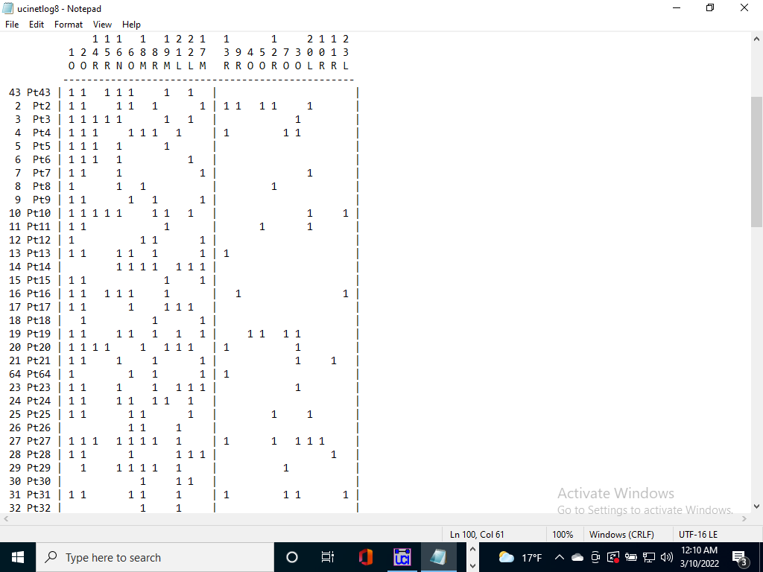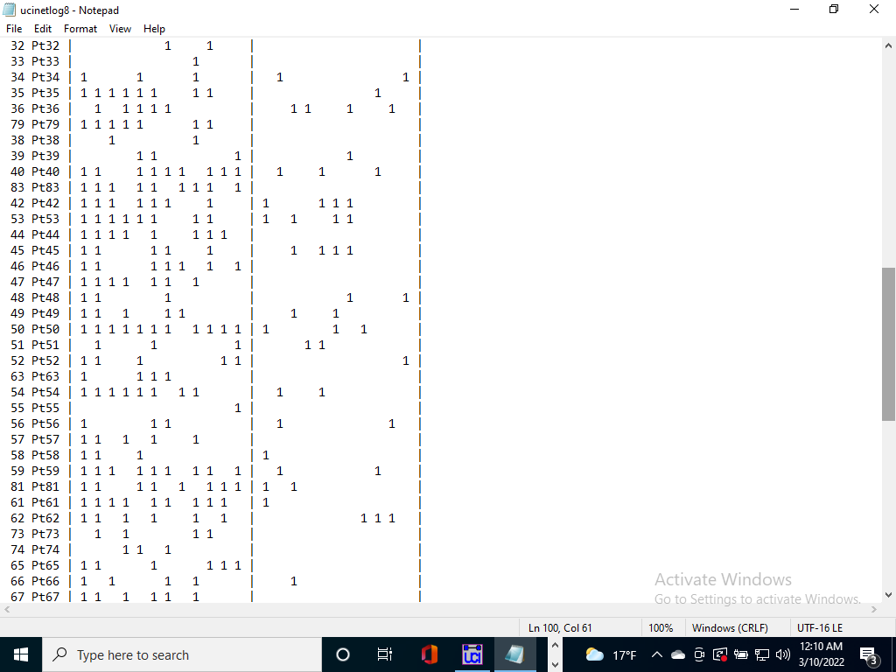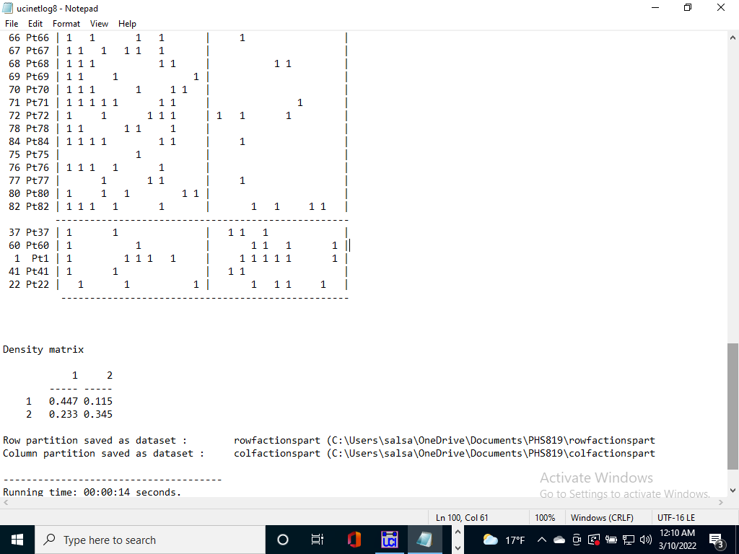

**Office 1, 2 and 6, RN_MA7, RN_MA1 and RN_MA8, NP1, MD2, MD1, MD3, Lab 2, Lab 3**

**9. Are there any surprises in who is considered to be in the core?**

**Not really. Most people are quite anticipated like office 1 and 2, Nurse, physicians. We have seen previously that they hav higher centrality measures as well.**

**Task 6: Summary write-up**

Write up a short description of your analysis of patient/care team 2-mode data. Suggest directions for future research.

It appears that nurses have high eigenvector centrality and doctors have a high betweenness. Maybe we can test if and why that happens. Also, we can test if really office members are more connected with nurses compared to doctors.

pt 60, pt 1, pt 22, pt 41, pt 37 are together. They might have similar health conditions and we can test it.