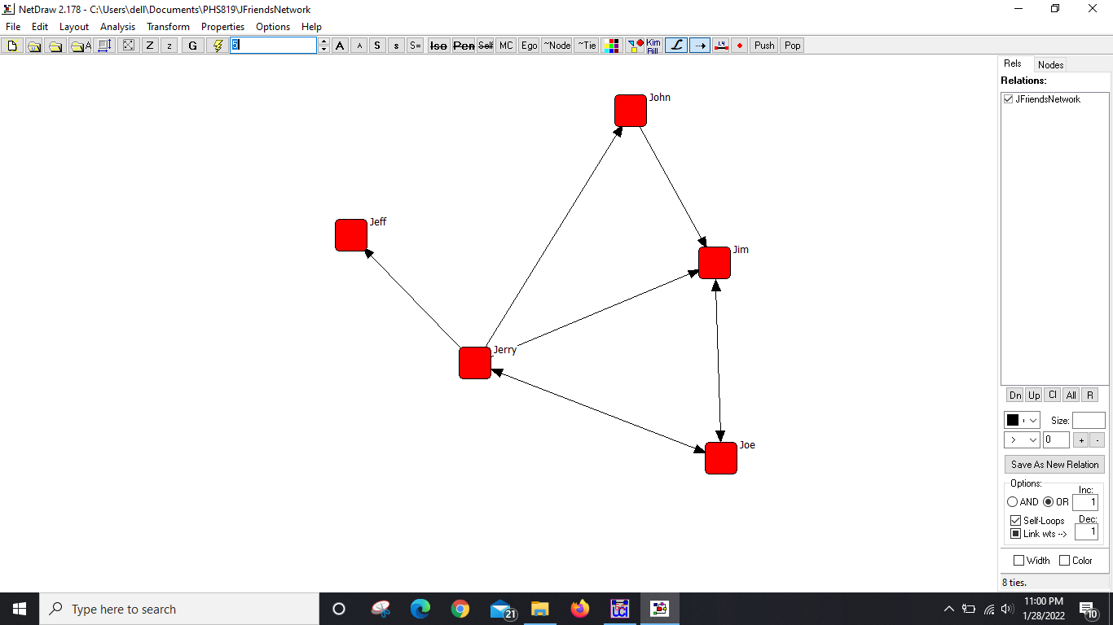

10. The vna files in the notepad show the connection and the description of the network diagram. It shows the “from” and “to” connection between the nodes. Also, the x and y axis of each node, nodes’ color, size, shape, label in the Node Properties section. In the tie properties section, it shows each tie, color, size of arrowhead. I am not sure what it means by “active” though.

