2. Screenshot of Xiang and Professor exchange:

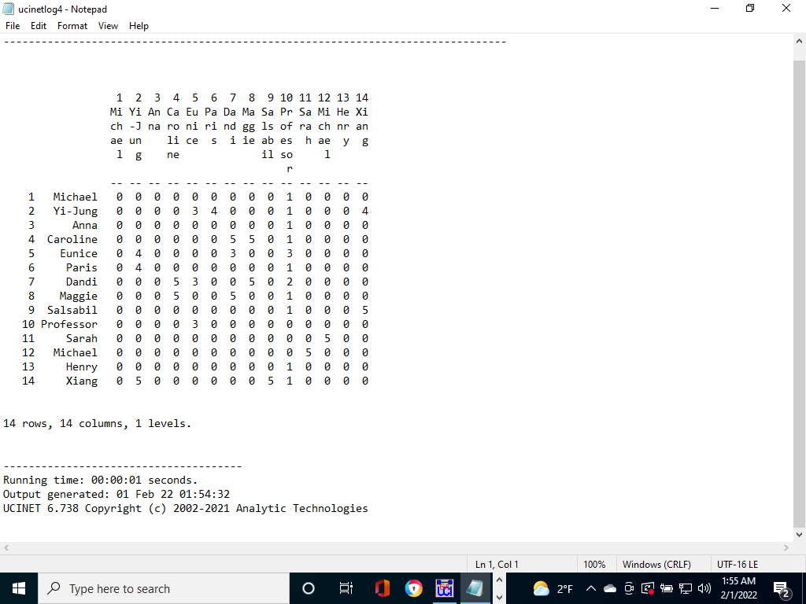

4. Dandi’s egonetwork:

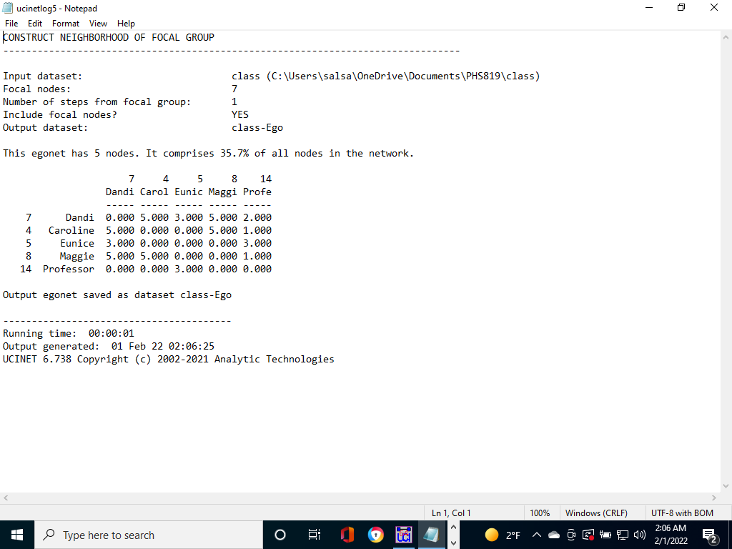

7. dichotomized, symmetrized network, size of the nodes to be proportional to the number of

connections each person has:

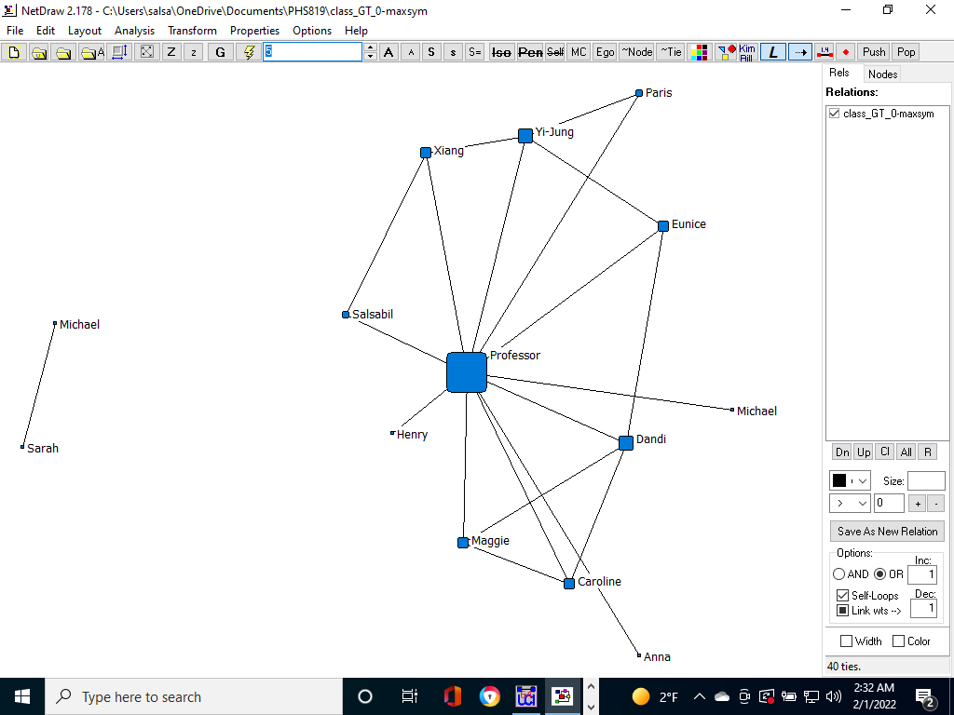

1. Describe the class network.

From the class network, we can see that most of the students are connected to each through the

Professor. Professor has the highest number of connections followed by Dandi and Yi-Jung both having

the same number of connections. The network has two components. Michael and Sarah are disconnec-

ted from the rest of the network.

1. What is the average number of connections across the class? (Return to Ucinet and   
   use Network-Cohesion-Multiple cohesion measures to see average degree).

The average degree is 2.857.

1. Which layout best represents your network of family relations? Explain your choice.

The Graph-Theoretic layout best represents my family network. In this layout, the cluster and degree

of connections are much more visible and clear. The first and second-degree connections are better

represented in this layout.

1. Explain how your family ties are represented in the network and how nodes are organized or clustered.

The ties are represented in clusters based on degree. The first-degree connections of a person are clustered together and closer whereas the second-degree connections are distant and closer to their own first-degree connections.

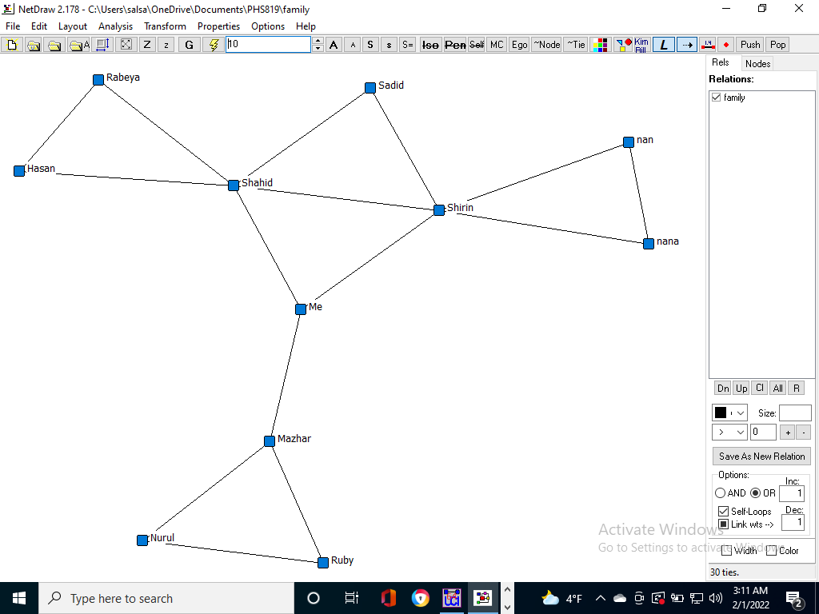

Fig: my family network