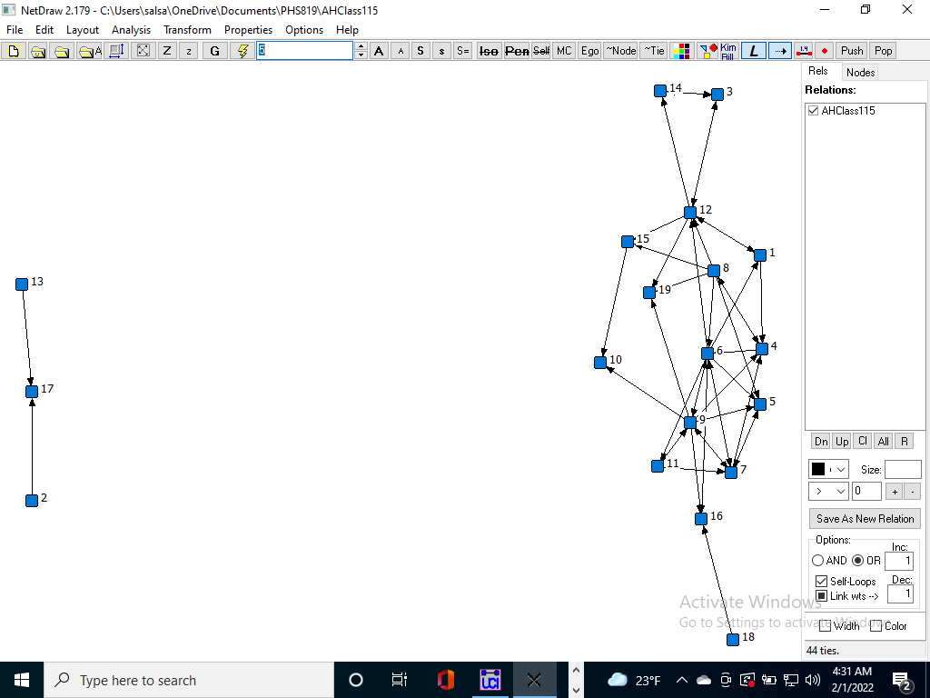

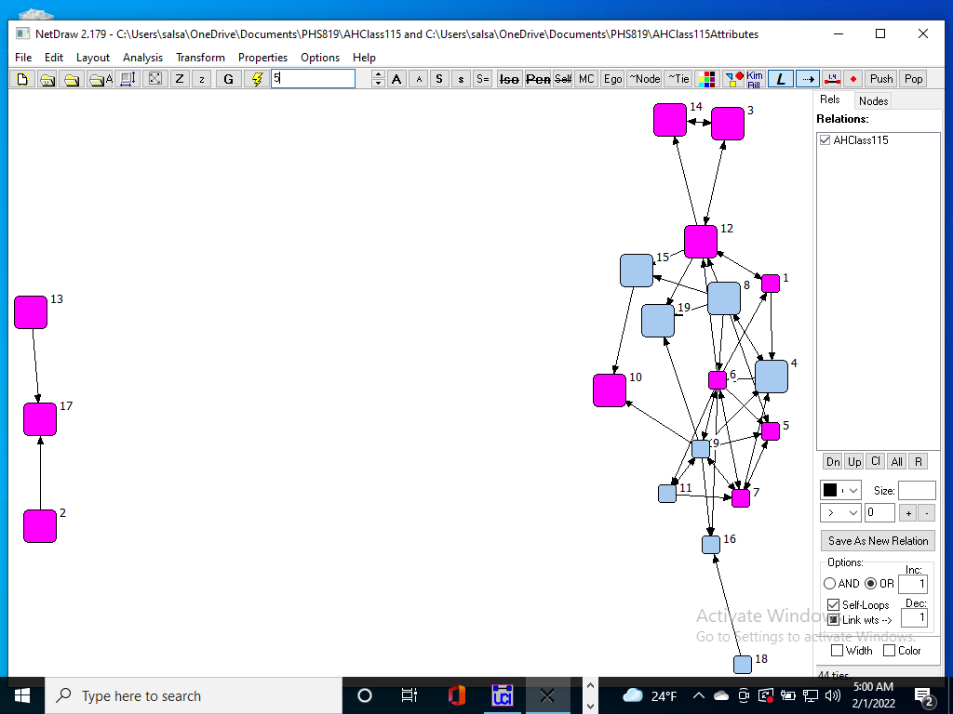

1. How many of the students did not nominate any of the other students as friends? (Remember—  
   the friendship nominations a student makes are row data.If necessary, you may want to look   
   at univariate statistics for the class (Tools->Univariate statistics).

ans: 4 students

1. Describe how the students are connected in the network.  
   Other than three students, all the other are completely connected. So the network basically has two   
   components. node no 2, 17, and 13 are disconnected from the rest of the network. 2 and 13 are   
   connected through 17 and they are all in the same grade.
2. Which students appear to be located in the center of the class network?   
   Node 6 appears to be in the center.

4.Is the attribute dataset a square or a rectangular matrix? Why?

Rectangular, because they are not connections. We only get n rows in the attribute

dataset, where n is the no of students. However, column size can be much larger.

5. How many attributes are associated with each node?

with each node, there are 24 attributes associated.

6. What patterns do you see between male and female nodes?

The students are clustered together based on their grades and gender. Again, clusters are

closely situated based on grades. 7th-grade female students more dense connection

rather than the 7th-grade males.

8.In what network positions are the most frequent drinkers?  
ans: 6 and 9 are the most frequent drinkers. and they are centrally located in the

network.

9.

What hypotheses would you be interested to test with regard to alcohol

use and friendships?  
If the connection/ no of connections/ popularity/ centrality might have something to do.

If parents drinking habit have any connection with the children. Wave might have an

impact as well.

10. What patterns do you see in regard to smoking?

smokers and non-smokers are kind of clustered.

11. List at least 2 hypotheses about smoking and friendships that would be

interesting to test.

If the people who smoke are densely connected to each other than the ones who are

non-smoker and vice-versa.

Does smoking has anything to do with hangout and club participation e.g., students who

are more socially active might have better chance to smoke or try at least once.

12. Do any of the other variables (e.g., scholastic aptitude (AH_PVT),

race/ethnicity, # of clubs) appear to be associated with friendships?

Clusters have a kind of closer AH_PVT, but the signal is not very prominent.

People who are densely connected have a moderate number of clubs which is similar

across the dense part of the network. Seems like peripheral nodes have higher or lower

number of clubs.

However, race or ethnicity is difficult to tell because all the students were white. Based on

that, seems like either the other ethnicity is absence from the school or race has very very

high impact on friendship as well the clusters has sane ethnicity.

Task 5. Summary write-up Write up a short description of your SNA analysis of health

behaviors observed among the students in the Class115 dataset. Suggest directions

for future research.

Firstly, we can say that friendship has some connection with gender and grade. Female

students appear to be in the center of the network which means they are more socially

active, at least inside the school community. It might be a good research direction to see

if connection or position in the network has anything to do with drinking as the center

nodes seem to have higher alcohol consumption. Another observation is that smoking

is more prevalent among younger people. It might be interesting to see If smoking and drinking have any connection

with family income/povertypct and parents’ drinking habit.