Abstract
After a major earthquake, emergency managers must decide where to set up temporary medical centres (TMCs) and how to send casualties to hospitals and TMCs. Aftershocks keep arriving for weeks, so a site that looks safe on day one may be struck by damaging shaking before the centre is closed. Published work either treats this hazard as fixed, or produces hazard maps that never reach an operational allocation decision.
AARO (Aftershock-Aware Response Optimizer) closes that gap for the 2023 Kahramanmaraş–Gaziantep Mw 7.8 earthquake sequence. The system has five parts. (1) A data preparation layer builds analysis-ready site, hospital, demand and aftershock datasets from open and curated sources. (2) A probabilistic seismic aftershock hazard analysis (PSAHA), combining Omori decay, Gutenberg–Richter magnitude weighting and the BSSA14 ground-motion model, gives every candidate site an unsafe probability and a representative peak ground acceleration (PGA). (3) A deterministic mixed-integer facility-location model decides which sites to open and how to route casualties, run once with the hazard filter (risk-aware) and once without (risk-blind). (4) Two stochastic medical-response models consume probability-weighted scenarios: a scenario-wise lexicographic linear program (Scenario-wise LP) and a two-stage sample average approximation (SAA) that chooses TMC sites under a site budget. An AHP/TOPSIS multi-criteria ranking supports candidate screening. (5) A web dashboard presents all results and lets a user upload a dataset and run the pipeline live.
The main results are as follows. Of 803 sites with a hazard value, 38 exceed the 0.2 g safety threshold, and 34 eligible TMC candidates are excluded by the filter. A hazard-blind plan opens 377 TMCs, of which 26 sit above the threshold; the risk-aware plan opens 387, none above it. On out-of-sample scenarios, the SAA policy serves 79.1% of expected casualties at a 25-site budget and 88.6% at the full 120-site budget. Across every model, the same rural sub-districts remain far from care, which shows that under-coverage is a candidate-infrastructure problem, not a solver defect.
Keywords: post-earthquake facility location, aftershock hazard, PSAHA, mixed-integer programming, stochastic programming, sample average approximation, temporary medical centres.

Table of Contents
1. Introduction 1
1.1 Background 1
1.2 Problem Statement 1
1.3 Objectives 1
1.4 Scope 2
1.5 Status against the Original Plan 2
1.6 Purpose and Structure of This Document 2
2. Requirements 3
2.1 Functional Requirements 3
2.2 Expected Requirements 3
2.3 Exciting Requirements 4
2.4 Non-Functional Requirements 4
3. System Overview and Architecture 5
3.1 Stakeholders and Users 5
3.2 System Context 5
3.3 Architectural Style 5
3.4 Layers and Components 5
3.5 Main Data Flow 7
3.6 Key Design Decisions 7
4. Data Design and Persistent Storage 8
4.1 Storage Areas 8
4.2 Conceptual Data Entities 8
4.3 Data Provenance 9
4.4 Data-Quality Rules Applied 10
5. Component-Level Design 11
5.1 Design Classes by Component 11
5.2 Class Relationship Overview 12
5.3 Component Contracts 13
5.4 Behavioural Design 13
5.5 Class Relationships 15
5.6 Deployment 16
6. Applied Methodology 18
6.1 Hazard Analysis (C2) 18
6.2 Multi-Criteria Ranking (C2) 18
6.3 Deterministic Facility Location (C3) 19
6.4 Scenario Generation (C3) 19
6.5 Scenario-Wise Medical LP 19
6.6 Two-Stage SAA Budget Model (C3) 20
6.7 Rationale for Three Decision Models 20
6.8 Technology Stack 21
7. Interface Design 22
7.1 User Analysis 22
7.2 Task Analysis 22
7.3 Interface Objects and Their Operations 22
7.4 Events That Change Interface State 23
7.5 Interface States 24
7.6 Screen Layouts 24

8. Validation 29
8.1 Validation Strategy 29
8.2 Input Validation 29
8.3 Hazard Model Validation 30
8.4 Deterministic Model Validation 30
8.5 Stochastic Model Validation 31
8.6 Cross-Model Consistency 32
8.7 Threats to Validity 32
8.8 Validation Summary 33
9. Testing 34
9.1 Test Strategy 34
9.2 Pass and Fail Criteria 34
9.3 Risks and Contingencies 35
9.4 Test Cases 35
10. Conclusion 37
10.1 Summary of Work Completed 37
10.2 Findings 37
10.3 Limitations 37
10.4 Future Work 38
Appendix A. User Manual 39
A.1 Requirements 39
A.2 Accessing the Dashboard 39
A.3 Interpreting the Views 39
A.4 Sharing a View 40
A.5 Executing the Pipeline on a User Dataset 40
A.6 System Messages 40
Appendix B. Repository, Installation and Running 41
B.1 Repository 41
B.2 Installation 41
B.3 Executing the Pipeline 41
B.4 Executing the Verification Checks 41
B.5 Starting the Dashboard 41
Appendix C. Acceptance Demonstration and Code Review 42
C.1 Acceptance Demonstration Script 42
C.2 Code Review Checklist 42
References 43

Table of Figures
Figure 1: AARO architecture with five components and one-way data flow 6
Figure 2: Design classes and their relationships, grouped by component 15
Figure 3:AARO deployment showing the browser, application server and file storage 17
Figure 4: Home/Upload Page 24
Figure 5: Briefing Tab 25
Figure 6: Hazar & Site Ranking Tab 25
Figure 7: Siting Plan Tab 26
Figure 8: Casualty Allocation Table for Risk-blind MILP 26
Figure 9: Medical Response Summary for Scenario-wise LP 27
Figure 10: Medical Response Summary for SAA 27
Figure 11: Sensivity Analysis for SAA 28
Figure 12: Research Lab Tab 28

1. Introduction

1.1 Background
An earthquake causes two waves of damage. The mainshock produces collapsed buildings, blocked roads and an initial casualty surge within hours. Aftershocks follow for days or weeks and can bring down structures the mainshock only weakened. A temporary medical centre needs to operate for weeks, so its site must be judged against the hazard it will face during that whole period, not only against distance and capacity on day one.
Two lines of published work address parts of this problem. Oksuz and Satoglu [1] jointly optimise facility location, casualty allocation and medical staffing, but treat the safety of candidate sites as given. Ommi and Janalipour [2] apply probabilistic seismic aftershock hazard analysis with remote sensing to rank shelter sites, but stop at a ranking and never use it in an allocation model. AARO joins the two and measures what the join changes.

1.2 Problem Statement
Three limitations motivate the project:
- Static siting. Candidate sites are treated as fixed and admissible for the whole planning horizon, although a 30-day aftershock window changes the ground-motion picture considerably.
- Hazard as soft penalty or ignored. A facility opened at an unsafe site does not just cost more; it can fail while it is most needed. Treating hazard as a soft cost understates that failure mode.
- Hazard analysis that stops before optimisation. A ranking is not a decision. Nothing tells the planner which sites to actually open under demand, capacity and routing constraints.
A fourth limitation became clear during the project. Real planning is uncertain in casualties, hospital damage and road damage, so a single deterministic plan is not enough. The system therefore also needed models that handle scenarios.

1.3 Objectives
- Estimate the probability of damaging shaking at every candidate site during the operating window, from the observed aftershock record.
- Use that estimate as a hard screen inside a facility-location and casualty-allocation model, and quantify the difference against a hazard-blind plan.
- Rank candidate sites with a multi-criteria method (AHP and TOPSIS) over hazard, terrain and accessibility.
- Plan medical response under uncertainty, with scenario-wise and two-stage stochastic models that include triage classes, hospital damage, road damage and staffing.
- Validate the stochastic models by out-of-sample evaluation, paired comparison of candidate pools and sensitivity analysis.
- Deliver a browser-based dashboard to explore results and to run the pipeline on a user-supplied dataset.

1.4 Scope
In scope: the Kahramanmaraş Province study area (36.5–38.5°N, 35.5–38.5°E); a 30-day post-mainshock planning window; TMC siting, casualty routing and additional-staff planning; a dashboard for planners and researchers.
Out of scope: real-time field dispatch, live sensor integration, user authentication, and monetary costing of facilities. The objective is measured in casualty-kilometres, not currency, by deliberate choice: no defensible per-TMC cost standard exists, and a currency conversion would add unverifiable assumptions without changing the model's structure.

1.5 Status against the Original Plan
The midterm report covered the deterministic phase. The table shows the full 16-week plan; every item is now complete.
Weeks | Planned Activity | Status Now
1–2 | Literature review, formulation, data acquisition and validation | Complete
3–4 | Probabilistic aftershock hazard estimation | Complete
5–6 | Deterministic location–allocation model | Complete
7–8 | Hazard screening and hazard-blind comparison | Complete
9 | Interactive results interface | Complete
10–11 | Multi-criteria site suitability (AHP/TOPSIS) | Complete
12–13 | Scenario-based uncertainty and two-stage reformulation | Complete
14–15 | Demand and capacity uncertainty | Complete
16 | Validation of the complete framework | Complete

1.6 Purpose and Structure of This Document
This is the final report for SE801. It presents the requirements, the design (at system, component and interface level), the implementation, the validation of the models, and the testing of the system. Chapter 2 gives requirements, Chapter 3 the system architecture, Chapter 4 data design, Chapter 5 component-level design, Chapter 6 the methods, Chapter 7 interface design, Chapter 8 validation, Chapter 9 testing, and Chapter 10 the conclusion. The user manual, repository details and installation notes follow in the appendices.

2. Requirements
Requirements are grouped using Quality Function Deployment: normal requirements (what the system must do), expected requirements (qualities users take for granted) and exciting requirements (extras that add value).

2.1 Functional Requirements
ID | Requirement | Status
FR1 | Fit temporal decay and magnitude-frequency models to an aftershock catalogue and compute expected ground motion per site | Done
FR2 | Compute per-site probability of exceeding a damaging-shaking threshold within the window, plus a representative PGA | Done
FR3 | Solve a joint TMC-location and casualty-allocation model | Done
FR4 | Exclude candidate sites above the safety threshold (hazard-aware mode) | Done
FR5 | Solve the identical model without the filter (hazard-blind baseline) | Done
FR6 | Compare both plans per site and flag unsafe sites the blind plan would open | Done
FR7 | Rank candidate sites by AHP weights and TOPSIS closeness | Done
FR8 | Generate probability-weighted scenarios of casualties, road damage and hospital capacity loss | Done
FR9 | Solve a scenario-wise lexicographic LP over triage classes, time periods and staffing | Done
FR10 | Choose TMC sites under a site budget with a two-stage SAA and evaluate them out of sample | Done
FR11 | Run both stochastic models on two candidate pools (all candidates and TOPSIS top 120) for paired comparison | Done
FR12 | Run one-at-a-time sensitivity analysis on model parameters | Done
FR13 | Export all results into one validated bundle with a manifest | Done
FR14 | Present hazard, siting, medical response, robustness and research views in a browser | Done
FR15 | Accept an uploaded dataset, validate it, and run the pipeline end to end with visible progress | Done

2.2 Expected Requirements
- ER1 Reported solution quality. Every solve reports termination status and optimality gap; a time-limited result is never presented as optimal.
- ER2 Legible failure. A missing result or failed stage is reported by name with the underlying reason.
- ER3 Input validation. An invalid upload is rejected with a specific reason before anything runs.
- ER4 Per-site auditability. Any site's hazard, terrain and status under each plan can be inspected on its own.
- ER5 Reproducibility. The same seed and settings regenerate the same scenarios and results.

2.3 Exciting Requirements
- XR1 Live re-solve on a user's own data, stage by stage.
- XR2 Shareable interface state: the view, model and dataset are carried in the address.
- XR3 Parameter robustness exposed through sweeps of judgement-chosen parameters.
- XR4 Filterable, sortable, exportable result tables.

2.4 Non-Functional Requirements
Quality | Requirement
Reproducibility | Fixed random seeds; checkpointed SAA runs that resume with identical settings
Performance | Every solve is bounded by a time limit and an optimality gap so a run always terminates
Transparency | Every assumption (distributions, penalties, thresholds) is documented and exposed in the interface
Maintainability | Separate preparation, modelling and presentation components; configuration kept in one settings module per model
Portability | Python 3.9+ pipeline; modern desktop browser for the dashboard
Safety of interpretation | Results from different models are never presented on a shared denominator when their demand assumptions differ

3. System Overview and Architecture

3.1 Stakeholders and Users
- Response planner: requires a rapid answer to operational questions: where it is unsafe, which sites should open, how casualties are routed and which districts are underserved.
- Researcher: requires the means to verify and reproduce a finding: inspecting individual sites, filtering to the rows behind a claim, exporting data and rerunning the pipeline on new inputs.
- Supervisor and examiners: assess correctness and design, and require documented assumptions and traceable results.
Both user roles use the same screens. A Planner/Research switch only controls how much supporting detail appears.

3.2 System Context
AARO takes five kinds of external input (earthquake catalogue, map-derived sites and boundaries, terrain and soil rasters, building damage maps, and a curated hospital list) and produces one validated results bundle. A user interacts only through the dashboard.

3.3 Architectural Style
AARO is a batch analysis pipeline with a thin service-and-presentation layer on top. The research side runs to completion offline and leaves versioned files behind. It needs no concurrent writers or live queries, so files (CSV and JSON) are the source of truth and no application database is used. A regenerable SQLite catalogue is available for ad-hoc querying only. The service side reads one results bundle and, along one path only (upload and live solve), creates a new isolated bundle per job instead of modifying shared data.

3.4 Layers and Components
The system is organised into five components, shown with their responsibilities.
# | Component | Responsibility | Consumes | Produces
C1 | Data Preparation | Extract, clean and validate raw sources into analysis-ready datasets | Raw catalogue, map, terrain, soil, damage, curated hospital list | Candidate sites, hospitals, demand points, aftershock catalogue
C2 | Hazard Analysis | Estimate unsafe probability and PGA per site; rank sites with AHP/TOPSIS | C1 datasets | Per-site hazard table, TOPSIS ranking
C3 | Optimization Models | Deterministic MILP (risk-aware and risk-blind), Scenario-wise LP, SAA | C1 datasets, C2 outputs | Siting plans, casualty allocations, staffing, budget-policy results
C4 | Export and Service | Combine all results into one validated bundle; serve it; run uploaded datasets as isolated jobs | C1–C3 outputs | Results bundle with manifest; job status
C5 | Dashboard | Present views, filters, exports and the upload workflow | C4 service | Interactive interface
The dependencies are strictly one-directional (C1 → C2 → C3 → C4 → C5), with one exception: TOPSIS scores from C2 are also read by the SAA model in C3 to screen candidates. Within C3, the deterministic model, Scenario-wise LP and SAA are independent of one another. They differ in demand assumptions, so their outputs are compared only with explicit labelling.
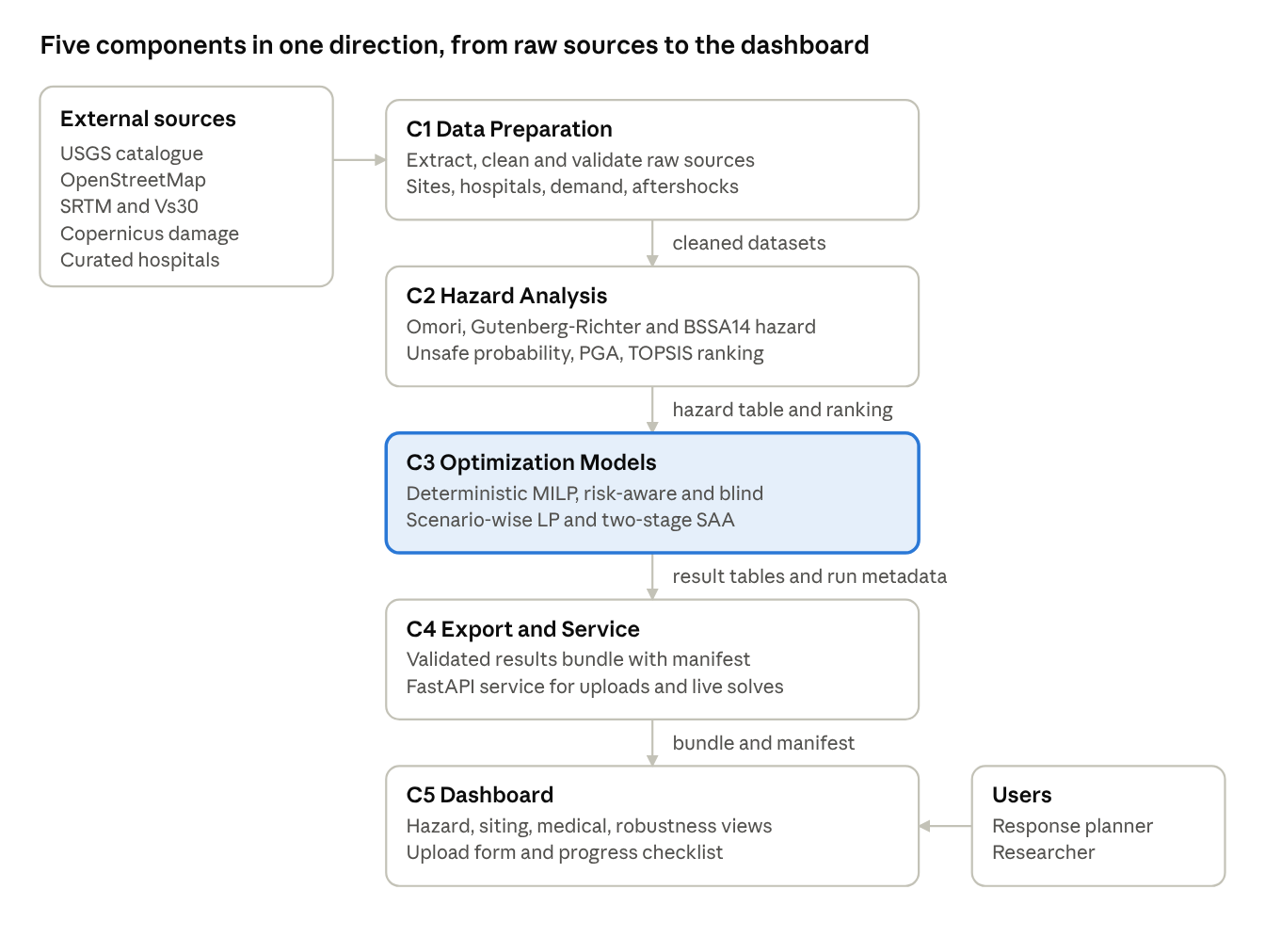
Figure 1: AARO architecture with five components and one-way data flow
Figure 1 shows the flow. The highlighted component, Optimization Models, holds the three decision models. Data moves only downward through result files, except that TOPSIS scores from C2 are also read by the SAA model in C3.

3.5 Main Data Flow
- Raw sources are extracted and validated into processed datasets (C1).
- The aftershock catalogue is fitted by Omori and Gutenberg–Richter models; a ground-motion model converts each scenario into PGA at each site; these combine into a per-site unsafe probability (C2).
- Sites are ranked by AHP/TOPSIS (C2), advisory only.
- Model inputs are prepared: a distance matrix, capacities, demand, candidate sets (C3).
- The deterministic MILP is solved twice, with and without the PGA filter; Scenario-wise LP and SAA are solved on the scenarios (C3).
- All results are exported into one bundle with a manifest recording each file's validation status (C4).
- The dashboard reads the bundle; a user upload triggers the same chain on an isolated job directory (C4, C5).

3.6 Key Design Decisions
Decision | Reason
Hazard as a hard filter, not a soft penalty | A facility at an unsafe site can fail outright, which a soft cost cannot represent
Objective in casualty-kilometres | No defensible per-site cost exists; units stay honest; sensitivity to the penalty is tested
AHP/TOPSIS kept advisory | Ranking and routing are separate deliverables in the source methodology; mixing them would hide the effect of each
Files as source of truth | A batch process needs no concurrency control; results stay inspectable and versionable
Separate stochastic models | The scenario-wise LP answers "how well can we respond per scenario"; SAA answers "which sites should we commit to before knowing the scenario"
Isolated job directories for uploads | A user upload cannot change or corrupt the reference results

4. Data Design and Persistent Storage
AARO stores everything in files. Files fit a batch pipeline that runs to completion, and they leave a versioned, inspectable trail of every intermediate result. An optional local SQLite catalogue loads the 18 canonical CSV files with a SHA-256 fingerprint of each source file. It is regenerable, idempotent, and never used by the solvers or the dashboard, so CSV stays the source of truth.

4.1 Storage Areas
Data moves through six storage areas, each written by one component and read by the next.
Area | Written by | Read by | Content
Raw sources | External download, curated files | C1 | Catalogue, map extracts, elevation and soil rasters, damage shapefiles, curated hospital list
Processed datasets | C1 | C2, C3 | Cleaned site, hospital, demand and aftershock tables
Hazard outputs | C2 | C3, C4 | Omori and Gutenberg–Richter parameters, PGA table, per-site hazard, TOPSIS ranking
Model inputs and outputs | C3 | C3, C4 | Demand, facilities, distance matrix; selected TMCs, allocations, utilisation, per mode
Stochastic outputs | C3 | C4 | Scenario results, allocations, unmet demand, staffing, budget-sweep tables, run metadata
Dashboard bundle | C4 | C5 | One validated export of all the above plus a manifest

4.2 Conceptual Data Entities
The table lists the entities the system reasons about. Relationships are logical joins on identifiers, not database foreign keys.
Entity | Identifier | Contents | Related to
Candidate site | site_id | Location, facility type, terrain, soil, hazard estimate, damage context | Selected TMC, site status, ranking
Hospital | hospital_id | Beds, outpatient capacity, pre-quake staffing, operating fraction after the quake, capacity source and confidence | Allocation, utilisation
Demand point | sub_district_id | Centroid, population, casualty demand, per-scenario triage counts and scenario probability | Allocation, distance
Aftershock event | event_id | Time, location, depth, magnitude, days since mainshock | Hazard fit
Hazard estimate | site_id | Exceedance probability per event, expected exceedances, unsafe probability, representative PGA | Candidate site
Site ranking | site_id | Criteria values, closeness score, rank | Candidate site
Distance record | demand point, facility | Straight-line distance | Demand point, facilities
Siting plan | site_id (per mode) | Opened TMCs, assigned casualties, utilisation | Candidate site
Casualty assignment | demand point, facility (per mode); plus triage and period in medical models | Flow, distance, travel burden | Demand point, facility
Site status | site_id | Candidate and selected flags under both modes, "blind pick unsafe" flag | Candidate site
Scenario result | scenario_id | Probability, unmet demand, travel, extra staff, TMCs used | Casualty assignment
Budget policy | budget, replication | Opened site set, in-sample and out-of-sample service | Candidate site
Scenario manifest | scenario | Study window, safety threshold, file inventory and validation status | All bundle files

4.3 Data Provenance
Every input traces back to a checkable source.
Dataset | Source | Notes
Aftershock catalogue | USGS earthquake catalogue | 30 days after the mainshock; study region; mainshock and incomplete records excluded
Candidate sites | OpenStreetMap (schools, universities, sports facilities, stadiums, hospitals) | 344 of 804 sites carry no map name and are labelled by site ID; geometry and capacity are unaffected
Site area | OpenStreetMap polygons | Used for capacity; node-type sites receive a type-median area, flagged in the data
Elevation and slope | SRTM global 30 m elevation model | Used for ranking
Soil (Vs30) | USGS global Vs30 map | Feeds the ground-motion model
Road access | OpenStreetMap road network | Distance to nearest road
Building damage | Copernicus EMSR648 | High resolution for the city centre, coarser elsewhere
Hospitals | Curated, source-cited list from Turkish Ministry of Health statistics | Each figure marked official, reported or estimated; coordinates cross-checked against map data; Pazarcik District Hospital is closed after the quake and excluded
Sub-districts | OpenStreetMap boundaries | 11 real districts
Casualty projections | PAGER and HAZUS-style projections | Distributed by population share; used to generate scenarios

4.4 Data-Quality Rules Applied
- Capacity from area. TMC capacity is the site's polygon area divided by 30 m² per person (Sphere/UNHCR transitional-settlement figure), clipped to the range 30 to 2,000. This replaced an earlier set of unsourced flat guesses and lowered the casualty-weighted average assignment distance from 42.0 km to 30.5 km.
- Hospitals are curated, not extracted. No public API provides per-hospital capacity for Turkey. The earlier hand-made hospital list had wrong capacities and coordinates and was superseded.
- Effective capacity. The hospital source's effective post-quake capacity sums to 2,568 beds, while the raw total column sums to 2,693. The model uses the effective figure.
- Validated exports. The configuration file fixes expected row counts and bounding boxes; validators label problems as auto-fixable or needing review, and only auto-fixable problems are corrected, and only on request.
- Known gap. One candidate site (S804) has no hazard row. It is dropped from the ranking, and the deterministic prototype treated missing hazard as safe, which is the wrong default direction. This is recorded as a limitation (Section 10.3).

5. Component-Level Design
The previous design documents described the code module by module. This chapter instead describes each component through the design classes it contains, the contract it offers to its neighbours, and how it behaves. Implementation is mostly scripts and tables; the classes are design-level abstractions, each mapped to a component.

5.1 Design Classes by Component
C1 Data Preparation
Class | Responsibility | Key Attributes
AftershockCatalogue | Hold the cleaned 30-day record and compute days since the mainshock | time, location, depth, magnitude, days since mainshock
CandidateSite | One location that could host a TMC | identity, type, terrain, soil, area, damage context
Hospital | One existing hospital with fixed, curated capacity | beds, staff, operating fraction, capacity source
DemandPoint | One district's casualty demand | location, population, casualty demand, per-scenario triage counts
HospitalDataValidator | Check hospital data and coordinates against map data | capacity, confidence level
C2 Hazard Analysis
Class | Responsibility | Key Attributes
SeismicHazardModel | Combine Omori decay, Gutenberg–Richter weights and the BSSA14 ground-motion model | K, c, p; a, b; fault style
HazardEstimate | Per-site exceedance probability, expected exceedances, unsafe probability, representative PGA | q, Λ, P_unsafe, PGA
SiteRanking | AHP weights and TOPSIS closeness over PGA, slope, elevation, road distance | weights, closeness score, rank

C3 Optimization Models
Class | Responsibility | Key Attributes
TMCCandidate | A site eligible to open as a TMC, with capacity and opening penalty | capacity, penalty, hazard-filter flag
FacilityLocationModel | Deterministic MILP: which TMCs to open, how to route casualties | open and flow decisions, mode, time limit, gap
SitingPlan | Opened TMCs, assignments and hospital utilisation for one mode | opened set, flows, utilisation
RiskComparisonReport | Compare risk-aware and risk-blind plans per site | candidacy and selection flags, unsafe-blind-pick flag
ScenarioSet | Probability-weighted casualty, road-damage and hospital-damage scenarios | scenario probability, triage counts, damage fractions
ScenarioResponseModel | Scenario-wise lexicographic LP over triage, periods and staffing | untreated demand, travel, extra staff
BudgetPolicyModel | Two-stage SAA: shared TMC openings under a site budget, recourse per scenario, out-of-sample evaluation | budget, opened set, served fraction, unmet
C4 Export and Service
Class | Responsibility | Key Attributes
ResultsBundle | One validated export of every result, with a manifest recording each file's status | files, row counts, validation status
DashboardService | Serve the active bundle read-only; accept uploads; start and monitor jobs | active source, job registry
UploadJob | One uploaded dataset's lifecycle in an isolated directory | job ID, directory, status
PipelineOrchestrator | Run the pipeline stages in order, stop at the first failure | stage list, run status
C5 Dashboard
Class | Responsibility | Key Attributes
DashboardSession | Hold the interface state: view, model, candidate pool, detail level, selected site | all carried in the page address
Views | Briefing, Hazard, Siting plan, Medical response, Robustness, Research lab, Site detail, About this run | one view component per screen

5.2 Class Relationship Overview
The relationship table in Section 5.5 shows ownership and dependency between these classes. Three patterns explain most of the structure:
- Record classes (CandidateSite, Hospital, DemandPoint, AftershockCatalogue) carry data only; they are populated by C1 and read by everyone.
- Model classes (SeismicHazardModel, FacilityLocationModel, ScenarioResponseModel, BudgetPolicyModel) each take records in and produce a result class; none calls another model directly.
- Result classes (HazardEstimate, SitingPlan, RiskComparisonReport, ResultsBundle) are the only things that cross component boundaries.
Because models never call each other, any of them can be replaced or rerun alone. This is why the deterministic and stochastic models can be compared fairly: each reads the same records but makes its own demand and decision assumptions.

5.3 Component Contracts
The contract between components is the set of result files, not function calls.
From → to | Contract | Guarantee
C1 → C2 | Aftershock catalogue; candidate sites with soil and terrain | Row counts and coordinate bounds validated
C2 → C3 | Per-site hazard table (probability and PGA); TOPSIS ranking | Probabilities lie in [0, 1]; expected exceedances ≥ 0
C1 → C3 | Demand points, hospitals, candidate TMCs, distance matrix | Every demand point can reach at least one facility; capacities positive
C3 → C4 | Per-model result tables and run metadata | Solver status and gap recorded with every solve
C4 → C5 | Results bundle and manifest | Missing or invalid files are reported by name, never invented

5.4 Behavioural Design
Four behaviours matter most for understanding the system.
Pipeline run (upload job). A job moves through a fixed sequence of states and stops at the first failure. The final state records the failed stage and the reason.
State | Entry Condition | On Failure
Received | Upload accepted | Rejected with specific reason (wrong type, corrupt archive, missing data folder)
Validated | Structure check passes | Failed: validation
Preparing | Data preparation starts | Failed: preparation
Hazard analysis | Preparation outputs pass checks | Failed: hazard
Planning | Hazard table ready | Failed: planning
Exporting | Both siting plans solved | Failed: export
Completed | Bundle and manifest written | not applicable
Deterministic solve. Load inputs, validate them, apply the hazard filter if the mode is risk-aware, build the model, solve under the time limit and gap, check the termination status, extract the plan and write outputs. A solution that stopped without a feasible integer point is never reported as a result.
Scenario-wise LP. For each scenario independently, solve three stages in order. First minimise untreated demand (Z1). Then, holding Z1 at its best, minimise damage-adjusted travel (Z2). Then, holding both, minimise additional staff (Z3). Weighted aggregates use scenario probabilities, and the worst case is the scenario with greatest Z1.
SAA replication. For each replication: sample training scenarios; solve nested budget policies in increasing order, each keeping the sites opened under the previous budget; evaluate every distinct opened-site set on a common set of out-of-sample draws; aggregate across replications. Checkpoints after each replication let an interrupted run resume.

5.5 Class Relationships

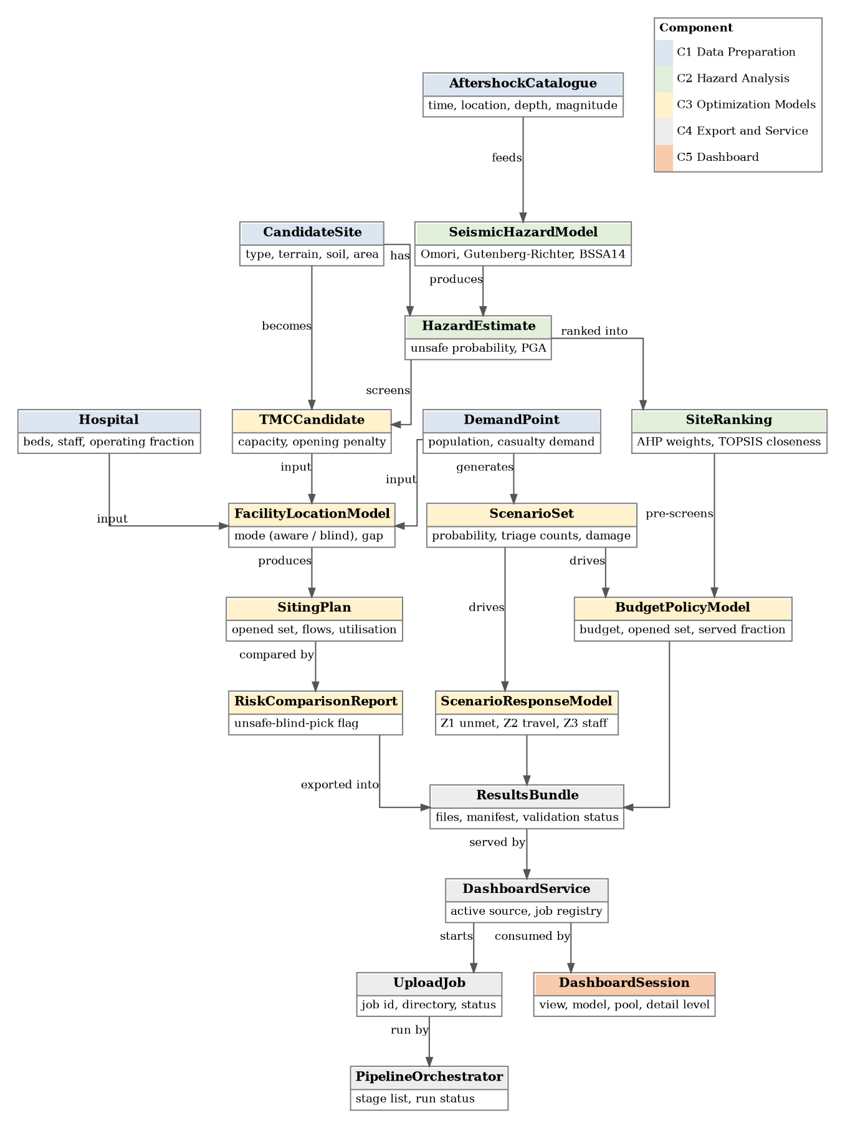
Figure 2: Design classes and their relationships, grouped by component

The table lists every relationship between design classes; Figure 2 shows the same relationships as a class diagram.
From | Relationship | To | Meaning
AftershockCatalogue | feeds | SeismicHazardModel | Events are used to fit decay and magnitude models
SeismicHazardModel | produces | HazardEstimate | Per-site probability and PGA
CandidateSite | is described by | HazardEstimate | One estimate per site
CandidateSite | becomes | TMCCandidate | Adds capacity and opening penalty
HazardEstimate | screens | TMCCandidate | Risk-aware mode removes sites above 0.2 g
HazardEstimate, CandidateSite | are ranked into | SiteRanking | AHP weights, TOPSIS closeness
SiteRanking | pre-screens | BudgetPolicyModel | Top 120 candidate pool
Hospital, DemandPoint, TMCCandidate | are inputs to | FacilityLocationModel | Deterministic MILP
FacilityLocationModel | produces | SitingPlan | One plan per mode
Two SitingPlans | are compared by | RiskComparisonReport | Flags unsafe sites the blind plan opens
DemandPoint, Hospital | generate | ScenarioSet | Casualty, road and hospital-damage scenarios
ScenarioSet | drives | ScenarioResponseModel, BudgetPolicyModel | Both stochastic models
All result classes | are exported into | ResultsBundle | One validated bundle with manifest
ResultsBundle | is served by | DashboardService | Read-only
UploadJob | is run by | PipelineOrchestrator | Isolated job directory
DashboardService | is consumed by | DashboardSession and Views | Dashboard reads results, starts jobs

5.6 Deployment
AARO runs as three cooperating parts: a browser, one application server, and a file store. The server hosts the FastAPI service and, beside it, the Python pipeline with its solvers. The service reads the reference results bundle read-only, and it starts uploaded-dataset runs as isolated jobs. A job writes only inside its own directory, so it can never alter the reference results. The browser fetches map tiles from the OpenStreetMap tile service. Open data sources are contacted only when the extraction stage is run on new data.
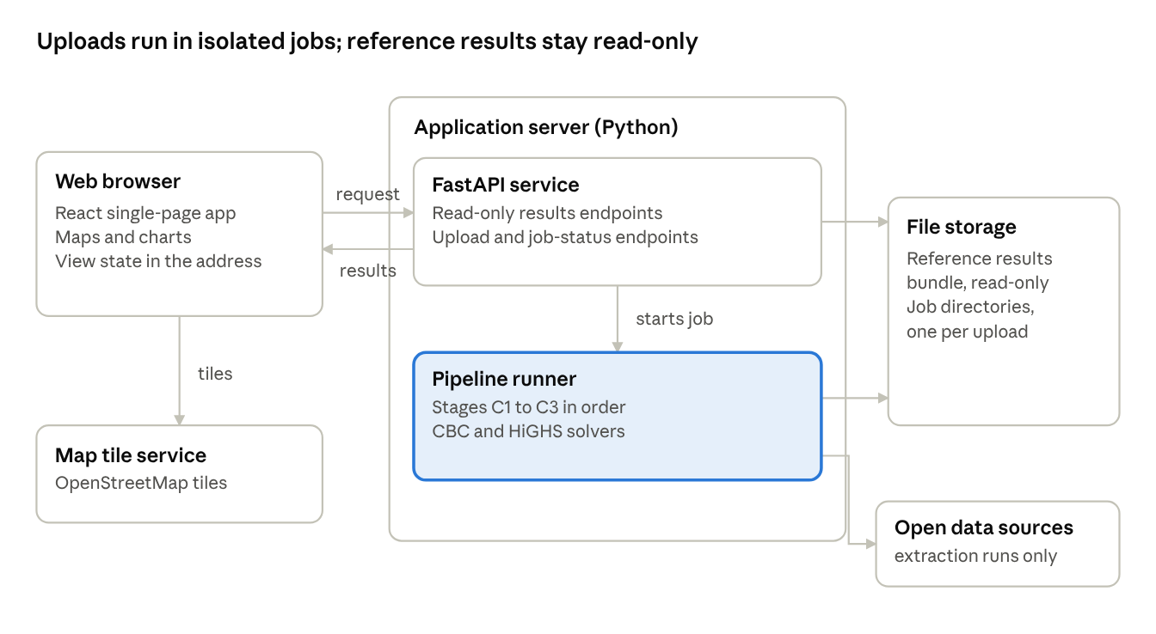
Figure 3:AARO deployment showing the browser, application server and file storage
Figure 2 shows the deployment nodes. The pipeline runner is the only node that writes new results, and it writes only to a job directory.
Local execution. Create a Python virtual environment and install the dependencies, run the pipeline stages in order (or use the reference bundle as is), start the service, then start the dashboard. The commands are in Appendix B.
Operational notes.
- Configuration is held in one settings module per model and one extraction configuration file; nothing is hard-coded in the interface except the study bounds.
- Solvers are bounded by a time limit and an optimality gap so a request always terminates.
- Long stochastic runs are started from the command line with checkpoints, not from the dashboard.
- There is no authentication or rate limiting. This is acceptable for a supervised research tool and would be the first thing to add for a shared deployment (Section 5.7).

6. Applied Methodology
This chapter states each method at the level needed to understand and defend the design. Parameter values and settings are in the project configuration files and are not repeated here.

6.1 Hazard Analysis (C2)
Hazard analysis answers one question for every candidate site: what is the probability of damaging shaking within the 30-day window? It combines three fitted models.
- Modified Omori Law gives the aftershock rate over time. K, c and p are fitted by maximum likelihood; for any (c, p) the best K has a closed form, so only c and p are searched on a grid.
- Gutenberg–Richter law gives the share of aftershocks at each magnitude. The fitted b value weights small, frequent events above large, rare ones.
- BSSA14 ground-motion model (Boore, Stewart, Seyhan and Atkinson [3]) gives median PGA and its variability for a given magnitude, distance and site soil stiffness (Vs30). A strike-slip mechanism is assumed, as the 2023 sequence was predominantly strike-slip.
For one aftershock of magnitude M at distance R, the chance of exceeding the damaging threshold $g^{*}$ (0.2 g, the EMS-98 masonry-damage level) is:
$$P\left(PGA>g^{*}∣M,R\right)=1-Φ\left(\frac{lng^{*}-μ}{σ}\right)$$
Averaging over the magnitude weights and observed epicentres gives a per-event probability q for the site. With N(T) expected aftershocks in the window:
$$Λ_{i}=q_{i} N\left(T\right), P_{i}^{unsafe}=1-e^{-Λ_{i}}$$
The representative PGA of a site is the largest median PGA over magnitude 5 and above scenarios. It ranges from 0.03 to 0.45 g. An earlier toy ground-motion formula overpredicted (0.21–4.3 g) and was replaced by BSSA14.

6.2 Multi-Criteria Ranking (C2)
Eligible candidates are ranked on four criteria: PGA (cost), terrain slope (cost), elevation (benefit) and distance to road (cost). AHP derives weights from a 4×4 pairwise-comparison matrix: 0.518 for PGA, 0.242 for slope, 0.086 for elevation and 0.155 for road distance, with consistency ratio 0.022 (acceptance limit 0.10). TOPSIS then scores each of the 698 sites with complete data by closeness to the ideal. The ranking is advisory: it does not decide which sites open. It is used only to pre-screen candidates for the SAA model.

6.3 Deterministic Facility Location (C3)
The deterministic model is a mixed-integer linear program. Let I be demand points, $J^{H}$ existing hospitals and $J^{T}$ candidate TMCs. The decisions are $x_{ij}$ ≥ 0, the casualties routed from i to j, and $y_{j}$ ∈ {0, 1}, whether TMC j opens.
min i​j​dij xij + Fj∈JT​yj

j​xij=popi ∀ i∈I
i​xij≤capj ∀ j∈JH
i​xij≤capj yj ∀ j∈JT
Both objective terms are in casualty-kilometres. F is a parsimony penalty (1,000 casualty-km at the reference setting): opening one more TMC must save at least that much travel. In risk-aware mode, $J^{T}$ keeps only sites with PGA ≤ 0.2 g; in risk-blind mode it keeps all. The model is solved with the CBC branch-and-cut solver under a time limit and optimality gap.

6.4 Scenario Generation (C3)
Both stochastic models draw on the 20 existing casualty scenarios, each with a probability. The SAA model adds sampled uncertainty on top of them.
Uncertain Quantity | Distribution | Basis
Scenario choice | Uniform over the 20 source scenarios | Existing scenario set
Casualty multiplier | Log-normal with mean 1 and sigma 0.20 | Modelling assumption
Road damage | Uniform(0, 0.30) | Modelling assumption
Hospital capacity loss | Observed local damage fraction × Uniform(0, 0.50) | Modelling assumption
The distribution families and parameters are assumptions, not estimates from data, and are therefore varied in the sensitivity analysis (Chapter 8).

6.5 Scenario-Wise Medical LP
Each scenario is solved independently as a continuous LP with HiGHS in three lexicographic stages: minimise untreated demand Z1; minimise damage-adjusted travel Z2 subject to the best Z1; minimise additional staff Z3 subject to the best Z1 and Z2. Casualties are split into triage classes T1 to T3. Untreated casualties carry forward in time according to configured health-state transitions; treated cohorts move through a treatment transition matrix, and deaths and discharges leave facility occupancy. Inpatient (T1, T2) and outpatient (T3) occupancy is capped each period using damaged hospital capacities and TMC capacities. T1 casualties can only go to hospitals within the distance limit, after inflating distance by road damage. Existing hospital staff are scaled by the operating fraction; extra staff are decision variables.
There is no site-opening decision: a TMC that receives flow in a scenario is reported as used in that scenario. Aggregates weight scenarios by probability; the worst case is the scenario with the greatest Z1.

6.6 Two-Stage SAA Budget Model (C3)
The SAA model chooses TMC sites before the scenario is known. The first-stage binary $y_{j}$ (open site j) is shared by all scenarios, subject to a site budget B:
j​yj≤B, B∈{0,10,25,50,100,120}
The second stage routes and staffs per scenario, with flows to TMC j bounded by capacity times $y_{j}$. Unique unmet casualties $U_{s}$ satisfy $U_{s}$ + ${treated}_{s}$ ≥ ${generated}_{s}$. The objective is the expected recourse cost:
$$min λ_{U} E\left[U_{s}\right]+λ_{T} E\left[\text{casualty-km}\right]+λ_{S} E\left[\text{extra staff-periods}\right]$$
The unmet penalty $λ_{U}$ is derived from the full distance matrix: at least ten times the greatest possible travel cost of one casualty, plus a staffing margin. This guarantees that serving one more casualty is always preferred to leaving them unserved. There is no opening-cost term; use of TMCs is controlled by the budget alone. Budget policies are nested within each replication, so every larger budget keeps the previous budget's sites, which makes service non-decreasing in budget by construction.
Two candidate pools are supported: all prepared candidates, or the 120 highest TOPSIS-scoring candidates. The same settings and seed regenerate the same draws, so the two pools can be compared on identical scenarios.

6.7 Rationale for Three Decision Models
Model | Decision Question | Demand | Site Decision
Deterministic MILP | Which sites to open and where to send a fixed casualty total? | One fixed demand (117,398 projected casualties) | Opens or closes each site
Scenario-wise LP | How well can the network respond in each scenario, including staffing and triage? | Scenario demand (about 174,000 in total) | None; reports sites used
Two-stage SAA | Which sites to commit to before the scenario is known, for a given budget? | Sampled scenarios (expected demand about 122,000) | Shared first-stage choice
The three demand totals differ because each model uses a different demand definition. Results are therefore compared within a model, or between models only with this difference stated.

6.8 Technology Stack
Layer | Technology
Preparation and hazard analysis | Python, pandas, numpy, scipy, geopandas, rasterio, osmnx
Deterministic model | PuLP with the CBC solver
Stochastic models | HiGHS (continuous LP; SAA integer stage through PuLP, CBC or HiGHS)
Service | FastAPI
Dashboard | React with Vite, Leaflet for maps, Recharts for charts
Optional catalogue | SQLite

7. Interface Design
The dashboard serves a single purpose: to let a planner or researcher obtain an answer quickly and to let a researcher verify it. This chapter defines who uses it, what objects and actions it offers, how its state changes, and what each state looks like.

7.1 User Analysis
- Response planner: requires a rapid, scannable answer. Representative questions are where it is unsafe, which sites should open, which districts are underserved and how many casualties go unserved.
- Researcher: requires the means to verify and reuse a finding. Representative questions are why a site was opened, what changes with the penalty, whether the underlying rows can be exported and whether the pipeline can be run on other data.
Both roles use the same screens. A Planner/Research switch controls only how much supporting detail appears.

7.2 Task Analysis
- Choose or upload a dataset.
- Open a view: Briefing, Hazard, Siting plan, Medical response, Robustness or Research lab.
- Choose a model: risk-blind, risk-aware, scenario-wise LP or SAA; for the two stochastic models, choose a candidate pool.
- Inspect a site, filter a table, export rows.
- Upload a new dataset and watch the live solve.
- Share the current view by copying the address.

7.3 Interface Objects and Their Operations
The table groups objects by screen. Each object lists the operation it offers.
Screen | Purpose | Main Objects | Operations
Application shell | Frame for all screens | Dataset switch, view tabs, Planner/Research switch, model and candidate-pool selectors, About this run, Export run | Switch view, model or detail; open explanation; download run as JSON
Briefing | One-screen answer | Plan comparison table, metric cards, explanation panels | Read; the selected model drives the summary
Hazard | Where it is unsafe | Map with site markers coloured by PGA, PGA-band legend, headline metric | Pan, zoom, filter by band, click a site for details
Siting plan | Where casualties go | Allocation map with demand, hospitals and opened TMCs; demand-point filter; line mode; allocation table; risk comparison table | Filter by demand point, choose line display, sort, filter and export tables
Medical response | Triage, staffing and unmet demand | Scenario selector, stat cards, unmet-by-triage chart, scenario and staffing tables, sensitivity table | Choose scenario, sort and export
Robustness | How stable the result is | Budget-versus-service chart, budget sweep table, candidate-pool comparison | Switch pool, sort and export
Research lab | Audit trail | Selected run details, export inventory with validation status, provenance, limitation notice | Read; full detail in Research mode
Site detail drawer | One site, on its own | Hazard, terrain, soil, ranking, status under each plan | Open from map or table; close
Upload and live solve | Run on new data | File chooser, stage checklist, success or failure message | Choose a zip, start run, watch progress, switch back to reference
All tables share one component with a filter box, three-state column sorting and CSV export of the visible rows.

7.4 Events That Change Interface State
Event | Trigger | Result
Load | Page opens or address with parameters is visited | Reference or chosen dataset loads; view, model and detail restored from the address
Select view | Tab click | Matching screen shown; model controls hidden on Hazard
Select model | Model button | Screen content switches to that model's result
Select candidate pool | Pool button (stochastic models only) | Stochastic screens switch pool
Switch Planner/Research | Toggle | Extra provenance and metadata appear or disappear
Open site | Marker or table-row click | Site drawer opens
Filter PGA band | Legend click | Map shows only that band; second click clears
Filter, sort, export table | Typing, header click, export button | Rows recompute; CSV holds the visible rows
Choose scenario | Scenario selector | Allocations and statistics restricted to it
Upload dataset | File chosen and confirmed | Validation runs; on success the live solve starts
Stage completes or fails | Backend progress | Checklist updates; on success the dashboard switches to the new results; on failure the failed stage is named
Switch dataset | Dataset switch | Reference or uploaded results shown without restart
Export run | Header button | JSON bundle for the selected model downloads

7.5 Interface States
The dashboard moves between four global states. The shell is visible in every one.
State | Displayed to the User | Exit Condition
Loading | Shell with skeleton placeholders in the body | Data arrives or a request fails
Ready | Chosen screen with data | A user event or a dataset change
Running | Stage checklist with the current stage highlighted | Job completes or fails
Error | A notice naming what is missing or which stage failed, placed under the header or in the checklist | The user fixes the cause, retries or switches dataset
Within Ready, the user moves between the six views as described in Section 7.4. The main planner path is Briefing, then Hazard (inspect PGA and open a site), then Siting plan (allocations and unsafe blind picks), then Medical response or Robustness if a stochastic model is selected.

7.6 Screen Layouts
Every screen shares the same shell: a header with the run badge and the About and Export buttons, a tab bar for the six views, a model bar (hidden on Hazard), and the view body.
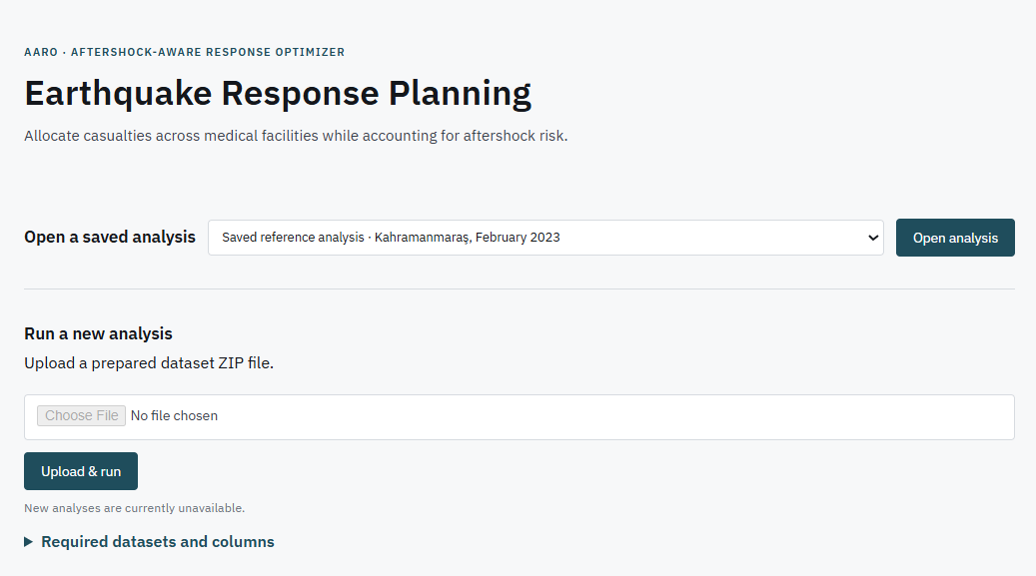
Figure 4: Home/Upload Page
Figure 3 shows upload layout. Screenshots of the individual screens are presented in Figure 4 (Briefing), Figure 5 (Hazard map), Figure 6 (Siting plan with allocation lines), Figure 7 (Risk comparison table), Figure 8 (Medical response), Figure 9 (Robustness), Figure 10 (Upload progress) and Figure 11 (Error notice).
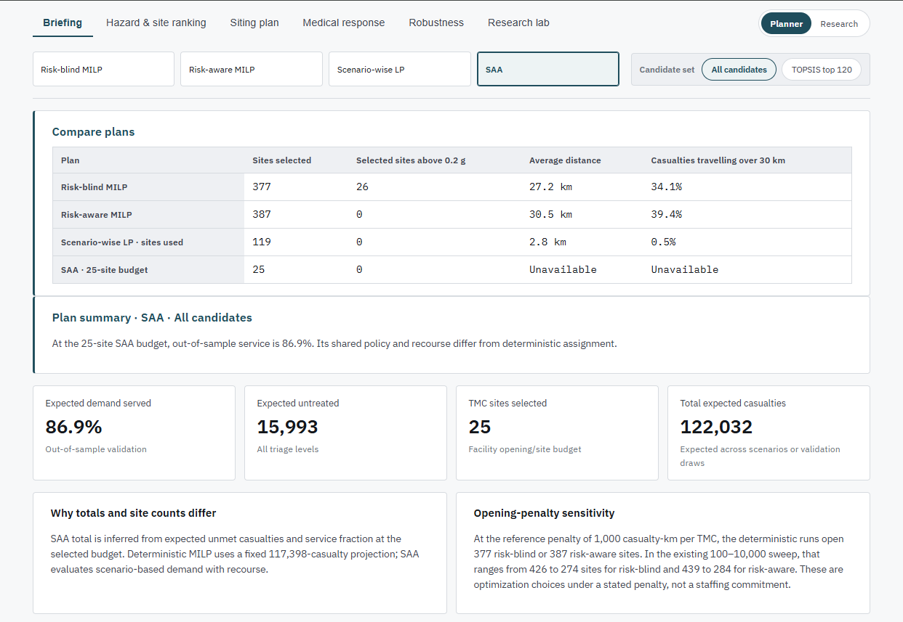
Figure 5: Briefing Tab
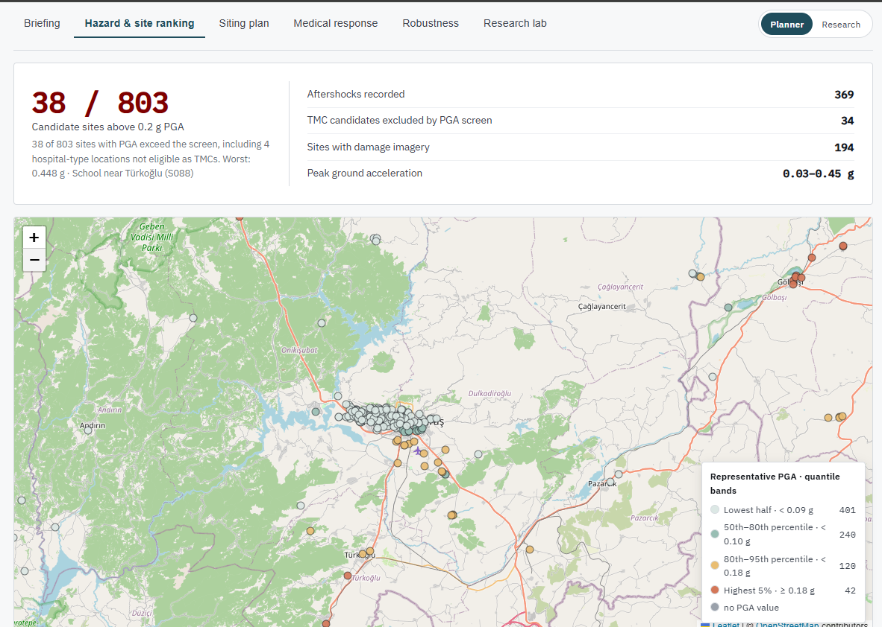
Figure 6: Hazar & Site Ranking Tab
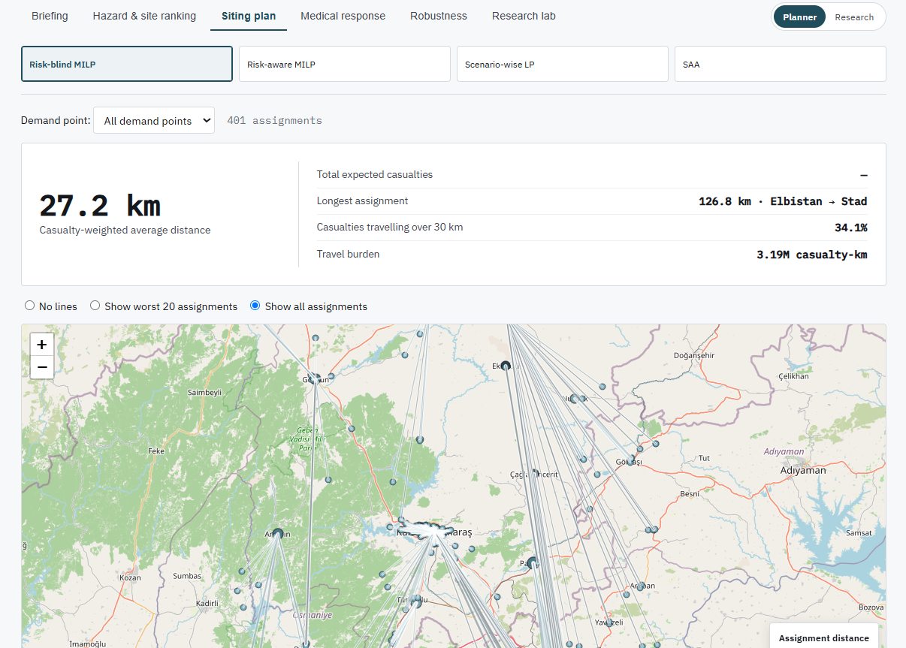
Figure 7: Siting Plan Tab
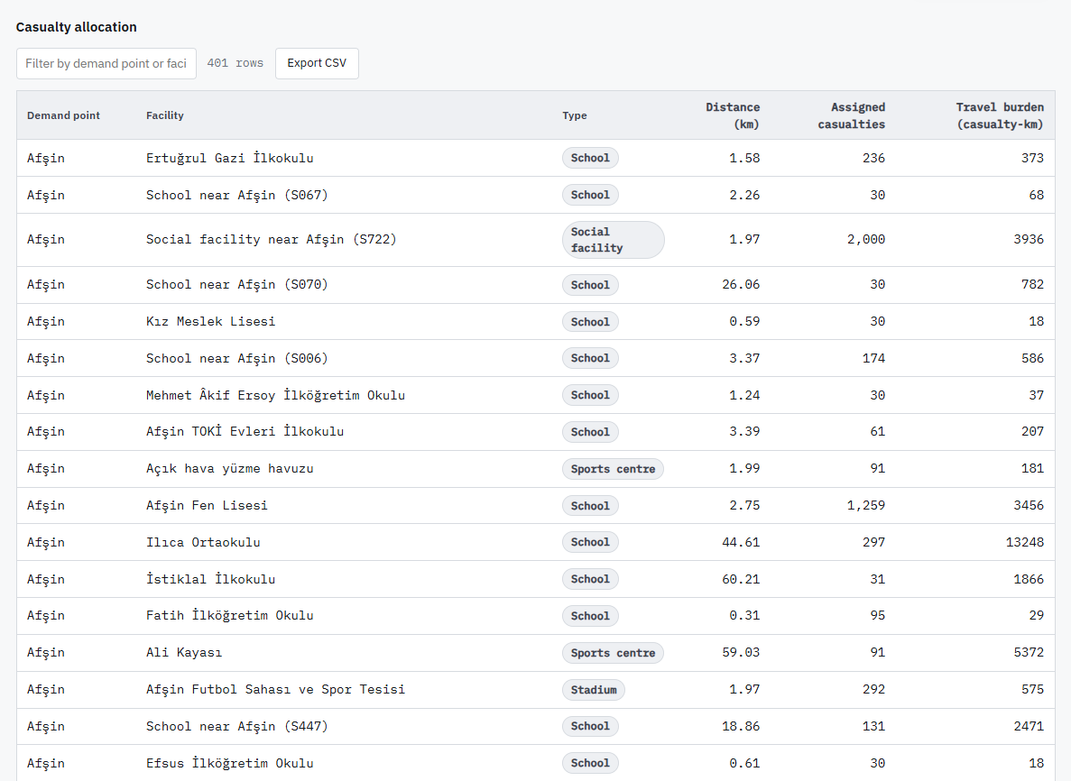
Figure 8: Casualty Allocation Table for Risk-blind MILP
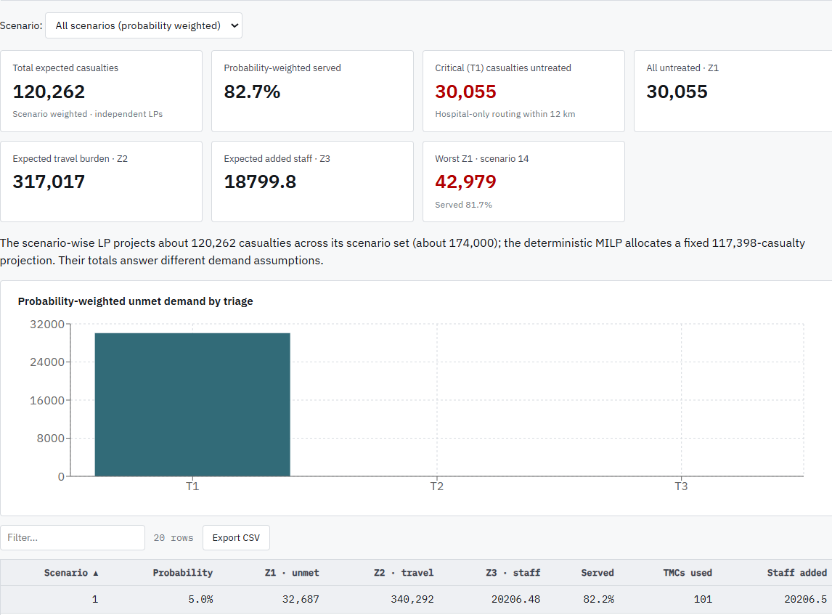
Figure 9: Medical Response Summary for Scenario-wise LP
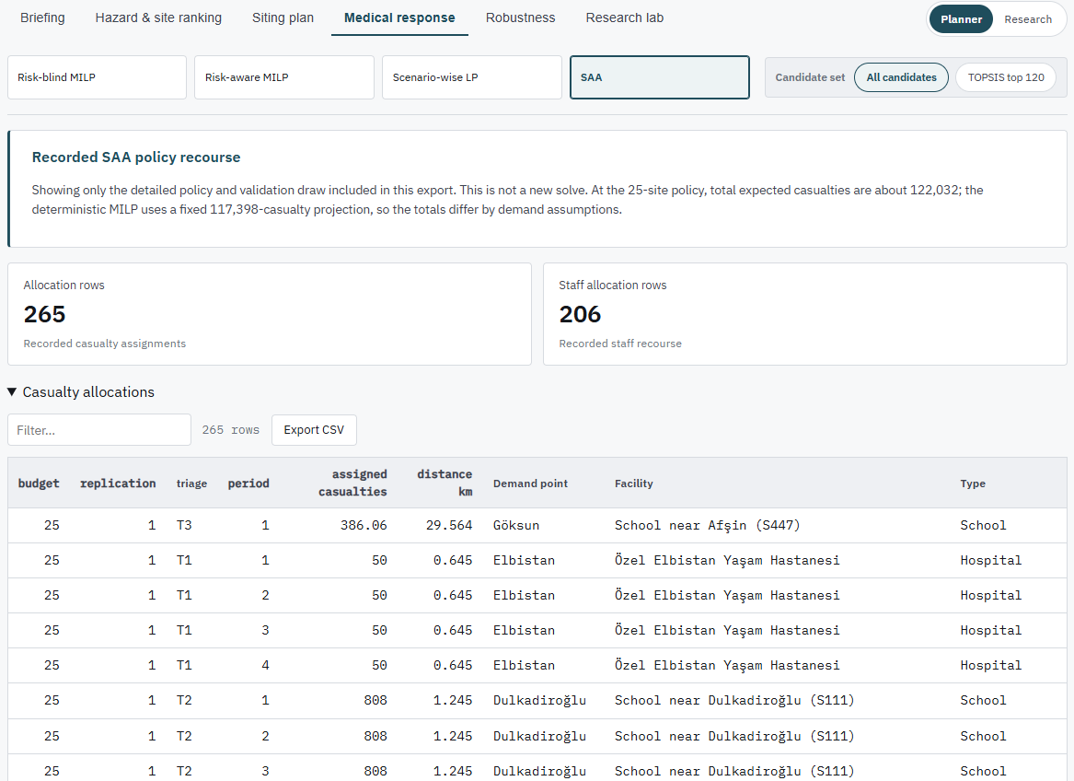
Figure 10: Medical Response Summary for SAA
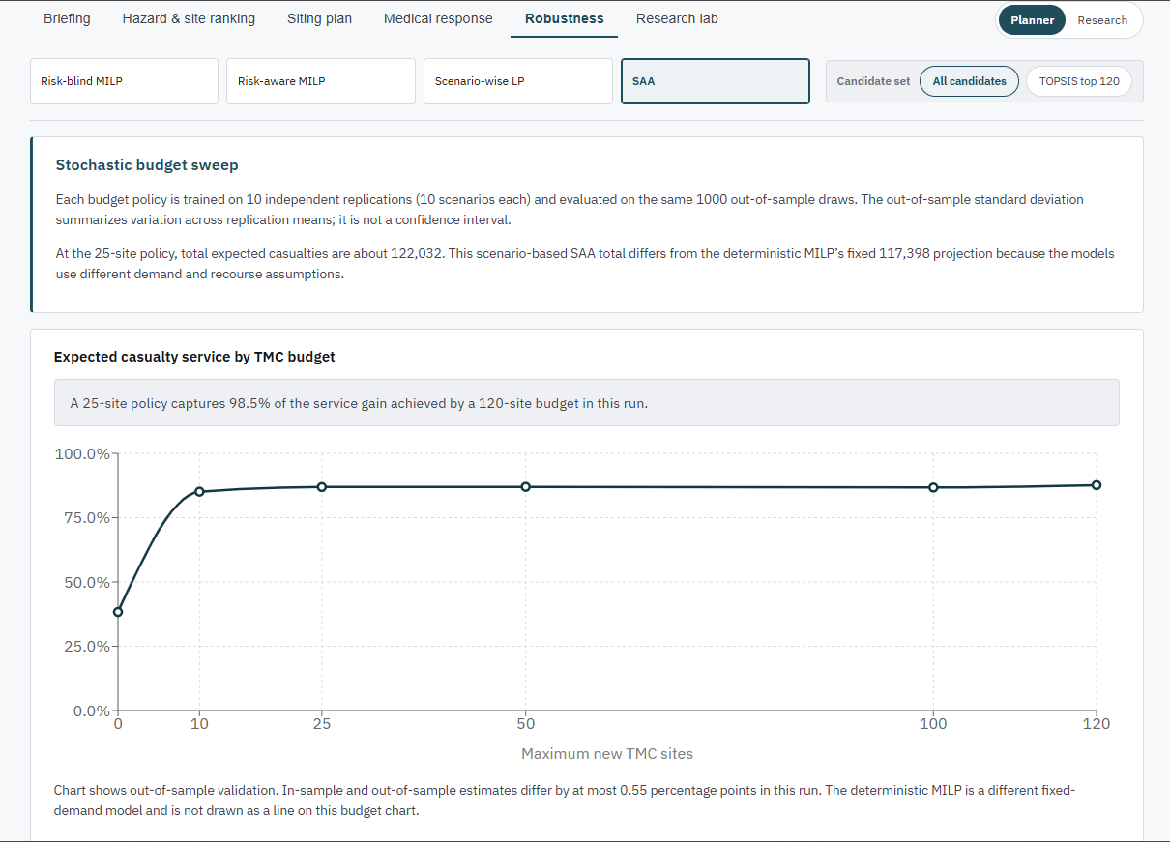
Figure 11: Sensivity Analysis for SAA
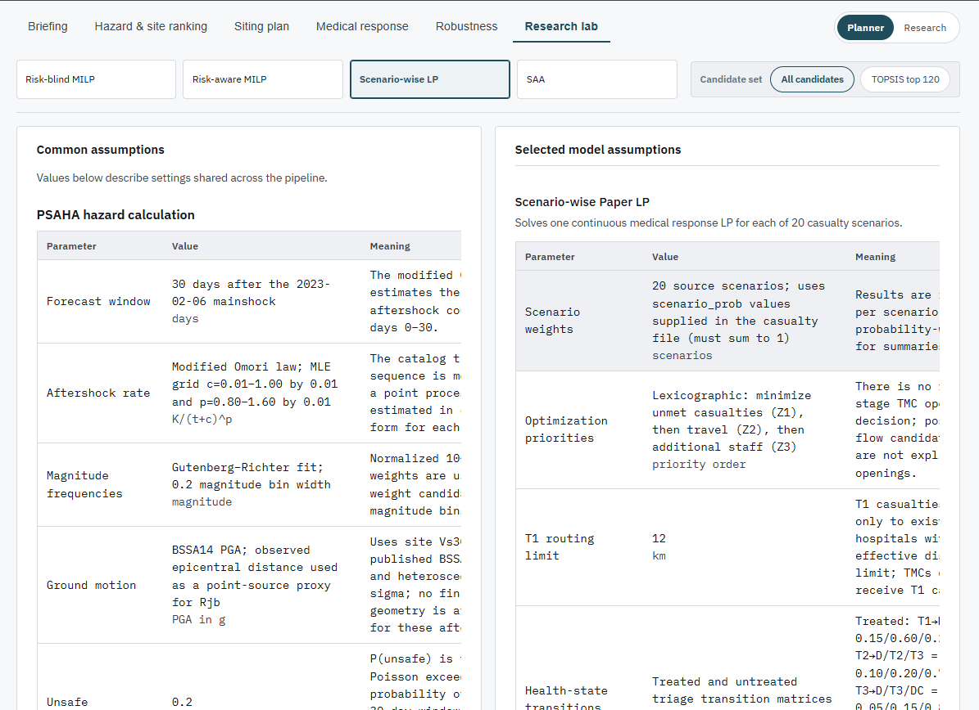
Figure 12: Research Lab Tab

8. Validation
Validation asks whether the models give answers that can be trusted for the decision they support. This chapter separates four questions: are the inputs sound, are the models built correctly, do they behave sensibly, and are the conclusions robust to the assumptions we had to make. Testing of the software itself is in Chapter 9.
One point shapes the whole chapter. No ground truth exists for "the best set of TMC sites" after a real earthquake, so the models cannot be validated by comparing their output with an observed optimum. Validation therefore relies on consistency checks, reproducibility, out-of-sample evaluation, comparison against defined baselines, and sensitivity analysis.

8.1 Validation Strategy
Question | Method
Are the inputs sound? (Section 8.2) | Source citation, coordinate cross-checks, expected row counts, validators
Is the hazard model credible? (Section 8.3) | Published model and coefficients, physical range check, comparison with the superseded model, AHP consistency
Is the deterministic model correct and informative? (Section 8.4) | Feasibility checks, reproducibility, risk-aware against risk-blind baseline, penalty sweep
Do the stochastic models generalise? (Section 8.5) | Out-of-sample evaluation on common draws, nested budgets, deterministic baseline on the same draws, paired candidate pools, sensitivity suite
Do the models agree with each other? (Section 8.6) | Cross-model comparison with demand definitions stated
How far do the conclusions depend on assumptions? (Section 8.7) | Threats to validity

8.2 Input Validation
- Hospitals. The hand-made hospital list was found to have wrong capacities, wrong coordinates and a missing 1,000-bed city hospital, and was replaced by a curated, source-cited list. Every figure carries a confidence label (official, reported or estimated), and coordinates are cross-checked against the cached map-data hospital query. A closed hospital (Pazarcik District Hospital) is excluded.
- Capacity. TMC capacity derives from measured site area using the Sphere/UNHCR standard instead of unsourced flat values. This changed the casualty-weighted average assignment distance from 42.0 km to 30.5 km, which exposed the earlier capacities as an input defect, not a solver defect.
- Extraction. A configuration file fixes bounding boxes, dates, magnitude cutoffs and expected row counts. The validators separate auto-fixable problems from those needing human review, and the review-needed class is never auto-resolved.
- Districts. The district fallback was corrected to 11 real districts (two towns had been counted as districts) and casualty projections were re-derived.

8.3 Hazard Model Validation
Check | Result
Ground-motion model is a published equation | BSSA14, with coefficients transcribed from the OpenQuake reference implementation and checked against the paper's table
Probabilities and counts in valid range | All per-site probabilities in [0, 1]; all expected exceedances ≥ 0
Physical plausibility of PGA | Representative PGA 0.03 to 0.45 g, against 0.21 to 4.3 g from the earlier toy formula that overpredicted
Threshold is grounded | $g^{*}$ = 0.2 g is the EMS-98 masonry-damage threshold, used both for the unsafe probability and for the deterministic filter
Hazard discriminates between sites | 38 of 803 sites with a hazard value exceed 0.2 g, so the filter neither excludes everything nor nothing
AHP weights are consistent | Consistency ratio 0.022 against a limit of 0.10; weights reproduce the source methodology's reference values (0.518, 0.242, 0.086, 0.155)
Omori and Gutenberg–Richter fits | Fitted parameters and plots written to the hazard output folder for inspection

8.4 Deterministic Model Validation
Correctness checks. Every demand point's casualties are fully allocated (the allocations sum to 117,398 projected casualties); hospital and TMC capacities hold; TMCs receive flow only if open; repeated solves on the same input agree within tolerance.
Hazard filter effect. Because the same solver runs with and without the filter on identical data, the difference isolates the cost of ignoring hazard.
Measure | Risk-Blind | Risk-Aware
TMCs opened at reference penalty (1,000 casualty-km) | 377 | 387
Opened TMCs above 0.2 g | 26 | 0
Eligible candidates excluded by the filter | 0 | 34
The 38 sites above threshold on the hazard map and the 34 excluded candidates are different populations: four high-PGA records are hospital-type locations outside the TMC candidate pool. Reports always state which denominator applies.
Parameter sensitivity. The opening penalty is a judgement-chosen parameter, so it was swept over 100, 300, 1,000, 3,000 and 10,000 casualty-km. Risk-blind openings range from 426 to 274, and risk-aware openings from 439 to 284. The qualitative findings hold at every value: the hazard-blind plan opens sites above the threshold, and the same rural districts (Andirin, Ekinozu, Elbistan, Caglayancerit) remain at a casualty-weighted average distance of 45 km or more under both plans.
Interpretation. Because the rural districts are far from care under both modes and at every penalty, the cause is facility density near them, not the solver or the hazard filter. This is a stronger finding than the risk-aware versus risk-blind difference alone.

8.5 Stochastic Model Validation
Scenario-wise LP. Each scenario is solved to a lexicographic optimum, and the report gives the probability-weighted aggregates and the worst-case scenario. The model's expected unmet T1 demand is about 30,055. This number does not change when TMCs are added, because T1 casualties may only go to hospitals within 12 km and TMCs are not eligible for T1. Seeing this effect in the output confirms that the distance rule is applied as designed, and it states plainly that TMCs cannot relieve severe cases in this formulation.
SAA design for honest evaluation. The SAA protocol is built so that reported performance is not an artefact of fitting the same scenarios twice.
Design Feature | Purpose
Independent training replications (10 in the final profile, 10 scenarios each) | Show variability of the chosen site set across samples
Out-of-sample evaluation on 1,000 draws, generated once and reused for every policy | Measure generalisation; common draws make policies comparable
Nested budget policies within a replication | Larger budget keeps smaller budget's sites, so service cannot fall as budget rises, in sample or out of sample
Deterministic baseline evaluated on the same draws | Compares the risk-aware deterministic opened set (387 TMCs) with SAA policies fairly
Unmet penalty set above the greatest single-casualty travel cost | Serving one more casualty is always preferred, so unmet counts are exact
Same seed and settings for both candidate pools | Paired comparison of all candidates against the TOPSIS top 120
Checkpoints after each replication | Interrupted runs resume without changing results
Main result. In the final TOPSIS-120 profile (10 replications), the out-of-sample served fraction rises from 38.3% with no TMCs to 79.1% at a 25-site budget and 86.8% at 50 sites, and levels off at 88.6% with 120 sites. The first 25 sites therefore deliver most of the gain, and the remaining 95 add less than ten percentage points. The budget sweep covers 0, 10, 25, 50, 100 and 120 sites.
Budget (Sites) | Out-of-Sample Served Fraction | Expected Unmet | Replications
0 | 38.3% | 72,722 | 10
10 | 73.4% | 32,724 | 10
25 | 79.1% | 25,848 | 10
50 | 86.8% | 16,092 | 10
100 | 88.2% | 14,136 | 10
120 | 88.6% | 13,555 | 10
Candidate-pool comparison. Screening to 120 candidates reduces problem size. Because both pools are run on identical draws with the same seed, the service lost to screening can be read directly from the paired results in the Robustness view. The values reported above are those of the TOPSIS-120 profile.
Sensitivity suite. A one-at-a-time sweep of the scenario-wise LP parameters was run separately for each candidate pool, with the existing parameter levels unchanged.
Known coverage gaps. The current pipeline does not yet report per-site selection frequencies, SAA unmet by triage class, or an SAA optimality-gap table. These are stated as limitations and should not be cited as results.

8.6 Cross-Model Consistency
The three decision models deliberately use different demand definitions (117,398, about 174,000 and about 122,000 casualties). Their numbers are therefore never placed on one denominator. What can be compared across models are qualitative findings, and these agree: sites above the safety threshold are excluded or avoided; coverage of the rural districts is limited by facility density; and the benefit of adding TMCs flattens as the budget grows.

8.7 Threats to Validity
Threat | Effect | Mitigation or Statement
Distributions of casualty multiplier, road damage and hospital loss are assumptions | Stochastic results depend on them | Sensitivity suite; assumptions stated and exposed in the interface
Straight-line distances | Underestimate real travel | Stated; T1 rule uses a road-damage inflation factor; straight-line matrix used consistently across models
Epicentral distance as a proxy for fault distance | Approximate PGA | Stated; no finite-fault geometry exists per aftershock
Fixed strike-slip mechanism | Approximate PGA | Matches the 2023 sequence; catalogue has no per-event mechanism
Synthetic casualty scenarios | Demand is modelled, not observed | Official totals distributed by population share; scenarios probability-weighted
Estimated hospital figures | Capacity uncertainty | Confidence label on every figure
One earthquake case study | Limited generalisation | Dataset structure supports other regions through upload
Opening penalty is a modelling choice | Number of TMCs depends on it | Penalty sweep from 100 to 10,000
Missing hazard value defaulted to safe | One site could be wrongly admitted | Recorded as a limitation; recommended fix is to exclude or flag missing values

8.8 Validation Summary
Claim | Evidence | Status
Inputs trace to real sources | Provenance table, curated hospital list, validators | Supported
Hazard values are physically credible | Published model, valid ranges, comparison with earlier model | Supported; Omori back-test recommended
The hazard filter changes the decision | 26 of 377 blind-opened sites above threshold; none under risk-aware | Supported
Result does not hinge on the opening penalty | Sweep from 100 to 10,000 | Supported
Rural under-coverage is structural | Same districts underserved under both modes at every penalty | Supported
SAA policies generalise | 1,000 out-of-sample draws on common samples, 10 replications | Supported
Candidate screening is justified | Paired runs on identical draws | Supported

9. Testing
Testing asks whether the software does what it claims. The strategy mixes automated tests on pipeline outputs, model checks, and manual tests of the interface.

9.1 Test Strategy
Level | Scope | Method | Tooling
Data | Extraction outputs and bundle | Validators with expected counts and bounds | Extraction validation command
Unit | Hazard, ranking and solver helpers | Automated assertions on known inputs | Python unit tests (for example the TOPSIS ranking check)
Model | Solutions of all three decision models | Feasibility and output checks against the model's own constraints | Model check script and unit tests on stochastic outputs
Integration | Chain from preparation to export; upload to live solve | End-to-end run on the reference dataset and on a valid and invalid upload | Pipeline run, API calls
System and acceptance | Dashboard views and workflows | Manual walk-through against expected outcomes | Browser; live demonstration

9.2 Pass and Fail Criteria
- Automated test: passes if every assertion holds, using a small numeric tolerance where floating-point rounding is expected.
- Model check: passes if the solution is feasible, solver status and gap are recorded, and no constraint is violated beyond tolerance.
- Manual test: passes only if the exact expected outcome in the test case is observed.
- Release gate: all high-priority tests pass; no open defect that makes a result wrong or silently hides a failure.

9.3 Risks and Contingencies
Risk | Likelihood | Impact | Contingency
Solver reaches the time limit without a proven optimum | Medium | Result less optimal | Report status and gap; use the best feasible solution only if it passes the feasibility check
External services (map tiles, geocoding, data downloads) unavailable during the demo | Medium | Dashboard map or extraction fails | Cached geocodes, reference results bundle, offline fallback of results
Long stochastic runs interrupted | Medium | Lost compute time | Checkpoints and resume with identical settings
Uploaded dataset malformed | High | Wasted run | Validation before any stage; specific rejection reason
Stale or partial export | Low | Misleading dashboard | Manifest status per file; dashboard names the missing file
Environment differences between machines | Medium | Pipeline fails to start | Documented dependency list and setup steps; fixed seeds
Misreading of results across models | Medium | Wrong conclusion | Different demand definitions labelled on every comparison

9.4 Test Cases
TC-01 to TC-10 were executed at the midterm stage and are unchanged. TC-11 to TC-24 cover the work added since.
ID | Scenario | Expected Outcome | Result
TC-01 | Hazard outputs stay within valid bounds | Probabilities in [0, 1]; expected exceedances ≥ 0 | Passed
TC-02 | Every candidate has a hazard value | Known gap: one site has none and defaults to safe (limitation) | Passed (gap documented)
TC-03 | Risk-aware candidates respect threshold | No risk-aware candidate above 0.2 g; risk-blind set is a superset | Passed
TC-04 | Deterministic solve is feasible, both modes | All demand allocated; hospital and TMC capacities respected | Passed
TC-05 | Objective value reproducible | Repeated runs agree within tolerance | Passed
TC-06 | Mode comparison recomputable | Flagged unsafe-blind picks match a fresh recomputation | Passed
TC-07 | Upload rejects invalid files | Non-zip, corrupt zip and zip without data folder each rejected with a specific reason | Passed
TC-08 | Upload accepts valid bundle | Valid bundle completes live solve end to end | Passed
TC-09 | Dashboard views render with real data | Each view renders without error | Passed
TC-10 | Missing dataset | Message names what is missing | Passed
TC-11 | AHP weights and consistency | Weights equal the reference values; consistency ratio below 0.10 | Passed
TC-12 | TOPSIS output well formed | One row per ranked site; scores in [0, 1]; ranks unique and ordered by score | Passed
TC-13 | Candidate pool selection | TOPSIS profile keeps exactly 120 validly ranked sites, ties broken by site ID | Passed
TC-14 | Scenario-wise LP feasibility | Every scenario returns an optimal status; Z1, Z2 and Z3 are non-negative; capacities respected each period | Passed
TC-15 | Lexicographic order | Z2 and Z3 are solved with Z1 held at its best | Passed
TC-16 | T1 distance rule | No T1 assignment to a hospital beyond the damage-adjusted distance limit | Passed
TC-17 | Probability-weighted aggregates | Aggregates equal scenario values weighted by scenario probability; worst case is the scenario with greatest Z1 | Passed
TC-18 | SAA budget respected | Opened sites never exceed the budget in any replication | Passed
TC-19 | Nested budgets monotone | Each budget's opened set contains the previous budget's; served fraction does not fall | Passed
TC-20 | SAA reproducibility | Same seed and settings regenerate identical training and evaluation draws | Passed
TC-21 | SAA resume | Interrupted run resumes from checkpoint and yields the same result as an uninterrupted run | Passed
TC-22 | Export bundle integrity | Manifest lists every file with status; a deliberately removed file is reported missing by name | Passed
TC-23 | Stochastic views and pool switch | Medical response and Robustness render; switching candidate pool changes the data or shows a notice if the pool is absent | Passed
TC-24 | Deep link | Opening a copied address restores view, model, pool and detail level | Passed
One further acceptance scenario is scripted for the live demonstration: open the dashboard, inspect a hazardous site, compare risk-blind and risk-aware plans, open the Robustness view for the SAA budget sweep, then upload a valid dataset and watch the live solve to completion.

10. Conclusion

10.1 Summary of Work Completed
AARO chains a probabilistic aftershock hazard analysis into three decision models and presents the results in a dashboard that can also run on new data. The hazard analysis gives every candidate site an unsafe probability. The deterministic model uses it as a hard filter. The scenario-wise LP and the two-stage SAA model extend the planning to uncertain casualties, hospital damage and road damage, including triage, staffing and a site budget. Validation by out-of-sample evaluation and sensitivity analysis supports the conclusions, and the testing chapter defines how the software is checked.

10.2 Findings
- Hazard changes the decision. A hazard-blind plan opens 377 TMCs, and 26 of them lie above the 0.2 g threshold; the risk-aware plan opens 387 and none lie above it.
- The finding is robust. It holds at every opening penalty from 100 to 10,000 casualty-km.
- Rural under-coverage is structural. Andirin, Ekinozu, Elbistan and Caglayancerit stay far from care under both plans and at every penalty. The limit is candidate-facility density near them, which is a pre-positioning and infrastructure question no solver setting can fix.
- A small site budget delivers most of the benefit. A 25-site SAA policy raises the out-of-sample served fraction from 38.3% (existing hospitals only) to 79.1%, and the full 120-site budget reaches 88.6%.
- TMCs do not relieve the most severe cases here. Expected unmet T1 demand (about 30,055) is unchanged by adding TMCs, because T1 casualties may only go to hospitals within 12 km.

10.3 Limitations
- Distributions for casualty multiplier, road damage and hospital loss are modelling assumptions.
- Distances are straight-line, and ground motion uses epicentral distance and a fixed fault mechanism.
- Scenarios are synthetic projections; hospital figures partly estimated.
- One candidate site has no hazard value and is treated as safe; it should be excluded or flagged.
- The pipeline does not yet report per-site selection frequencies, SAA unmet by triage class, or an SAA optimality-gap table.
- Ranking scores are not yet carried into the dashboard export.
- The service has no authentication or job queue.

10.4 Future Work
- Update hazard estimates as new aftershocks arrive during the planning window.
- Replace straight-line distance with road-network travel time under damage.
- Add the missing SAA reports (selection frequency, unmet by triage, optimality gap).
- Harden the service for shared use: authentication, restricted origins and a job queue.
- Let the dashboard edit staffing and override routes, turning it from a viewer into a planning tool.
- Apply the framework to another earthquake through the upload path.

Appendix A. User Manual

A.1 Requirements
- A current desktop browser with JavaScript enabled.
- Network access to the service and to the map tile service.
- A prepared dataset: the reference case study, or a zip archive structured like the reference bundle.

A.2 Accessing the Dashboard
- Navigate to the dashboard address. The Briefing view is displayed with the reference case study.
- Use the tab bar to move between Briefing, Hazard, Siting plan, Medical response, Robustness and Research lab.
- Use the model bar to choose Risk-blind, Risk-aware, Scenario-wise LP or SAA. For the last two, also choose All candidates or TOPSIS top 120. The model bar is hidden on the Hazard view.
- Use the Planner/Research switch to show or hide supporting detail.
- Select About this run for an explanation of each model and the run settings.

A.3 Interpreting the Views
View | Usage
Briefing | Read the comparison table of plans first, then the metric cards for the selected model. Different models use different demand totals; the page says so.
Hazard | Sites are coloured by representative PGA. Click a legend band to show only that band, click again to clear. Click a marker for the site detail drawer.
Siting plan | For the deterministic models, choose a demand point to see where its casualties go, and choose no lines, worst 20 or all lines. The risk comparison table lists sites whose status differs; click a row for site detail. For the stochastic models, choose a scenario or the recorded policy.
Medical response | Choose a scenario or all scenarios. Read the unmet-by-triage chart, then the scenario and staffing tables.
Robustness | Read the budget-versus-service chart for SAA and the candidate-pool comparison.
Research lab | Check the common assumptions and parameters set by each model.
Every table has a filter box (type to filter any column), sortable headers (click to cycle ascending, descending, unsorted) and an Export CSV button that saves the rows currently shown. Export selected run in the header saves the selected model's results as one JSON file.

A.4 Sharing a View
The address always carries the current view, model, candidate pool and detail level. The address may be copied in order to share the exact view.

A.5 Executing the Pipeline on a User Dataset
- Select Your own data and choose a .zip file structured like the reference bundle.
- The file is checked first. A wrong file type, a corrupt archive or a missing data folder is rejected with a specific reason, and nothing runs.
- A stage checklist shows progress through preparation, hazard analysis, planning and export.
- On success the dashboard switches to the results of the uploaded dataset. On failure the checklist shows which stage failed and why.
- Switch back to the reference dataset at any time.

A.6 System Messages
Message | Meaning | Recommended Action
Upload rejected: not a zip archive | Wrong file type | Choose a .zip file
Upload rejected: archive cannot be opened | Corrupt zip | Create the archive again
Upload rejected: required data folder missing | Wrong structure | Match the reference bundle layout
Stage failed: named stage with reason | A pipeline stage stopped | Fix the cause named and upload again
Result file missing: named file | Bundle incomplete | Re-export, or choose the reference dataset
Candidate pool not available | The selected pool was not run | Choose the other pool or run it

Appendix B. Repository, Installation and Running

B.1 Repository
Public repository URL: https://salsabilazaman.github.io/aftershock_aware_response_optimizer
The repository contains the pipeline, the dashboard source, the documentation and a reference results snapshot. Superseded code is kept in an archive folder and is not built on.

B.2 Installation
AARO has no installer. It is installed from source. Python 3.9 or later and a recent Node.js are required.
git clone <repository-url>
cd earthquake_response
python -m venv psaha-env
# Windows: psaha-env\Scripts\activate Linux/macOS: source psaha-env/bin/activate
pip install numpy pandas scipy matplotlib pulp highspy osmnx geopandas rasterio shapely requests fastapi

B.3 Executing the Pipeline
# Hazard analysis and ranking
python pipelines/psaha/step1_omori.py
python pipelines/psaha/step2_gutenberg_richter.py
python pipelines/psaha/step3_gmpe.py
python pipelines/psaha/step4_hazard_probability.py
python pipelines/psaha/step5_ahp_topsis.py
# Deterministic model (add MODEL_MODE=risk_blind for the baseline)
python pipelines/deterministic_current/step1_prepare_data.py
python pipelines/deterministic_current/step2_solve_model.py
# Scenario-wise LP, both candidate pools
python pipelines/stochastic_medical/run_scenario_lp.py --candidate-pool all
python pipelines/stochastic_medical/run_scenario_lp.py --candidate-pool topsis
# Two-stage SAA, publication-sized, both pools
python pipelines/stochastic_medical/run_saa.py --profile final
python pipelines/stochastic_medical/run_saa.py --profile final --candidate-pool all
# Export everything for the dashboard
python pipelines/extraction/export_dashboard.py
The default SAA profile (3 replications, 100 out-of-sample draws, 60 s limit, 2% gap) is for development. The final profile uses 10 replications of 10 training scenarios, 1,000 out-of-sample draws, a 300 s limit and a 1% gap. Add --resume to continue an interrupted run with the same seed and settings.

B.4 Executing the Verification Checks
python pipelines/stochastic_medical/check_model.py
python -m unittest tests.test_stochastic_model_outputs -v

B.5 Starting the Dashboard
Start the FastAPI service, then the dashboard development server from the frontend folder
npm run dev

Appendix C. Acceptance Demonstration and Code Review

C.1 Acceptance Demonstration Script
Step | Action | Expected
1 | Open the dashboard | Briefing loads with the reference results
2 | Open Hazard, click a high-PGA site | Drawer shows PGA, unsafe probability, status under both plans
3 | Open Siting plan, compare risk-blind and risk-aware | Table lists sites the blind plan opens that the aware plan refuses
4 | Select a rural demand point | Allocation lines show long assignments to far facilities
5 | Choose SAA, open Robustness | Served fraction rises with budget, from 38.3% at 0 sites to 88.6% at 120 sites
6 | Switch candidate pool | Data changes, or the notice appears if the pool is absent
7 | Upload an invalid file, then a valid bundle | Specific rejection; then stage checklist to completion
8 | Copy the address into a new tab | Same view restored

C.2 Code Review Checklist
Area | Item to Review | Status
Models | Objective and constraints match Chapter 6 | Reviewed
Models | Hazard threshold used consistently (0.2 g) | Reviewed
Reproducibility | Seeds fixed; checkpoints resume correctly | Reviewed
Error handling | Failures raise named errors, not silent exits | Known gap: process exit on validation failure
Duplication | Shared distance helper | Known gap: duplicated in several modules
Configuration | Mode passed explicitly | Known gap: read at import
Service | Allowed origins, authentication | Known gap: open for research use
Interface | Threshold read from manifest | Known gap: constant in the interface
Documentation | Comments agree with the code | Known gap: stale comments on ranking and sibling repository

References
[1] M. K. Oksuz and S. I. Satoglu, "Integrated optimisation of facility location, casualty allocation and medical staff planning for post-disaster emergency response," 2024.
[2] S. Ommi and M. Janalipour, "Selection of shelters after earthquake using probabilistic seismic aftershock hazard analysis and remote sensing," 2022.
[3] D. M. Boore, J. P. Stewart, E. Seyhan and G. M. Atkinson, "NGA-West2 equations for predicting PGA, PGV, and 5%-damped PSA for shallow crustal earthquakes," Earthquake Spectra, vol. 30, no. 3, pp. 1057–1085, 2014.
[4] Sphere Association, The Sphere Handbook, 4th ed. Geneva: Sphere Association, 2018.
[5] OpenStreetMap contributors, OpenStreetMap, https://www.openstreetmap.org.
[6] U.S. Geological Survey, "M 7.8 - Pazarcik earthquake, Kahramanmaras earthquake sequence," Event ID us6000jllz.
[7] OpenTopography, "SRTM GL1 (Global 30 m)."
[8] U.S. Geological Survey, "Global Vs30 Map Server."
[9] T. Utsu, "A statistical study on the occurrence of aftershocks," Geophysics Magazine, vol. 30, pp. 521–605, 1961.
[10] B. Gutenberg and C. F. Richter, "Frequency of earthquakes in California," Bulletin of the Seismological Society of America, vol. 34, no. 4, pp. 185–188, 1944.
[11] T. I. Allen and D. J. Wald, "On the use of high-resolution topographic data as a proxy for seismic site conditions (Vs30)," Bulletin of the Seismological Society of America, vol. 99, no. 2A, pp. 935–943, 2009.

