Component-Level Design
This document describes the design of the published AARO system from the code in this repository. Domain classes are used even where the implementation is procedural (pandas DataFrames and scripts). Each class is mapped to the modules that actually implement it. Nothing is invented: if a class has no object-oriented type in Python or React, that is stated.

1. Design classes
The problem domain is post-earthquake casualty response: aftershocks, candidate sites, hospitals, demand at sub-districts, hazard at each site, ranking, facility opening, casualty routing, and a planner-facing dashboard.

1.1 AftershockEvent
Responsibilities | Represent one recorded aftershock used to fit temporal decay and spatial ground-motion scenarios.
Key attributes | event_id, time_utc, t_days, latitude, longitude, depth_km, magnitude
Key methods | load_and_convert_times (elapsed days since mainshock)
Collaborators | OmoriModel, GutenbergRichterModel, GroundMotionModel
Implemented in | pipelines/psaha/step1_omori.py; catalog file examples/reference_results/aftershocks.csv

There is no Python class named AftershockEvent. Rows of the catalog DataFrame play this role.

1.2 CandidateSite
Responsibilities | Represent an OSM-derived location that may become a Temporary Medical Centre (TMC). Hold terrain, access, soil, and optional damage attributes.
Key attributes | site_id, osm_id, name, latitude, longitude, facility_type, elevation_m, slope_deg, dist_to_road_m, vs30_ms, soil_class, resolution_tier
Key methods | Built by extraction (extract_02 … extract_06) and assembled in export_dashboard.build_sites_table
Collaborators | HazardEstimate, SiteRanking, TMCCandidate, SiteStatus
Implemented in | pipelines/extraction/export_dashboard.py (build_sites_table); examples/reference_results/sites.csv; dashboard frontend/src/views/Hazard.jsx, SiteDetail.jsx

1.3 Hospital
Responsibilities | Represent an existing hospital with curated capacity and staffing. Closed facilities (effective_capacity_postquake = 0) cannot receive casualties.
Key attributes | hospital_id, hospital_name, latitude, longitude, bed_capacity_total, effective_capacity_postquake, n_doctors_pre, n_nurses_pre, capacity_confidence, capacity_source
Key methods | HospitalDataValidator.validate; build_hospitals_jh; find_nearest_osm_hospital
Collaborators | DemandPoint, CasualtyAssignment, HospitalDataValidator
Implemented in | pipelines/data_prep/validate_hospital_data.py (class HospitalDataValidator); pipelines/deterministic_current/prep_support.py; examples/reference_results/hospitals.csv

HospitalDataValidator is one of the few real Python classes in the pipeline.

1.4 DemandPoint
Responsibilities | Place casualty demand at a sub-district centroid and require full allocation in the deterministic model.
Key attributes | sub_district_id, name, latitude, longitude, population, pop_i (casualty demand)
Key methods | build_demand_points, add_demand_coordinates
Collaborators | CasualtyAssignment, DistanceRecord
Implemented in | pipelines/deterministic_current/prep_support.py; examples/reference_results/demand_points.csv

1.5 OmoriModel / GutenbergRichterModel / GroundMotionModel / HazardEstimate
These four classes form the PSAHA (Probabilistic Seismic Aftershock Hazard Analysis) chain.
Class | Responsibilities | Key attributes / methods | Implemented in
OmoriModel | Fit modified Omori decay n(t) = K/(t+c)^{p} by MLE | K, c, p; fit_omori_mle, expected_aftershock_count | pipelines/psaha/step1_omori.py
GutenbergRichterModel | Fit magnitude-frequency weights | fit_gutenberg_richter; magnitude bins and weights | pipelines/psaha/step2_gutenberg_richter.py
GroundMotionModel | Median PGA and sigma at a site for a scenario | compute_pga_bssa14 (BSSA14), haversine_distance | pipelines/psaha/step3_gmpe.py
HazardEstimate | Per-site q_{i}, Λ_{i}, P_{unsafe}, representative PGA | qi, Lambda_i, P_unsafe, PGA_representative_g; compute_site_qi, compute_psaha_output | pipelines/psaha/step4_hazard_probability.py

Collaborators: AftershockEvent, CandidateSite. Threshold g* = 0.2 g matches PGA_MAX in pipelines/deterministic_current/settings.py.

1.6 SiteRanking
Responsibilities | Rank risk-aware TMC candidates with AHP weights and TOPSIS closeness CC_{i}. Advisory only; not the deterministic opening rule.
Key attributes | site_id, pga_g, slope_deg, elevation_m, dist_to_road_m, CC_i, rank, D_plus, D_minus
Key methods | compute_ahp_weights, build_decision_matrix, topsis
Collaborators | CandidateSite, HazardEstimate, SAAPolicy (candidate screening in the stochastic pipeline)
Implemented in | pipelines/psaha/step5_ahp_topsis.py

The published sites.csv snapshot does not currently include CC_i or rank (see Gaps).

1.7 TMCCandidate
Responsibilities | A site that may be opened as a TMC: capacity, opening penalty, and optional PGA filter.
Key attributes | site_id, cap_j, F_j (opening penalty in casualty-km), facility_type, set (= JT)
Key methods | build_tmc_candidates, assign_opening_penalty
Collaborators | CandidateSite, HazardEstimate, FacilityLocationModel
Implemented in | prep_support.build_tmc_candidates; written to model_inputs/<mode>/candidates_jt.csv

Capacity is clip(site_area_m2/30, TMC_MIN, TMC_MAX) when area is present; otherwise a type fallback. Risk-aware mode drops sites with PGA > 0.2 g.

1.8 DistanceRecord
Responsibilities | Store travel distance from a demand point to a hospital or TMC.
Key attributes | demand_point, facility, distance_km
Key methods | build_distance_matrix, haversine_km
Collaborators | DemandPoint, Hospital, TMCCandidate
Implemented in | prep_support.build_distance_matrix; examples/model_inputs/risk_aware/distance_matrix.csv

1.9 FacilityLocationModel
Responsibilities | Decide which TMCs to open (y_j) and how many casualties to send (x_{ij}). Minimise travel burden plus opening penalty, in casualty-kilometres.
Key attributes | Decision variables x[(i,j)] continuous, y[j] binary; C_TRANS, MIP_GAP, TIME_LIMIT_SEC, MODEL_MODE
Key methods | load_solver_inputs, build_model_data, extract_solution, write_solution_outputs
Collaborators | DemandPoint, Hospital, TMCCandidate, DistanceRecord, CasualtyAssignment, SitingPlan
Implemented in | pipelines/deterministic_current/step2_solve_model.py, solver_support.py, settings.py; demo entry examples/run_solver_demo.py

This is a PuLP mixed-integer linear program (CBC), not a Python class.

1.10 CasualtyAssignment and SitingPlan
Class | Responsibilities | Key attributes | Implemented in
CasualtyAssignment | One positive flow from demand to a facility | demand_point_id, facility_id, facility_set (JH/JT), assigned_casualties, distance_km, travel_burden_casualty_km | solver_support.extract_solution; casualty_allocation.csv
SitingPlan | Opened TMCs and hospital use for one solver mode | y_j, assigned_casualties, utilisation_pct | tmc_selected.csv, hospital_utilisation.csv
SiteStatus | Per-site comparison of risk-blind vs risk-aware | candidate_risk_blind, candidate_risk_aware, excluded_by_pga_filter, selected_risk_blind, selected_risk_aware, blind_pick_unsafe | export_dashboard.build_site_status; site_status.csv

1.11 ScenarioData and MedicalResponseModel
Responsibilities | Scenario-wise lexicographic LP: unmet demand (Z1), then travel (Z2), then extra staff (Z3). Triage T1–T3, periods, hospital damage, T1 distance rule.
Key attributes | demand_ids, hospitals, tmcs, distance, casualties, probabilities, road_damage, damage, bed_capacity, outpatient_capacity, doctors, nurses, candidate_pool
Key methods | load_scenario_data, eligible_t1_pairs, build_scenario_lp, solve_lexicographic, extract_solution
Collaborators | DemandPoint, Hospital, TMCCandidate, StaffingAssignment
Implemented in | pipelines/stochastic_medical/scenario_lp_support.py (@dataclass ScenarioData); run_scenario_lp.py

1.12 SAAPolicy
Responsibilities | Two-stage sample average approximation: first-stage shared TMC openings under a site-count budget; second-stage routing and staffing on sampled draws. Compare in-sample vs out-of-sample service.
Key attributes | budget, selected site set, served fraction, unmet, objective components Zunmet, Ztravel, Zstaff
Key methods | make_draw, solve, fraction_served
Collaborators | ScenarioData, SiteRanking (optional TOPSIS screening), CasualtyAssignment
Implemented in | pipelines/stochastic_medical/run_saa.py, solver_support.py

1.13 ScenarioManifest and PagesDataBundle
Class | Responsibilities | Key attributes / methods | Implemented in
ScenarioManifest | Describe the study window, PGA threshold, file inventory, and validation status for the dashboard | generated_utc, scenarios[], files, validation, data_source | export_dashboard.py; examples/reference_results/scenario_manifest.json
PagesDataBundle | Convert the CSV/JSON snapshot into static JSON files that mimic /api/... paths | records, write_json, export_profile, main | scripts/build_pages_data.py → frontend/public/data/api/

1.14 DashboardSession
Responsibilities | Planner/researcher UI: select view and model, load frozen results, open site detail, export a JSON bundle.
Key attributes | view, model, detail (planner/research), manifest, sites, detailSiteId, error
Key methods | reloadData, exportSelectedRun, openDetail, setView, setModel, setDetail
Collaborators | CandidateSite, SitingPlan, ScenarioManifest, SiteRanking (when ranks exist)
Implemented in | frontend/src/App.jsx, useUrlState.js, api.js

Views are React function components, not classes: Briefing, Hazard, AllocationMap, Compare, StochasticSiting, PaperLPResults, SAAMedicalResponse, SAAResults, ProfileComparison, ResearchLab, SiteDetail, AboutRun.

1.15 Class diagram
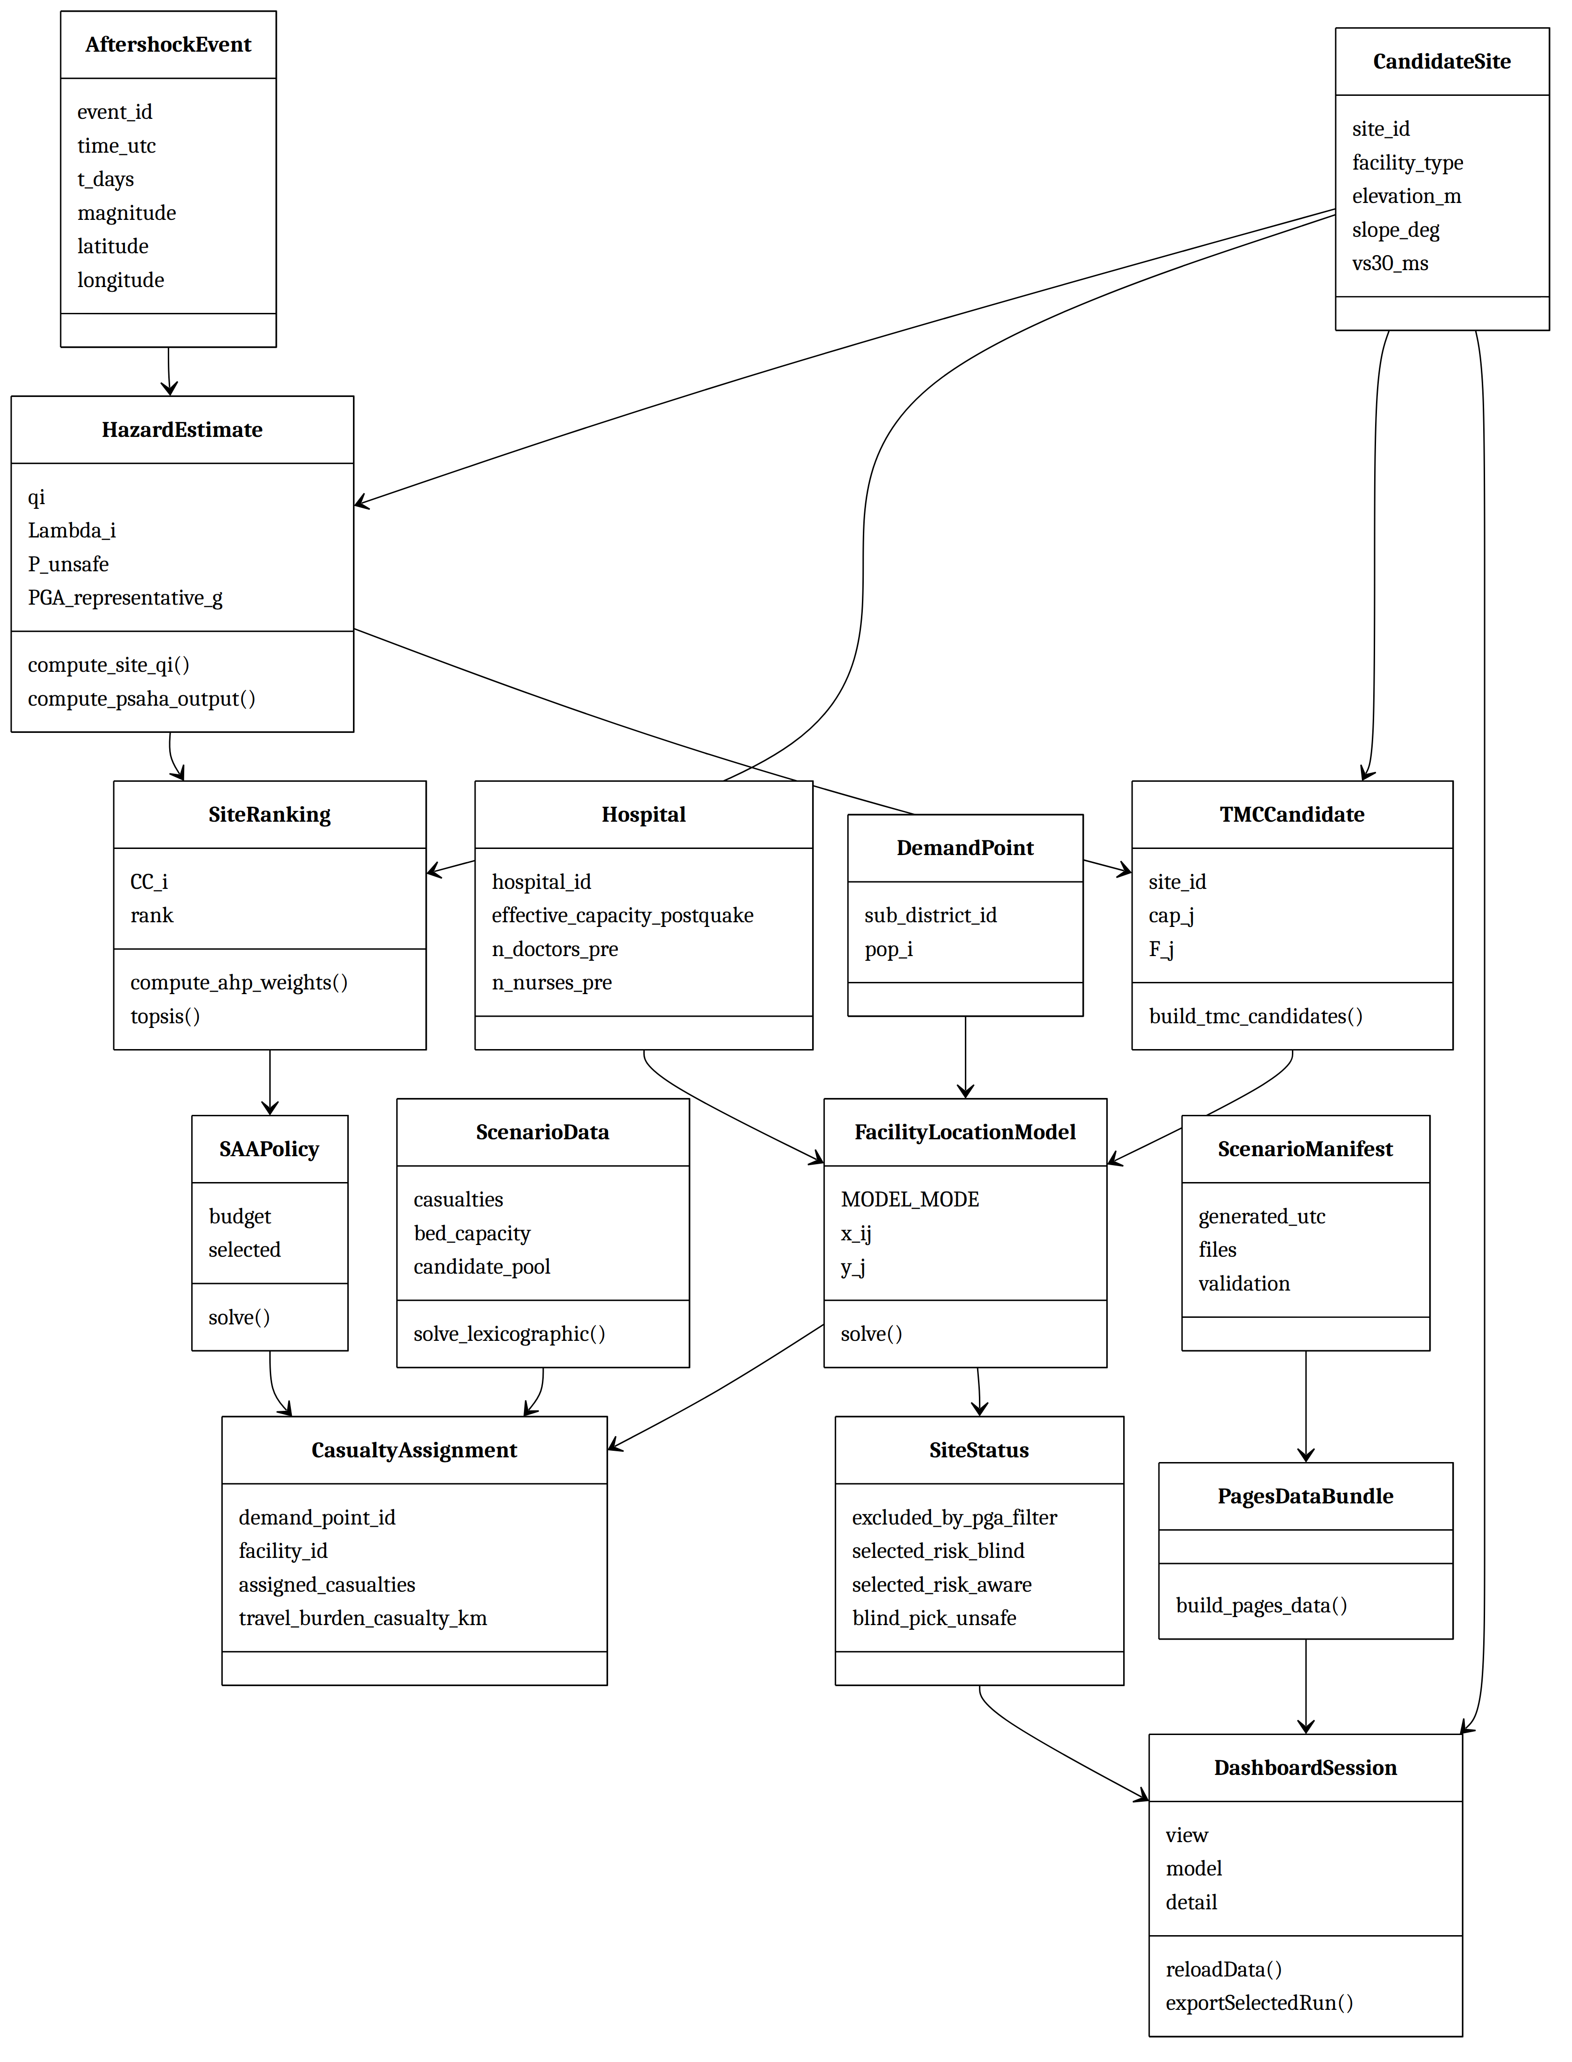
Figure 1: Class diagram of the AARO domain classes

2. Persistent data
There is no database. Persistence is files: CSV, JSON, and (for the full research run, not shipped here) rasters and caches.

2.1 Data stores in this repository
Store | Purpose
examples/reference_results/ | Frozen Kahramanmaraş result snapshot used by the public dashboard
frontend/public/data/api/ | Static JSON generated by scripts/build_pages_data.py (git-built locally / CI)
examples/model_inputs/risk_aware/ | Tiny synthetic solver inputs
examples/model_outputs/risk_aware/ | Output of examples/run_solver_demo.py
Full pipeline dirs (data_raw/, data_processed/, model_inputs/, model_outputs/, outputs_psaha/, outputs_stochastic/, dashboard_data/) | Used when the complete pipeline is run locally with external inputs; not included in the public snapshot (see docs/full-pipeline-inputs.md)

2.2 Published result files (keys and relationships)
Primary key is shown first. Relationships are logical (CSV joins), not SQL foreign keys.
File | Fields (from the snapshot) | Keys / relationships | Mapped classes
sites.csv | site_id, OSM fields, terrain, Vs30, qi, Lambda_i, P_unsafe, PGA_representative_g, damage fields, resolution_tier | PK site_id. Joins to site_status, TMC selections | CandidateSite, HazardEstimate
site_status.csv | candidate/selected flags per mode, excluded_by_pga_filter, blind_pick_unsafe | PK site_id → sites | SiteStatus
hospitals.csv | ids, coordinates, bed and staff fields, provenance | PK hospital_id | Hospital
demand_points.csv | sub_district_id, name, coords, population, pop_i | PK sub_district_id | DemandPoint
aftershocks.csv | USGS-style catalog plus t_days | PK event_id | AftershockEvent
scenario_manifest.json | scenario metadata, files inventory, validation | Document root | ScenarioManifest
<mode>/tmc_selected.csv | site_id, cap_j, F_j, y_j, assignment, utilisation | PK site_id → sites; mode ∈ {risk_blind,risk_aware} | SitingPlan
<mode>/casualty_allocation.csv | demand, facility, set JH/JT, flow, distance, travel burden | FK demand_point_id, facility_id | CasualtyAssignment
<mode>/hospital_utilisation.csv | site_id, hospital_id, capacity, assigned, utilisation | FK hospital / site | Hospital + assignment
paper_lp/scenario_results.csv | scenario_id, scenario_prob, Z1–Z3, served/unmet, TMC/staff counts | PK scenario_id | ScenarioData results
paper_lp/casualty_allocation.csv | scenario, demand, facility, triage, period, flow, distance | composite key | medical CasualtyAssignment
paper_lp/unmet_by_triage.csv | scenario, demand, triage, period, unmet | composite key | ScenarioData
paper_lp/staffing_plan.csv | scenario, facility, staff_type, period, extra_staff | composite key | staffing
paper_lp/sensitivity_summary.csv | one-at-a-time parameter sweep rows | parameter + level | robustness
saa/budget_sweep_summary.csv | budget, in/out-of-sample served and unmet, SDs, replications | PK budget | SAAPolicy
saa/budget_sweep_in_sample_by_replication.csv | per-replication in-sample metrics | budget + replication | SAAPolicy
saa/budget_sweep_out_of_sample_by_draw.csv | per-draw out-of-sample metrics | budget + draw | SAAPolicy
saa/run_metadata.json | run settings (replications, draws, budgets) | document | SAAPolicy

Synthetic solver inputs:
File | Fields | Keys
examples/model_inputs/risk_aware/demand_points.csv | sub_district_id, name, coords, pop_i | PK sub_district_id
hospitals_jh.csv | site_id, cap_j, … | PK site_id
candidates_jt.csv | site_id, cap_j, F_j, type, name, coords | PK site_id
distance_matrix.csv | demand_point, facility, distance_km | composite PK

2.3 ER diagram (file entities)
The ER diagram is split into four parts so that it stays readable on an A4 page. The entity TMC_SELECTED appears in parts 1 and 2 because it links the two groups.
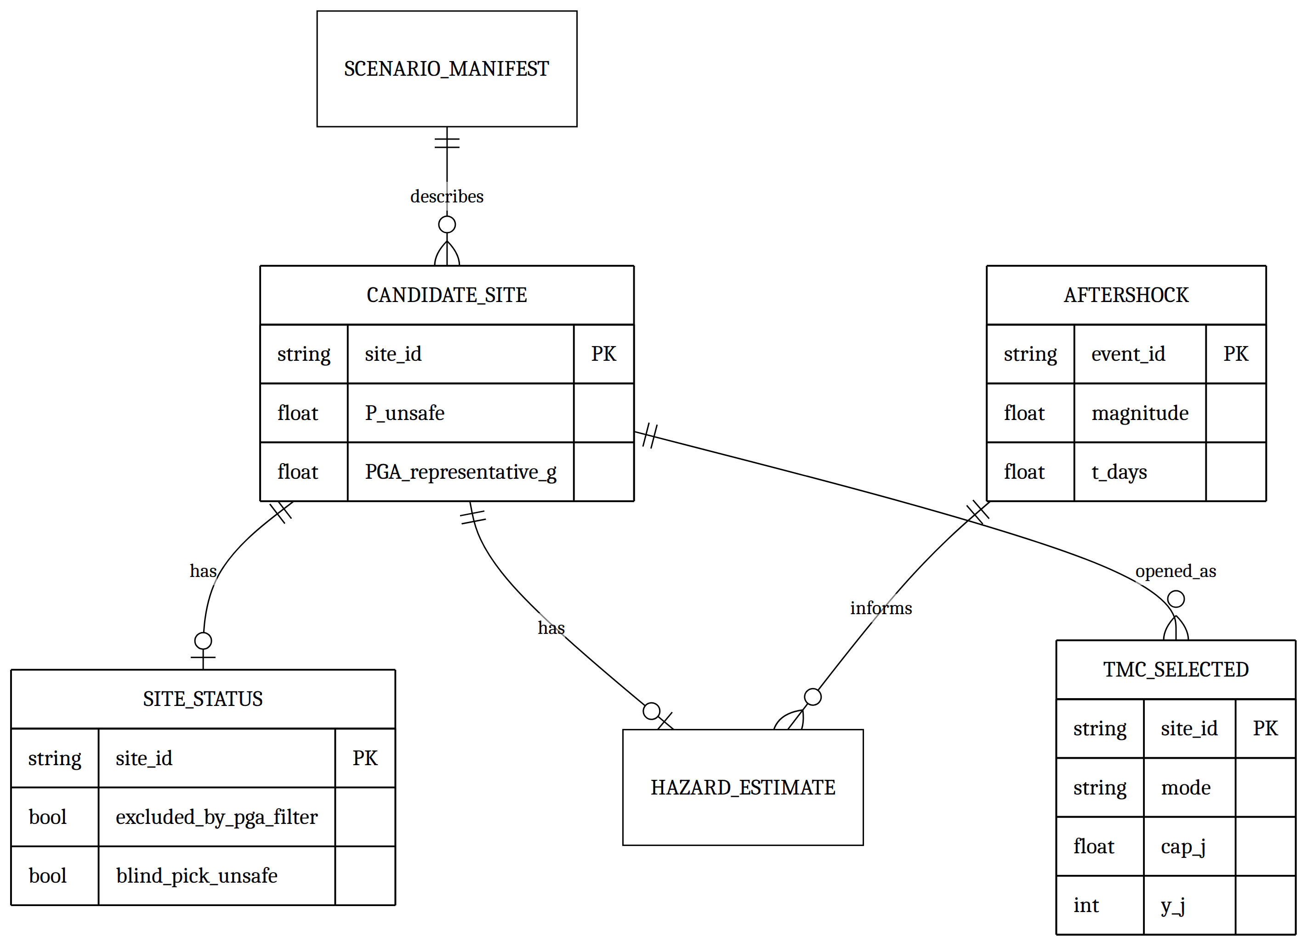
Figure 2: ER diagram of file entities, part 1 of 4: candidate sites, hazard estimates and selected TMCs
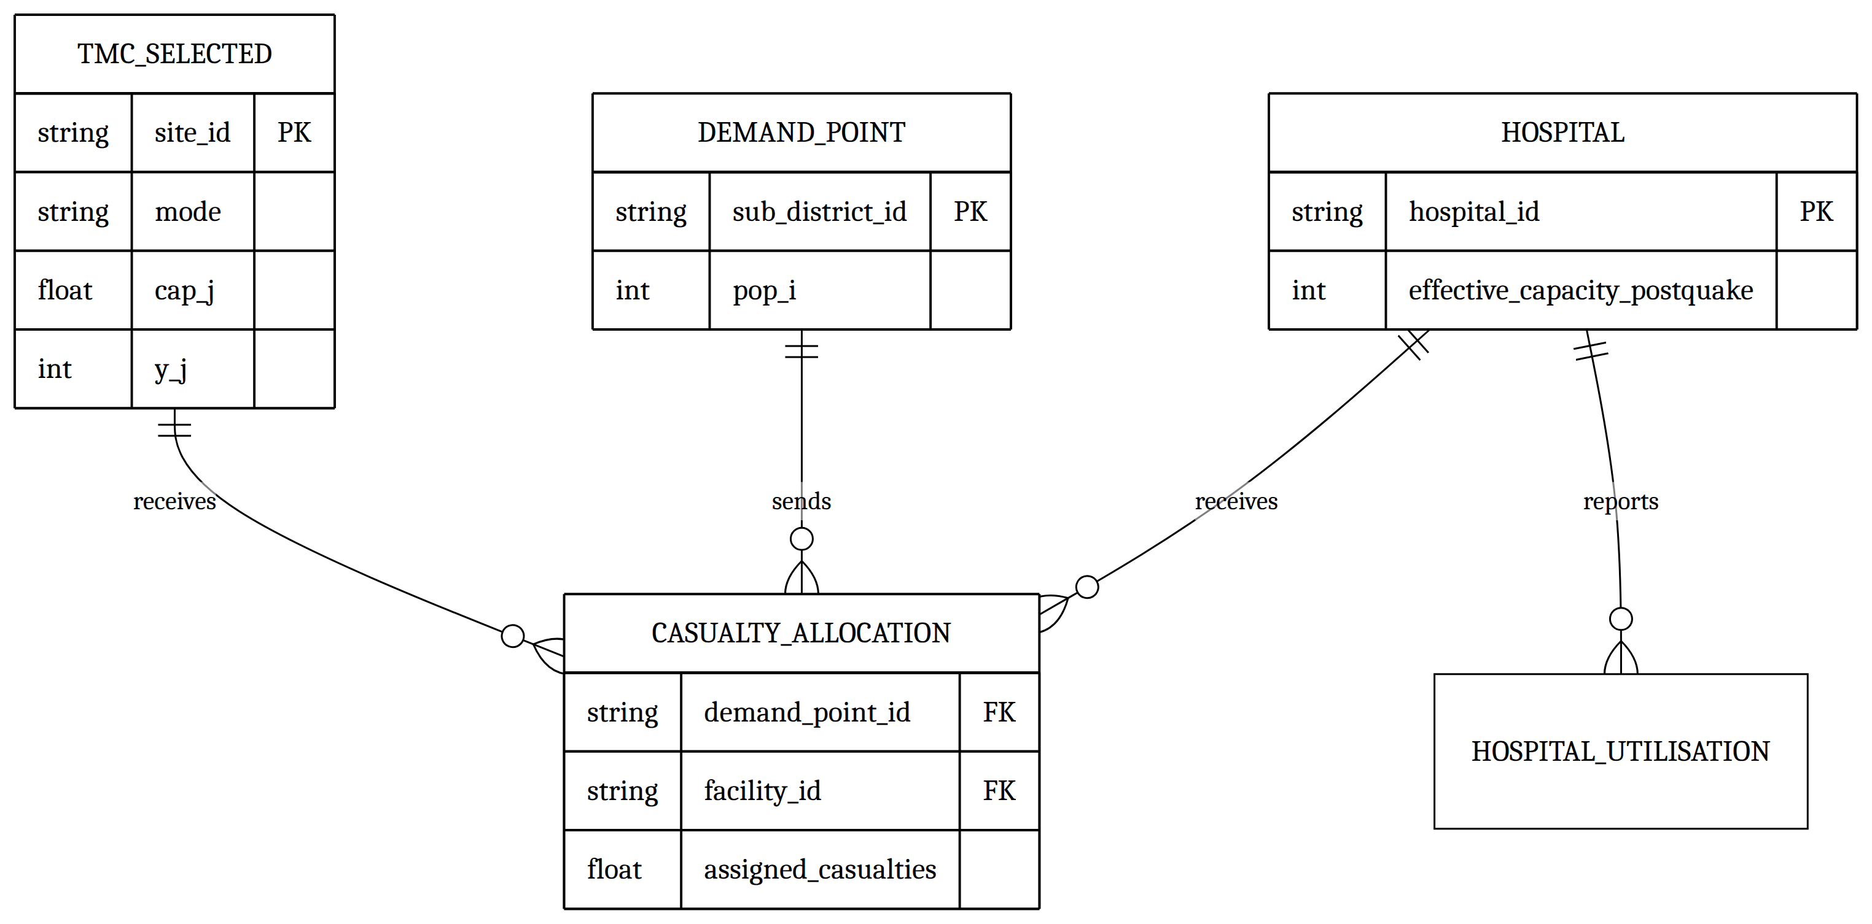
Figure 3: ER diagram of file entities, part 2 of 4: casualty allocation and hospital utilisation
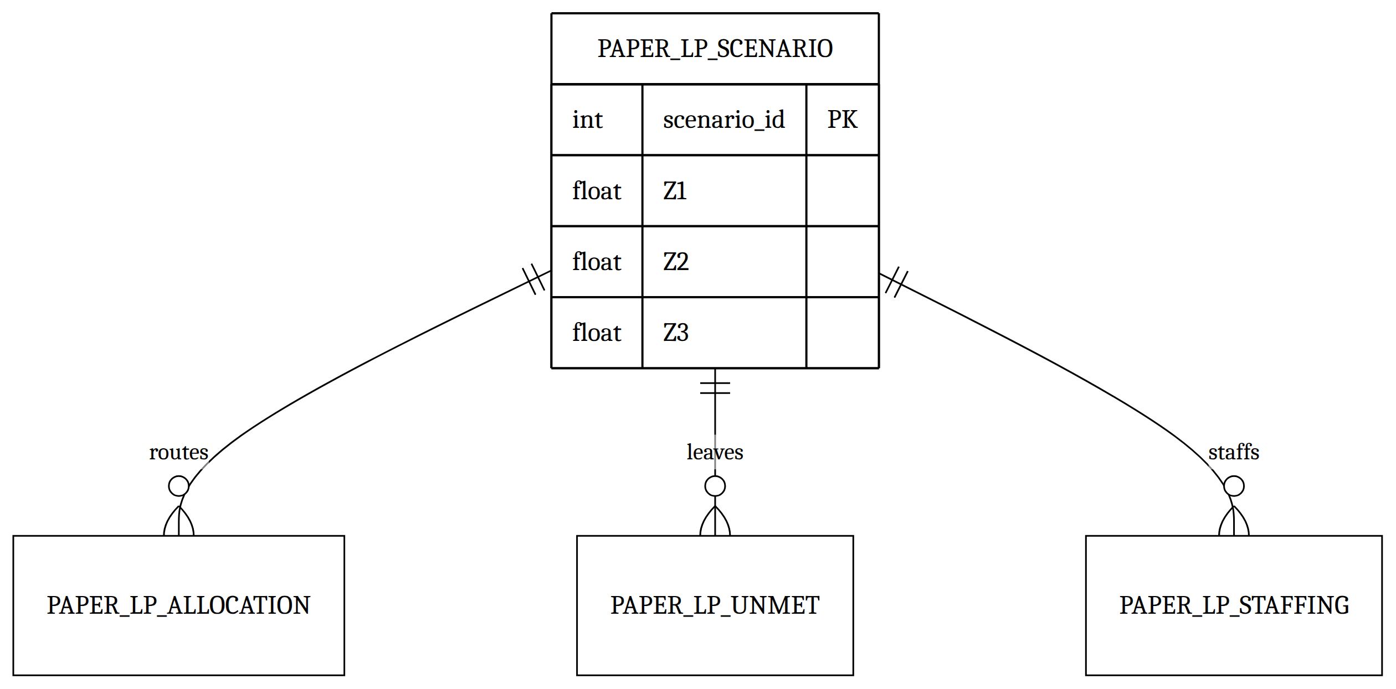
Figure 4: ER diagram of file entities, part 3 of 4: Paper LP scenario results
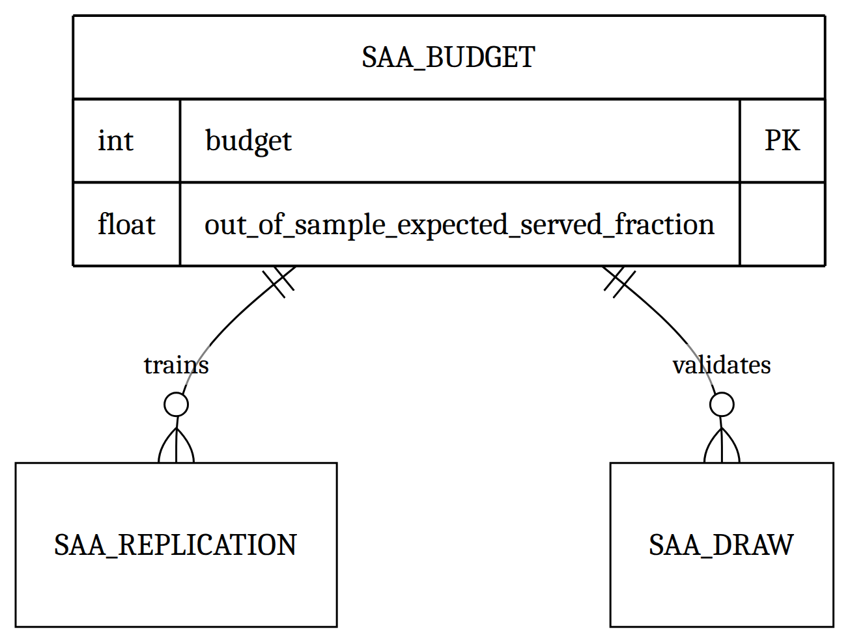
Figure 5: ER diagram of file entities, part 4 of 4: SAA budget sweep

2.4 Class-to-store map (dashboard path)
PagesDataBundle copies the snapshot into JSON:
- sites.json, site_status.json, hospitals.json, demand_points.json, scenarios.json, model-options.json
- solutions/risk_blind.json, solutions/risk_aware.json
- paper_lp/all_candidates.json (from paper_lp/ files via the fallback in profile_source)
- saa/all_candidates.json (from saa/ files via the same fallback)
frontend/src/api.js maps /api/... fetch paths onto those JSON files. There is no live FastAPI process in this repository.

3. Behavioural representation
The four components that drive the main flows are DashboardSession, FacilityLocationModel, HazardEstimate, and SAAPolicy.

3.1 DashboardSession — state diagram
The published app has no dataset-chooser or upload stage. App loads the reference bundle on mount.
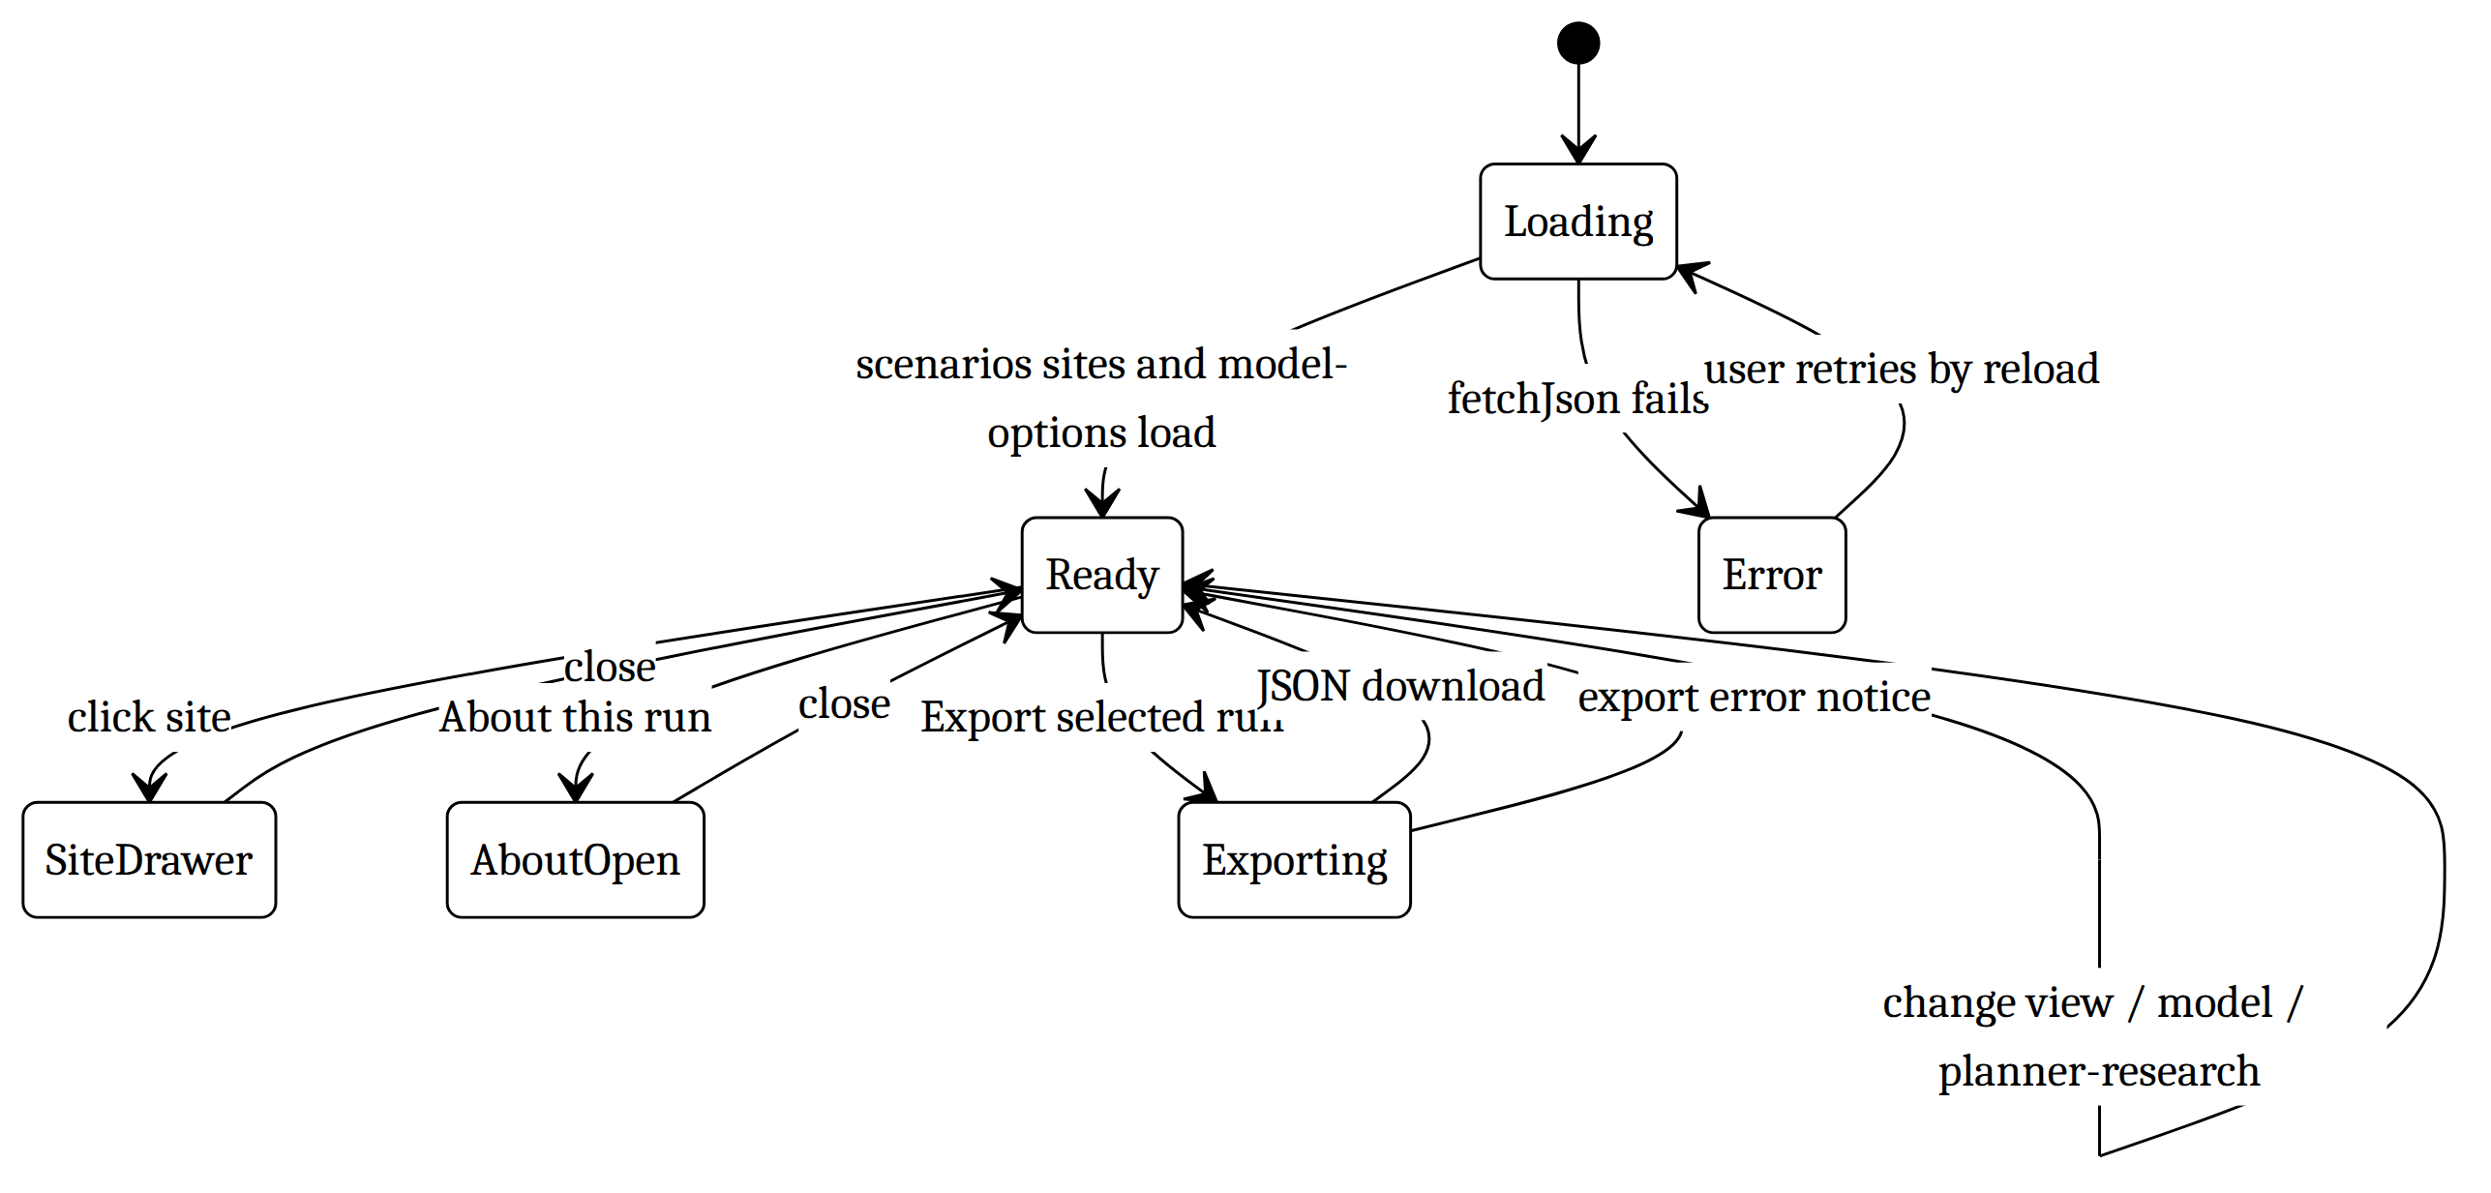
Figure 6: State diagram of DashboardSession
Flow. reloadData calls fetchJson('/api/scenarios'), /api/sites, and /api/model-options. Tab buttons set view. Model buttons set model only if available is true. URL state (useUrlState) stores view, mode, model, and detail so the page is deep-linkable. Site clicks set detailSiteId and SiteDetail loads /api/sites/{id}.

3.2 DashboardSession — sequence (planner inspects hazard and a site)
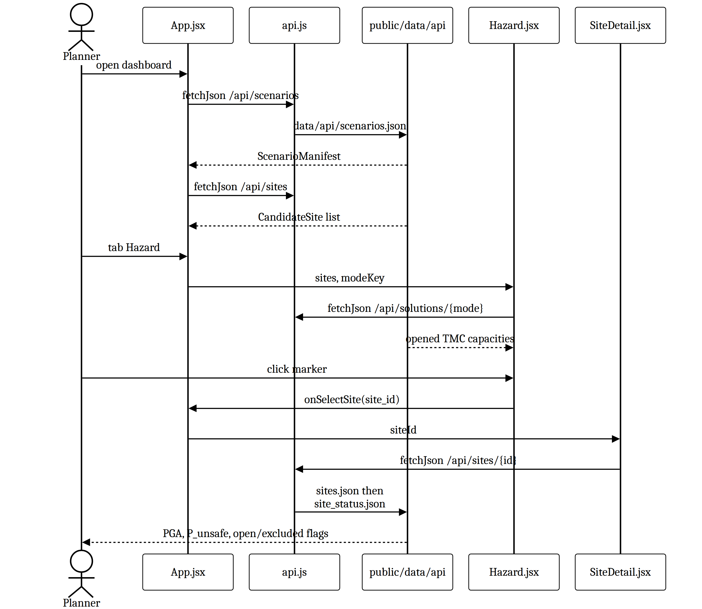
Figure 7: Sequence diagram: planner inspects hazard and a site

3.3 FacilityLocationModel — state diagram
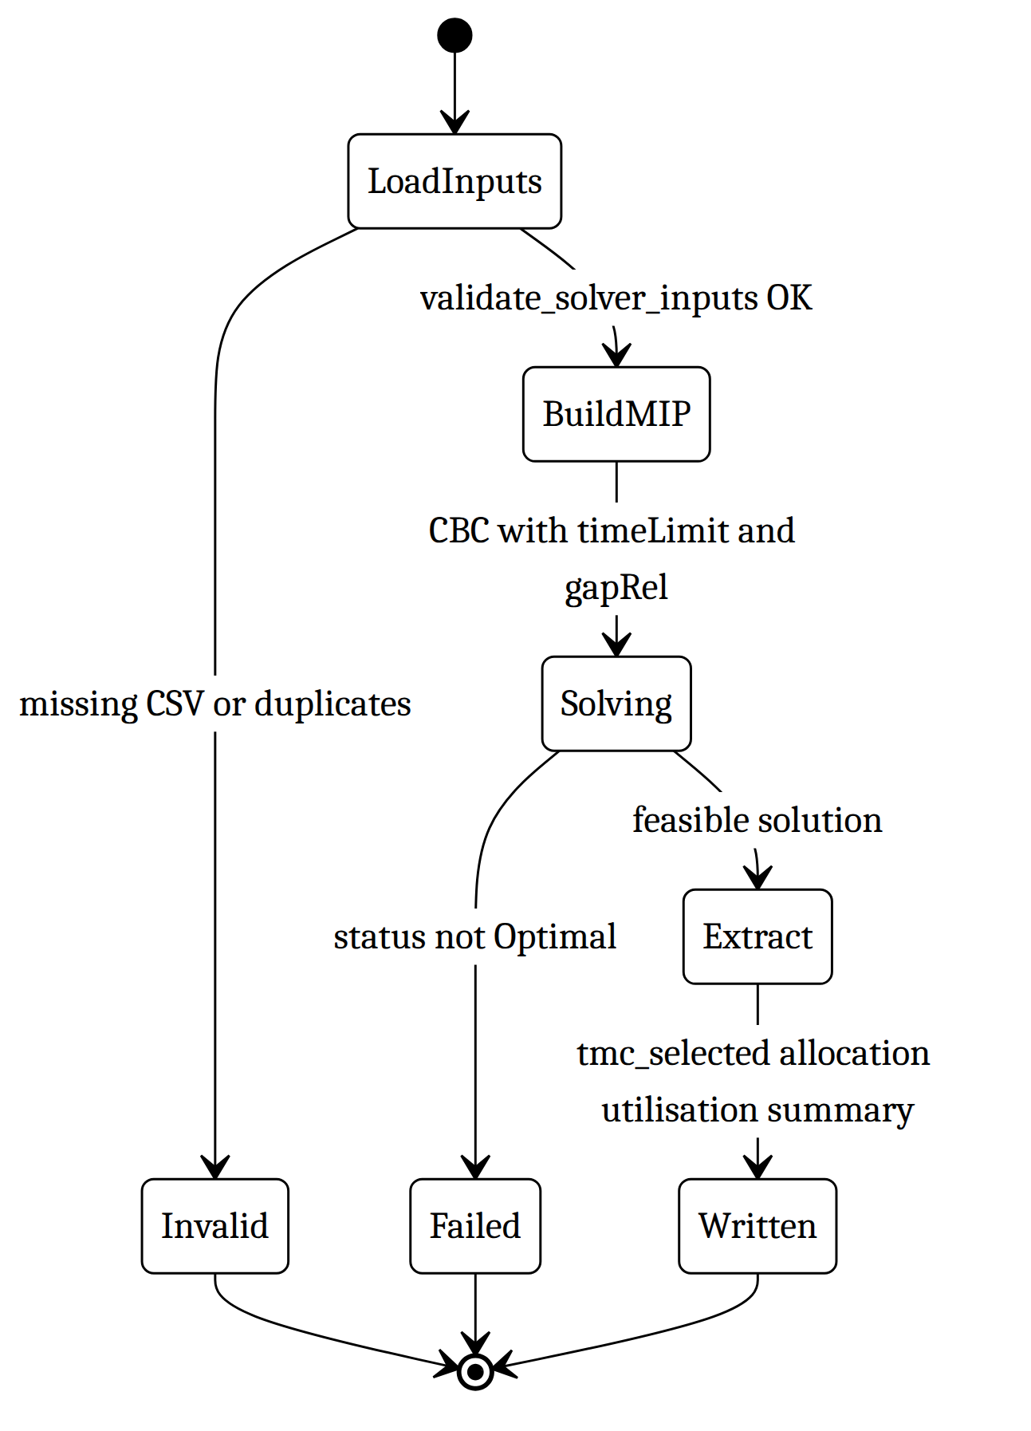
Figure 8: State diagram of FacilityLocationModel
Flow. examples/run_solver_demo.py sets PIPELINE_ROOT=examples and MODEL_MODE=risk_aware, then runs step2_solve_model.py. The MIP requires full demand allocation, hospital capacity, and TMC capacity only if y_j=1. Objective = ∑ C_{TRANS} d_{ij} x_{ij} + ∑ F_{j} y_{j}.

3.4 FacilityLocationModel — sequence (synthetic demo)
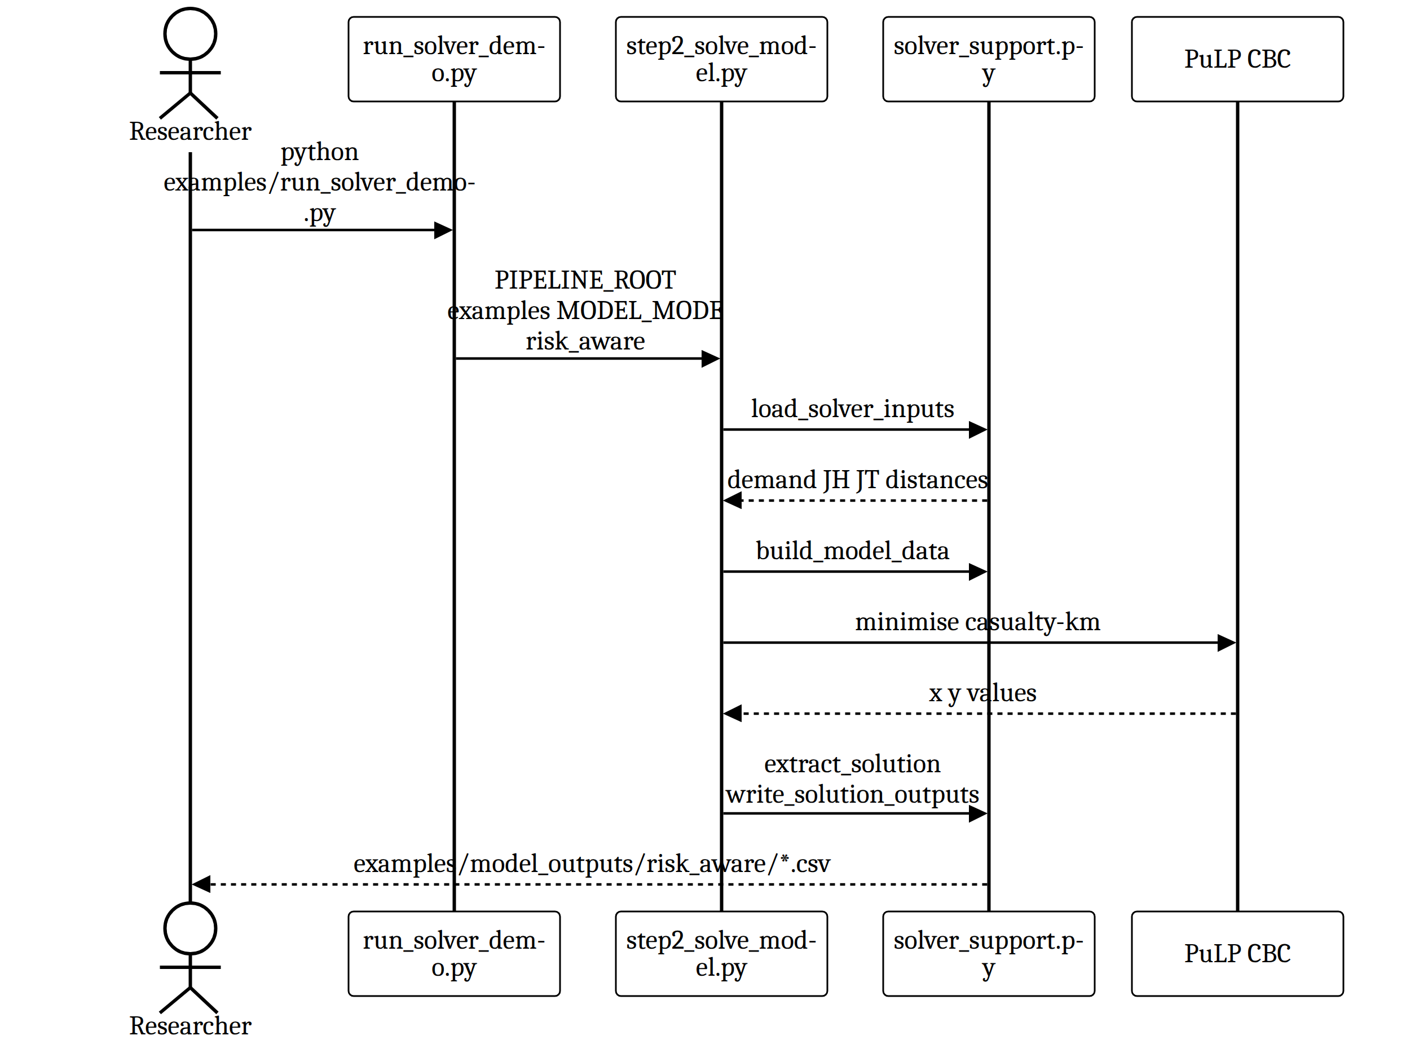
Figure 9: Sequence diagram of FacilityLocationModel (synthetic demo)

3.5 HazardEstimate — state diagram
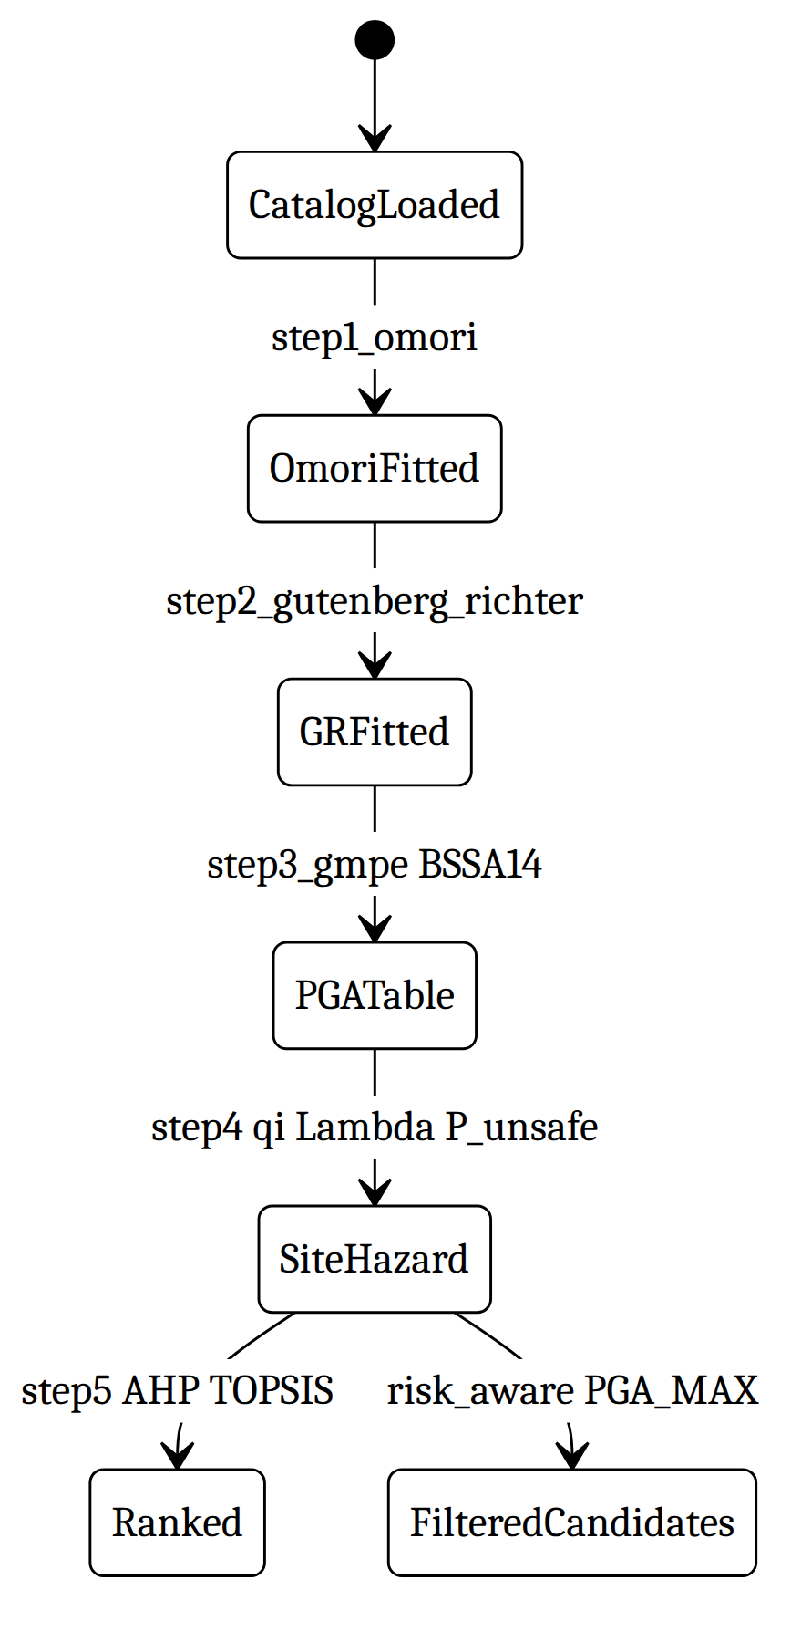
Figure 10: State diagram of HazardEstimate
Step 5 is parallel to the MILP: ranking does not set y_j. Risk-aware filtering is in build_tmc_candidates.

3.6 HazardEstimate — sequence (full pipeline, local inputs required)
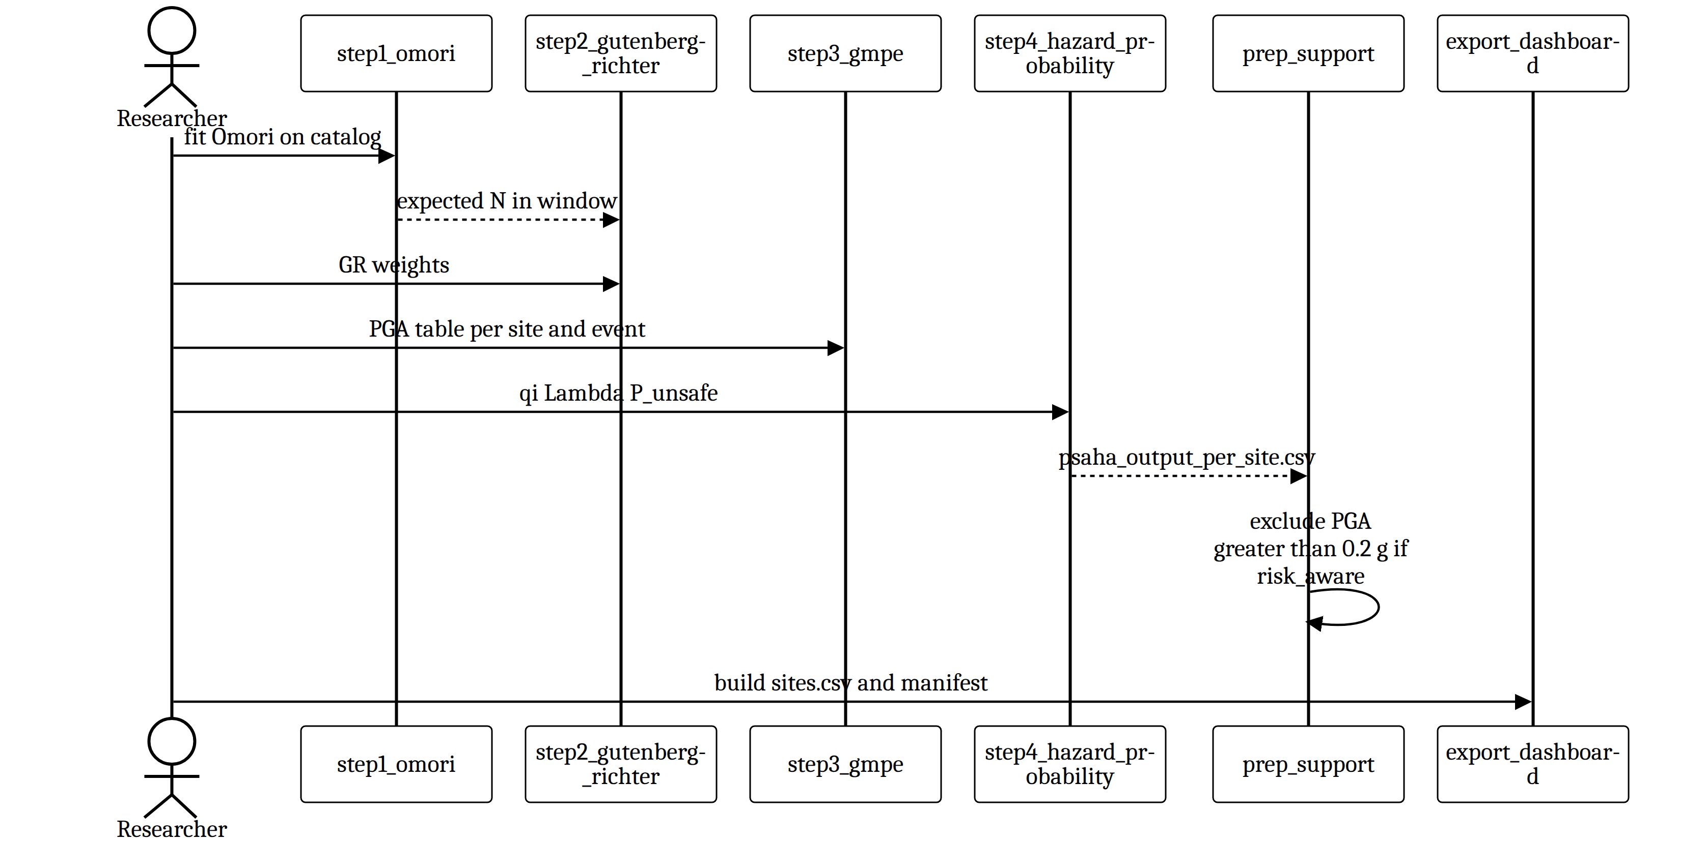
Figure 11: Sequence diagram of the full hazard pipeline
The public GitHub Pages site does not run this sequence. It only displays a previously exported snapshot.

3.7 SAAPolicy — state diagram
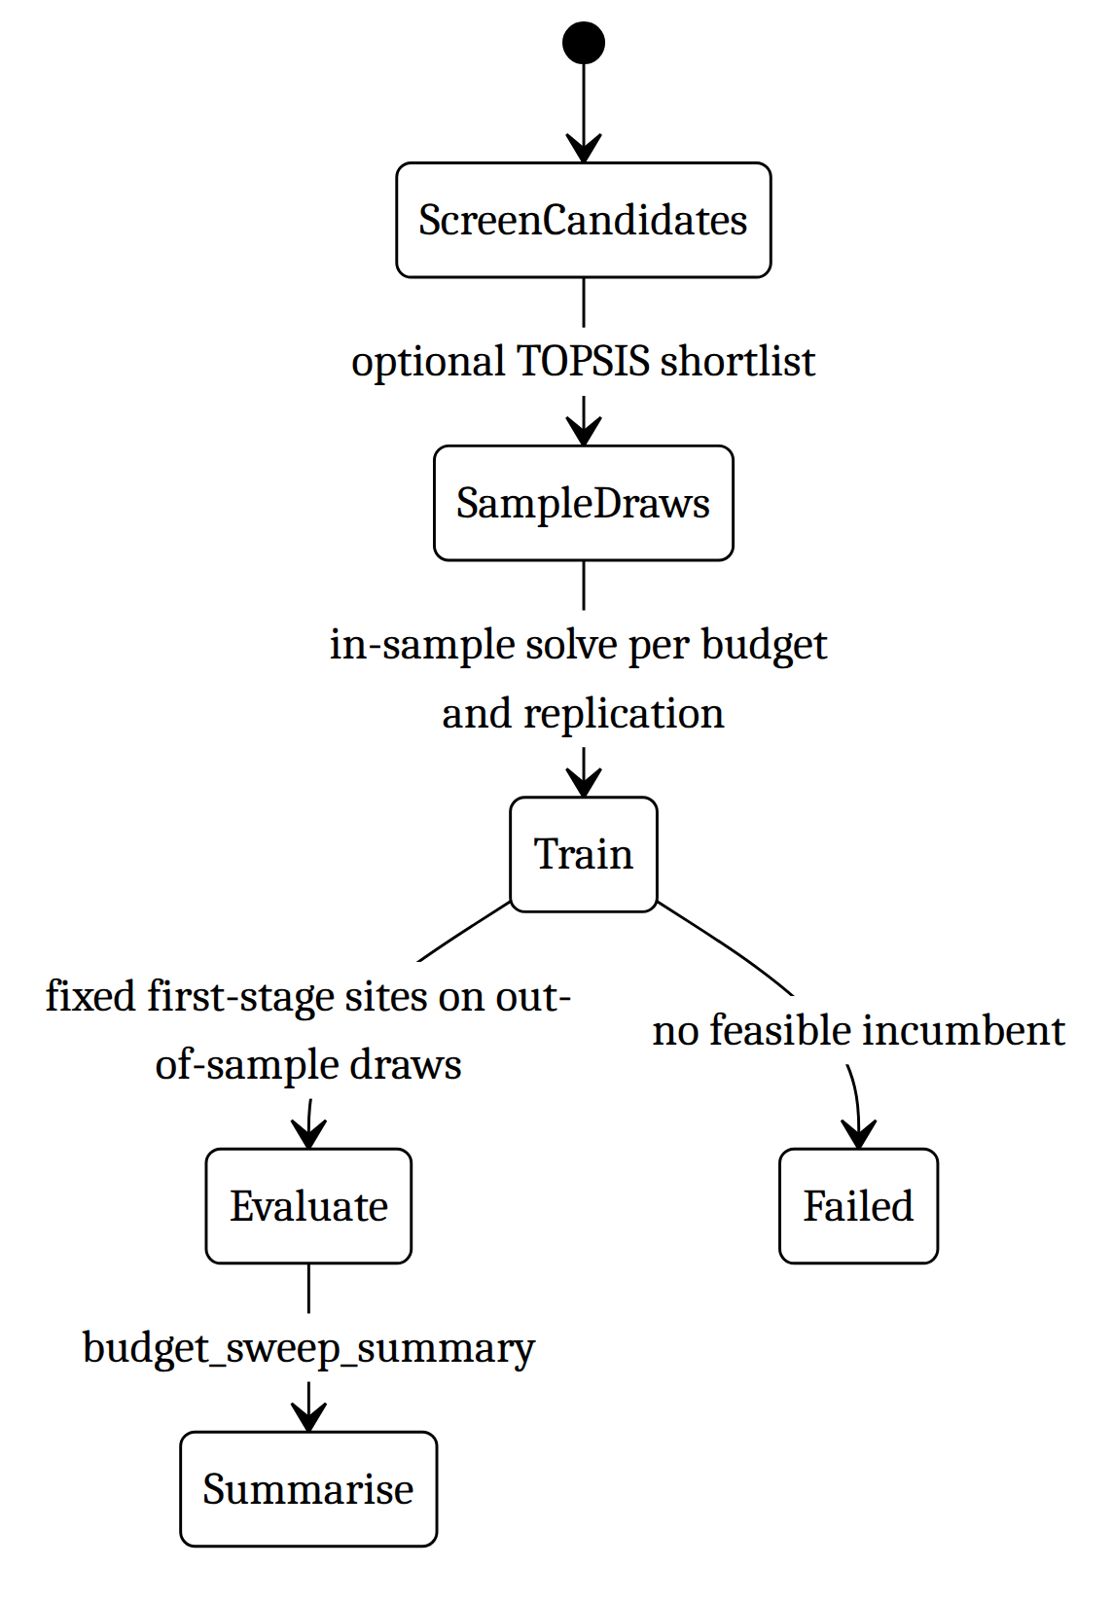
Figure 12: State diagram of SAAPolicy
The published SAA files are a completed sweep (saa/budget_sweep_*.csv). The dashboard SAAResults view reads them through static JSON. Detailed per-policy site lists are not in the snapshot (saa detail endpoints are absent from api.js and build_pages_data.py).

4. Deployment diagram
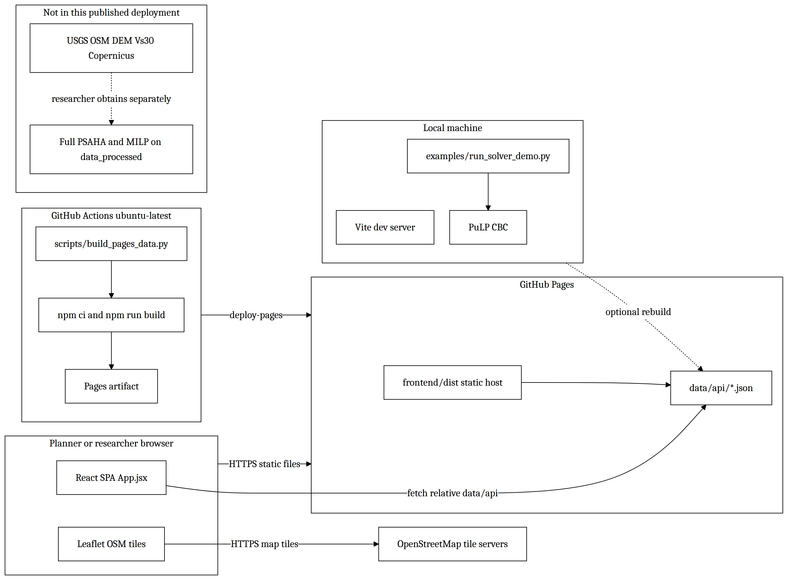
Figure 13: Deployment diagram of the AARO system
Hosting / deployment (from docs/publishing.md and .github/workflows/pages.yml).
- The public product is a static site. GitHub Actions on main (paths: frontend/**, examples/reference_results/**, scripts/build_pages_data.py) runs Python 3.11 + pandas, Node 20, npm ci, npm run build, and actions/deploy-pages.
- frontend/vite.config.js sets base: './' so assets work on a project Pages URL.
- The dashboard does not accept uploads and does not run models on Pages.
- Local UI: cd frontend && npm ci && npm run dev.
- Local solver demo: python examples/run_solver_demo.py (needs requirements-demo.txt).
- External services at runtime: OSM map tiles only. USGS/Overpass/DEM APIs are used only if the full extraction pipeline is run with private inputs.
- No application database, no authentication, no FastAPI process in the published architecture.

5. Refactoring and alternatives

5.1 Research pipeline (PSAHA + prep + solvers)
Original design. Numbered one-off scripts and a monolithic facility-location file (still under archive/). Settings and paths were mixed into scripts. TMC capacity was a flat per-type guess. Ground motion used an unpublished attenuation formula. Opening “cost” was an unlabeled constant.
Alternative considered. (1) Keep TOPSIS scores inside the MILP opening penalty. (2) Price transport in currency (fuel). Both were rejected in comments in prep_support.assign_opening_penalty and settings.py: TOPSIS is a separate ranking deliverable; currency would add unverifiable prices without changing the MILP ratio structure.
Refactoring applied. Logic split into prep_support.py / solver_support.py with thin step1/step2 entry points. Dual MODEL_MODE trees. Area-derived capacity. BSSA14 GMPE. Objective documented as casualty-km. AHP/TOPSIS restored as step5_ahp_topsis.py without driving y_j.
Code smells still present.
- God scripts / missing types. Domain objects are DataFrames. Only ScenarioData and HospitalDataValidator are types. Recommended: extract small dataclasses (DemandPoint, TMCCandidate) without changing solver math.
- Import-time configuration. settings.py reads MODEL_MODE at import (pipelines/deterministic_current/settings.py lines 15–18). That forces run_both_modes.py and the demo to use subprocesses. Alternative: pass mode into functions.
- Duplicated haversine_km. Same helper in prep_support.py (deterministic), pipelines/stochastic_medical/prep_support.py, step3_gmpe.py, and hospital extraction. Extract a shared geo module.
- Stale comment vs code. assign_opening_penalty still says topsis_ranking.csv is never produced (lines 292–298), but step5_ahp_topsis.py now writes it. Update the comment so design docs and code agree.
- sys.exit on validation. solver_support.load_input_csv terminates the process. Alternative: raise exceptions so tests and a future API can handle errors.

5.2 Medical models (Paper LP and SAA)
Original design. Archived AUGMECON2 / step6 placeholders (archive/stochastic_medical_partial/).
Alternative considered. One multi-objective model for both ranking and routing. The current split keeps scenario-wise Paper LP independent of SAA first-stage openings.
Refactoring applied. ScenarioData dataclass; lexicographic LP in scenario_lp_support.py; SAA in run_saa.py with budget and out-of-sample draws.
Code smells. Large run_saa.solve (status handling, objective checks, metrics in one function). Duplicate distance/capacity construction vs the deterministic prep. Recommended: extract a SolveResult type and share network loading.

5.3 Dashboard (React static adapter)
Original design. A sibling FastAPI app served dashboard_data/ live, including ZIP upload and run_demo_job.py. This publish repo removed the backend and kept the same /api/... client paths.
Alternative considered. Keep FastAPI on a hosted server so researchers can upload new regions. Trade-off: hosting, secrets, job isolation, and no auth in the old API (allow_origins=["*"]). Static Pages is simpler and safer for a public demo.
Refactoring applied. frontend/src/api.js maps REST-like paths to JSON files. scripts/build_pages_data.py is an Adapter from CSV snapshot to that contract. useUrlState replaced duplicated tab/mode state and avoided adding react-router.
Code smells.
- Leaky API illusion. Comments and fetchJson('/api/paper-lp/...') look like a server. Recommended: rename generated files or a thin DataRepository module with methods getSites(), getSolution(mode) so the UI does not speak HTTP paths.
- Incomplete static parity. api.js does not implement SAA /detail or /draws. App.exportSelectedRun still calls /api/saa/{profile}/detail and will fail on Pages (caught, empty allocations). Either drop that call in the static client or export detail JSON.
- Profile fallback. Snapshot stores paper_lp/ and saa/ without all_candidates/ / topsis_120/ folders. profile_source maps both UI profile buttons onto the same files if nested paths are missing. The TOPSIS-120 model buttons can appear unavailable (model-options available flag). Document this honestly in the UI copy.
- exportSelectedRun complexity. Nested conditionals in App.jsx (lines 51–87) mix MILP, Paper LP, and SAA. Extract buildExportBundle(model).
- Magic PGA in the UI. Hazard.jsx hard-codes PGA_MAX = 0.2 instead of reading scenario_manifest.json (pga_filter_threshold_g).

5.4 Data export
Original design. Dashboard would read model_outputs/ directly.
Refactoring applied. Single validated bundle (export_dashboard.py) plus manifest files[].status so the UI can show missing data instead of inventing it.
Smell. export_dashboard.py still comments about “the dashboard repo”; this repository now contains the frontend. Update that header. Published sites.csv omits TOPSIS columns even though step 5 exists — re-export if ranking must appear on the map.

Gaps / Recommendations
- No database and no FastAPI in this repo. Persistence is CSV/JSON; the public site is static. Design classes above are domain types mapped onto scripts and React modules.
- Full study inputs are not published. Extraction, PSAHA, and stochastic solves cannot be reproduced from this clone alone (docs/full-pipeline-inputs.md).
- No tests/ tree in this repository. Correctness tests live in the internal research checkout, not here.
- AHP/TOPSIS ranks are not in the published sites.csv header. Ranking code exists (step5_ahp_topsis.py) but the snapshot used by Pages does not carry CC_i / rank.
- Paper LP and SAA in the snapshot are a single profile (paper_lp/, saa/), not two candidate pools. The six model buttons in App.jsx overstate what the frozen JSON contains unless both profiles are exported.
- SAA detailed recourse (opened sites, period allocations, staffing) is not in build_pages_data.py output.
- Upload-and-run researcher workflow is not in this frontend (RunDemo is absent). Researchers run Python locally (run_solver_demo.py or the full pipeline with private data).
- No authentication, rate limiting, or hosted job queue — appropriate for static Pages; not an operational multi-user DSS.
- Interactive medical dispatch (edit staffing, override routes) is not implemented; medical views are read-only tables and charts.
- Comments and archive code still describe dropped or sibling-repo designs; clean those when touching the files listed in §5.

