Development Environment

开 发 环 境

* Environment Composition - [环境构成]
* Software Development toolKits - [开发套件，SDK]

JDK - [[Java Standard Edition Development Kit](http://www.oracle.com/technetwork/java/javase/downloads/index.html)]

* Integrated Development Environment - [集成环境，IDE]

**Utility Suite => [IntelliJ IDEA](https://www.jetbrains.com/idea/) / [Eclipse](https://www.eclipse.org/downloads/) / [NetBeans](https://netbeans.org/downloads/index.html)**

**Edit / Compile / Link / Debug / Execute (Launch/Interpret) / Build / Deploy / Maintain / Assistance / Monitor**

**Performance Analysis - [性能分析]**

* Language Plugin Bundle - [语言插件，LPB]
* [IntelliJ IDEA Chinese Patch](https://pan.baidu.com/s/1dF43YST) - [汉化补丁]
* [Eclipse Babel Project](http://www.eclipse.org/babel/) - [语言插件]
* [](http://www.oracle.com/technetwork/java/javase/downloads/index.html)Environment Construction - [环境搭建]
* Download - [下载]
* Installation - [安装]
* Configuration - [配置]
* Environment Variable - [环境变量]
  1. INSTALLATION DIRECTORY - [套件安装路径]

JAVA_HOME = C:\Program Files\Java\$JDK-$FEATURE. $INTERIM. $UPDATE

* 1. EXECUTABLE DIRECTORY - [命令搜索路径]

PATH = %JAVA_HOME%\bin

* 1. LIBRARY DIRECTORY - [类库查询路径]

CLASSPATH=.; %JAVA_HOME%\lib\dt.jar; %JAVA_HOME%\lib\tools.jar

* Verification - [验证]

CLI(Command Line Interface) => java -version

* 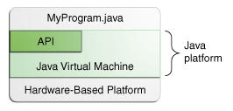Utilization - [运用]
* Platform Profile - [平台解析]
* Application Orientation - [应用方向]
* Java Standard Edition - [爪哇标准版，Java SE]
* Java Enterprise Edition - [爪哇企业版，Java EE]
* Java Micro Edition - [爪哇微机版，Java ME]
* System Architecture - [体系结构]

[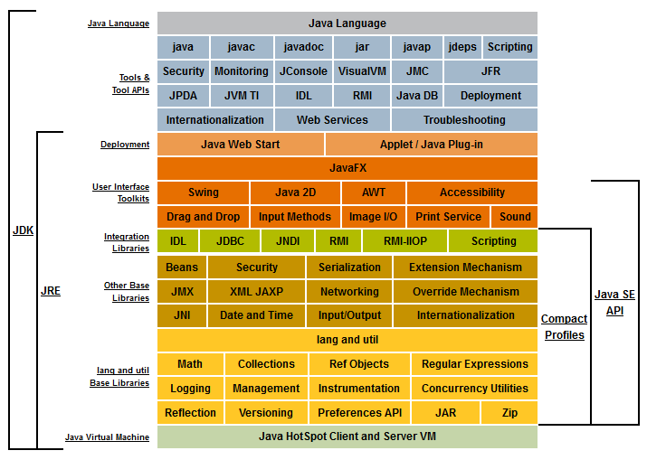](http://docs.oracle.com/javase/8/docs/)

* Programming Language Specification - [语言规范，PLS]

**[The Java Language Specification](https://docs.oracle.com/javase/specs/jls/se9/html/index.html) - JLS**

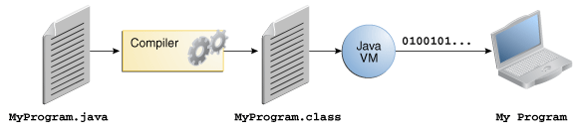

* Application Programming Interface - [应用编程接口，API]

**A Large Collection of Predefined Software Components That Provide Many Useful**

**Capabilities, Grouped into Library of Related Class & Interface. these libraries are known as packages**

[Standard Basement Library](https://docs.oracle.com/javase/9/docs/api/overview-summary.html) - [基准类库，SBL]

Reference Template Package - [参考模板，RTP]

Application Development Framework - [开发框架，ADF]

* Virtual Execution System - [虚拟执行系统，VES]

**Java Runtime Environment - [JRE]**

**Execution Engine(执行引擎) : Java Virtual Machine - [JVM]**

**[The Java Virtual Machine Specification](https://docs.oracle.com/javase/specs/jvms/se9/html/index.html)**

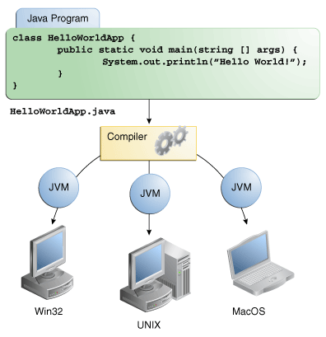

**Software Development Kits Version Naming Scheme - [开发套件版本命名方案]**

**[$CATEGORY-$FEATURE. $INTERIM. $UPDATE. $PATCH_$OS-$ISA_bin. $EXTENSION](https://docs.oracle.com/javase/10/install/version-string-format.htm)**

**→ jdk-10.0.1_windows-x64_bin.exe**

**→ jdk-10.0.1_linux-x64_bin.rpm**

**$EXTENSION - .msi / .exe / .rpm / .deb -> Package Scheme**

Directory Structure - [目录结构]

INSTALLATION DIRECTORY - **JAVA_HOME**

JDK-$FEATURE. $INTERIM. $UPDATE - **Java Development Kits**

BIN DIR - **Executables**

An implementation of the Java Runtime Environment (JRE). The JRE includes a Java Virtual Machine (JVM™), class libraries, and other files that support the execution of programs written in the Java programming language. This directory also includes tools and utilities that will help you develop, execute, debug, and document programs written in the Java programming language.

CONF DIR - **Configurations**

Files that contain user-configurable options. Files in this directory can be edited to change the JDK's access permissions, configure security algorithms, and set the Java Cryptography Extension Policy Files which might be used to limit the JDK's cryptographic strength.

INCLUDE DIR - H**eaders**

C-language header files that support native-code programming with the Java Native Interface and the Java Virtual Machine (JVM) Debugger Interface.

JMODS DIR - **Modules**

Compiled modules used by jlink to create custom runtimes.

LEGAL DIR - **Copyright & License**

License and copyright files for each module. Includes third party notices as .md (markdown)files.

LIB DIR - **Libraries**

Additional class libraries and support files required by the JDK. These files are not intended for external use.

COPYRIGHT/README/RELEASE