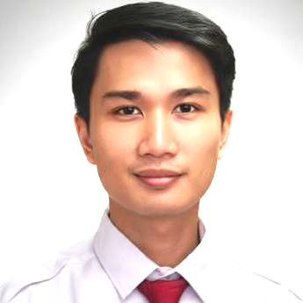 | Gama Candra Tri Kartika  Grogol Asri C1 Limo, Depok, West Java, Indonesia - +62 89 654 393 995   candragctk17@gmail.com -  www.linkedin.com/in/gama-candra-tri-kartika-18b735106/ -  saltfarmer.github.io
I am a Data Science professional with an M.Sc. in Applied Data Science from Utrecht University and a B.Sc. in Computer Science from Universitas Gadjah Mada. Currently, I serve as a Junior Manager at PT Bank Rakyat Indonesia, where I apply expertise in MySQL, PostgreSQL, and Apache Superset to data development and audit operations. My background combines international experience in Amsterdam with a strong technical foundation in statistical learning to drive data-driven solutions.

Experience
 | AUGUST 2024 – CURRENT  Junior manager data Development & operation team, BANK RAKYAT INDONESIA  - Developed comprehensive visualizations to monitor yearly audit progress, enhancing leadership's ability to track performance.  - Engineered new Key Risk Indicators (KRIs) to proactively identify potential audit issues.  - Streamlined data provision processes for auditors, ensuring timely access to critical information.  - Built a custom search engine to facilitate rapid retrieval of audit documentation, improving team efficiency.
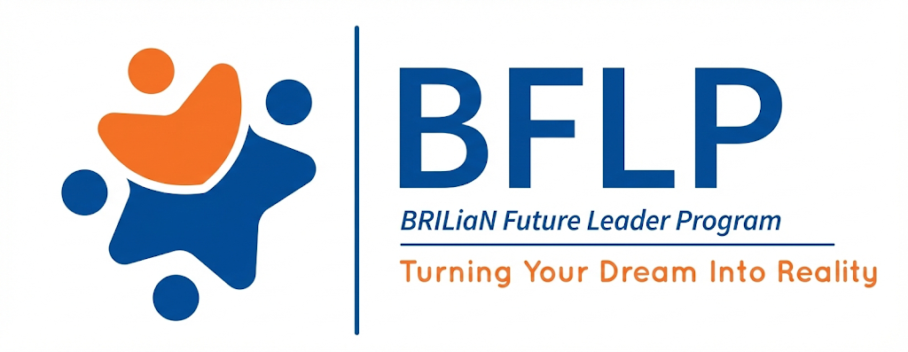 | OCTOBER 2023 – AUGUST 2024  BRIlliant future leader program, BANK RAKYAT INDONESIA  - Gained deep expertise in banking operations, business processes, and audit methodologies through an intensive leadership development program.  - Conducted a strategic study on Risk Indicators, utilizing PowerBI to model and visualize potential risks for the audit department.
 | September 2022 – September 2023  Data Science Trainee, In2intel  - Designed and deployed interactive dashboards using PowerBI to visualize complex datasets.  - Implemented web scraping pipelines to harvest social media data and performed sentiment analysis to derive actionable insights.  - Contributed to a high-tech Digital Twins project utilizing Microsoft Azure, simulating physical systems for predictive analysis.

Education
 | gRADUATED ON 2022  Master of applied data science, utrecht university
 | GRADUATED ON 2019  Bachelor of computer science, gadjah mada university

Thesis

Understanding Text Features and Time Importance Of A Machine Learning Model on Plumbers Reviews
Supervised by Dr. Rense Corten

A Comparative Study of Features Extraction, Features Selection, and Classifier Methods on Sentiment Analysis During Indonesian Election
Supervised by Mr. Sri Mulyana Drs., M.Kom.

Skills
- Python  - Superset  - Microsoft PowerBI | - Streamlit  - Plotly  - Tableau | - Microsoft Excel  - Microsoft Powerpoint  - Pandas

Organizational Experience

2018

Instructor OF Database Class, OmahTI Learning Center

2017

Chief Organizer, C-Compiler

2016

Event Coordinator OF Database Class, OmahTI Learning Center

2015 – 2016

Member of Information Media Division, BEMKM FMIPA UGM

2015 – 2017

Member of Knowledge Discovery Community division, Omahti

HONORS AND AWARDS

2017 Finalist DiLO Hackathon Festival

2017 1st Place Retas Hackathon UGM

2016 FINALIST Hackathon Compfest 8 Universitas Indonesia

2016 Finalist Competitive Programming Bukalapak PROGRAMMING CONTEST

