

***Artificial Intelligence***

**State of the art**

**Specialized Drone Object Identification with Master Control and Confidence Assessment**

**Professor: Luís Miguel Machado Lopes Macedo**

**Group 20**

**Diogo Alexandre Santos Rosário nº 2023185395**

**João Eduardo Monteiro Raposo nº 2023147060**

**Ketevan Kartvelishvili**

1. **Introduction**

The proposed project, focusing on specialized drone object identification and master control, is situated at the intersection of multiagent systems, machine learning, and trustworthy AI. This "State of the Art" report offers a comprehensive overview of the latest advancements in these areas and their relevance to the project's objectives.

1. **Multiagent Systems**
   1. **Team Formation, Cooperation, and Exploration of Unknown Environments**

**Team Formation**: In the realm of multiagent systems, algorithms play a role in the formation of teams. While pathfinding is important, it's crucial to note that this project primarily emphasizes the master's role in team formation and trust attribution rather than detailed pathfinding algorithms.

**Cooperation**: Effective cooperation among specialized drones is pivotal for successful object identification. Communication protocols and strategies facilitate cooperation, with a focus on the master's role in guiding cooperation and trust management.

**Exploration of Unknown Environments**: Exploration algorithms are vital for multiagent systems, although path planning isn't the project's primary focus. The emphasis is on the master's ability to manage and make decisions in unknown environments by attributing trust to specialized drones.

1. **Machine Learning**
   1. **Object Detection and Specialization with Convolutional Neural Networks (CNN)**

**Object Detection**: Machine learning techniques, such as Convolutional Neural Networks (CNN), underpin object detection for specialized drones. CNNs are a class of deep learning models known for their accuracy in image-related tasks. These networks excel in identifying objects within images and have become a cornerstone in modern object detection technology.

**Specialization**: The project centers on training specialized drones with specific datasets and employs transfer learning techniques that leverage pre-trained CNNs. Transfer learning allows drones to adapt their knowledge to specific categories, enhancing their accuracy and efficiency in object identification tasks.

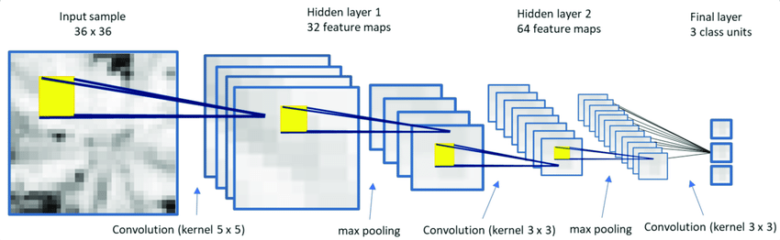

**Figure 1. Example of CNN model**

1. **Trustworthy AI**
   1. **Confidence, Reliability, and Robustness**

**Confidence Assessment:** Trustworthy AI relies on specialized drones using a combination of algorithms and models to estimate their confidence in object identifications. Confidence calculation and aggregation are key, with the master playing a pivotal role in applying these estimates.

**Reliability:** Ensuring reliable object identification is paramount, with the project focusing on minimizing false positives and false negatives. While CNNs contribute to the reliability of object identification, the master's role in decision-making and trust management further enhances the system's reliability.

**Robustness**: Robust AI systems are capable of withstanding various challenges. In object identification, robustness is achieved by addressing issues like data bias, model robustness, and generalization. The master's role in ensuring robustness in dynamic environments is integral to the project's success.

1. **Conclusion**

The state of the art in multiagent systems, machine learning, and trustworthy AI is propelling the proposed project forward. While algorithms are pivotal in various aspects, the project's primary focus is on the master's role in trust attribution, guidance, and ensuring the trustworthiness, reliability, and robustness of object identification. As these domains continue to evolve, the project is poised to leverage the latest innovations to improve object identification, decision-making, and system reliability in real-world scenarios.