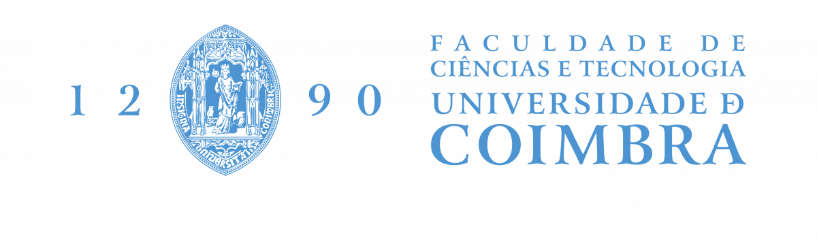

***Artificial Intelligence***

**Mastering of Tools**

**Specialized Drone Object Identification with Master Control and Confidence Assessment**

**Professor: Luís Miguel Machado Lopes Macedo**

**Group 20**

**Diogo Alexandre Santos Rosário nº 2023185395**

**João Eduardo Monteiro Raposo nº 2023147060**

**Ketevan Kartvelishvili**

1. **Introduction**

Throughout this report, we will explore the technological underpinnings that make specialized drone object identification possible. We will also delve into real-world use cases, highlighting the benefits and challenges faced by practitioners, researchers, and organizations leveraging these cutting-edge tools. Ultimately, our exploration will reveal the potential of mastering tools, showcasing how specialized drones are reshaping industries, enhancing efficiency, and broadening the horizons of what is achievable through the fusion of robotics and artificial intelligence.

1. **TensorFlow**

TensorFlow is an open-source machine learning framework developed by the Google Brain team. It's one of the most popular and widely used libraries for building and training machine learning and deep learning models. TensorFlow is known for its flexibility, scalability, and ease of use, making it a preferred choice for both researchers and developers. Here's an overview of TensorFlow and some examples of what it can do:

**2.1. Core Features:**

1. **Tensor Computation:** TensorFlow operates on tensors, which are multi-dimensional arrays, making it suitable for a wide range of mathematical operations.
2. **Automatic Differentiation:** TensorFlow provides automatic differentiation capabilities, allowing you to easily compute gradients for optimization algorithms like gradient descent.

**2.2. High-Level APIs:**

* **Keras**: TensorFlow includes an integrated high-level API called Keras, which simplifies the process of building and training neural networks. It's user-friendly and suitable for beginners.
* **TF Estimators:** TensorFlow Estimators provide a high-level API for defining complex machine learning models, handling data input pipelines, and managing training.

**2.3. Deployment Options:**

* **TensorBoard:** A visualization tool that helps you monitor and analyse the training process of your machine learning models.
* **TensorFlow Data Validation (TFDV):** A library for understanding and validating input data.

**2.4. Wide Range of Applications:**

* **Image Classification:** TensorFlow can be used to build deep neural networks for tasks like image classification, object detection, and image generation.
* **Natural Language Processing (NLP):** It's widely used for text analysis tasks, including text classification, language modelling, and machine translation.
* **Reinforcement Learning:** TensorFlow is used for developing and training reinforcement learning agents, which can be applied to games, robotics, and control systems.
* **Anomaly Detection:** TensorFlow can be used to build models for anomaly detection, helping detect unusual patterns in data.
* **Recommendation Systems:** It's used to create recommendation engines that personalize content for users.

**2.5. Community and Ecosystem:**

TensorFlow has a large and active community, which means you can find a wealth of resources, tutorials, and pre-trained models to help you get started and solve complex problems.

* 1. **Support for Hardware Acceleration:**

TensorFlow provides support for GPU and TPU (Tensor Processing Unit) acceleration, which significantly speeds up the training of deep learning models.

***Here are a few examples of TensorFlow in action:***

* **Image Classification:** Using TensorFlow and pre-trained models like Inception or ResNet, you can build image classification systems capable of recognizing objects in images.
* **Language Translation:** TensorFlow can be used to train sequence-to-sequence models for language translation, such as English to French translation.
* **Natural Language Processing (NLP):** TensorFlow can be used to build sentiment analysis models, text generation models, and chatbots.
* **Reinforcement Learning:** TensorFlow can be used for training agents to play games like chess, Go, or video games.
* **Anomaly Detection:** TensorFlow can be used to detect fraudulent credit card transactions by building models that recognize unusual patterns in transaction data.
* **Recommendation Systems:** You can create recommendation systems that suggest products, movies, or content to users based on their historical behaviour.

TensorFlow's versatility and comprehensive features make it a powerful framework for a wide range of machine learning and deep learning tasks, from computer vision to natural language understanding and beyond.

1. **YOLOv8**

YOLOv8 is the latest iteration of the YOLO (You Only Look Once) series of real-time object detection algorithms. YOLOv8 is known for its exceptional speed and accuracy in identifying and locating objects within images or video streams. Developed by Alexey *Bochkovskiy* and the *Ultralytics* team, YOLOv8 is a popular choice for computer vision tasks that require fast and efficient object detection.

**3.1. Key Features:**

* **State-of-the-Art Performance:** YOLOv8 builds upon the strengths of its predecessors and achieves state-of-the-art object detection performance with impressive accuracy.
* **Real-Time Detection:** YOLOv8 maintains the real-time object detection capability of YOLO models, making it suitable for applications requiring low latency, such as autonomous vehicles, surveillance, and robotics.
* **Flexible Architectures:** YOLOv8 offers various model configurations, including YOLOv8-S, YOLOv8-M, and YOLOv8-L, each with different trade-offs between speed and accuracy. This flexibility allows users to select the model that best suits their specific requirements.
* **Support for Multiple Frameworks:** YOLOv8 is implemented using the PyTorch framework, making it compatible with a wide range of hardware platforms and software libraries. This compatibility simplifies deployment and integration with other deep learning tools.
* **Extensive Pretrained Models:** The YOLOv8 project provides a repository of pretrained models trained on large datasets, which can serve as a starting point for various object detection tasks.
* **Object Detection on Diverse Scales:** YOLOv8 excels in detecting objects of different sizes and scales within an image, which is crucial for tasks like detecting both small and large objects in a scene.
* **Efficient Post-Processing:** YOLOv8 employs non-maximum suppression and other post-processing techniques to improve the accuracy of object localization and classification.

**3.2. Applications:**

YOLOv8 is widely used for a variety of computer vision applications, including but not limited to:

* **Autonomous Vehicles:** YOLOv8 can detect and track objects in real-time, making it valuable for self-driving cars, where timely object recognition is critical.
* **Surveillance and Security:** YOLOv8 is suitable for video surveillance, helping to identify and track objects and people in crowded or dynamic environments.
* **Retail and Inventory Management:** It can be used to monitor inventory levels, detect product placement, and track customer behavior in stores.
* **Agriculture**: YOLOv8 is applied to tasks such as crop monitoring, pest detection, and livestock tracking.
* **Robotics**: Robots can benefit from YOLOv8's object detection capabilities in navigation, object manipulation, and interaction with the environment.

**3.3. In summary:**

YOLOv8 is a powerful and efficient object detection framework known for its real-time performance and high accuracy. It is widely adopted in various industries and research domains, making it a popular choice for applications that demand rapid and reliable object detection in images and video streams. Its flexibility in model configurations and strong community support contribute to its ongoing success in the field of computer vision.