Blender

To learn to use Blender from the start, we recommend the following tutorial:
http://blender-tutorial.de/

For non-German speakers, the following page of Wikibooks provides a list of tutorials:
https://en.wikibooks.org/wiki/Blender_3D:_Noob_to_Pro/Tutorial_Links_List

Export with Blender for Unity

To be able to use exports from Blender for Unity without any troubles, use the fbx export as shown in the two figures.

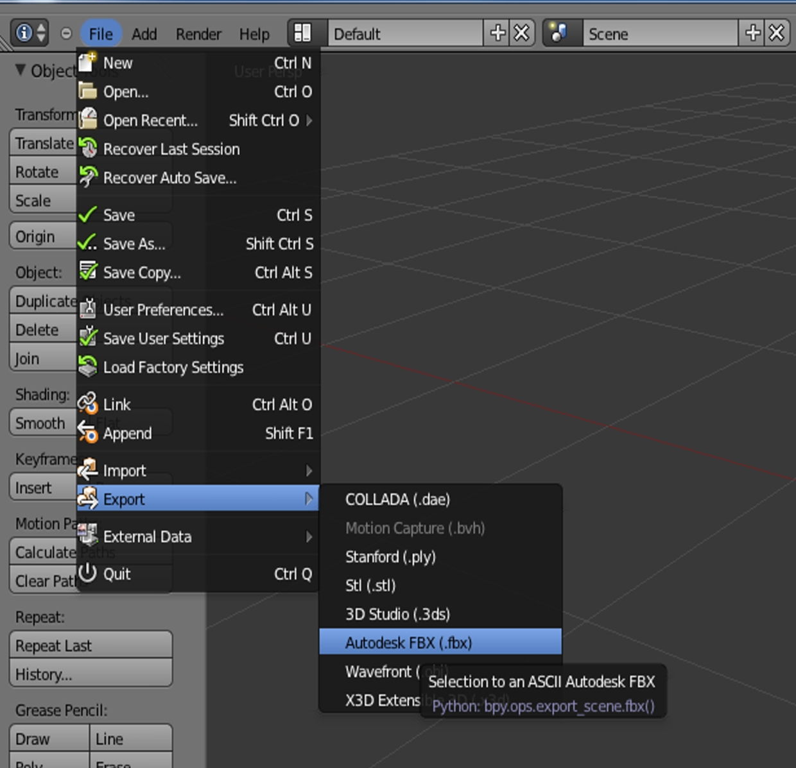
Export FBX with the following settings:

