User Documentation

How to Create Animations in DAZ 3D and Import Them in Unity 4.2
Author: Jeannine Oertel

Contents
1 DAZ 3D 2
1.1 Quick Start Guide 2
1.1.1 Loading 2
1.1.2 To Dress 2
1.1.3 Links 3
1.2 Materials and Textures 3
1.2.1 Links 4
1.3 Create Animations in DAZ Studio 3D 5
1.3.1 Example: Idle Animation 5
1.3.2 Create an Animation 6
1.3.3 Editor 6
1.3.4 Working with aniMate2 7
1.4 To Save an Animation in DAZ 8
1.4.1 Links 8
1.5 Save and Export DAZ-files 9
1.6 Save Animations for Unity 9
2 Unity 3D 10
2.1 Structure in Unity 10
2.2 Blending of Animations 11
2.3 Existing Animations of Felice in Unity 11
2.4 Split Animations in Unity 12

DAZ 3D

Quick Start Guide

Loading
- Click on Actors, Wardrobe & Props to select a character. Click on People and choose your favorite one. Now double click the character, which you want to use, and it will be loaded.

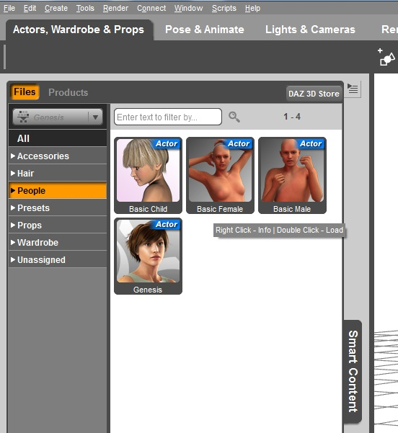

To Dress
- Click on a Wardrobe to choose the clothes for your character. Be sure that your character is still selected.
- Now you can pose or animate the character or find new textures/materials for your clothes (see following chapters).
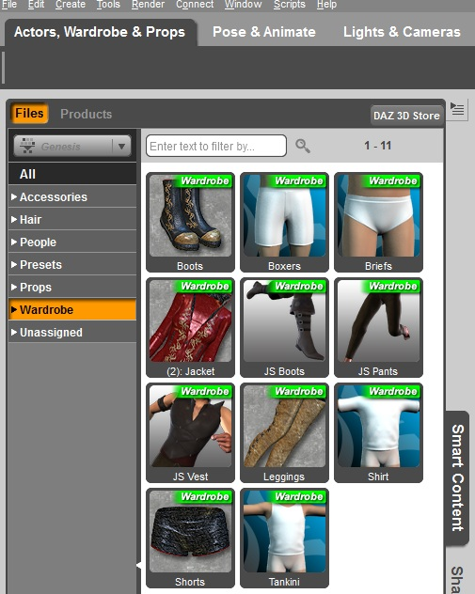

Links
- Introduction of the graphical UI: https://www.youtube.com/watch?v=ozvRcPU3mZA (English tutorials: https://www.youtube.com/watch?v=2G5IVarxTrU, https://www.youtube.com/watch?v=pUKSB0iL2k0)
- How you store and reuse your personal content / meta data: http://docs.daz3d.com/doku.php/public/software/dazstudio/4/userguide/finding_loading_and_organizing_content/videos/smart_content_files/start
- Character shaping: http://www.youtube.com/watch?v=fGVgSI7a0No

Materials and Textures
The following section describes a step-by-step guide to apply materials to your character:
- Be sure that you have a character which is dressed with wardrobes.
- Activate the surface selection tool (middle top).
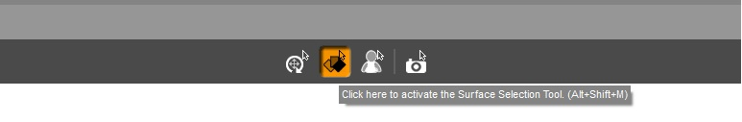
- Choose the clothes and click on them (only once).
- Now on the left side, you can see in the folder Presets the pre-built materials (seen in the left figure).
- Choose your texture with double click.
- With the Editor you can choose textures, lightning, etc. (seen in the right figure).
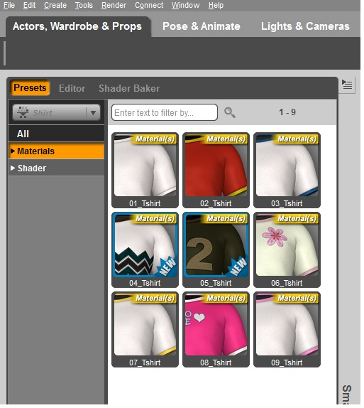
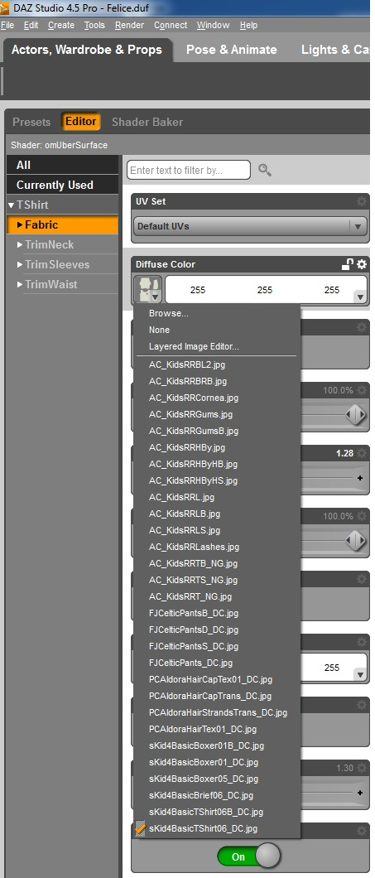

Links
Further information:
http://docs.daz3d.com/doku.php/public/software/dazstudio/4/userguide/surfaces/videos/surfaces/start

Create Animations in DAZ Studio 3D
Execute the following steps:
- Create a character (chapter 1) and save it as DAZ-file (.duf), e.g. felice.duf.
- This is your start file for every animation.
- Only save the basic position as .duf!
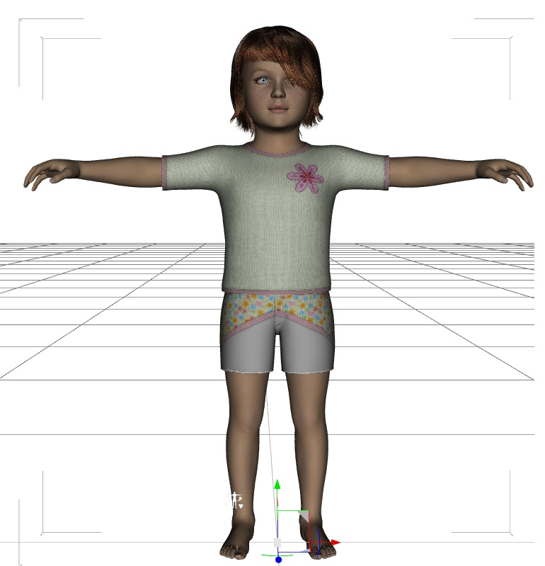
The .duf-file has always to
look like this.
- Attention: Do not overwrite the basic position with an animation or something else! Background: You have to start with the same position all the time. If you overwrite your basic position, your animations will not be similar. So you have to start again.

Example: Idle Animation
- Now create an idle animation.
- That occurs when the character does not do any action.
- To do this: choose Pose & Animate in the headline.
- Use one of the pre-assembled or create a new pose.
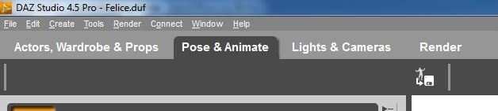
- Double click on your favorite image.
- Now you have a character and an idle-pose. Save it in DAZ and export it for Unity as a .fbx-file (chapter 4).
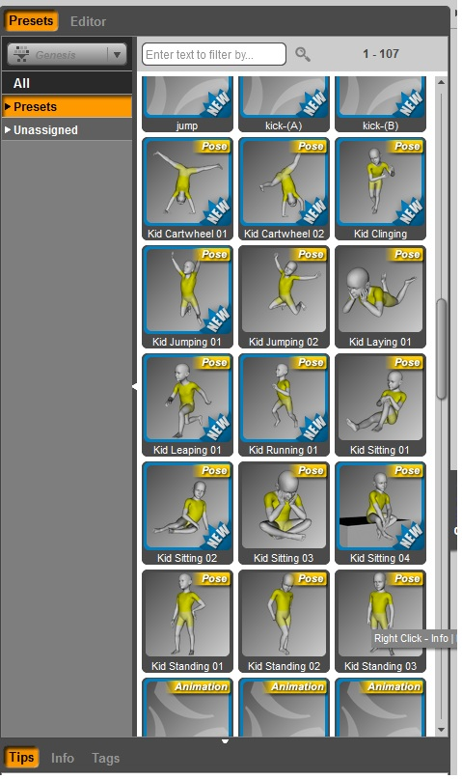

Create an Animation
- For real animations execute the following steps:
- Click on Timeline at the bottom.
- Use the features at the bottom to create and delete the frames.
- Each key frame marks the position of a part of the figure at a specific point in time on the time line. The animation then “extrapolates” the movement of the figure between the two points.
- Every node has their own key frames (select the frame with the arrow and select the right node, e. g. head).
- Click play to start the animation.
- Increase or reduce the time line on the right side for a longer animation.
- You can manipulate the animation by holding the nodes, bring them in another position or you can regulate them with the Editor.

Editor
- For working with the Editor you have to do this:
- Open Pose & Animate -> Editor
- Choose the right node at the avatar.
- Use the controller to change the position in X, Y and Z
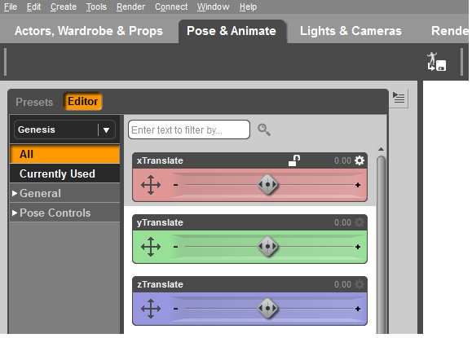

Working with aniMate2
- Tutorial → http://www.gofigure3d.com/site/?option=com_content&view=article&id=92&Itemid=86
- aniMate2 is important for storing a complex animation.
- You need to create an aniBlock of your key frames in your time line.
- Right click and choose Create aniBlock From Studio Keyframes.

- Thereafter the aniBlock will be created.
- Now save this new block in DAZ3D Studio for following projects.
- Right click on the blue aniBlock and choose Save As New.
- Then you will find it every time on the bottom.
- Double click to select your animation.

To Save an Animation in DAZ
- Now save the ready character with the animation and export the file as a .fbx (chapter 1.5).
- You can also save the files in DAZ (so you can use it in other projects). For saving in DAZ, click on the button which is shown below.
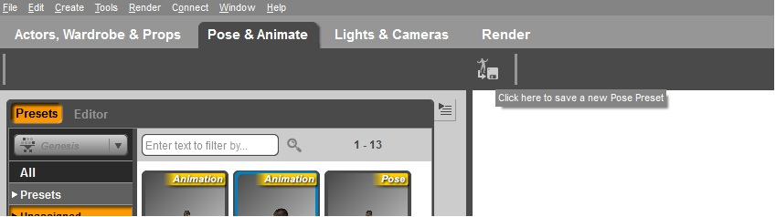
- Choose the correct folder and save it with a reasonable name (e. g. “idle” or “look_left”).
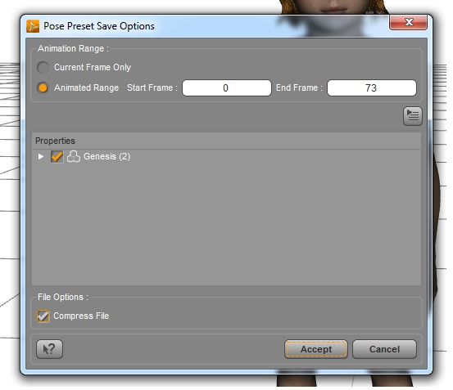

Links
- Posing Tutorial: http://www.youtube.com/watch?v=ELIUID6OR00

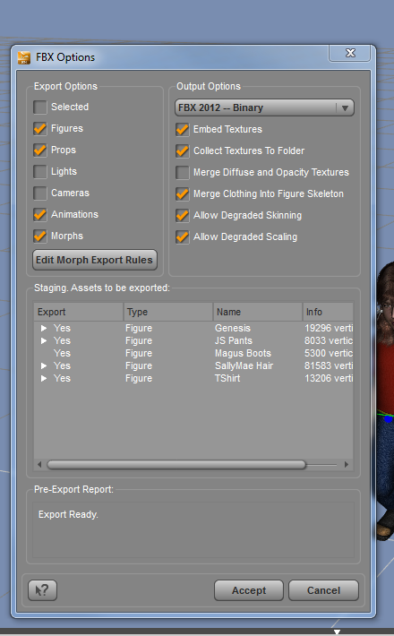
Save and Export DAZ-files
- At first, you have to create the character without the animations. You have to save and export this character only once.
- Export the file as a .fbx-file with the settings on the right figure. Name it like your character (e. g. “felice”).
- Now design an animation with this character. Save it as a DAZ-file like in Chapter 3 and export it as a .fbx-file.
- Export the second file with the same name like the first file and the name of the animation.
- Recommended name of the second file: <main character>@<name of the animation>.fbx
- Start creating the next animation with the basic DAZ-file (.duf) (see beginning chapter 3).

Save Animations for Unity
- Save all animations of the same type in one file (e. g. grasp).
- This method is better for a good and structured overview and should be used.
- Additionally, it saves disk space and improves the performance.
  - Choose all of your grasp animation-aniBlocks.

  - Save them as felice_grasp.fbx (chapter 5).
- Import this file into Unity.
- Split this one animation in their parts (Unity documentation).

Unity 3D

Structure in Unity
- DON’T TOUCH THE ASSETS FOLDER! Only copy, delete or rename in Unity.
- Every folder with 3D-Objects has a folder with materials.

Kinderzimmer
common
furniture, decoration,pillows...
cars
sweets
unused
experiment
Categorization
only folders, no 3D-Objects
toys
cars
sweets
pens
labyrinth
toys
pens
assets
Labyrinth World
Children's room
Lego
blocks
Lego
lerpz
childroom
animations
objects
physic materials
Plugins
prefab
Resources
Scenes
Sounds
Textures
Standard Assets
Scripts
only folders, no 3D-Objects

Blending of Animations

- Blends two or more animations with the added relation/weight. You can also define blending between two or more animations, for example to define a grid of grasping animations like used in the experiment with the table and the objects.

- if (Input.GetKey (KeyCode.Y)) {

gameObject.animation.Blend ("show_left", 0.1F, 10F);
gameObject.animation.Blend ("show_middle_high", 0.5F, 2F);

a * b = 1
This relation of the two animations is 50% to 50%.

Existing Animations of Felice in Unity

Currently, there are two animation sets of Felice in Unity. The grasp file includes 16 grasp animation and the point file includes five point animations. They were split in Unity and added to the body of Felice in the scene.
In the following figures you can see the names and end positions of these animations. You will find the coordinates of the grasp animations in the document “Animation_Coordinates.ods”.

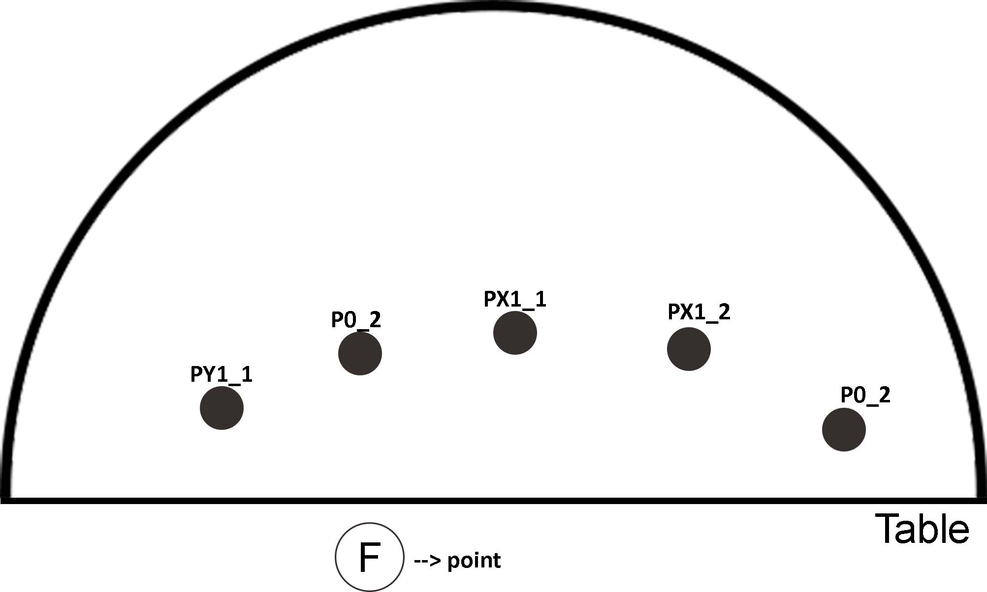
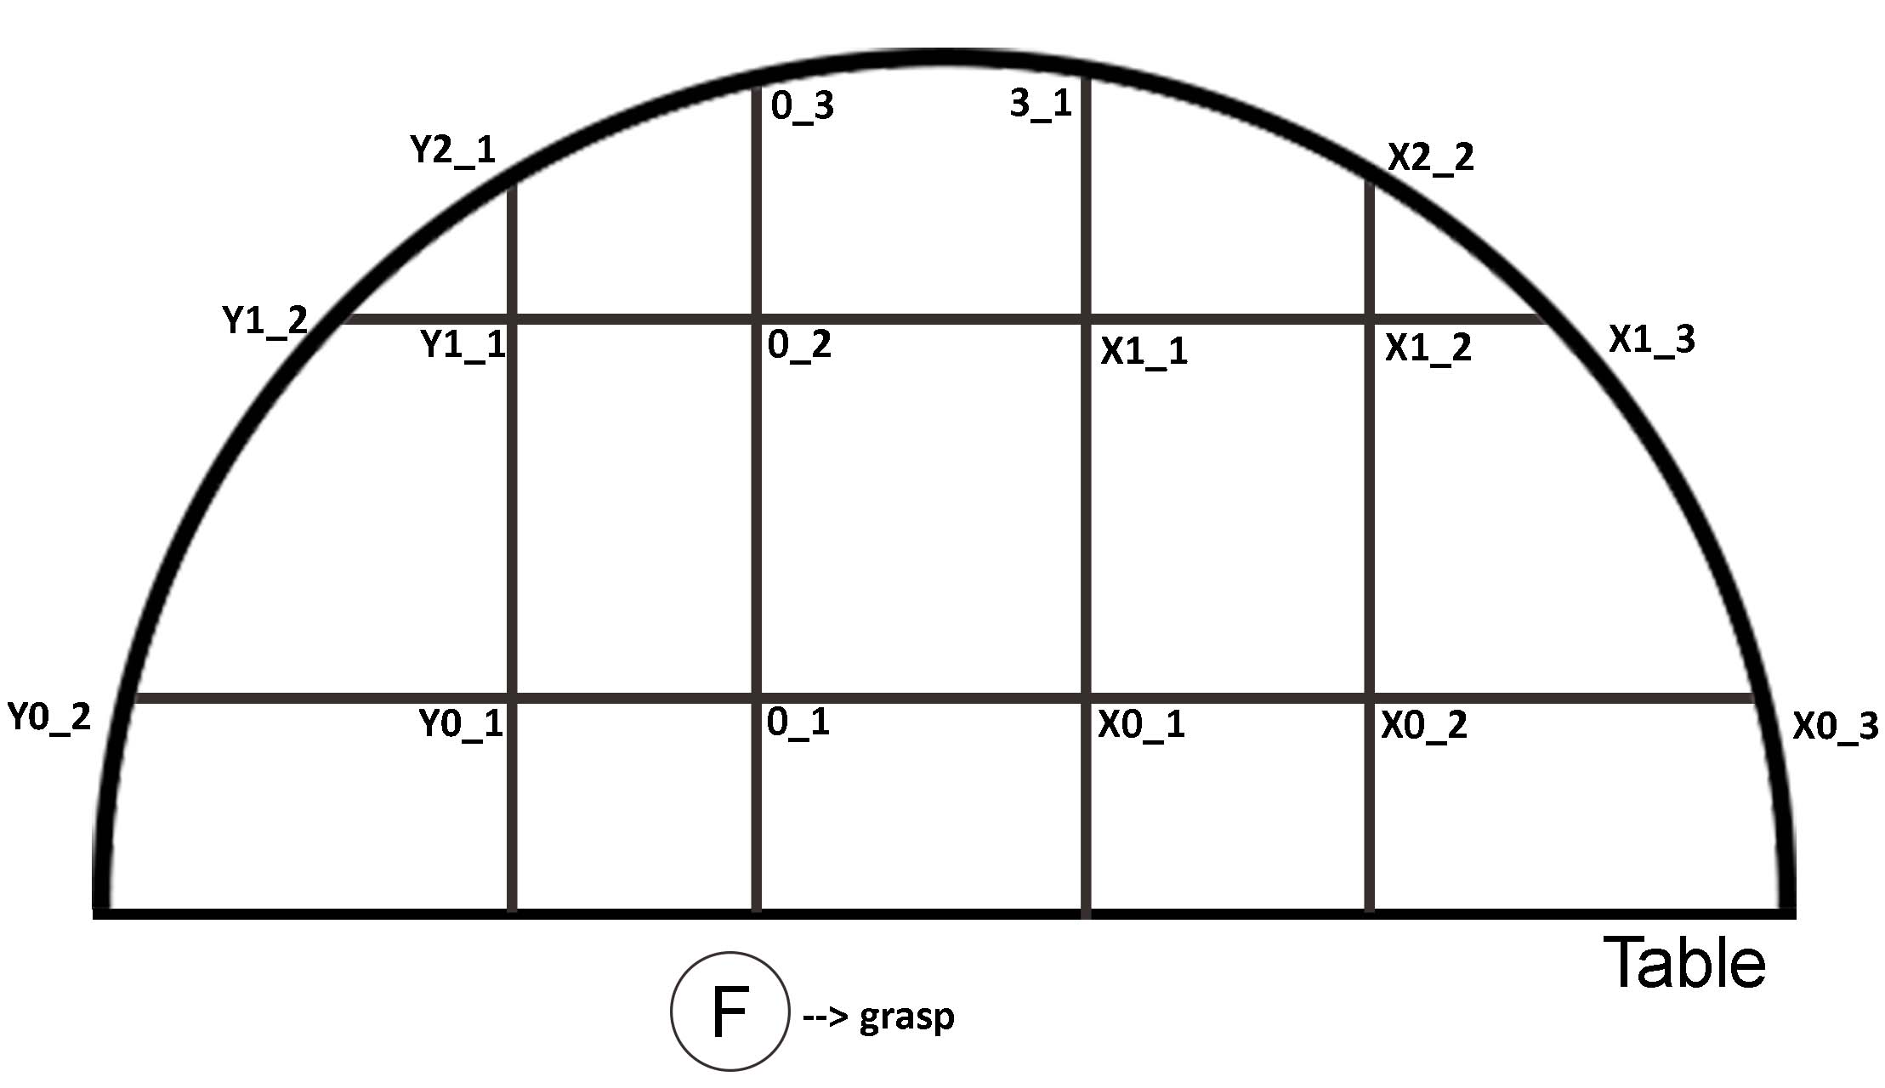

Split Animations in Unity
There are two ways to import new assets like our animations.
- Drag and drop the file in the correct folder in Unity.
- Right-click in the correct folder in Unity and choose Import New Assets...
Thereafter, left-click on the animation set. Now on the right side, you see the tool for the animation splitting. Left-click on the animation set (right) and select the start point and end point of your animation. After that, rename your animation. Then, click the plus button and you will get a new tab for a new animation. Choose your start point and end point and rename this animation. Repeat this steps until your whole animation is split.
Now left-click on Felice in the scene. On the right side, you will see the animation functions. Insert the number of your animations in size (top). Thereafter, you can choose your animations. Choose one of the Elements and click on the right circle. There you see all of your created animations. Choose the one you need for an experiment and left-click on it. Then, you will see it in the field on the right side.

Another important setting is the legacy rig property. Left-click on the animation set. Click Rig on the right side (top). After that, choose Legacy in Animation Type. Without this the animations will not work.

