- For GLLP-Route-Seed-Diagnostic-2026116.md, I accept the propesd bounded scope for review. Lets make that at ticket in the Trello board, and start that before any continued development.
- Genome Path unlock path shown below, each tier has the costs associcated with unlocking or leveling up the requisite genome upgrade. 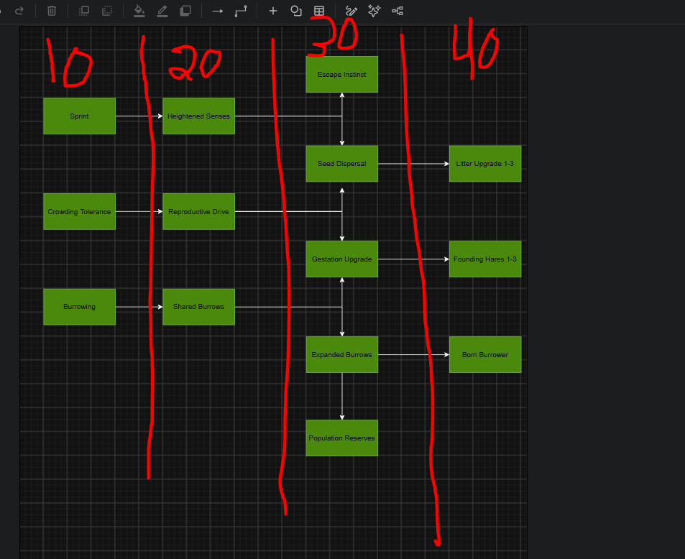
Litter Mutation ranks will increase maximum litter size by 1, up to a max of 3. Same Minimum Litter upgrade with automaticcaly go to 2 if you have the litter upgrade level 3 unlocked.
- A hare with define a threat being passed as soon as a fox is no longer in attack range. If all emergence cells are occupied, allow the burrow to stay untill a cell clears up and can be occupied by the inhabitants of the burrow. A hare can only create one burrow for itself, but if shared burrow is active, they could have access to many burrows.
- This will continue to stay open at this point in time. You can use whatever makes sense for now, and we can tune and define it more later.
- Lets create a 4 simulation 3 shop journey so we can implement 1.5x, 1.75x, 2x in the player facing shop correctly.
- Keen senses should allow for longer range detection of predators.
- Reproduction chance should start at .5

