Final Project Report
Consumer360 – Retail Customer Analytics & Churn Risk Identification System
Author: Salu Ann George
Project: Enterprise Data Analytics – Project 1
Organization Context: Infotact Solutions

Executive Summary
Consumer360 is a comprehensive, end-to-end retail analytics solution developed to transform raw transactional sales data into actionable customer intelligence that directly supports business decision-making. The project addresses a critical retail challenge: understanding customer behavior at an individual level in order to improve retention, maximize customer lifetime value, and reduce churn.
The solution integrates SQL-based data engineering, Python-driven analytical modeling, and interactive Power BI dashboards into a unified production-style pipeline. Through systematic data cleaning, feature engineering, and behavioral analysis, the system builds a robust Recency, Frequency, and Monetary (RFM) segmentation framework. This framework classifies customers into meaningful business segments such as Champions, Loyal Customers, Potential Loyalists, At-Risk, and Hibernating, enabling targeted and personalized marketing strategies. In addition to segmentation, the solution incorporates cohort analysis to evaluate long-term customer retention trends and purchasing patterns over time. This allows business stakeholders to assess the quality of customer acquisition periods and measure how customer engagement evolves across different cohorts.
A key strength of Consumer360 is its automated architecture. The complete ETL and analytics workflow is productionized using Python and scheduled execution, ensuring that customer scores, segments, and churn-risk indicators are refreshed regularly without manual intervention. This guarantees that decision-makers always have access to the most up-to-date insights.
The final output is delivered through executive-level Power BI dashboards that present intuitive visualizations, dynamic filters, and a dedicated churn-risk customer action list. These dashboards empower business leaders and marketing teams to quickly identify high-value customers, monitor retention performance, and proactively intervene with customers showing early signs of churn. Overall, Consumer360 demonstrates how automated data analytics can convert operational retail data into a strategic asset that drives revenue growth, customer loyalty, and informed business planning.

Business Problem
In today’s highly competitive retail environment, organizations are facing increasing pressure from declining customer loyalty, reduced repeat purchases, and rising customer churn. While large volumes of transactional data are being generated every day, most retail businesses still rely on traditional reporting systems that focus mainly on overall sales, revenue, and product performance.
These conventional reports are descriptive in nature and fail to answer critical business questions such as:
- Who are our most valuable customers?
- Which customers are slowly disengaging and likely to churn?
- How do customer behaviors change over time?
- Which customer groups should be targeted with specific marketing strategies?
The objective of this project was to build a scalable and automated customer analytics system to support data-driven marketing and retention strategies.

Data & Tools
Data Source
- Retail transactional sales dataset
- Includes orders, customers, products, dates, regions, and revenue

Technology Stack
- MySQL: Data storage, schema design, and structured querying
- Python (Pandas, SQLAlchemy): Data cleaning, RFM modeling, automation
- Power BI: Interactive dashboards and business visualization
- Windows Task Scheduler: Automation and scheduled execution
Github Link:
https://github.com/SaluAnnGeorge/Retail-Customer-Analytics-RFM-Cohort-Analysis-

Solution Architecture
The solution follows a modern analytics pipeline:
MySQL Database → Python ETL & RFM Engine → Processed CSV → Power BI Dashboard
Architecture Components:
- SQL layer manages raw and cleaned transactional data
- Python layer performs feature engineering, RFM modeling, segmentation, and output generation
- Power BI layer delivers interactive dashboards for business users
- Automation layer schedules the pipeline to refresh insights daily
This architecture ensures scalability, modularity, and production readiness.

Methodology

5.1 Data Engineering (Week 1)
- Designed structured tables and validated schema
- Cleaned raw data (date conversion, null handling, consistency checks)
- Created SQL views for consolidated customer-level data
5.2 Analytical Core – RFM Modeling (Week 2)
RFM analysis was used to quantify customer behavior:
- Recency: Days since last purchase
- Frequency: Number of transactions
- Monetary: Total revenue generated
Customers were scored from 1 to 5 for each dimension and combined into an RFM score. Based on score ranges, customers were segmented into:
- Champions
- Loyal Customers
- Potential Loyalists
- At Risk
- Hibernating
This enabled behavioral classification aligned with business use cases.
5.3 Dashboard Construction (Week 3)
Power BI dashboards were developed to visualize:
- Sales and customer trends
- RFM segment distribution
- Cohort retention matrix
- Regional performance
- Churn-risk customer table
Row-Level Security (RLS) was implemented to restrict regional views for managers.

5.4 Automation & Productionization (Week 4)
- Converted RFM logic into a production-style Python pipeline
- Automated execution using Windows Task Scheduler
- Validated full end-to-end refresh from database to dashboard
- Created churn-risk action list for business handoff

Key Analytical Findings

- A small percentage of customers contribute a disproportionately large share of total revenue.
- Champions and Loyal Customers demonstrate high frequency and monetary value.
- At Risk customers exhibit increased recency and declining engagement.
- Recent customer cohorts show stronger retention compared to older cohorts.
- Churn-risk customers can be identified early and targeted proactively.

Automation & Deployment
The entire RFM pipeline was automated using Windows Task Scheduler.
The system executes daily without manual intervention and performs:
- Data extraction from SQL
- RFM recalculation
- Customer re-segmentation
- Output refresh for Power BI
This automation ensures dashboards consistently reflect the most current customer behavior patterns.
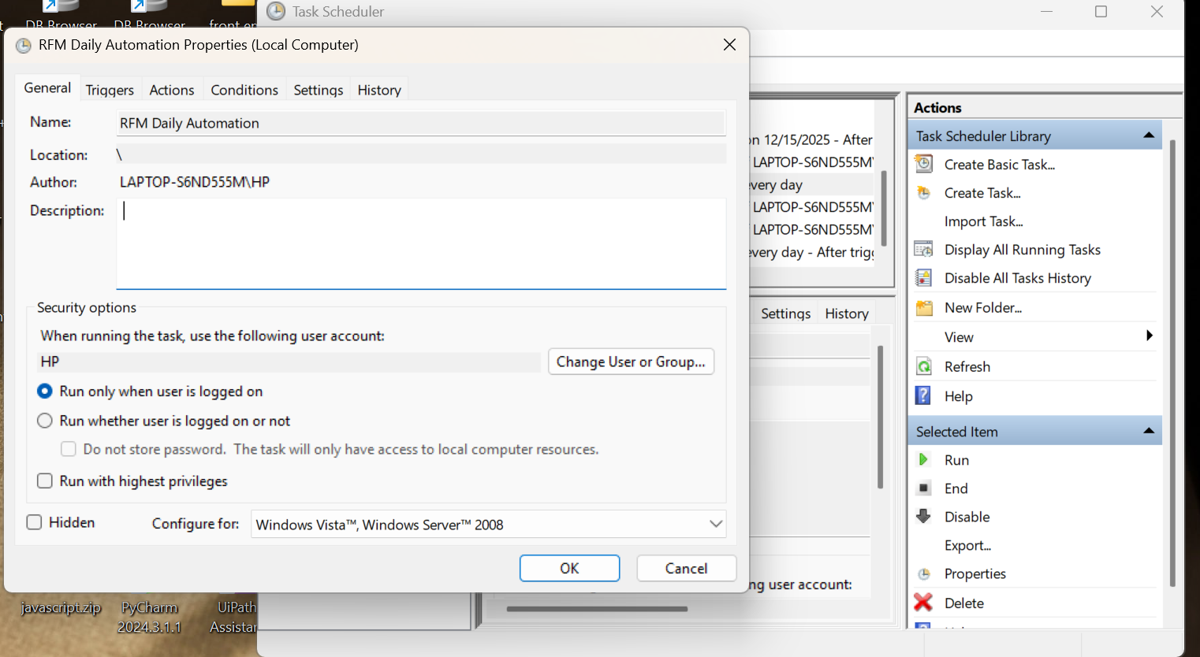

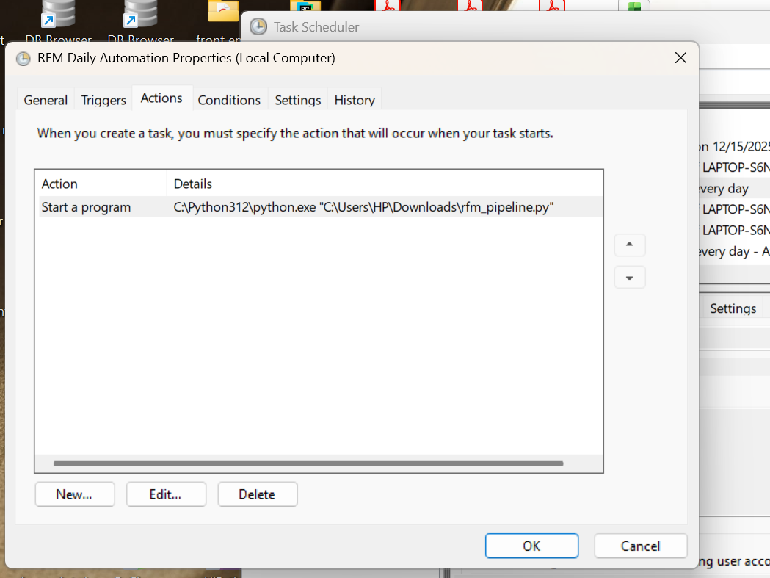
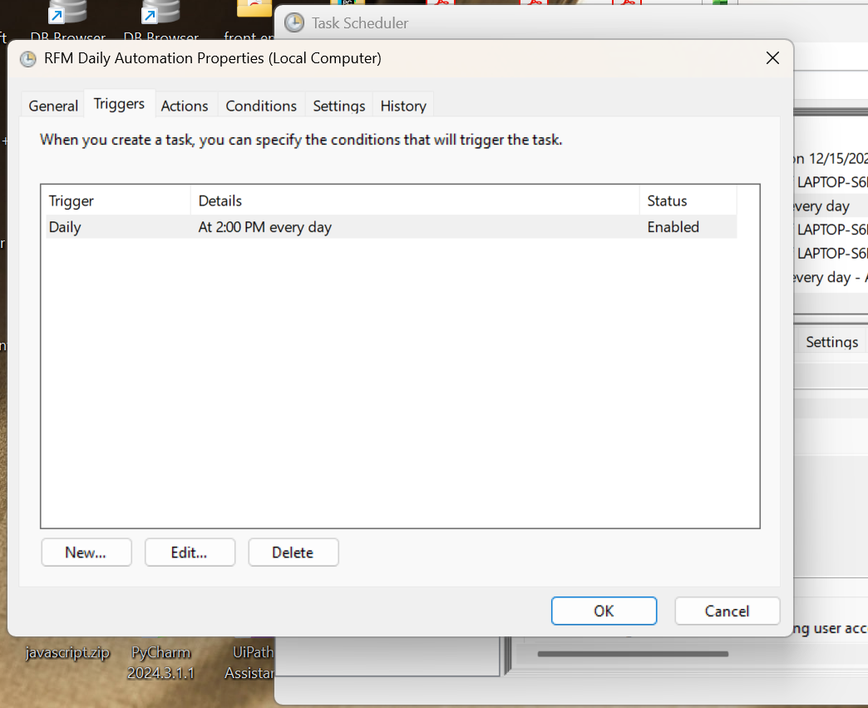

Conclusion

The Consumer360 solution demonstrates how an automated analytics framework can effectively transform raw transactional data into strategic customer intelligence. By integrating data processing, behavioral modeling, and visualization into a single pipeline, the system moves beyond traditional sales reporting to deliver actionable, customer-level insights.
The solution enables the business to identify high-value customers, segment the customer base meaningfully, and detect early churn signals, empowering marketing and retention teams to take proactive, data-driven actions. Executive-ready dashboards provide a clear, real-time view of customer health, revenue concentration, and retention trends.
Overall, Consumer360 establishes a scalable and automated decision-support system that enhances customer understanding, strengthens retention strategies, and supports long-term revenue growth.

