ABILITIES SYSTEM

In RPG (Role-Playing Game) video games, ability systems are crucial mechanics that govern the actions and capabilities of the player's characters. These systems provide players with a variety of skills, spells, and talents to customize their characters and enhance their gameplay experience. Here's a description of common types of ability systems in RPG video games:

- Class-Based System:

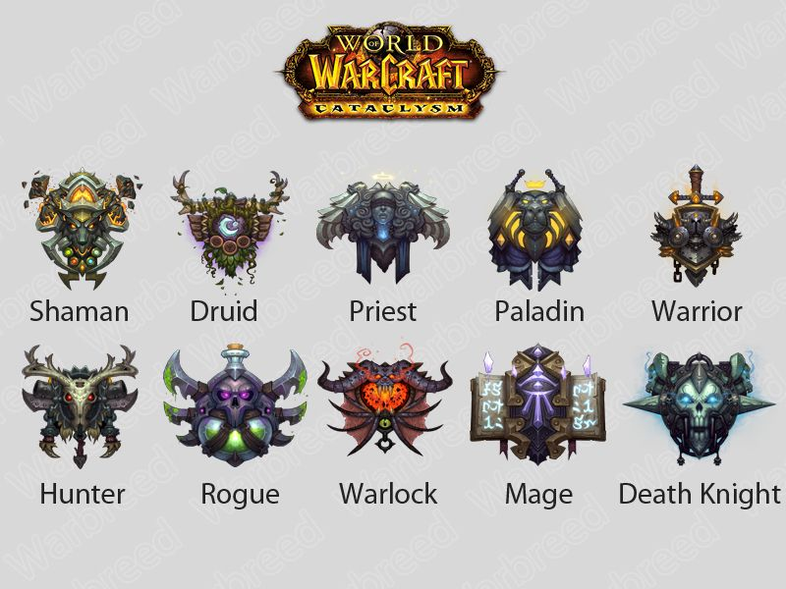
- Description: In a class-based system, characters are assigned to specific classes or professions, each with its own set of predetermined abilities. These abilities typically align with the theme and role of the class, such as warrior, mage, rogue, etc.

- Types: Classes can include melee fighters with high strength and defensive abilities, spellcasters with powerful magical spells, stealthy rogues with agility-based skills, and more. Players choose a class at the beginning of the game or during character creation.

- Example: In the RPG game "World of Warcraft," players choose from various classes such as Warrior, Mage, Rogue, Priest, etc. Each class has its own unique abilities, strengths, and playstyles. For instance, Warriors excel in melee combat with high health and heavy armor, Mages wield powerful spells for ranged damage, and Rogues specialize in stealth and dealing burst damage from behind.

- Skill Trees/Progression System:

- Description: Skill trees offer players a more flexible approach to character development, allowing them to customize their characters' abilities by investing points into various skill branches. Skills are often categorized into different trees, such as combat, magic, and utility.

- Types: Players can specialize in specific branches of skills, unlocking more powerful abilities as they progress. Some games feature linear skill trees where unlocking one skill leads to access to others, while others offer more open-ended progression, allowing players to mix and match skills from different branches.

- Example: In "The Elder Scrolls V: Skyrim," players progress their characters' abilities through skill trees known as "perks." As players level up, they can invest points into different perk trees corresponding to skills like One-Handed Weapons, Destruction Magic, Sneak, and Smithing. Each perk provides specific bonuses or unlocks new abilities, allowing players to tailor their characters' development to their preferred playstyle.

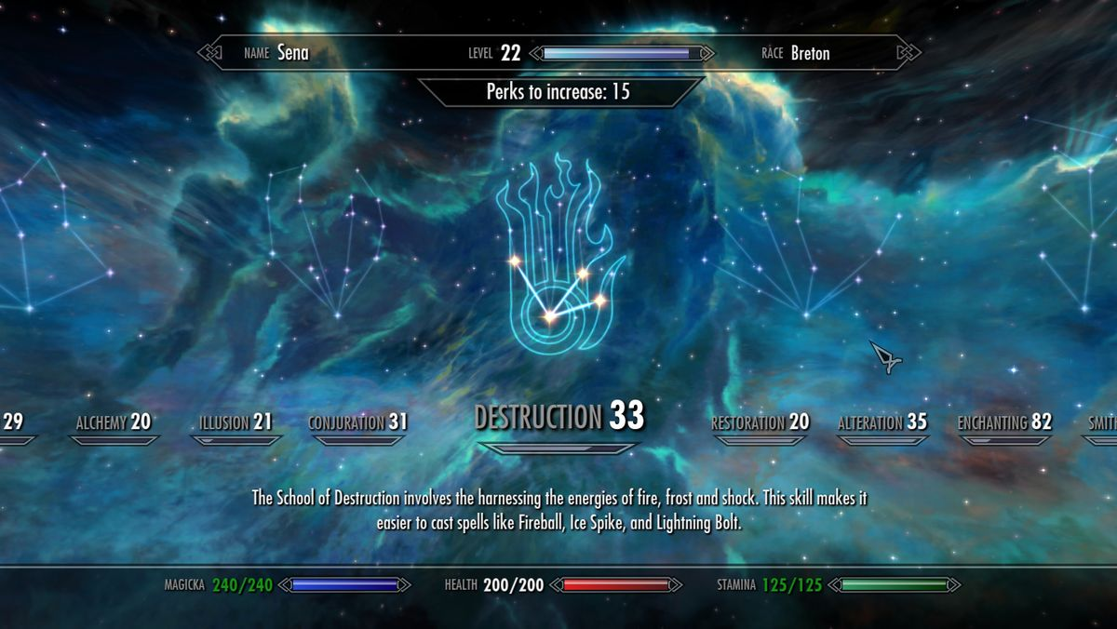

- Ability Points Allocation:

- Description: In this system, players earn ability points through leveling up or completing quests, which they can then allocate to different abilities or attributes of their characters. This allows for more direct control over character customization.

- Types: Players can distribute points into attributes like strength, agility, intelligence, etc., or invest in specific abilities such as weapon proficiency, spellcasting, stealth, and more. The allocation of points often determines the effectiveness of the character in different aspects of the game.

- Example: In the RPG "Dragon Age: Origins," players earn ability points as they level up, which they can allocate to attributes like Strength, Dexterity, Magic, and Cunning, as well as specific abilities within their chosen class. For example, a Warrior character might invest points into Strength to increase melee damage and into abilities like Two-Handed Weapon Mastery or Shield Defense for combat specialization.

- Learn by Doing/Experience-Based System:

- Description: Characters in this system gain abilities and skills through practice and experience rather than through predefined classes or skill trees. As characters perform certain actions repeatedly, they improve in those areas, unlocking related abilities.

- Types: Characters might become more proficient in weapon usage by using specific types of weapons frequently, or they might learn new spells by casting spells of a certain type. This system often emphasizes hands-on experience and experimentation.

- Example: In the action RPG "Dark Souls," characters improve their combat skills through practical experience gained in battles. As players engage in combat encounters, they become more proficient in weapon usage, dodging, and timing their attacks. With practice, players learn to read enemy patterns and adapt their strategies accordingly, gradually mastering the game's challenging encounters.
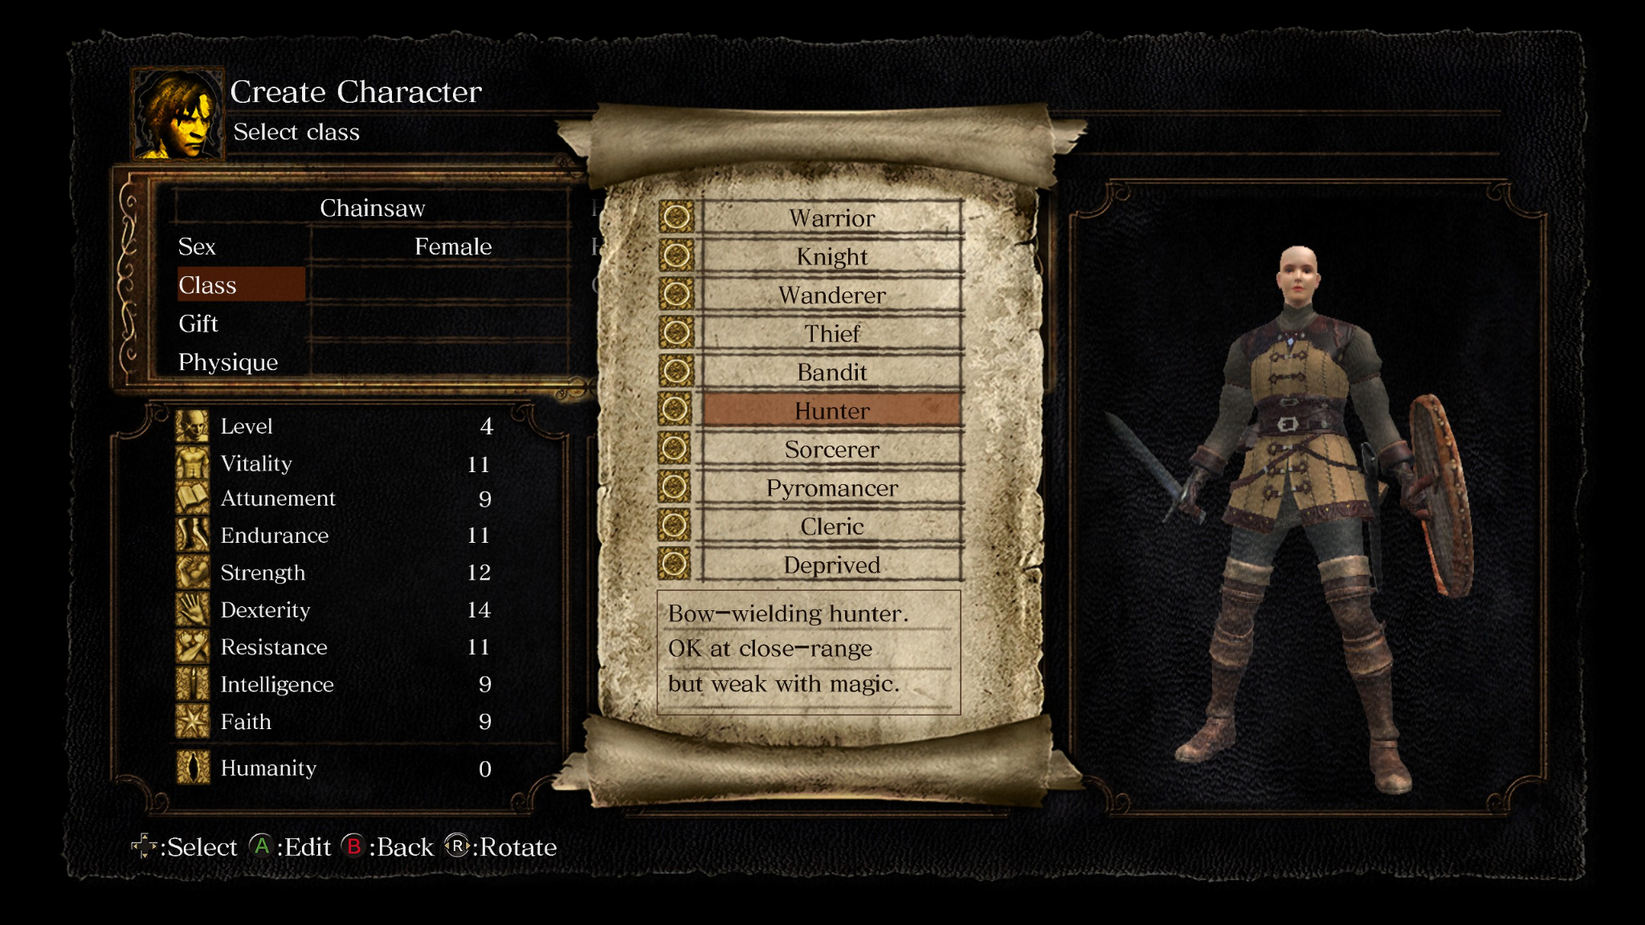

- Combo-Based System:

- Description: In a combo-based system, players string together sequences of actions or abilities to create powerful combinations or synergies. Successful execution of combos often requires timing, strategy, and coordination between different abilities.

- Types: Combos can involve chaining together specific attacks, spells, or maneuvers in a particular order to unleash devastating effects or gain strategic advantages. Mastery of combos is often rewarded with increased damage output or additional effects.

- Example: In the RPG "Divinity: Original Sin 2," players can execute combos by combining different elemental spells and environmental effects. For instance, casting a Water spell to create a puddle on the ground and then using a Lightning spell to electrify the water, shocking enemies standing within it. These combos deal additional damage and apply status effects like Stunned or Frozen.

- Equipment-Based Abilities:

- Description: Some RPGs tie abilities or skills to specific equipment or items that characters possess. Characters gain access to these abilities only when equipped with the corresponding items.

- Types: Equipment might grant passive bonuses or active abilities that characters can utilize in combat or exploration. For example, a sword might grant a special attack or a piece of armor might provide a defensive buff when worn.

- Example: In the MMORPG "Final Fantasy XIV," players can equip various weapons, armor, and accessories that grant unique abilities or bonuses. For example, equipping a sword and shield might grant access to defensive abilities like "Shield Bash" or "Block," while wearing a specific set of armor could provide passive bonuses like increased health regeneration or resistance to status effects.
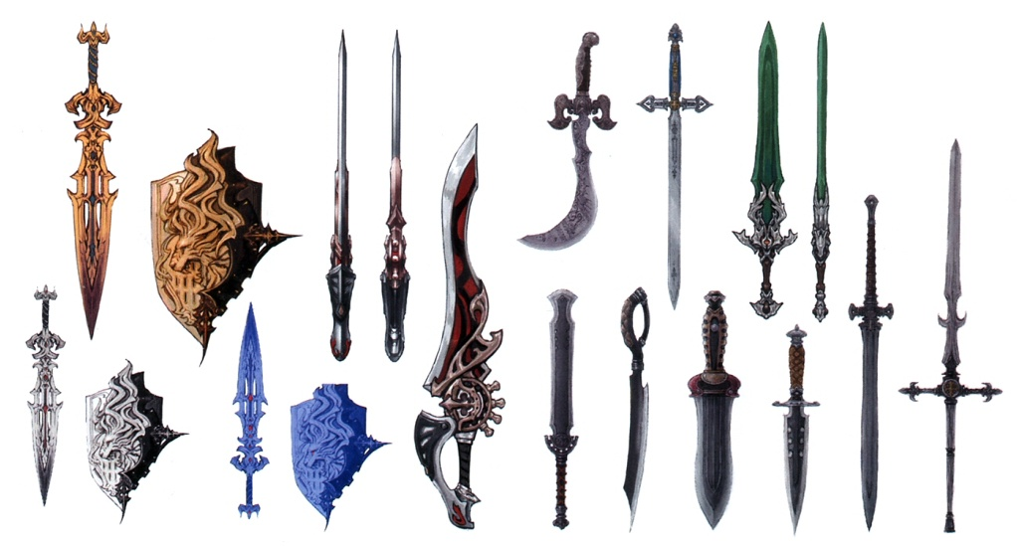

These are just a few examples of the diverse ability systems found in RPG video games. Many games combine elements from multiple systems to create unique and engaging gameplay experiences tailored to different playstyles and preferences.

POKEMON

Certainly! Let's explore how these ability systems could be implemented in a Pokémon game:

- Class-Based System:

- Description: Pokémon games often feature different trainer classes, each specializing in specific types of Pokémon and battle strategies. Trainers can choose their class or specialty, determining the types of Pokémon they encounter and the abilities they have access to.

- Types: Classes could include Pokémon trainers specializing in offensive strategies with strong physical attackers, defensive trainers focusing on tanky Pokémon with high defensive stats, and elemental specialists using Pokémon with specific types like Fire, Water, or Electric.

- Skill Trees/Progression System:

- Description: Trainers could have access to skill trees representing different aspects of Pokémon training, such as battling, breeding, and exploration. They earn skill points through battles and completing tasks, which they can allocate to various skills and abilities.

- Types: Skills might include improved Pokémon training techniques for faster leveling, breeding abilities to pass down specific moves or IVs (Individual Values), and exploration skills for finding rare items or encountering special Pokémon in the wild.

- Ability Points Allocation:

- Description: Trainers could earn Ability Points (AP) as they level up, which they can allocate to different attributes or abilities for themselves and their Pokémon. This system allows trainers to customize their playstyle and enhance their team's strengths.

- Types: Trainers might allocate points into attributes like Strength (increased damage output), Agility (faster Pokémon), and Intelligence (improved strategy and tactics). For Pokémon, points could enhance stats like Attack, Defense, Speed, or grant access to new moves.

- Learn by Doing/Experience-Based System:
- Description: Pokémon gain experience points (EXP) through battles, leveling up, and learning new moves. As Pokémon gain experience in battles, they become stronger, learn new moves, and evolve into more powerful forms.

- Types: Pokémon become more proficient in specific types of moves through repeated use, unlocking new moves within their movepool. For example, a Fire-type Pokémon might learn more powerful Fire-type moves as it gains experience in battles.

- Combo-Based System:

- Description: Trainers and Pokémon can execute combos by strategically chaining together moves and abilities during battles. Successful combos can result in increased damage, status effects, or other advantages in battle.

- Types: Trainers might coordinate moves between their Pokémon to trigger combo attacks, such as setting up a Fire-type move with a move that creates a sunny weather condition, boosting the power of Fire-type moves.

- Equipment-Based Abilities:
- Description: Trainers can equip items like held items or accessories to their Pokémon, granting them passive bonuses or access to special abilities during battles.
- Types: Held items might boost a Pokémon's stats, protect them from status conditions, or trigger special effects during battle, such as healing or increasing critical hit rate.

By incorporating these ability systems into a Pokémon game, players would have more options for customization and strategic depth, enhancing the overall gameplay experience.

