ECO-CITY RESCUE!

GAME DESIGN DOCUMENT

1. GENERAL VISION (Empathy and Definition processes)
- Description and synopsis of the video game (general description of the game and how it is expected to facilitate learning processes).
The game is a story about a teenager that wants to help make the planet healthier, it faces challenges that portray day by day things we ignore to be more cautious with what resources we use.
Some challenges the player may face is how to sort different types of garbage and how this could affect if paired together or ignored at all. Some characters can oppose and try to bring down the player to make it more interactive and not a very straight forward story.
The rough idea for the levels are 2/3 minigames depending on the environment the plates are in, for example in your house you have to play to turn off lights your family leaves on and have decreasing “health” rapidly if lights stay on after they have left the room.
Another minigame is a sorting game in which different types of waste are falling from the top of the screen and you have to drag them to their respective bin/bag to dispose of them carefully
- Target audience (description including an empathy map).
Our main target audience would be teenagers and young adults, (from 13 to 20) focusing on how to teach them to help around their houses and help them be more insightful if their living by their own

- Stakeholders map / matrix.
 | High power | Low power
High interest | Teachers and green organizations | Students and young adults in schools
Low interest | Users, influencers | Students who are unfamiliar or have a low interest in the subject.

- Other contextual information (i.e: in which context is the game expected to be played? At schools, with the help of actual teachers, etc).
This game can be played at schools for teaching about the environment and as support for recycle or green events. Preferably as a group activity to promote talk between users and be more interactive
- Number of players. In case of multiplayer: cooperative or competitive?
The game is single player, as its meant to be a more personal experience for the player, being able to engage the challenges thrown by the game in any way and any pace they want.
- Platform and main technologies (desktop, console, smartphone, VR, sensors?). The game is aiming need low requirements so it could be playable in a variety of different devices, with pc’s and smartphones as the main target, but it could also be implemented in consoles. Aiming it mainly at devices with easy access to everyone, like desktop or smartphone we could make the game more approachable from an educational standpoint.
- Market study of similar serious games. What elements differentiate this game from other titles?
We can find similar games like Water Crisis Simulation or Orano Simulation. The main difference between our game and similar titles is the approach, with our game aiming at targeting younger generations from a more approachable and relatable stance.
- List of the game’s learning goals.
1. Teaching to classify complex residue correctly (like batteries, organic residue, plastics…)
2. Teaching the differences between renewable an non renewable energies.
3. Encourage long term thinking and responsibility in regard to the cause and effect of contamination.

2. DESCRIPTION OF THE GAME. MECHANICS / DYNAMICS / AESTHETICS (Ideation and Prototyping phases).

2.1 CREATIVE REFERENCES
- Aesthetic / Creative references (mood board).
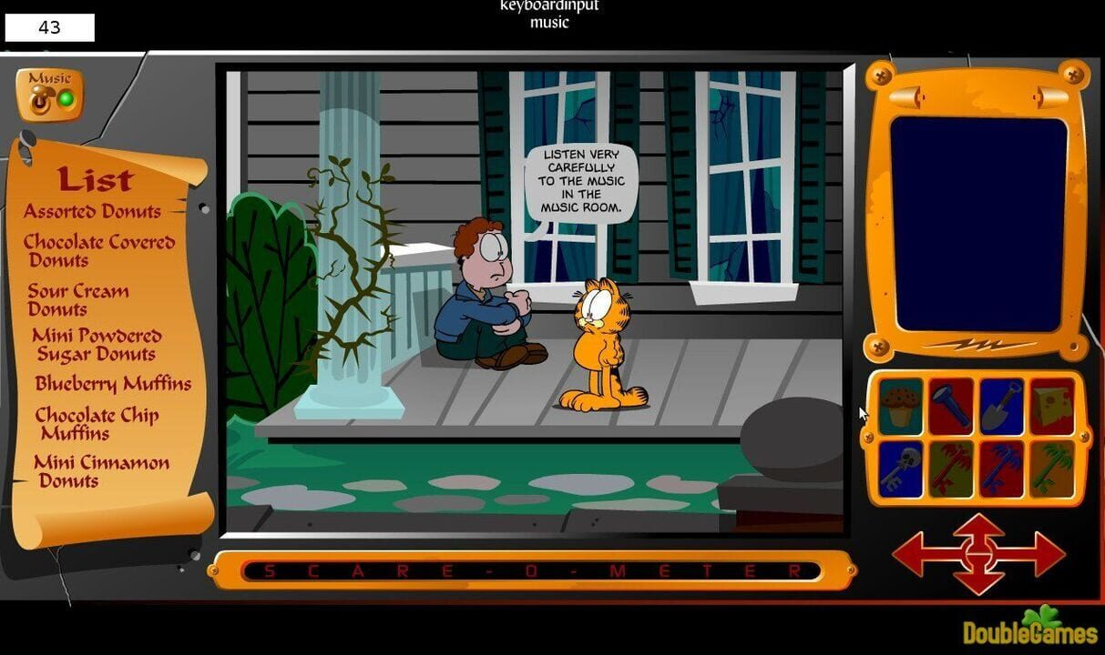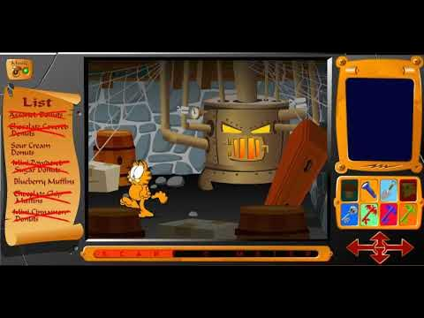
Game interface idea, list of objectives, intractable people and objects and the “health” mechanic that would start low and begin to increase and show itself on the environment by it seeming more clean
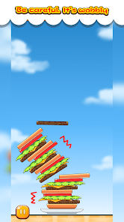 Idea for one minigame

2.2 MECHANICS
- Actions
  - Sorting, “high speed” reflexes to drop objects on their respective bin tapping/clicking on the screen.
- Rules
  - Objectives of the main game character / player.
The main player’s objective in the game is to clean the planet and reduce contamination and waste in any way they can, progressing during the game in the scope of their actions. (Starting with their room and progressing to promoting responsible behaviour outside)
  - Victory and defeat conditions (if any).
The game consists of a series of minigames encountered during the three areas the game takes place in with a point and click gameplay style the player will have to win the minigames to progress and follow through the areas until the end of the game.
  - How does the player progress in the game, is it a linear progression, can the player choose the levels to play (adaptive criteria), are there optional quests (adaptive criteria)?
The game follows a mostly linear progression, with the three main levels following a linear structure but the three mini games in each level being able to be done in any order the player chooses.
  - Are there rewards and penalties?
There is not an intrinsic system of rewards and penalties other than the game encouraging the user to keep engaging with the gameplay using a fun and replayable gameplay structure.
More than a penalty the player will notice a significant decrease in dirty streets if the minigames are completed correctly, the world only gets better if we all help a little
  - Obstacles and challenges:
The player can overcome obstacles through environmental awareness and the correct application of sustainable practices learned throughout the game. Rather than using weapons or combat, players rely on observation, recycling knowledge, resource management, and educational challenges to progress.

Careless Family Members (Level 1 – House)
Family members move through different rooms leaving lights, televisions, and electronic devices turned on.
Effects on the player:
- Increase the household's energy consumption.
- Reduce the Cleanliness/Energy Efficiency bar.
- Force the player to quickly locate and deactivate appliances.
Location:
- House environment.

Movement Pattern:
- NPCs follow predefined routes between rooms.
- Randomly leave devices turned on when leaving a room.
How to overcome:
- Follow NPCs and switch off devices before energy waste reaches critical levels.

Littering Citizens (Level 2 – Town Square)
Some citizens randomly throw cans, plastic bottles, and paper waste on the ground.
Effects on the player:
- Increase the pollution meter.
- Create additional waste that must be collected and sorted.
Location:
- Public square and surrounding streets.
Movement Pattern:
- Citizens walk around the map following random paths.
- Periodically generate litter behind them.
How to overcome:
- Collect the waste before pollution levels become too high.
- Correctly classify the collected waste into recycling bins.

Misinformed Students (Level 3 – School)
Students provide incorrect information regarding recycling and sustainability.
Effects on the player:
- Can spread misinformation.
- Reduce awareness points if not corrected.
Location:
- School classrooms and hallways.
Movement Pattern:
- Remain in groups and initiate educational dialogue events.
How to overcome:
- Complete short quiz challenges.
- Select the correct environmental answers to educate classmates.
- Resources
  - What resources can the player obtain, what are their effects, where are they obtained, how often do they appear, are they limited, how would the utility/scarcity trade-off be managed?)

Point based system
The main resource in the game.
Effects: Used to measure player skill during the minigames.
Obtained by: Completing mini-games, recycling correctly, and finishing objectives.
Story and fictional World
Although the game takes place in a fictional town, the setting is meant to be familiar to the player, putting them in a town that can be reminiscent to their current environment, drawing them in more to the game and making them reflect on their actions on the game and their actions in real life in a very similar setting.
Backstories
There is not an extensive backstory to explain the motivations of the player, the main character is a young boy that has suddenly become very aware of the current state of the planet by seeing the news at the start of the day and has become interested in doing their part to help any way they can. We have made the main character purposely vague in their motivations so the user can be identified with them and serve as a sort of self insert for young people interested in protecting the environment.

Environment and spaces:
The game will take place in three main environments, the main characters house, the town’s square and finally the main character’s school.
First at the start of the game the main character will come up with their motivation to start helping with the environment, and will start small with small tasks they can find in their house (turning off the lights other people are leaving in the house, puting every trash piece in their correct placement for recycling…
After the minigames in the house are done, the player will go outside into the town’s square, here the game opens up the scope and the character and player become aware of the issue going beyond the borders of their home, having to clean up cans and other trash thrown by people that’s slowly polluting the city.
After those minigames are done, the game closes off at the school, here the player will go on with minigames to clean the school, but other than clean the school the player will have another task, teach other young people of the dangers that pollution and contamination carry and encourage them to help with his taks too, sending a message of responsibility and encouraging community building to tackle the issue of eco responsibility.
Characters:
The most important character in the game is the young boy as the main character, he has become aware of the dangers of irresponsible behaviours and how they affect the environment, now he wants to help in any way he can to tackle the issue.
Other minor characters are the parents, and siblings, who live in the same house as the main character and appear during the first level, being unaware of how some of their actions affect the enviroment and how even some minor actions can be harmful in the long term.
Another set of characters appearing in the game are the students, a group of children of a similar age as the main character. Similar as with the family they too are unconcerned with the environment, maybe even more so than the protagonists family. Here the player has the task to raise awareness of how their behaviour harms the planet and persuade them to join him in his mission to help clean the town.

Interface:
On the interface you would have a “reminder list” that acts as the objectives the player has to complete to go to the next level/phase
Also displaying clean bar that acts as a counter for the player to see how much their actions helped and if they are close to completing the level:
- Pedagogical gameplay. Knowledge transmission mechanics and evaluation mechanics.
- Types of knowledge to be acquired: declarative, procedural and affective.
- Which of the above mentioned mechanics are about transmitting knowledge? Which are evaluation mechanics?
- Knowledge transmission mechanics and evaluation mechanics.
- Multimedia design principles included to facilitate learning (signaling, redundancy avoidance, etc).

2.3 DYNAMICS

Player's Journey
The player's journey is designed to gradually increase both the complexity of the gameplay and the level of environmental responsibility required. As the player progresses through the game, they move from solving simple personal problems to addressing larger community challenges, reinforcing the idea that individual actions can have a positive impact on society.

Stage 1: Awareness (Level 1 – House)
At the beginning of the game, the player discovers environmental issues through the news and becomes motivated to make a difference. The tasks are simple and take place in a familiar environment.

Player Experience
- Learning the basic controls.
- Discovering how everyday habits affect the environment.
- Receiving immediate feedback for positive actions.
Expected Behaviors
- Exploration.
- Curiosity.
- Trial and error learning.
Learning Outcome
- Understanding energy consumption and basic recycling practices.

Stage 2: Responsibility (Level 2 – Town Square)
The player realizes that environmental problems extend beyond their home and begin affecting the wider community. Challenges become more demanding and require faster decision-making.
Player Experience
- Managing multiple objectives at once.
- Seeing the direct impact of their actions on the environment.
- Feeling responsible for improving public spaces.
Expected Behaviors
- Problem-solving.
- Resource management.
- Strategic thinking.
Learning Outcome
- Understanding waste management and community responsibility.

Stage 3: Leadership (Level 3 – School)
In the final stage, the player is no longer only improving the environment but also teaching others. The focus shifts from individual actions to collective change.
Player Experience
- Applying all previously learned concepts.
- Educating classmates through quizzes and challenges.
- Making long-term sustainability decisions.
Expected Behaviors
- Cooperation.
- Communication.
- Critical thinking.
Learning Outcome
- Understanding renewable energy and environmental awareness.
- Recognizing the importance of educating others and working together to solve environmental issues.
2.4 AESTHETICS
The aesthetics of Eco-City Rescue are designed to create an engaging and rewarding experience while promoting environmental awareness. The game uses colorful graphics, positive feedback, and visual transformations of the environment to motivate players and reinforce learning.

Graphics and Visual Design
The game starts with environments that appear polluted, grey, and neglected. As the player completes objectives, the surroundings gradually become cleaner, greener, and more vibrant. This visual progression provides immediate feedback and allows players to clearly see the positive impact of their actions.

Story and Role-Playing
Players take on the role of a young teenager who becomes aware of environmental problems and decides to make a difference. By identifying with the protagonist, players are encouraged to reflect on their own habits and understand how individual actions can contribute to environmental improvement.

Aesthetic Elements

Fantasy
The game allows players to experience the transformation of an entire town through their actions, creating a simplified version of environmental change that would be difficult to achieve in real life.

Role-Playing
Players identify with the protagonist and experience the journey from becoming environmentally aware to actively helping their community.

Competition
Players can compare their final scores, and achievements with classmates or friends, encouraging replayability.

Cooperation
Although the game is single-player, players work together with NPCs such as students, family members, and citizens to improve the environment and complete community projects.

Overcoming Obstacles
Players must solve environmental challenges, manage limited resources, and correct mistakes made by other characters in order to progress.

Social Aspects
The game encourages discussion about environmental issues both inside and outside the classroom. Teachers can use the game as a starting point for conversations about sustainability, recycling, and responsible resource consumption.

3. DESCRIPTION OF THE GAME LEVELS (Prototyping phase).
Level 1: The House

Description
The game begins in the protagonist's home. After learning about environmental issues through the news, the player decides to start making small changes in their daily life. This level acts as a tutorial and introduces the basic mechanics of the game.

Learning Objectives
- Identify unnecessary energy consumption.
- Learn basic waste separation.
- Understand that individual actions have an environmental impact.

Main Activities
- Turn off lights and electronic devices left on by family members.
- Sort household waste into the correct recycling bins.
- Identify energy-efficient alternatives for common household appliances.

Success Conditions
- Reach at least 80% cleanliness and energy efficiency.
- Complete all tasks within the time limit.

Failure Conditions
- Energy consumption reaches a critical level.
- Too many recycling mistakes are made.

Level 2: Town Square

Description
After improving their home, the player realizes that environmental problems also affect the community. The objective is to clean the town square and encourage responsible waste management.

Learning Objectives
- Recognize the impact of littering in public spaces.
- Correctly classify more complex waste materials.
- Promote community responsibility.

Main Activities
- Collect litter left by citizens.
- Sort recyclable materials correctly.
- Install recycling bins in strategic locations.

Success Conditions
- Reduce pollution to a safe level.
- Clean all designated areas.

Failure Conditions
- Pollution meter reaches its maximum value.
- Time limit expires.

Level 3: School

Description
The final level takes place at the protagonist's school. The player must not only improve the environment but also educate classmates about sustainable habits.

Learning Objectives
- Understand renewable and non-renewable energy sources.
- Promote environmental awareness among peers.
- Apply all knowledge learned throughout the game.

Main Activities
- Complete sustainability quizzes.
- Correct recycling mistakes made by other students.

Success Conditions
- Achieve a high environmental awareness score.
- Successfully complete all educational challenges.

Failure Conditions
- Awareness score falls below the required level.
- Excessive misinformation remains uncorrected.

Level Sketches
Level 1 - House
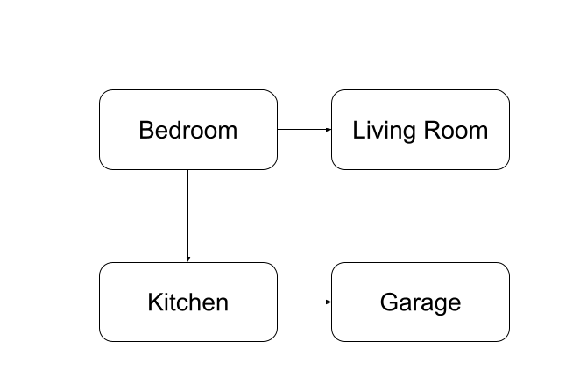
Tasks:
- Turn off lights.
- Sort waste.
- Save energy.
Level 2 - Town Square
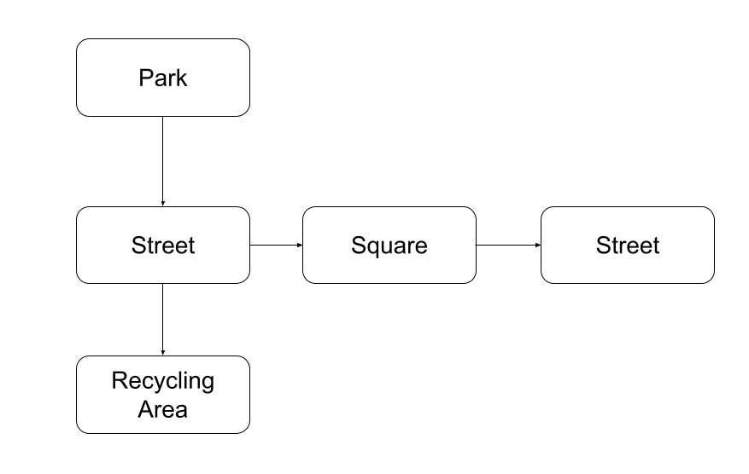
Tasks:
- Collect litter.
- Place recycling bins.
- Reduce pollution.
Level 3 - School
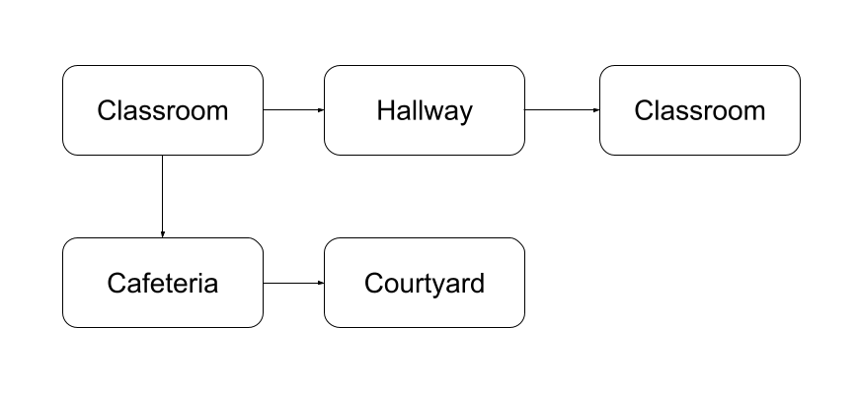
Tasks:
- Educational challenges.
- Recycling activities.
- Renewable energy projects.

Flow Chart
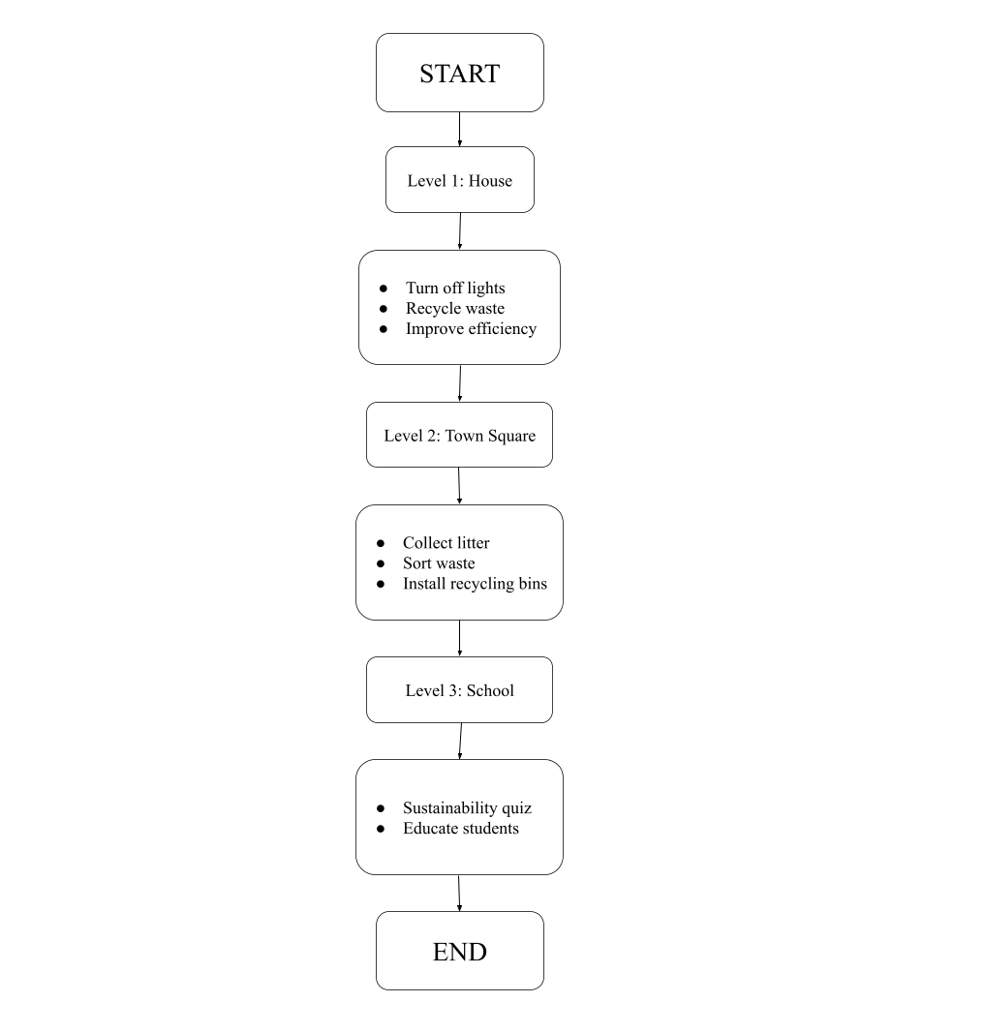

Interest Curve
The game gradually increases in complexity and responsibility. Level 1 introduces basic mechanics, Level 2 expands the scope to the community, and Level 3 combines environmental management with educational and decision-making challenges, creating the highest level of engagement.

4. VALIDATION CRITERIA (Testing phase).
- Validation techniques that would be used in case the game was tested in terms of usability, playability and educational impact (experiment, variables, types of tests, approximate sample sizes).
- Ways of collecting information (questionnaire, group discussion, observation, etc).
To evaluate the effectiveness of Eco-City Rescue, several testing methods would be used to assess usability, playability, and educational impact. The goal is to determine whether players can easily interact with the game, enjoy the experience, and achieve the intended learning outcomes.

4.1 Usability Testing

Objective
Evaluate whether the interface, controls, and game mechanics are intuitive and easy to understand.

Method
Participants would be asked to complete the three levels while being observed by researchers.

Variables
- Time needed to complete each level.
- Number of mistakes made during gameplay.
- Number of times players ask for help.
- Ease of navigation through menus and levels.
Sample Size
Students aged between 13 and 20 years old.

Success Criteria
- Most players complete the levels without assistance.
- Players understand the objectives and controls quickly.
- Few navigation or interaction errors occur.

4.2 Playability Testing

Objective
Measure player engagement, enjoyment, and motivation.

Method
Players complete the game and then answer a short satisfaction questionnaire.

Variables
- Enjoyment level.
- Perceived challenge.
- Motivation to continue playing.
- Willingness to recommend the game to others.

Success Criteria
- Average enjoyment score above 4 out of 5.
- Most players report that the game is engaging and motivating.
- Players remain interested throughout the three levels.

4.3 Educational Impact Testing

Objective
Determine whether the game improves environmental knowledge and awareness.

Method
A pre-test and post-test design would be used.
Before playing, participants answer a questionnaire about recycling, energy consumption, and sustainability. The same questionnaire is completed after finishing the game.

Variables
- Knowledge of waste classification.
- Understanding of renewable and non-renewable energy.
- Awareness of the environmental consequences of daily actions.

Success Criteria
- Significant improvement in post-test scores.
- Increased awareness of sustainable habits.
- Better understanding of environmental concepts.

Questionnaires
Used before and after gameplay to measure knowledge acquisition, satisfaction, and perceived difficulty.

Observation
Researchers observe players during gameplay, recording errors, confusion, and interaction patterns.

Gameplay Metrics
Data collected automatically by the game, including:
- Number of recycling mistakes.
- Completion time for each level.
- Score earned.
- Final environmental score.

5. FINAL REFLECTION.

- Justification of design decisions based on learning goals, and theories seen in class.

Design decisions | Relation to learning objectives | Related theory
Waste sorting mini-game | Teaches players to correctly identify and classify different types of waste. | Learning by Doing
Sustainability quizzes and educational challenges | Evaluates the player's understanding of recycling, pollution, and renewable energy concepts. | Constructivism
Rules (pollution meter, time limits, level objectives) | Encourage responsible decision-making and show the consequences of environmental actions. | Experiential Learning
Resources (Point system) | Promote long-term planning and resource management related to sustainability. | Self-Determination
Fiction / Narrative | Helps players connect environmental problems to everyday life through a relatable story. | Situated Learning
Main Character (environmentally conscious teenager) | Encourages identification with positive environmental behaviors. | Social Learning Theory
Secondary Characters (family members, students, citizens) | Demonstrate common environmental mistakes and provide opportunities for learning and teaching. | Scaffolding
Interface (cleanliness bar, objective list, pollution indicators) | Provides immediate feedback and helps players understand the impact of their actions. | Multimedia Learning Theory
Dynamics (progression from home to community and school) | Gradually increases complexity and reinforces learning through practice. | Scaffolding Theory
Aesthetics (city transforming from polluted to clean) | Reinforces motivation by visually showing the positive effects of sustainable actions. | Behaviorism / Positive Reinforcement
Other game components (badges, achievements, level progression) | Increase engagement and reward the acquisition of environmental knowledge. | Gamification Theory

6. REFERENCES (SOURCES CONSULTED IN THE RESEARCH PHASE OF THE PROJECT)

Games for inspiration:
Alba: A Wildlife Adventure
Recycle City Challenge

World Rescue

Clean and Green

Links:

Prototype
https://www.figma.com/proto/WzaowmbRmgjeDJ8JN6hqHX/Recycle?node-id=13-170&t=m4qeVPMu4c9Ho9U9-1&scaling=contain&content-scaling=fixed&page-id=0%3A1&starting-point-node-id=13%3A170

https://www.sciencedirect.com/science/article/abs/pii/S2210670716301834

https://tap-ts.eu/pluginfile.php/2857/mod_folder/content/0/LTP%204%20Unit%201/LTP4%20Unit%201_%20USING%20SERIOUS%20GAMES%20TO%20TEACH%20SUSTAINABILITY%20%20RESILIENCE%20%5BINTRO%5D_Fine%20Version.pdf

