Challenge 2: EvoWorkout

Definition

Problem identification
One of the biggest challenges when starting (and maintaining) a workout routine at the gym is not technical knowledge, but rather lack of motivation, absence of community and disconnection from personal progress. Many people give up on their fitness goals after just a few weeks due to monotony, a lack of short-term rewards and not having a social environment that encourages them to keep going.
This lack of immediate reinforcement clashes with how we seek quick gratification and especially when so many apps and digital environments are designed to constantly engage and reward users.

At the same time, even those who are already consistent with their gym routines can struggle with motivation drops or plateaus, particularly when they don’t feel visible progress or have limited social interaction in the gym environment. Feelings of insecurity or lack of technical knowledge can also hold back beginners, and there’s no existing platform that solves this problem with a gamified approach.

Similar applications only cover the functional part of tracking your own routines without any suggestions or ability to learn in the app, f.e. “Hevy”, which is widely used, only covers that part with a kind of a social network but not really encouraged nor featured.
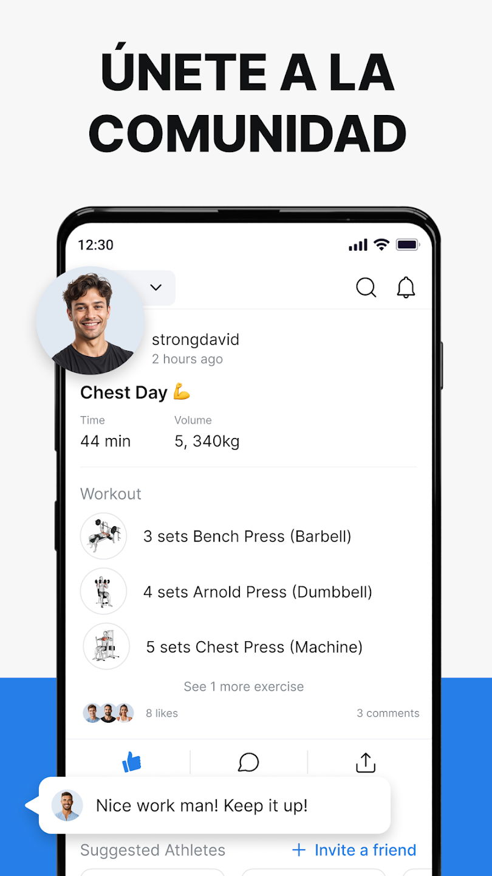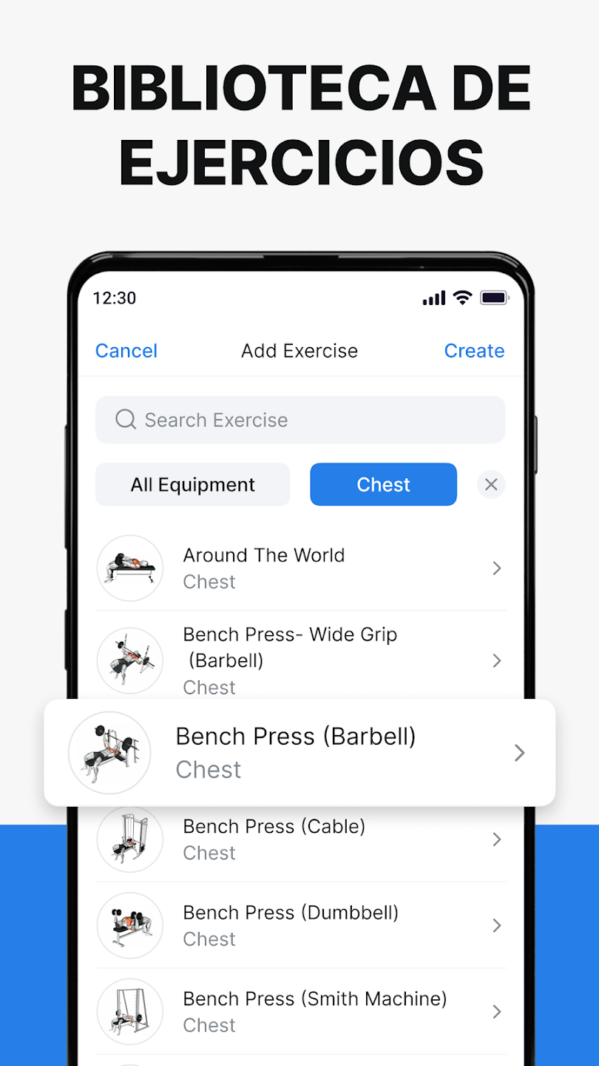

Most of the similar apps follow the same strategy as “Hevy” without the same success but there also are two applications that I could find which apply gamification elements and patterns. The two of them are “Workout Quest: Fitness Tracker” and “Liftoff”.
Workout Quest is a clear example of PBL, it has a bit more elements than that but in essence is the same as all the applications similar to “Hevy” with a PBL approach.
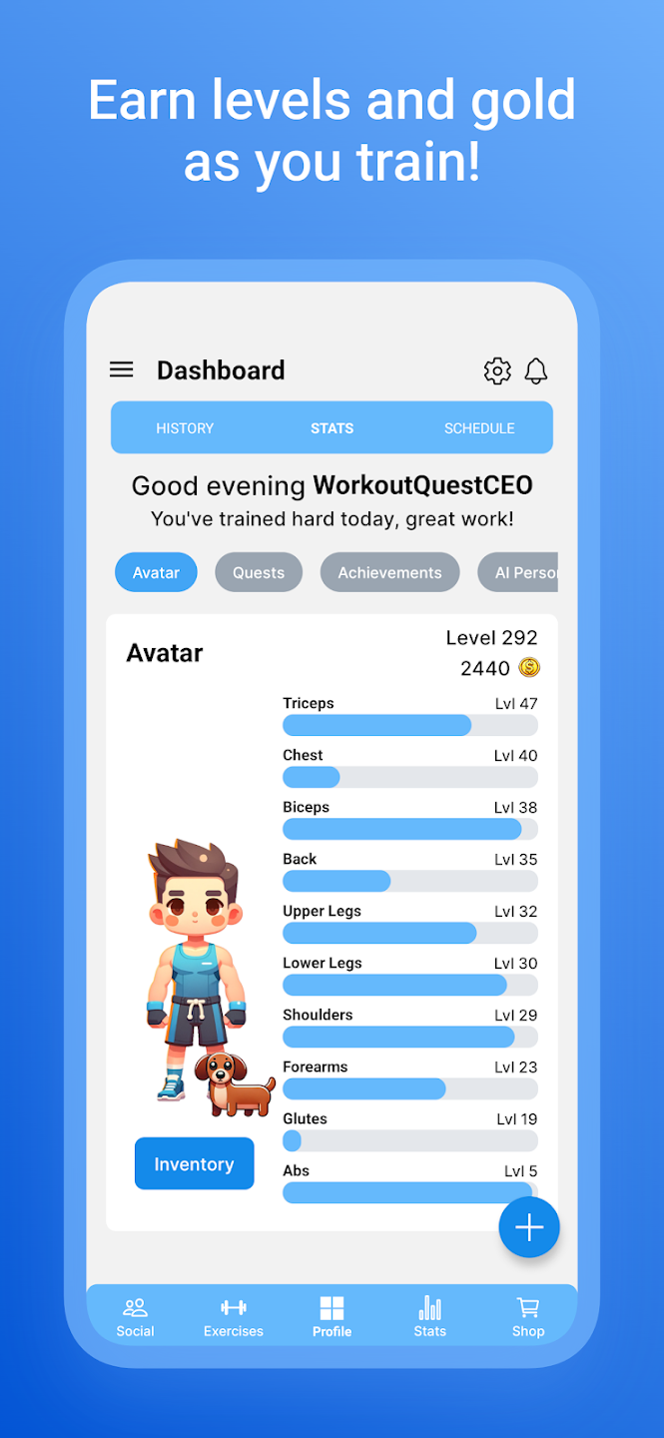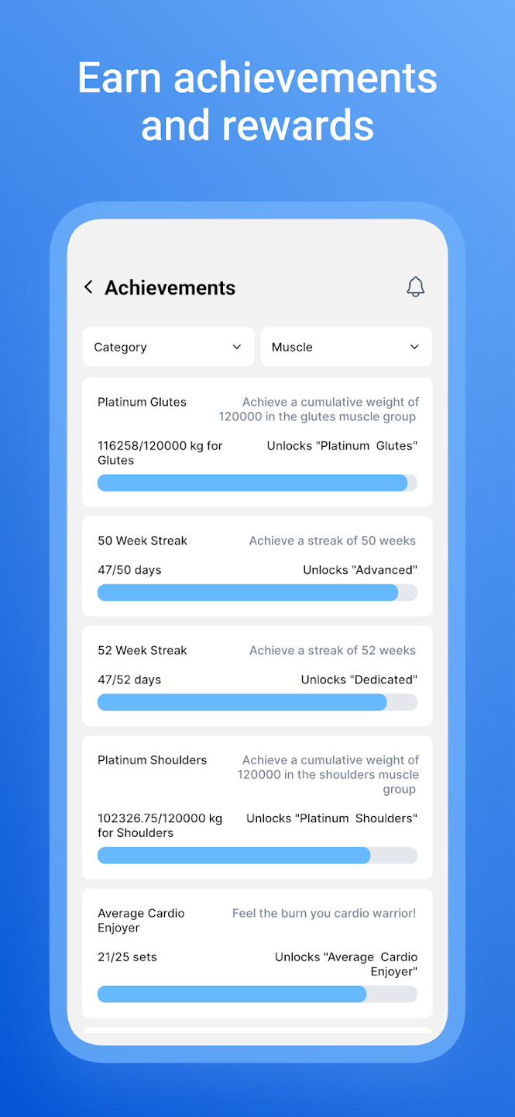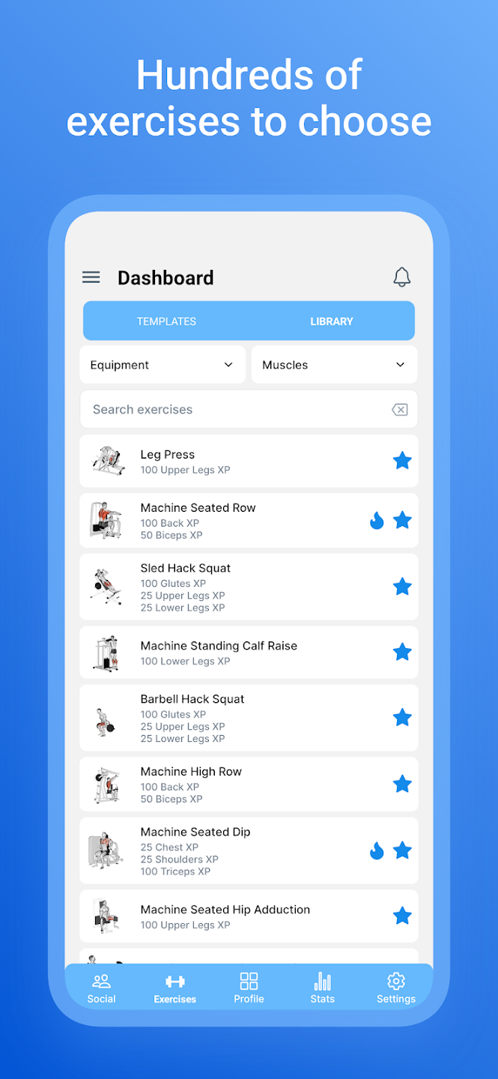
On the other hand, Liftoff is more complex in the gamified approach but it lies in the same problem of not helping newcomers, being excessively competitive and promoting a fake reality.
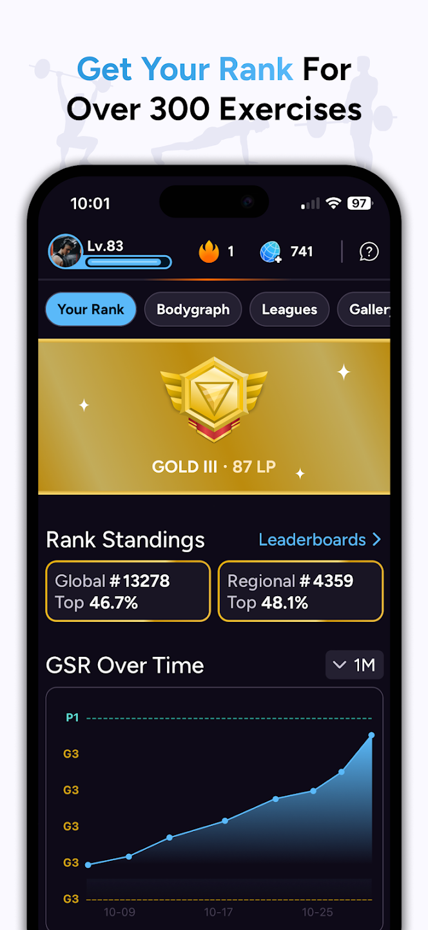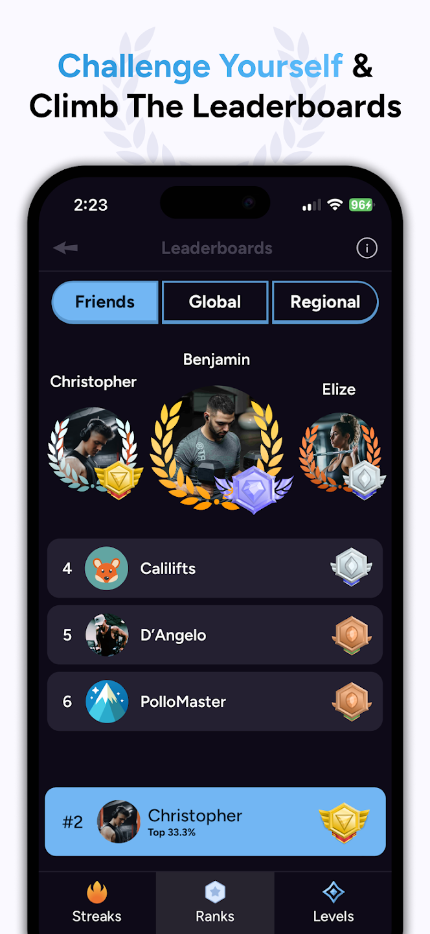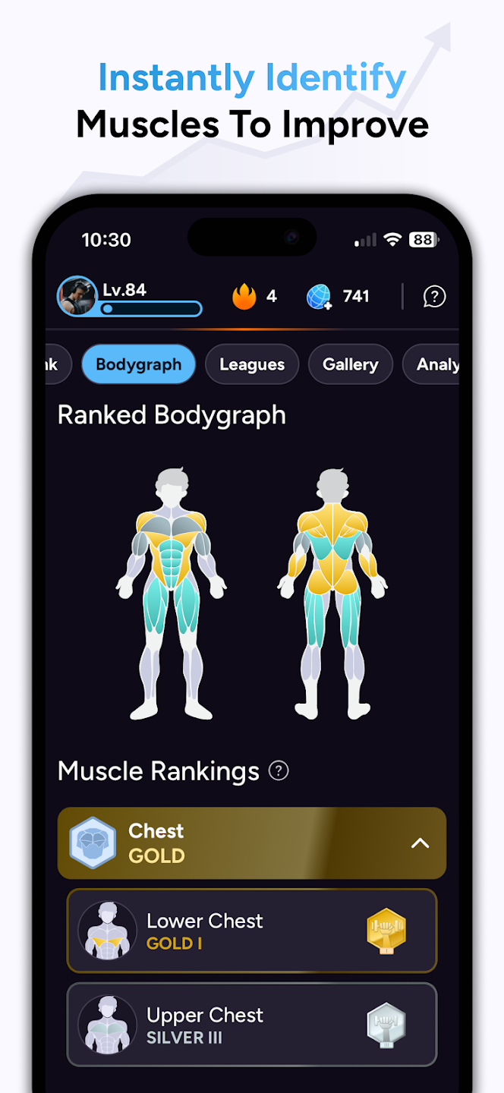

Motivation
The motivation behind EvoWorkout stems from a central question:
How can we keep people consistently motivated in their fitness journey without relying solely on external pressure or superficial rewards?
We want to turn physical progress into a visible, emotional, and socially connected experience, where the user's efforts are reflected in a virtual creature that evolves with them. This creature acts as an emotional avatar, growing and transforming based on the user’s consistency and effort, incentivizing healthy behaviors through both intrinsic and extrinsic rewards.
Additionally, by introducing a social layer based on exercise video verification, helpful rankings, cooperative gym-related minigames, and real-world icebreaker events, we aim to reduce the feeling of isolation and create opportunities to form new friendships through fitness without overloading the competitiveness.

List of Objectives
- Encourage workout consistency through daily and weekly engagement: Users are rewarded for completing their routines and participating in spontaneous app challenges, promoting habit formation and long-term physical activity.
- Increase social interaction and user retention through verification and community feedback: Users can upload exercise videos to receive form checks and feedback from others, and verify others videos in return. These interactions are rewarded, creating a loop of positive reinforcement.
- Create a visual and emotional representation of personal fitness progress through creature evolution: The user progress is reflected in the creature's visual changes and unlockable accesories, making consistency and improvement feel meaningful and exciting.
- Support beginners and reduce gym anxiety through suggestions and motivational content: Rankings show top performers in each exercise for the user to learn and break that knowledge barrier based on nº of verifications and weight lifted, making role models more relatable and accessible.
- Look for a sense of play and belonging through collaborative minigames and real-world “IceBreaker” events: Users can engage in interactive gym related minigames with their creature and with “known people” they've connected with via the app, building community and motivation through fun challenges.
- Drive user-generated content and peer learning: By incentivizing content creation (exercise videos), the platform turns users into both creators and learners, creating real-world exercise demonstrations, even for disabled people who then can relate.

Fieldwork
The idea behind EvoWorkout is based on a widely shared thing: staying consistent with fitness and with anything is hard. This isn’t just something we researched, it’s something we’ve heard and lived.
We’ve talked about this with friends, family, and people around us who’ve tried to start going to the gym or maintain a workout routine. The common answer is that everyone struggles with motivation, accountability and staying engaged over time.
To complement this personal input, we also observed conversations and trends in online fitness communities, such as:
- TikTok and Instagram videos
- Comments and discussions in YouTube channels
From these platforms, we noticed patterns like:
- People wanting to feel seen and validated in their efforts.
- A strong desire for community, even in solo sports like lifting with the “GymBro” movement throughout all social media, specially English TikTok and reels.
- Users naturally gamifying their own fitness journeys through challenges, milestones, or personal transformation stories.
In short, we didn't need formal research to see the problem. Consistency is the real battle, and EvoWorkout is designed to tackle exactly that, in a way that feels personal, social, and fun.

Targeted behaviours and gamification elements
Following Markzewski’s Periodic Table of Gamification Elements, we can center the targeted behaviours throughout the gamification elements.
- Fixed Rewards: Completing actions like verifying a video or finishing a workout always gives a guaranteed amount of points, reinforcing expected behavior and making the system predictable and motivating.
- Random Rewards: Some actions (e.g. completing a challenge) include surprise bonus rewards, creating dopamine spikes and keeping users engagement.
- On-boarding: An introduction and workout/exercise suggestions helps users set their first workout, create their creature, and explore the app without feeling overwhelmed.
- Investment: The more time users invest training, uploading and verifying the more evolved their creature becomes. This builds emotional attachment and makes the idea of quitting harder.
- Progress / Feedback: The creature is a visual feedback system. It evolves based on consistency and performance, giving the user an emotional and aesthetic representation of their fitness journey.
- Theme: The entire experience is around a fantasy/creature evolution theme, turning the gym into an adventure. The creature acts as a symbolic alter ego.
- Scarcity: Some accessories or items/boosters are available only during time limited events or challenges, increasing desire and encouraging daily use to not miss out.
- Social Network: EvoWorkout includes an internal network of users based on local proximity. Users can connect, collaborate, and grow their known-people list through video verification and feedback.
- Social Status: Users gain status through verified contributions.
- Social Discovery (IceBreakers): This is a key mechanic. EvoWorkout uses icebreakers to help users discover and connect with others in their local area or gym.There are two main types:
Event-Type Ice Breakers
  - “Wear red today” challenge: A notification to wear an item with a specific color and do a certain exercise. If you see someone at the gym doing it, you’ve just found another EvoWorkout user.
  - “Push-up chain”: Anyone spotted doing push-ups at a specific area starts a chain reaction where people can join and unlock collective rewards.
  - “Creature pin”: Limited-time pins or stickers for users to display (physical or digital), making them recognizable to others during real-world events.
Apart from Events and physical IceBreakers, minigames the user do with its own creature alongside people that have interacted with, are centered around the concept of IceBreakers. There would be a sedition in the app where the user can interact with known people and friends through “Creature Battles” without any strategic thinking, but instead a minigame that will decide the outcome of the combat:
  - "Quick Tap" Push-Up Contest (tap the screen in rhythm with push-ups)
  - "Hold & Breathe" Challenge (breath control or plank-hold minigame)
  - "Memory Reps" (repeat a sequence of movements shown by the app)
  - "Quiz Mode" (fitness trivia, guessing muscle groups, exercises, etc.)
  - “Friend Challenge” (try to guess others favourite or better performant exercises and activities)
  - "Rhythm” (synchronized movement challenge)
These games are accessible only between “known people” and “friends”, those who have interacted before, reinforcing social connections.
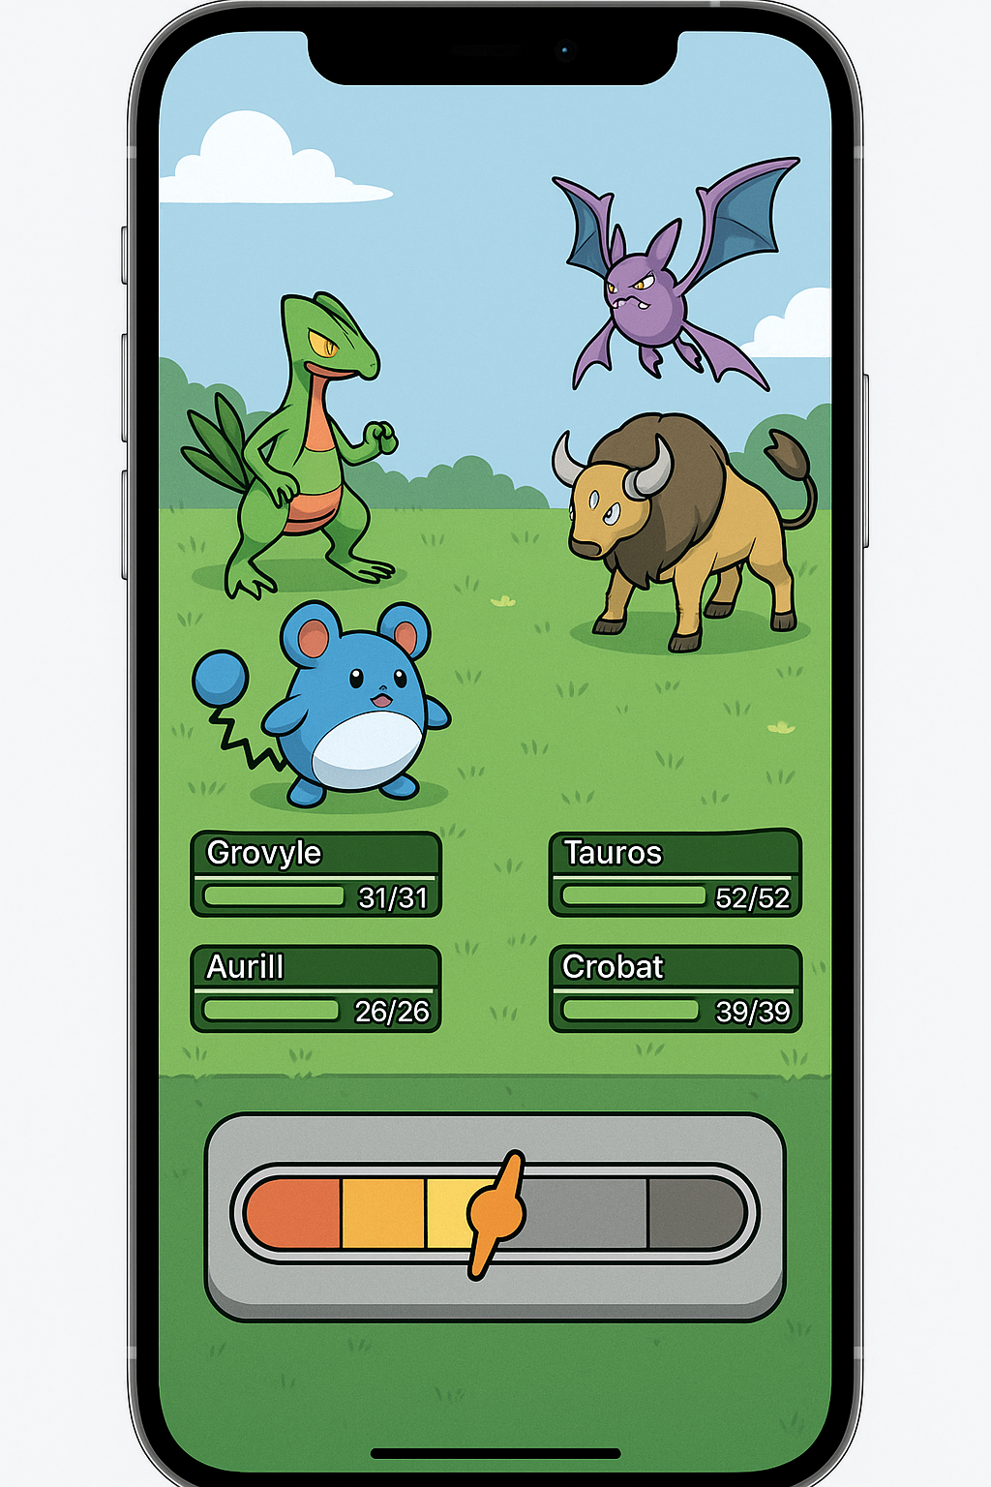
- Challenges: Spontaneous notifications like “Do 10 squats in the next 60 seconds accept the challenge?”, these small, real-time challenges create surprise, engagement and can only be taken in that specific moment.
- Learning: Users learn by watching top ranked exercise videos, receiving feedback from others, observing verified users techniques and suggestions and help by the app itself.
- Quests: Users define and complete their own workout routines.
- Customization: Points can be used to customize the creature with clothes, accessories, a room, background, and even mood related visual effects/expressions.
- Altruistic Purpose: Verifying others form, offering feedback, and contributing to rankings creates a culture of helping others, especially for beginners.
- Knowledge Sharing: Recording yourself and showing how to do exercises adds to the community and helps others improve.
- Points: The central currency is earned by
  - Completing workouts
  - Uploading/Verifying videos
  - Playing minigames
  - Participating in events or challenges
  - Points are used to unlock customizations, new creatures, creature evolutions, and limited time accessories.
- Leaderboards: Each exercise has a dual leaderboard, by weight lifted or by number of verifications received. This encourages both performance and proper form, not just brute force and extreme competitiveness.
- Anonymity: Users do not need to show their face or real name. Their creature becomes their profile, reducing friction and fear of judgment, especially for beginners.

User Types
Rather than focusing on just one audience, the app integrates a variety of game elements that would appeal to both intrinsic and extrinsic motivators. According to Andrzej Marczewski’s framework, these would be the ones that suit the most.
- Achiever: Users who enjoy improving their skills, mastering new challenges, and seeing real growth over time. EvoWorkout offers them:
  - The ability to define and refine their own routines (quests), track their progress and aim for consistency.
  - Access to a growing library of example videos showing proper form and technique.
  - Opportunities to earn evolution stages for their creature by improving performance, not just checking off tasks.
  - A sense of mastery over time, as their creature evolves to reflect their personal development.
These users are likely to dive deep into mechanics, test their limits and enjoy the feedback loop of self-improvement.
- Players: Users who are driven by external rewards like points, badges, unlocks, and visible progress. EvoWorkout captures their attention through:
  - A points system that allows them to unlock accessories, furniture, and creature upgrades/boosts.
  - Leaderboards to rank their uploaded exercise videos by weight lifted or peer validation.
  - Random and fixed rewards for actions like verifying others, uploading workouts, or completing spontaneous challenges.
This group will stay engaged as long as there is something new to unlock or improve.
- Socializers: Socializers value connection with others above all. EvoWorkout offers them:
  - A social network based on proximity and past interactions (verifications, feedback).
  - The “known people” list that builds over time and allows for social mini-games.
  - IceBreaker mechanics such as events (e.g. wear a color, perform a move in a public spot) and collaborative party games.
  - The ability to form mini-communities organically, based on shared routines or frequent interaction.
For socializers, working out becomes a shared experience, with connection, meeting and mutual support.
- Philanthropists: These users are motivated by the desire to help others, not necessarily by personal gain. So this app allows them through:
  - The verification system, where they can help beginners improve by reviewing exercises form.
  - A natural place in the app to offer constructive feedback and encouragement.
  - The chance to record educational videos, becoming contributors to the knowledge base and role models for others.
  - Social validation without competition, since rewards for verifying are capped/maxed ensuring users help out of genuine purpose, not farming.
These users find meaning in seeing others succeed, and the app gives them a space to mentor, guide, and contribute.

User Journey

Metaphor
The principal metaphor of the application is the evolution of a monster that reflects your own physical progress. This monster starts like a basic creature but when you start uploading your videos you receive verifications and you verify the activities for other users your monster would evolve and it gets stronger showing visually the growing and your hustle in the gym.
This metaphorical transformation serves two purposes:
- Visual Motivation: By making the user consistency and progress visible through their creature development, it taps into intrinsic motivation. Watching your creature grow becomes a mirror of your real-life growth, providing a tangible and emotional/symbolic connection to your effort. It replaces abstract numbers or stats with something alive and rewarding/cool to look at.
- Emotional Attachment: Just like in games like Pokémon or Tamagotchi, users build a bond with their companion. The creature is not just a “progress bar”, it’s a friend, a reflection of the work, someone they want to see thrive. This adds a layer of empathy and responsibility to the process. Missing workouts or ignoring challenges doesn’t just pause your own progress but stops your creature’s evolution (Alongside with Pou-like notifications).

Discover
The potential users are people that book to improve the technique in the gym or they want to share their progress. Usually EvoWorkout is known by recommendations of friends, social media or searching resources that allows them to grow in the most safe and efficient way.
Some usertypes that follow our app are the achievers because they want to achieve a healthy schedule to their lives. Other user types can be socializers because you get in contact with other people, philanthropist can be another one because you can help other users with giving feedback to the exercises.

On-boarding
During the onboarding it explains how to upload the videos and receive feedback from the community. The app suggests to you some custom exercises and routines based on the objectives and it presents the monster as your buddy in the progress reinforcing the motivation through the gamification and creating an emotional link to the app.

Loop flows
The main flow os the app consist in:
- Upload the videos of your exercises
- Receive the feedback and verifications of other users to improve the activities in the gym
- Win some points, go up in the ranking and see your monster evolve (is an auto reflection of the user)
- Repeat the cycle to improve the user technique and maintain a high motivation.
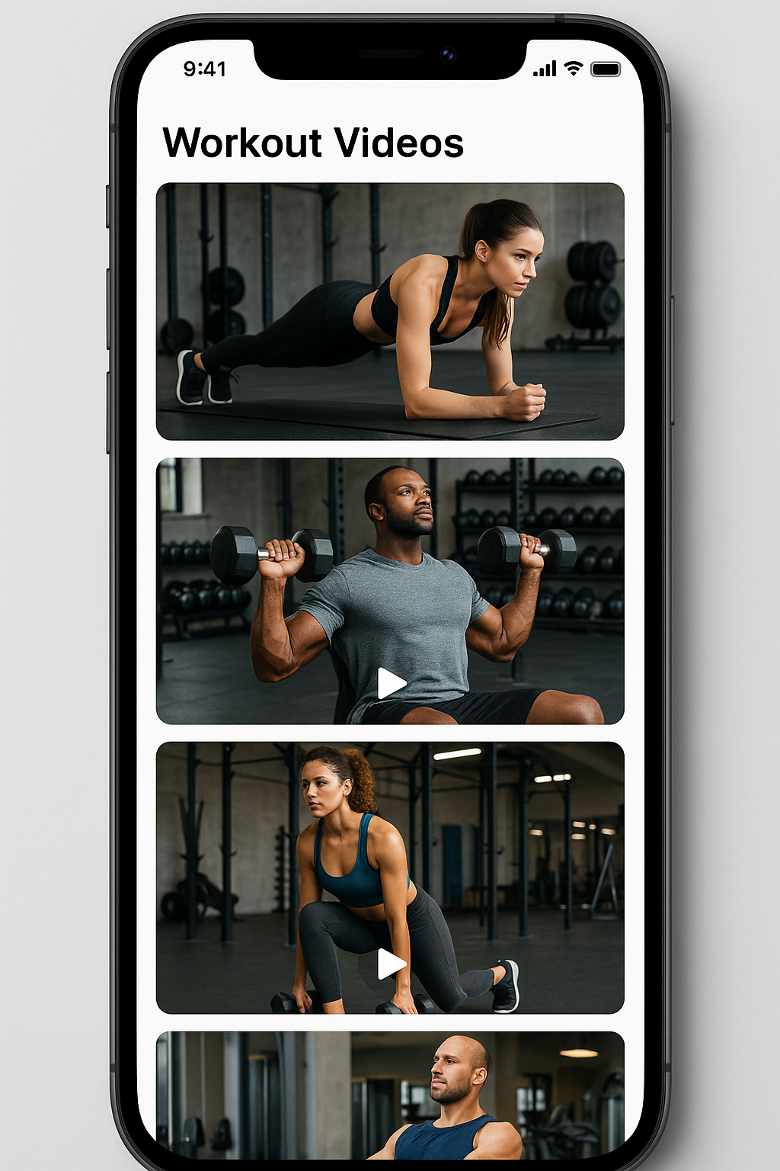
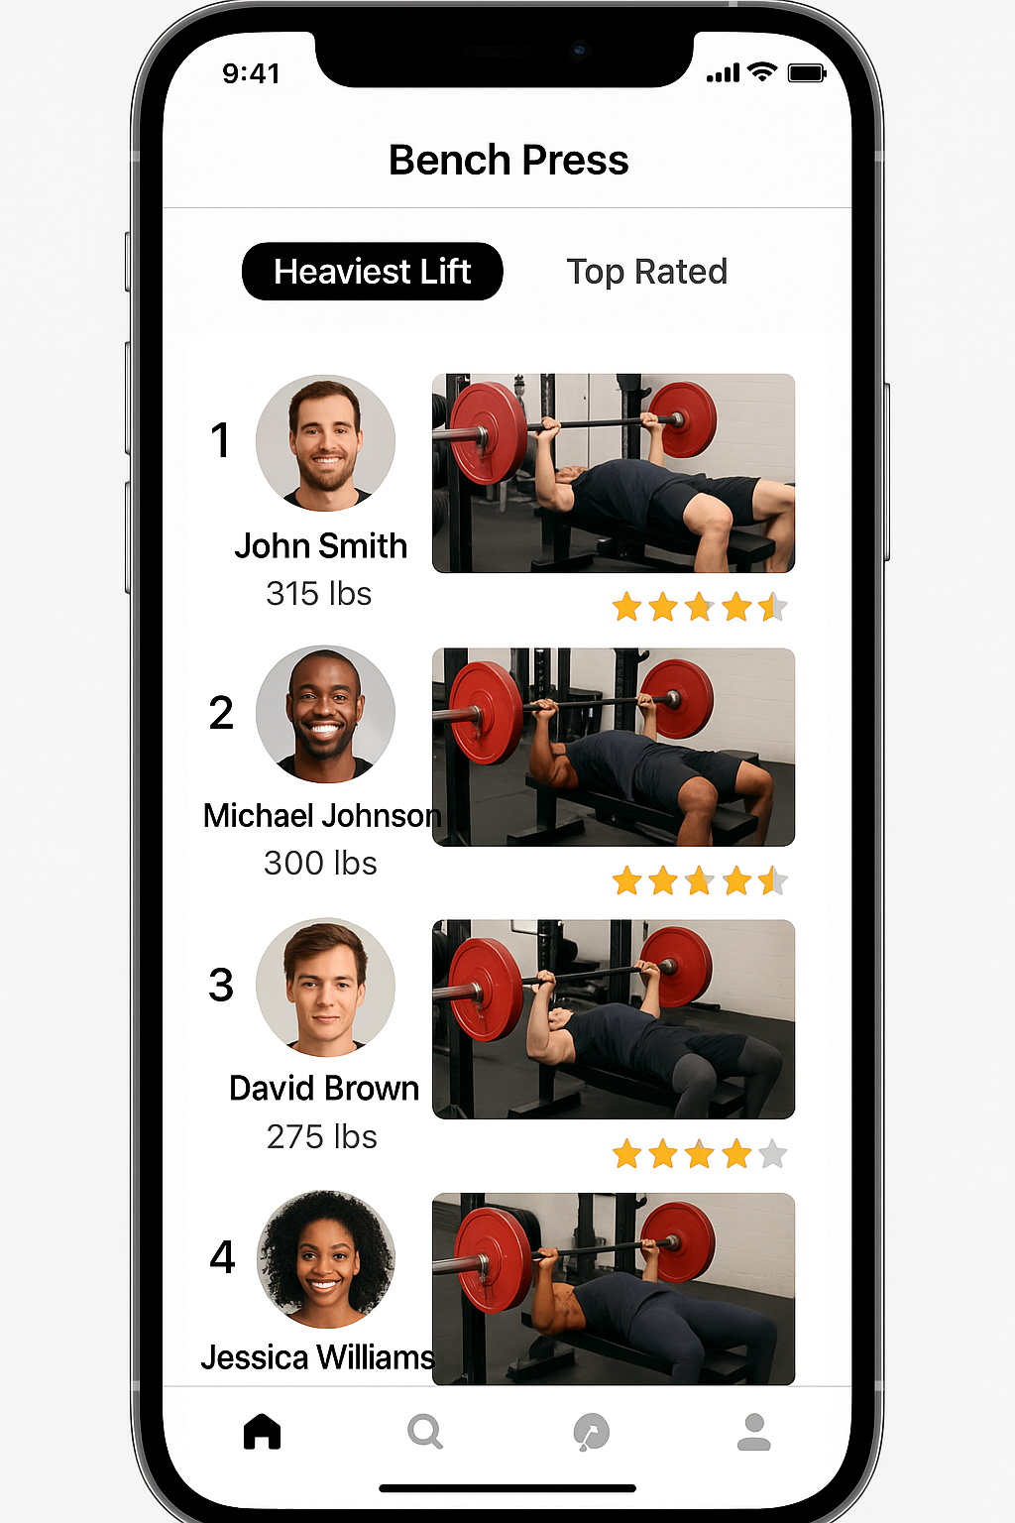

Master and replay
The app allows the user to revise old videos to see the user progress and compare the results. This foments the improvement and the personal growth also it incentivizes the repetition of the activities to dominate the technique.

Building and testing

Building
The app is built with a clear focus on gamification and the community. It prioritizes the functionality to upload the videos, receive the feedback and evolve your monster for the principal engine of your experience.

Prototypes and mockups
It has created prototypes that show the interface of the uploading videos, the feedback of the community and the evolution of your monster buddy. This prototypes help to visualize the experience of the user and polish details of the navigation and usability.

Metrics
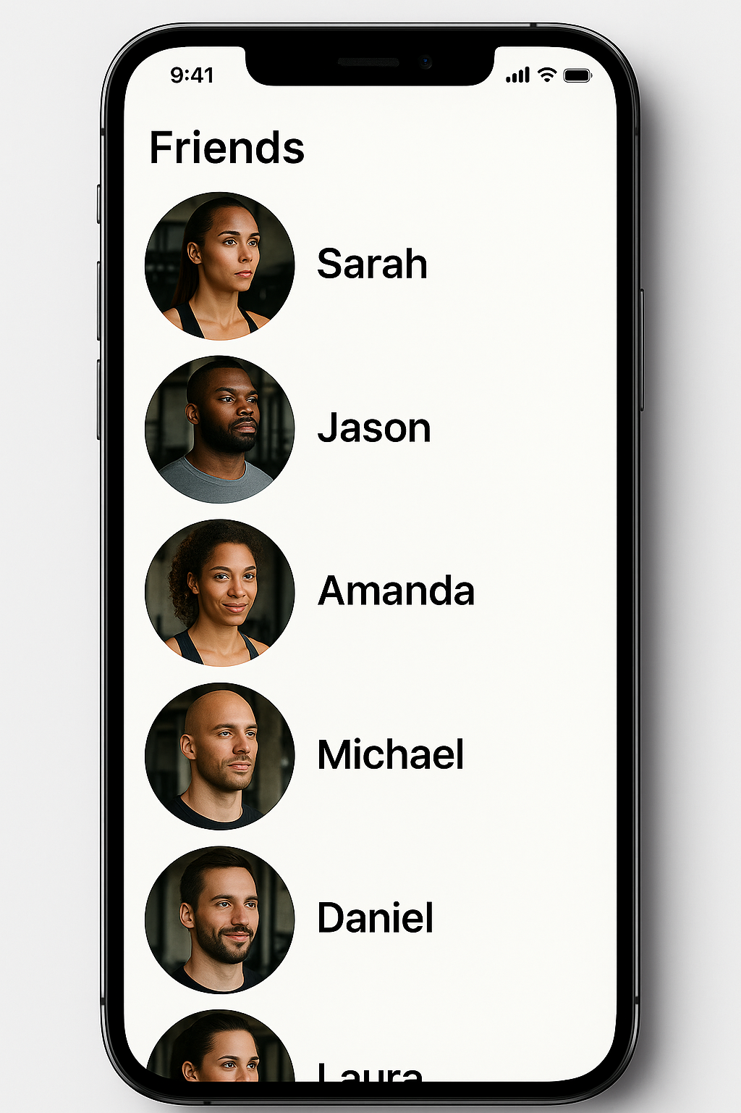
The key metrics include:
- Number of videos that the user has uploaded.
- The quantity of feedback that the user gets from the community.
- Average level of the monster of the users.
- Retention and frequency of use of the app.
- Average of the daily use of the app.

Ethical considerations
It garantizes the privacity of the users and the respect of the community. EvoWorkout implements moderation and options of the visibility control of the uploaded videos that the user has to ensure that the feedback is constructive and respective with a secure ambient and a lot of support.

Self-reflection
To us creating EvoWorkout has permitted us to think about the gamification and the community validation can transform the experience of the workout. The monster buddy is not only a funny symbol but a way to express and celebrate the individual progress of every user of the app.

Genially
https://view.genially.com/683356b17c044d8e43796640/presentation-workout

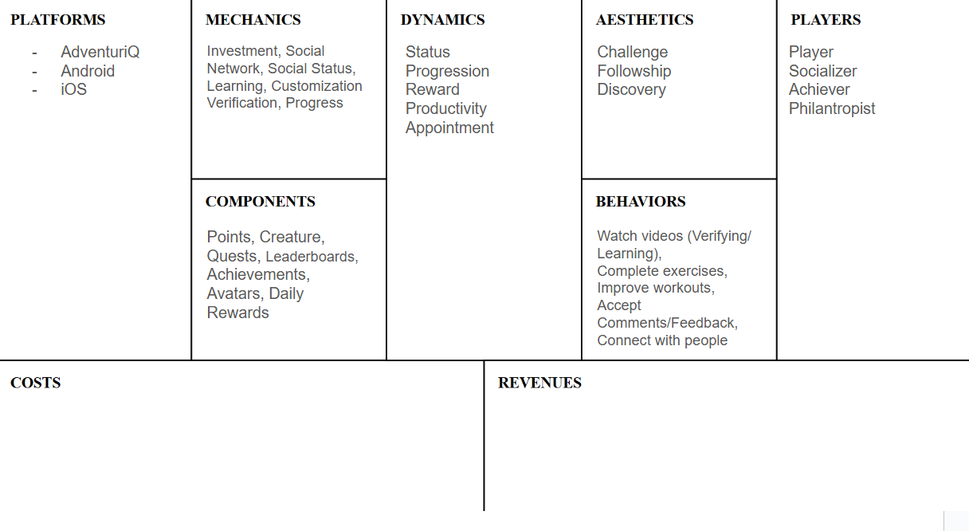
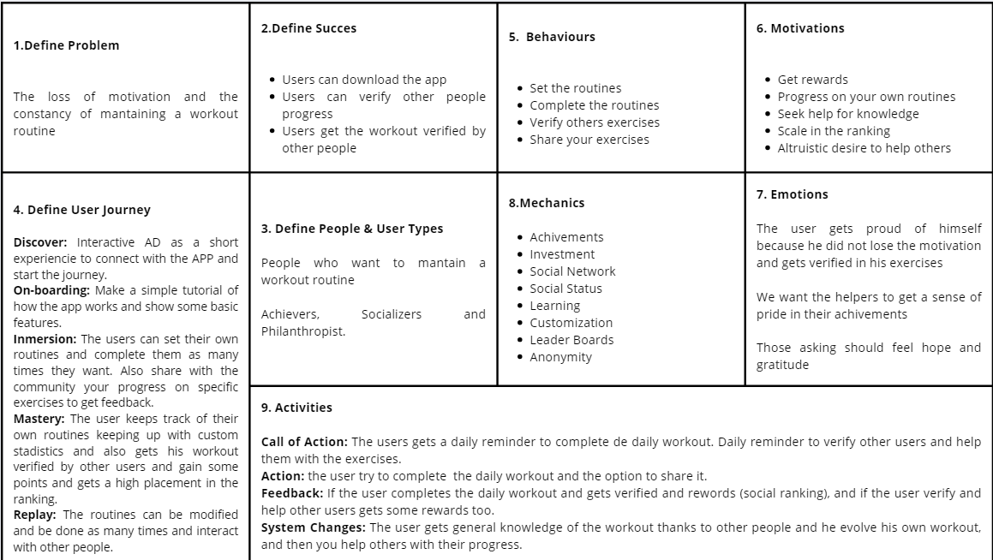
Canvases used:

