Slingshot Arcana

Milestone 1
02/05/2025
1. Description of the game
Slingshot Arcana is a VR multiplayer game with magical duels in a fantasy setting. The game is designed as a competitive multiplayer experience where players can face each other using a magic book with spells in real time.
The main mechanic of the game is related to the way of casting spells, our casting system tries to emulate a slingshot making it more precise and better to moderate the potency of the spell using the motion controllers.


1.1 General Objective
The main goal is to offer the players a good entertaining and dynamic VR experience with skill, reflexes and strategy.

1.2 Specific Objectives
- To learn how to design and implement gesture-based mechanics.
- To implement a networked multiplayer for real time duels.
- To ensure the experience is accessible to both VR newcomers and experienced players.

1.3 Targeted Sector
Slingshot Arcana is targeted at the entertainment sector, specifically within the domain of immersive virtual reality gaming. The project delivers a dynamic and magical multiplayer experience designed for casual VR users providing an incredible digital experience.

1.4 References and Inspirations
The concept draws inspiration from existing VR titles as:
- Blade & Sorcery: For its physics-driven combat and sense of presence aiming to recreate the spectacle of magical combat through vivid effects and detailed environments.
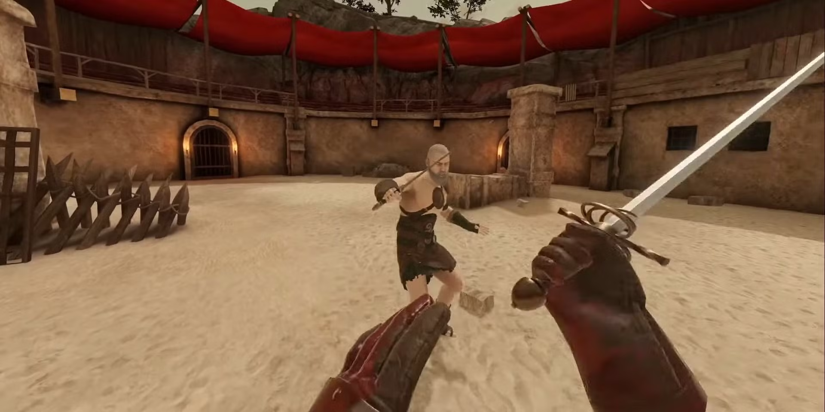
- The Unspoken: A magical dueling game that demonstrated the potential of gesture-based combat in VR
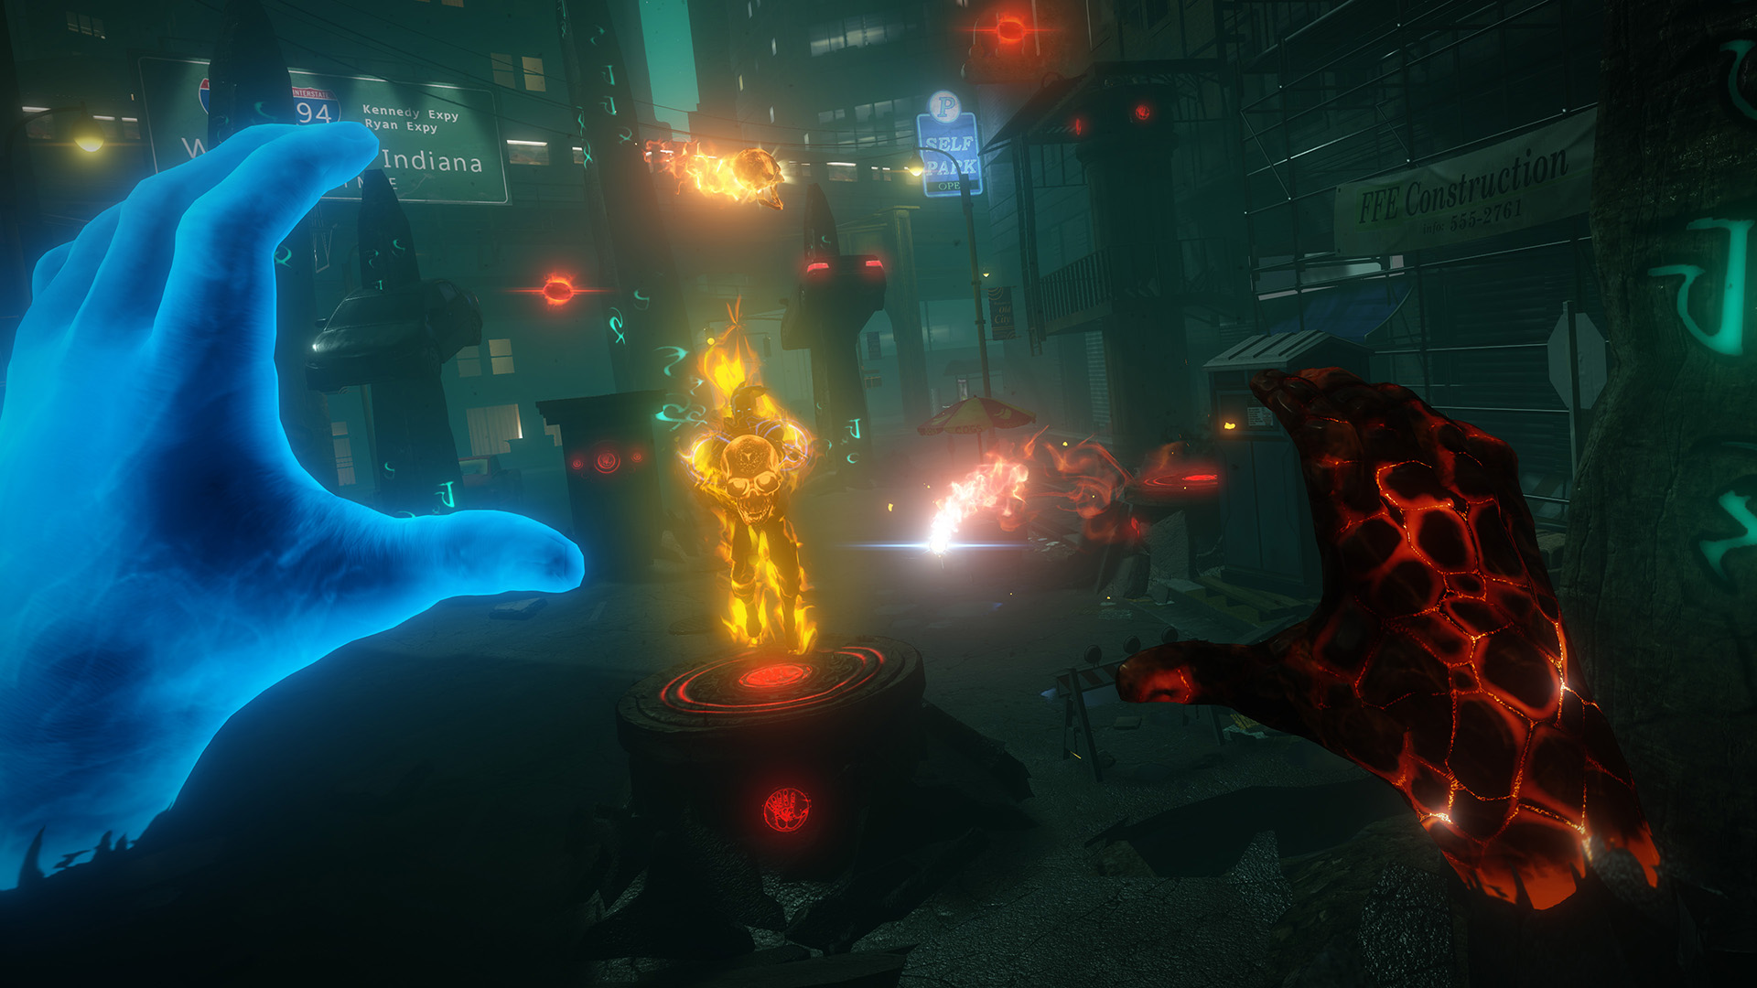
- Wands: A game known for its use of spell customization and arena-based duels.
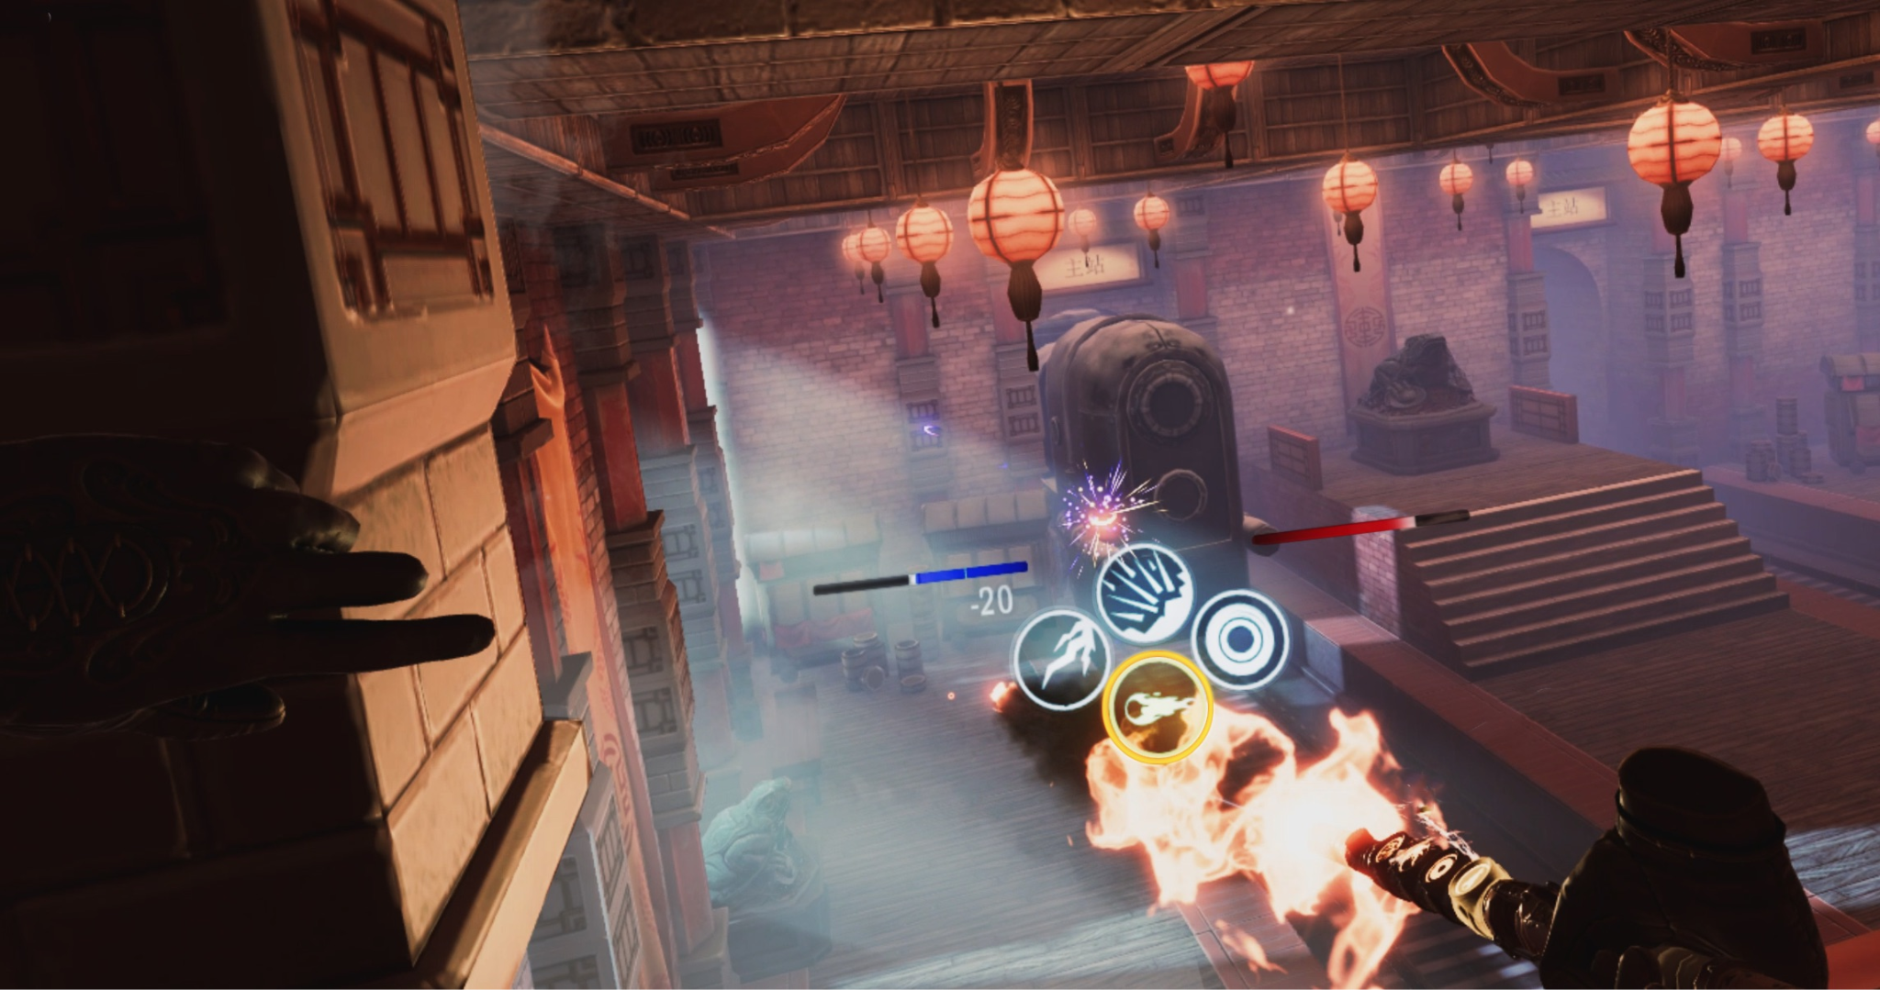

2. Target users and Requirements

2.1 User Profile
Slingshot Arcana is designed for casual VR players who enjoy magical combat and friendly duels without the pressure of competitive systems, as the main objective of the game is to have fun for a while by exploiting our well designed magic system.
This game is specifically aimed at:
- VR enthusiasts who enjoy expressing themselves and want a break from competitive and ranked games.
- Players who are new to VR, and want a well designed first experience that involves gesture-based gameplay.
- Players who are attracted to magical themes, especially those who enjoy casting spells.
- Gamers with access to devices like Meta Quest, Valve Index or HTC Vive.
- Streamers or content creators interested in virtual reality games with a multiplayer duel game.

2.2 Adaptation of characteristics to the target audience
To guarantee an experience suitable to the needs and expectations of the users. The design of the game have the next adaptations:
- Simple and quick duels: With no point system, ranking, or any kind of reward or progress for playing or winning duels.
- Intuitive gesture recognition: The spells are thrown by simple and natural gestures with the controllers that facilitates the learning and improves the sensation of inmersion.
- Accessible and adaptive interface: Floating menus, clear visual indicators and is very intuitive for the people that never played an virtual reality game

2.3 Physical and technical Requirements
- Space for playing: A secure area of at least 2x2 meters to allow the player movement without any risk.
- Compatible VR device: Meta Quest 2 / 3, Valve Index, HTC Vive or similar with movement controls.
- Stable Internet Connection: Required to multiplayer games.
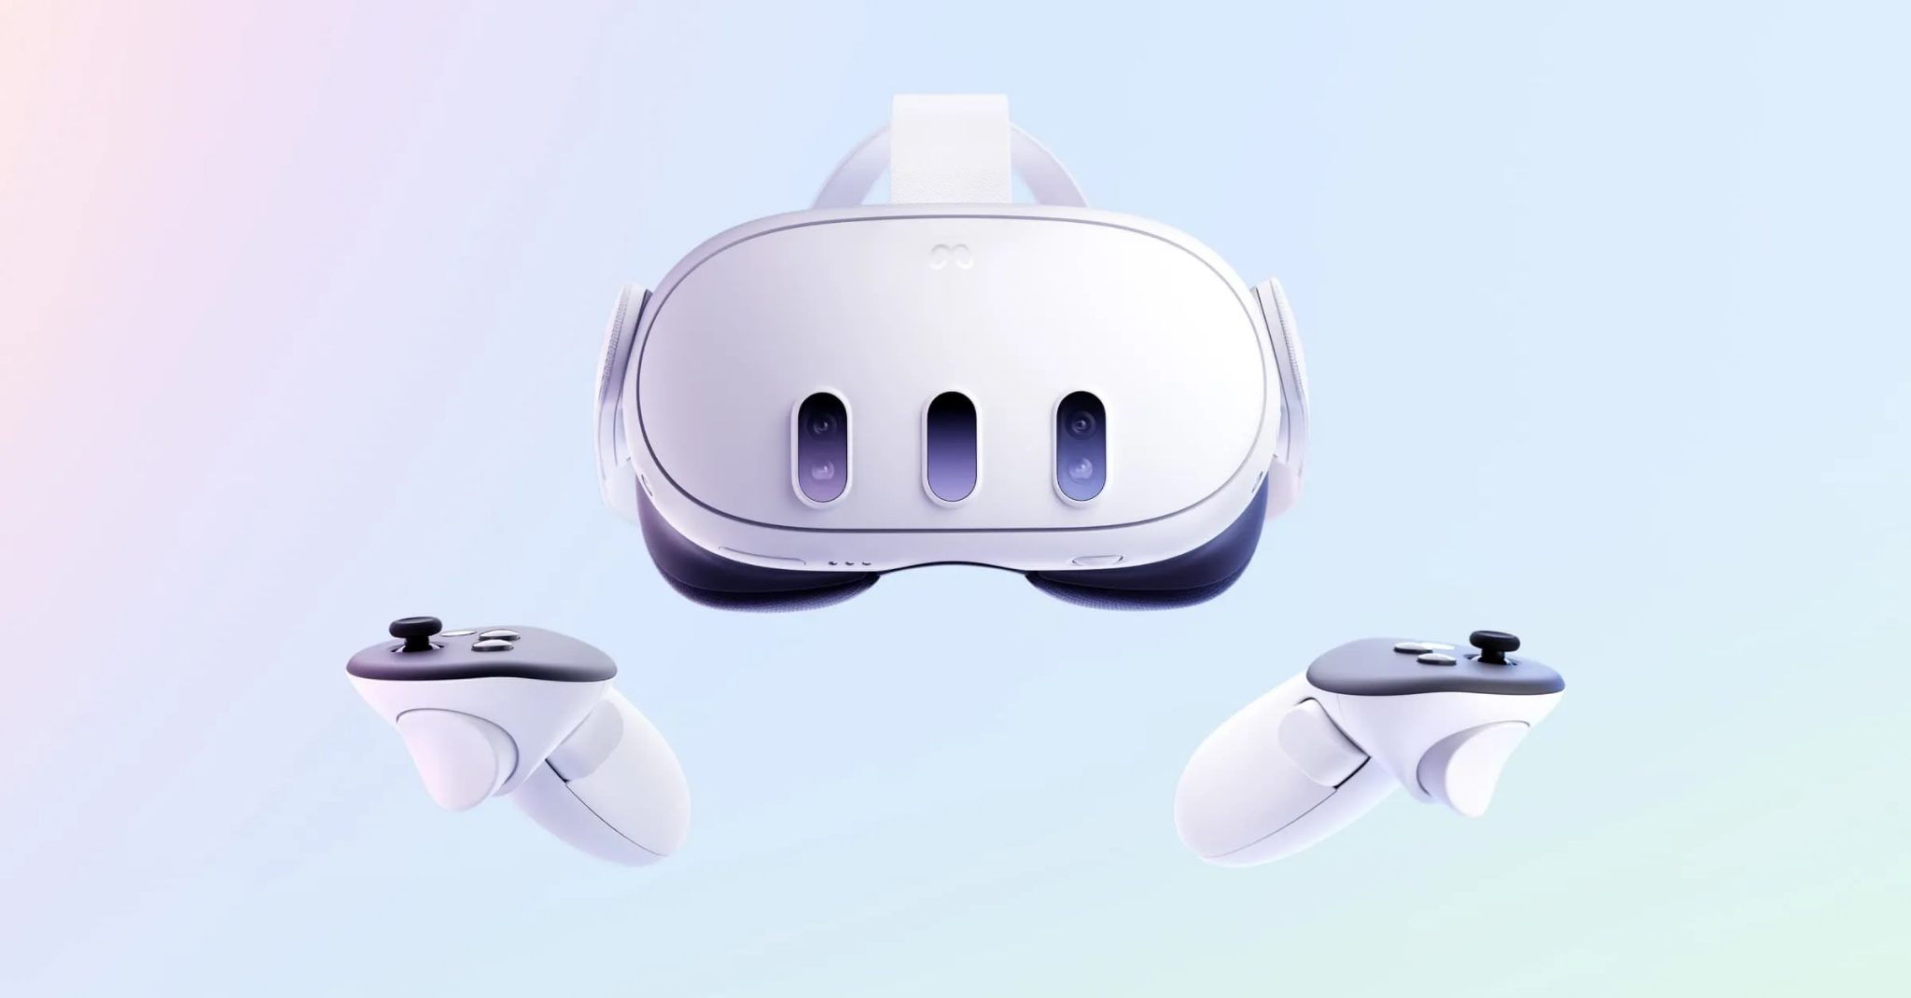
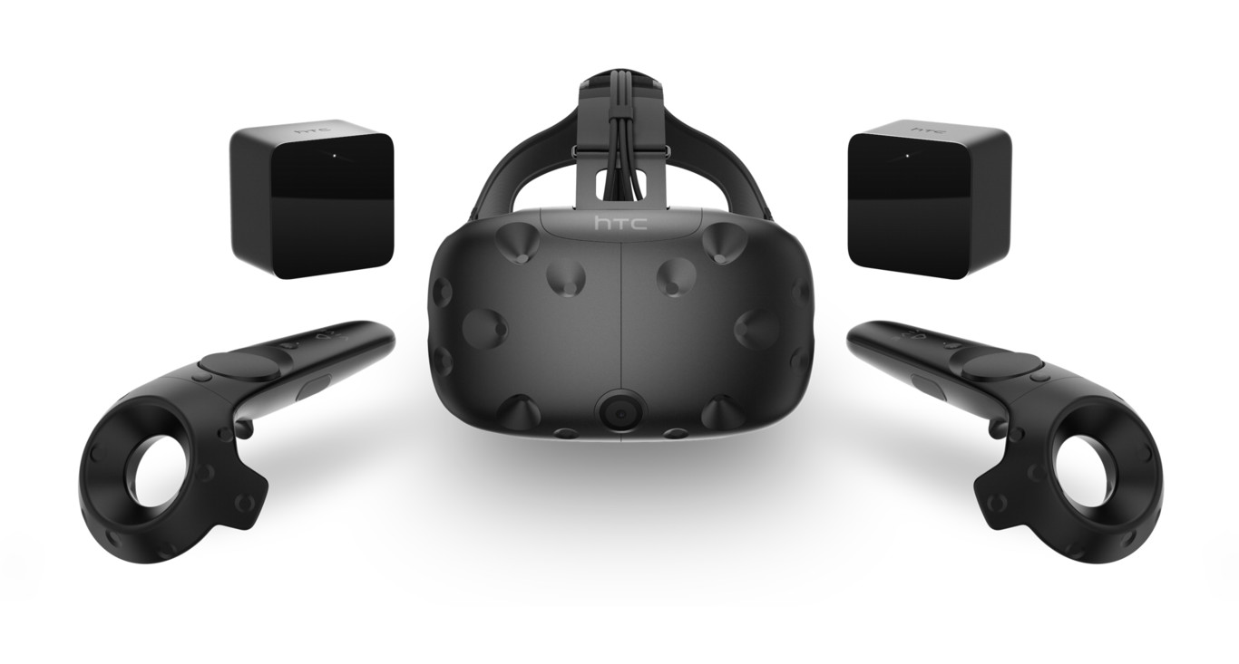
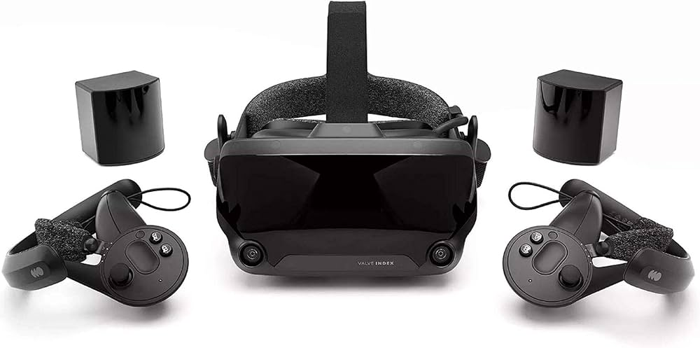
3. Team roles
Salvador Bernades (Designer and Programer)
- Researching similar games, designing the spells that the user can use. Adding SFX, and VFX. Documentation in the GDD.
Ivo Montes (Designer and Programmer)
- Designing the arena and the general mechanics of the game, programming some of the game mechanics and balancing. Documentation in the GDD.
Pau Mora (Programmer)
- The main programmer of the team. In charge of most of the scripting part of the game.
Sergi Gantzer (Designer & Artist)
- Gathering/Modeling props, animating, and helping design the game and fine tune UX.
Justo Tiscornia (Designer/Artist)
- Modeling props and doing the environment UI






4. Features and technical interaction design of the game application

- For the tracking system we will use:
  - 6DoF tracking for headset
  - Controllers to enable precise spellcasting gestures (different gestures for different spells)
- The game will support only standard VR controllers (Meta Quest, Valve Index, HTC Vive,...). No extra accessories required.
- Our game will feature object manipulation.
- It will feature smooth movement with an option for short-range teleportation to help reduce motion sickness.
- Visual, audio, and some haptic feedback for actions and spells to make the player feel super immersed.
- It is a fully immersive experience with a guardian system that ensures physical safety in a 2x2m space. If the user does not have a 2x2m space, it will do as Meta does, and warn the player that the space is not large enough to play safely.
- For the embodiment, the idea is to have a magic-themed avatar with visible upper body and animated hands synced to real gestures.
- We don’t have a direct narrative, our visuals and arena design support a consistent fantasy theme.
- To have more accessibility we will have adaptive UI, and no need for physical movement beyond standing.
Duelo de tirachinas magicos en una arena.
Los tirachinas son libros magicos y la munición son distintos hechizos.
Cambiar de hechizo pasando página del libro
Multiplayer

En medio del combate hay dummies que salen del suelo, si les aciertas con un proyectil podrían cambiar partes de la arena, darte munición, regenerar mana, etc.

Versión tirachinas normal: Tienes que coger el proyectil del cinturón, ponerlo en el tirachinas y disparar, debido a esa restricción física no sería necesario poner cooldown. También al mirar a tu cinturón podrías ver los distintos tipos de munición y la cantidad. También sería más fácil limitar la cantidad de munición si quisiéramos.

Versión tirachinas libro: el input para cambiar de proyectil podría ser arrastrando la página. Sería un poco limitante ya que tener muchos tipos de proyectil puede ser un poco lioso, también habría que poner cooldown para que el jugador no pueda spamear un mismo proyectil. Se podría implementar una barra de maná para evitar que el jugador spamee 1 hechizo y use otros.

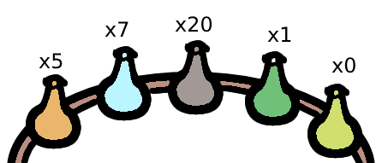
Version libro Version tirachinas

Controles:

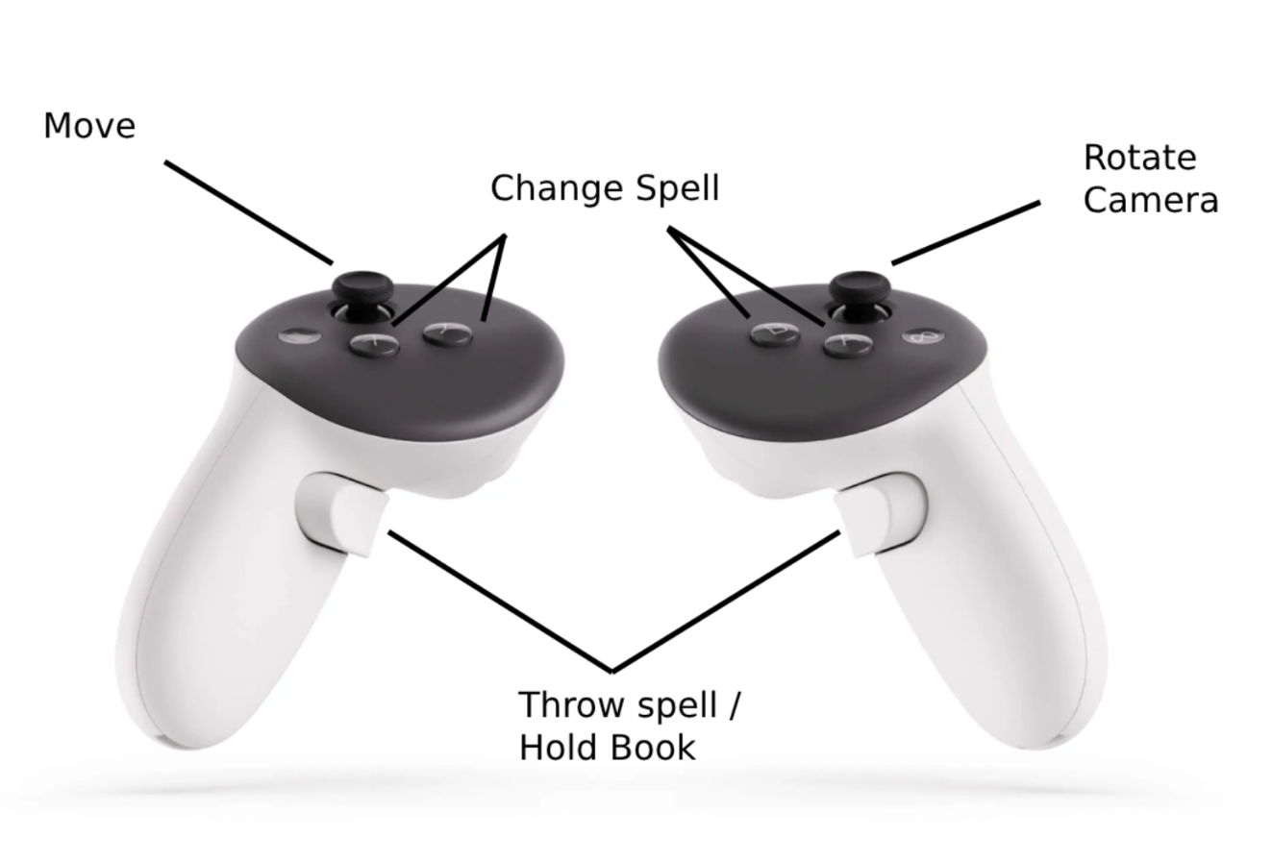

Si la vida base del player es 100

Tiro normal → 20 de daño

Fuego → 20 de daño y si le da al enemigo le aplica una quemadura de 10 de daño durante 4 segundos (10 segundos de cooldown)

Electricidad → 10 de daño y deja quieto al enemigo (no se puede mover). El disparo eléctrico va más rápido en el aire (15 segundos de cooldown)

Hielo → 10 de daño y no deja castear hechizos al enemigo durante 2 segundos. (15 segundos de cooldown)

Vacío → el que lanza el hechizo se teletransporta a la posición donde haya caído el hechizo (no puede pasar de mitad de la arena) (8 segundos de cooldown)

