ROBS GEORGE
Final Delivery - Level Design

Marc Avante
Salvador Bernades
Andrea Doña
Joan Marquès
Justo Tiscornia

Index
Index 2
FlowChart to complete the Levels 3
Puzzle 1: Door → Lockpick 3
Puzzle 2: Living Room → Hallway Key 4
Puzzle 3: Master Bedroom → Catch the Cat 5
Inspiration for this game 6
Design Issues 7
External Assets 8
Credits 9

FlowChart to complete the Levels
You start at the balcony, with no other choice but to try and force the door to the living room.
Lockpicking the door is based on a QTE where you have to press E on the right area 3 times, each time making the area smaller. Succeeding the QTE will open the door “stealthily” and award points, failing even once will make you destroy the door in rage. After that, you’ll be inside the living area, with a locked door, a safe and framed pictures of cats with a number. The combination of the safe is in the order of the colors of the cats, being Black -> White -> Grey -> Orange. There is no penalty for failing. Once you get the correct combination, a key will spawn that will allow you to open the door to the rest of the house and go to the other rooms. Across the building there will be collectibles that increase the score. One in the living room and one in the kitchen. Finally, on the master bedroom, there’ll be a cat either running and jumping around or trying to hide. Once you grab it, the game is over.

Puzzle 1: Door → Lockpick
- Minigame: There is a horizontal bar with a needle that moves back and forth (left to right). In the middle of the bar, there is a green zone.
- What to do: Click or tap the screen exactly when the needle passes over the green zone.
- Failure Condition: If you fail the minigame, the thief loses his patience and kicks the door down. This makes you lose stealth points or lowers your final score.
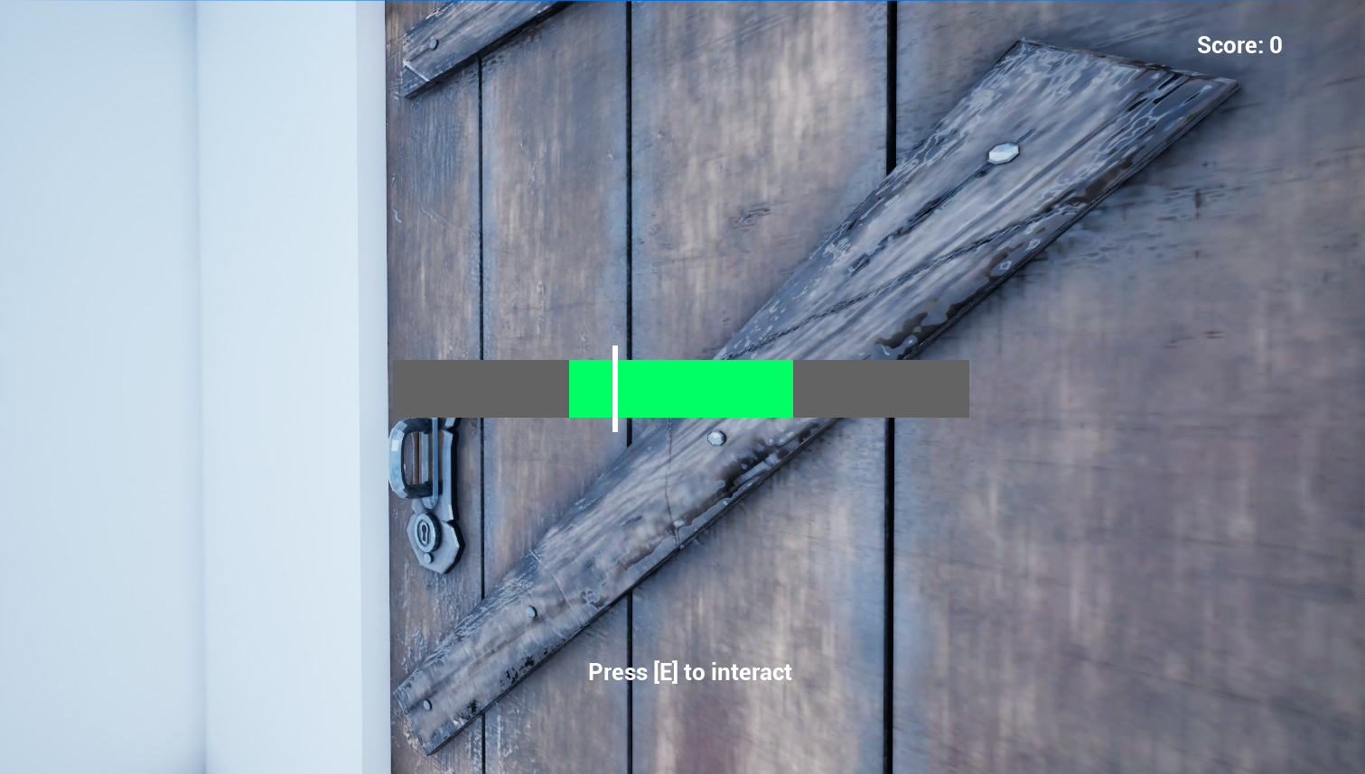
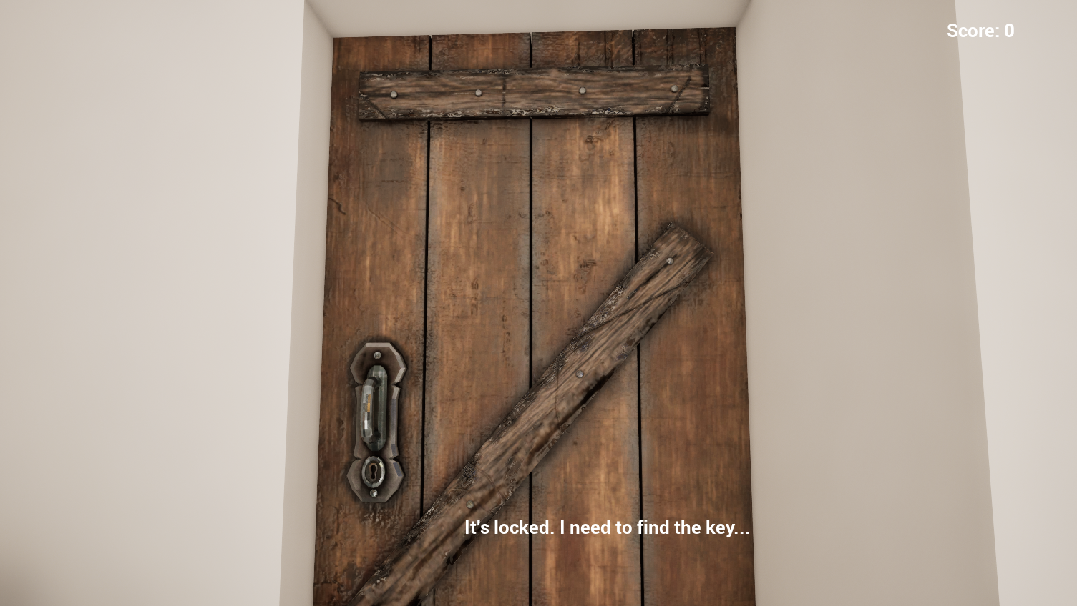

Puzzle 2: Living Room → Hallway Key
- Minigame: There is a painting on the wall with a safe hidden behind it. This safe has 4 buttons, each representing a different cat color.
- What to do: You need to explore the house to find clues about the cat's color. Once you know it, you press the correct button to open the safe.
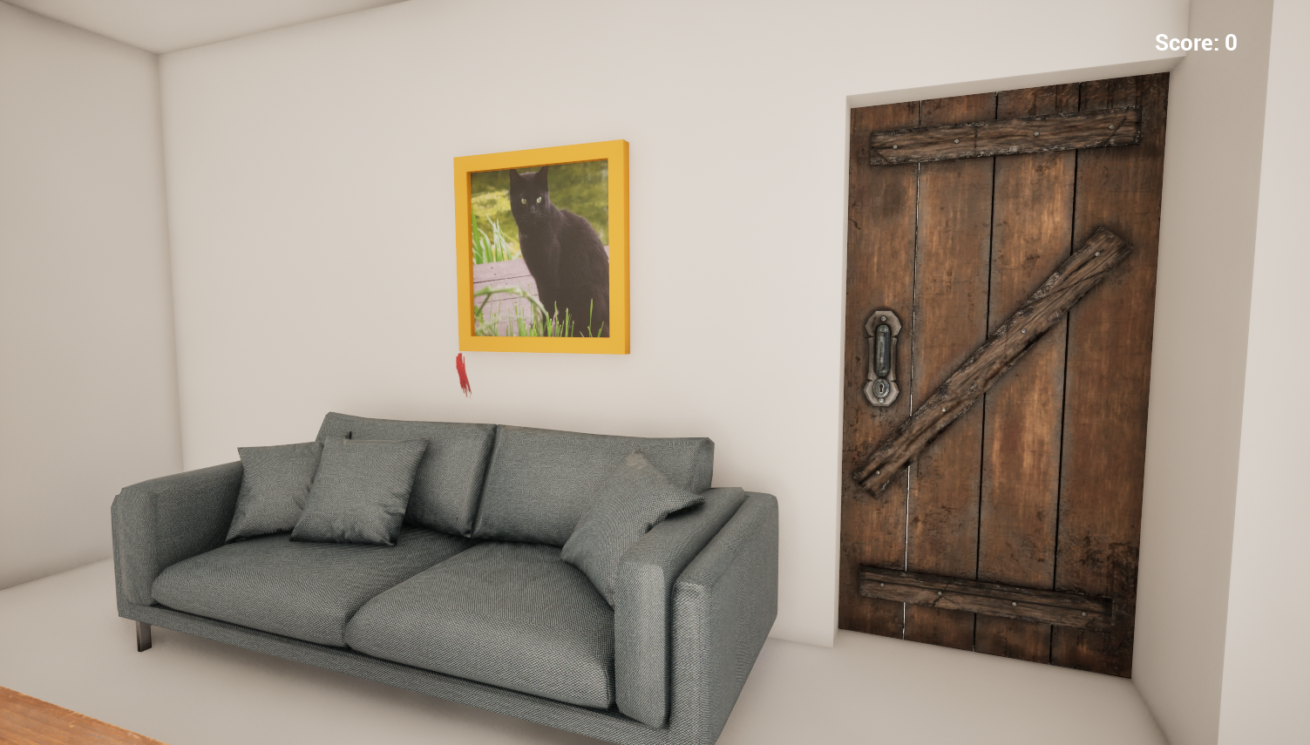
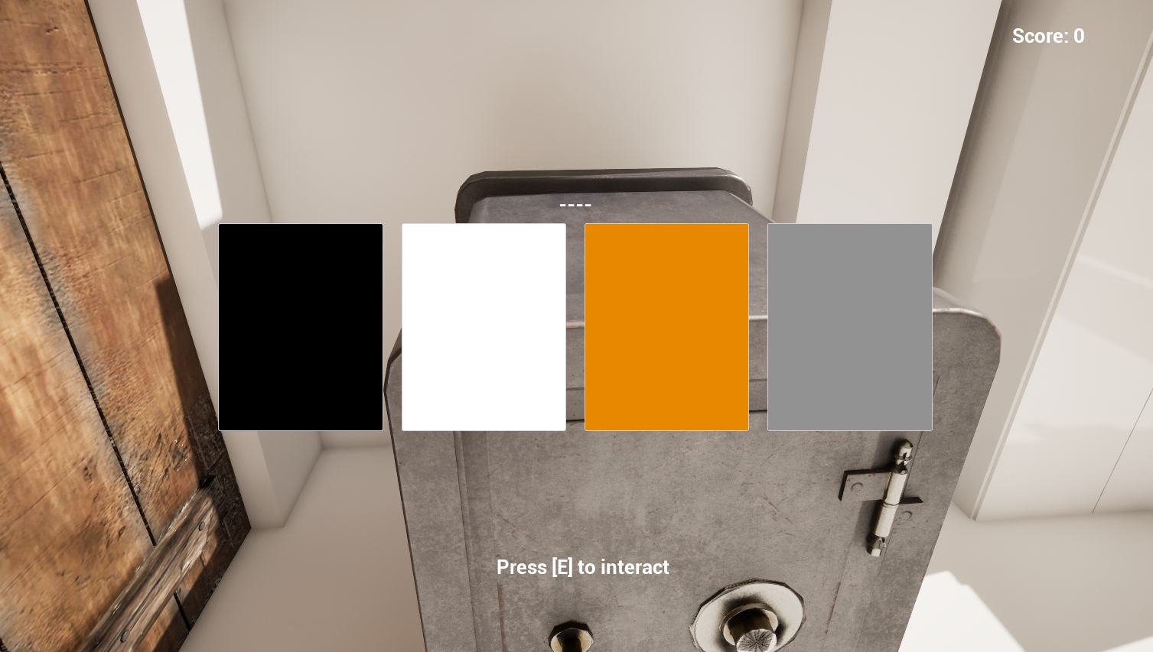
- Reward: The Hallway Key.

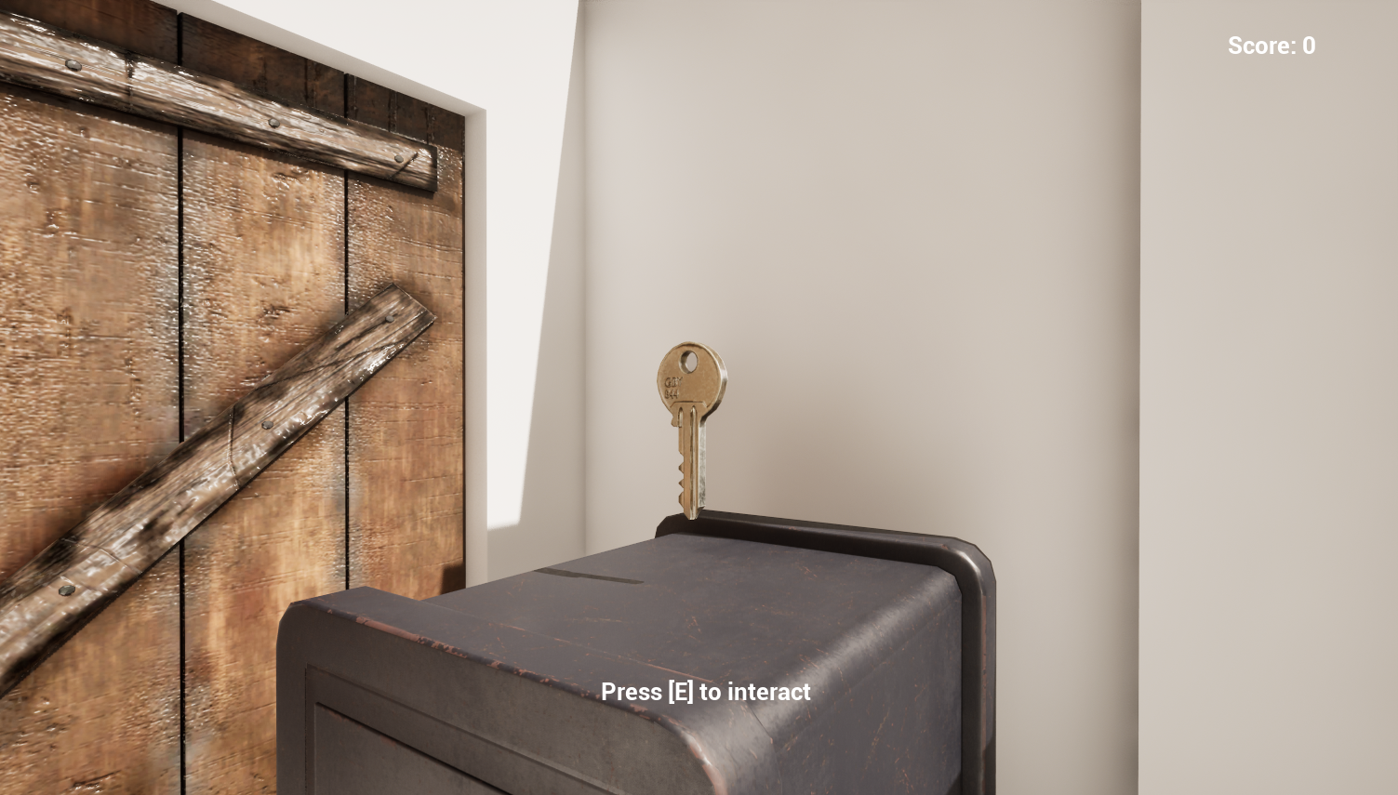

Puzzle 3: Master Bedroom → Catch the Cat
- Minigame: The cat runs all over the room super fast. It will hide under the bedsheets, under the bed, on top of the wardrobe, etc.
- What to do: You have to be really quick and throw a bag over the cat to catch it and carry it away.
- End Game: Once you catch the cat, the final summary screen pops up showing your score, clear time, and star rating.
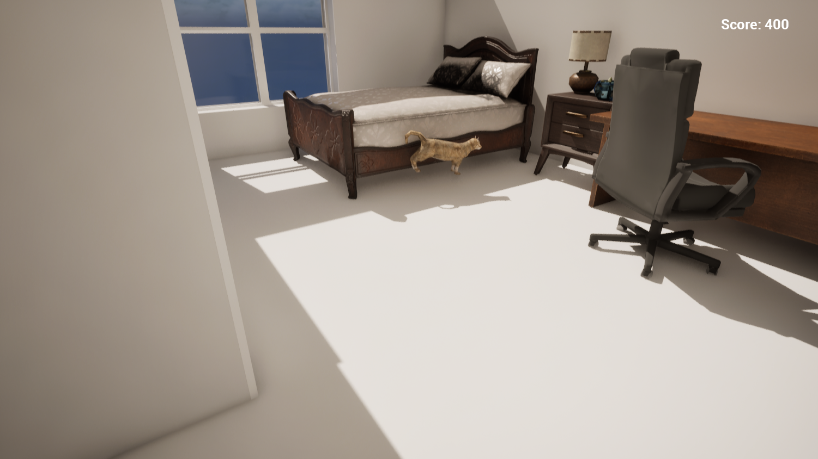

Inspiration for this game

The inspiration for this game comes from the beloved cat George and the affection his owner shows him. So, we thought about what aspect of a cat’s behavior we could use to create this game, and we came up with the idea of a game where you search for the cat hiding around the house, because sometimes cats hide among the furniture, and it can take hours to find them again.
With that in mind, we wanted to add a touch of drama to the game, and that’s when we realized that, besides looking for him, we actually want to break into the house to steal him.

Design Issues

When we were designing this game, our main concern was that just going around the house and collecting / stealing things would lose its fun after the first two rooms. That’s why we decided to go with a theme of being a robber and thus needing to get into the house and force locks or solve puzzles. We tried our best to make the two actual puzzles very different in nature but still easy and achievable, one with a relatively simple QTE and the other with a quick pattern recognition. Our goal with this was for the player to not spend much time in the same room and try to recreate the frantic nature of breaking and entering. With more time and resources, we’d also get a dynamic timer based on “noise” made while entering, actual threats to your routine and more variety in rooms and puzzles.

External Assets

sketchfab

Bed https://sketchfab.com/3d-models/victorian-bed-c56b0776992041648ba5c1615f6e1fed

Kitchen
https://sketchfab.com/3d-models/modern-kitchen-95163e53ab694ed6bcec1ae50158bc94

Living chair
https://sketchfab.com/3d-models/table-and-chairs-2aee19db562b4b26a199a81e62760109

Window
https://sketchfab.com/3d-models/glass-window-da69002c42b24cdaaff84a82f77a02f0

Key
https://sketchfab.com/3d-models/door-key-6538a6a21f5545e0b1dcf22bee5741a1

Safe
https://sketchfab.com/3d-models/old-iron-safe-8f5ed6f1b2f0400f8630349e7b484a99

Cat
https://sketchfab.com/3d-models/cat-ps1-low-poly-rigged-78d863ba43b34a6c9fdd6c61dbf5776f
Sofa
https://sketchfab.com/3d-models/sofa-ikea-nockeby-db5d6bbf7f34482ca1be89456fcc4070

Credits

All Group
- Core idea for the level

Marc Avante
- Creation of the repo and the floor plan.
- Interactuables.
- Raycasting.
- Blueprints for all puzzles
- Blueprints for cat movement

Salvador Bernades
- Puzzle Design
- Searching Fbx
- Documentation

Andrea Doña
- Flowchart of each part of the level.
- Documentation.

Joan Marquès
- Opening doors mechanism.
- Fbxs on the scene.

Justo Tiscornia
- Search for Fbxs.
- Making clues for safe puzzle
- Testing

