Project Proposal

CIS 434 Software Engineering

Term Project: Chess Game

Group 8

Christianna Brewer, Nicholas Filipovic, Corey Malloy, Hamza Srhiri, and Salvador Murillo

Department of Electrical and Computer Engineering

Cleveland State University

April 5, 2023

**Team Profile:**

Christianna Brewer: Third Year Computer Science major at CSU. I have most of my coding experience in Java, C, html, SQL, and a little bit of Python experience. For this project we are going to be using python.

Nicholas Filipovic: Fourth year Computer Science major at CSU. Most of my experience in Java, C, and Python and I have some experience in HTML and SQL programming.

Corey Malloy: Third year computer science major. I have most of my experience in java, c, and python

Hamza Srhiri:Third year Computer Science major at CSU. Experience in Python, Java, C, SQLite, CSS and HTML.

Salvador Murillo: Third year computer science student at CSU. I know programming languages such as C, Java, Python, and Javascript.

**Breakdown of Individual Contributions:**

* Christianna Brewer, Contribution: Python Logic
* Nicholas Filipovic, Contribution: GUI building
* Corey Malloy, Contribution: Python Logic
* Hamza Srhiri, Contribution: Python Logic
* Salvador Murillo, Contribution: GUI building

**Abstract:**

In this term project we will aim to create a Chess Game program that will allow for both two players as well as one player against a computer. For this project we will be using Python for the code and Tkinter or the GUI. Our main objectives for this project will be creating the rules for each type of chess piece, preventing both the user and computer from making illegal moves, keeping track of whose turn it is, and keeping score of who is winning. Some optional items that we are greatly considering having pop-ups for the winner and loser.

The term project will be split into individual parts for one or two group members. The project will be comprised of a menu with three options (a player vs player mode, player vs computer mode, and an exit application option). Two group members will be working on building the GUI for the application (chess board, menu) while three other group members will work on the functionality for the application (moving chess pieces, giving buttons function when clicked, the computer opponent). Although group members will have their section to contribute, they will have assistance from other group members when need be.

For the chess game the piece movement is very particular depending on which piece is being moved. The creation of these different movements and functions will be the key to creating the game. The rook can only move in a straight line either forwards, backwards, or side to side. The bishop can do the same just in a diagonal direction and the queen will be able to do both of those combined (straight and diagonally). The king can do the same as the queen but one space as a time instead of as many as possible. The knight's movements are the weirdest, as it is able to jump over other pieces but can only move in an odd “L” shape. In the process of making these movements work, we will then need to have many different functions and statements for each individual piece to say what is a legal move and what is not. The king itself can not move into a place where it can be taken so we have to take this into account as well.

**Introduction:**

The project involves creating a chess game application for the purpose of entertainment. The application will involve playing against another person on the same device the application is running on, as well as playing against an AI opponent. The contribution provided by each group member involves the construction of the interface (start menu, game mode options, chess board, chess pieces, and player stats), functionality of the interface, input from player for piece movement, and a very basic computer opponent (considering random number generation for input). These contributions are quite significant as they are core features and functions to the application. Other contributions being considered are win/lose screens, fullscreen option, and flipping the board so the current player is always at the bottom of the board. These contributions are not as significant compared to the ones previously discussed as they are nonfunctional features.

References to technical manuals will be utilized to create a responsive and effective application. Such technical references will be online manuals for Tkinter (for GUI), Python libraries, and group planning techniques.

A chess game application is nothing new or groundbreaking, there are several chess applications in several forms (website apps, 3D hardware rendered apps, calculator based apps, etc.). The state-of-the-art in chess applications would be the popular website based chess app ‘Chess.com’. Elements from ‘Chess.com’ such as piece movement, game mode options, and player stats (pieces taken) were taken into consideration when deciding how to design the chess application.

**Objectives:**

There will be multiple specific objectives in the project required to reach our main objective of creating a functioning chess game. One of these objectives is to create the GUI, which will consist of a menu to choose between playing with another player or with an AI, the chess board, and the individual pieces. Another objective will be the logic behind the game which will consist of creating an AI to play against, setting rules for how and where pieces can move, and setting the overall rules for a chess game. These would be the main objectives of the project, but if there is time to implement optional objectives, we plan to make multiple difficulties for the AI and add in additional GUI elements for the winners and losers of games.

**Methodology:**

For this project we are going to be utilizing the Waterfall method to reach our project objectives. Since we are doing the Chess game our objectives will all need to be completed in order for us to be able to test that all of our components are able to work together. This makes the waterfall method a good choice for our project’s needs. The project deliverables will consist mainly of the progress reports that will need to be done from time to time as well as the smaller steps shown in the gantt chart (Pieces, GUI Creation, AI Creation). Some of the experimental details will be the level of difficulty we need to make the AI/what it can do, also the visuals of the game when trying to make a move.

**Professional Awareness:**

Professional, ethical, legal, security and social issues that we are considering during the development of the chess game application are privacy, fairness, intellectual property, and user friendly dilemmas. For privacy, our application should not collect information from the user unless informed consent from the user is obtained. For fairness, player vs player mode should not give players an advantage over one another (flipping the board to the bottom for the current player for fairness). For intellectual property, any image, code, design, or other intellectual property should not be used unless license to use is obtained (don’t steal images, code, and designs). For user friendly issues, the design of the chess application should not harm the user in any way (bright flashing lights, very loud sound effects, etc.).

**Project Timelines:**

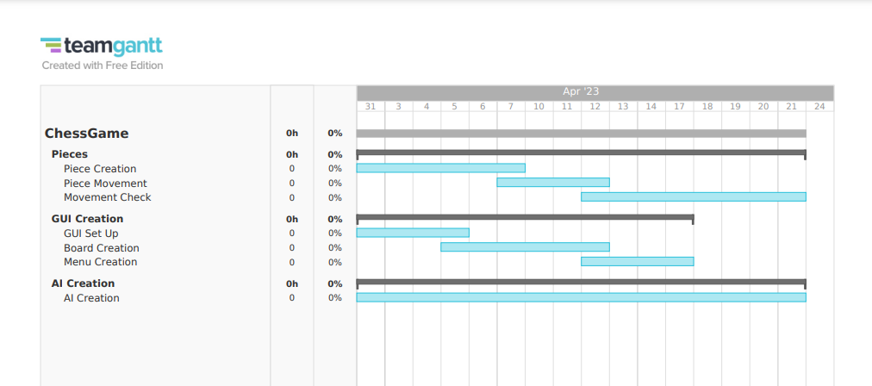

Figure 1: The group’s project timeline displaying the three major parts of the work to be done

**Turn Logic Flowchart:**

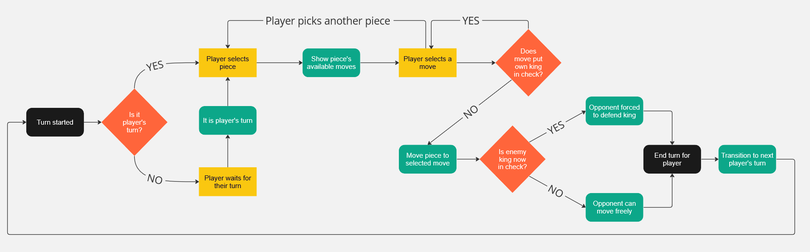

Figure 2: A flowchart demonstrating the logic of a single turn

**Conclusion:**

The chess project will be separated into three parts: the interface, the logic/functionality, and the AI for the computer opponent. Each member will be responsible for their designated section, but group members aren’t restricted to work just in their section. The motivation to accomplish this project is to make a user friendly application that has a competitive AI opponent. Technical references will be used to understand and learn the tools the group is working with. Ethical dilemmas will be considered during the design and development of the application. Project objectives will be achieved by following the timeline and meeting the milestone deadlines (completion of each task).

**References:**

[1] I. Sommerville, *Software Engineering*, 10th Edition, Pearson, 2016.

[2] “Tkinter - Python interface to TCL/TK,” *Python documentation*. [Online]. Available: https://docs.python.org/3/library/tkinter.html. [Accessed: 01-Apr-2023].

[3] “Python 3.11.2 documentation,” *3.11.2 Documentation*. [Online]. Available: https://docs.python.org/3/. [Accessed: 01-Apr-2023].