The IAnimal Interface Structure:
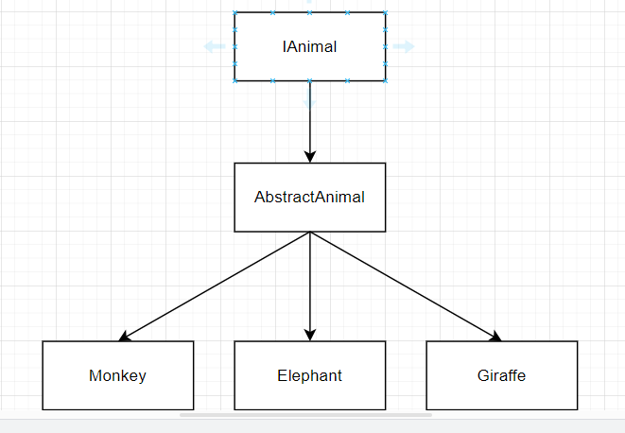
IAnimal.cs
An interface defining the contract for all animal types. It ensures that all concrete animal classes implement essential properties and methods, promoting consistency and interoperability.
AbstractAnimal.cs
An abstract base class representing a generic animal in the zoo simulator. It provides common properties and methods shared among all animal types, such as health management, unique identification, and basic behaviours.
Monkey.cs, Giraffe.cs, Elephant.cs
Concrete classes inheriting from AbstractAnimal, representing specific animal types in the zoo. Each class overrides properties and methods to reflect unique characteristics and behaviours of the respective animal.
Object-Oriented Principles
The Zoo Simulator leverages fundamental Object-Oriented Programming (OOP) principles to create a flexible and maintainable codebase. Here's how each principle is applied:
1. Abstraction
The AbstractAnimal class serves as an abstraction for all animals, encapsulating common properties like Health, Id, and services related to health management.
Interfaces such as IAnimal, IHealthService, and IHealthMonitorService define contracts without specifying concrete implementations, allowing for flexibility and interchangeability.
2. Inheritance
Monkey, Giraffe, and Elephant classes inherit from AbstractAnimal, reusing common functionalities and extending them with specific behaviors.
The use of virtual and abstract properties/methods in AbstractAnimal allows derived classes to override and implement specific behaviours, such as DeathThreshold, CanWalk, and WalkingSpeed.
The IAnimal interface ensures that different animal types can be managed uniformly, facilitating operations like health monitoring and behavior management.

Design Patterns:
Template Method Pattern:
Purpose: Defines the skeleton of an algorithm in an operation, deferring some steps to subclasses. This pattern lets subclasses redefine certain steps without changing the algorithm's structure.
Application:
- The AbstractAnimal class provides the template for initializing health services in its constructor. Derived classes like Elephant can override specific steps (e.g., providing a custom ElephantHealthMonitorService) without altering the overall initialization process.

Strategy Pattern
Purpose: Enables selecting an algorithm's behaviour at runtime by defining a family of algorithms, encapsulating each one, and making them interchangeable.
Application:
- The IHealthService and IHealthMonitorService interfaces represent strategies for managing and monitoring an animal's health.
- Concrete implementations like GeneralHealthService, GeneralHealthMonitorService, and ElephantHealthMonitorService encapsulate specific health management behaviours.
- The AbstractAnimal class uses dependency injection to assign these services, allowing different animals to have customized health strategies without altering the animal classes themselves.
Additional Design Considerations:
Dependency Injection:
The use of dependency injection in the AbstractAnimal constructor promotes loose coupling between classes. By accepting IHealthService and IHealthMonitorService interfaces, the AbstractAnimal class doesn't depend on concrete implementations, allowing for greater flexibility and easier testing.
Thread Safety:
The static AutoIncrementID ensures that each animal instance receives a unique identifier in a thread-safe manner using Interlocked.Increment. This approach prevents race conditions in multi-threaded environments.

The Animal Service Interface Structure:
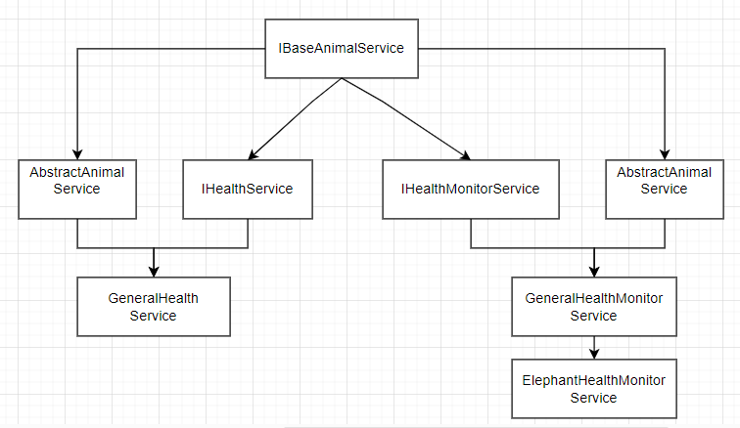
IBaseAnimalService:
IBaseAnimalService is a foundational interface for animal-related services within the simulator. It extends the IDisposable interface, ensuring that implementing classes can release unmanaged resources appropriately. This interface includes a property to associate the service with a specific animal.
IHealthService:
IHealthService extends IBaseAnimalService and defines methods for modifying an animal's health. This interface allows for increasing or decreasing an animal's health by specified percentages.
IHealthMonitorService:
IHealthMonitorService extends IBaseAnimalService and provides functionality for monitoring an animal's health status. It manages life state transitions and exposes properties to check the animal's current state.
AbstractAnimalService:
AbstractAnimalService is an abstract class that implements IBaseAnimalService. It serves as a base for all animal-related services, providing common functionalities such as associating the service with an animal and handling disposal of resources.
GeneralHealthService:
GeneralHealthService extends AbstractAnimalService and implements IHealthService. It provides general health modification functionalities, allowing the health of an associated animal to be increased or decreased by specified percentages.
GeneralHealthService:
GeneralHealthService extends AbstractAnimalService and implements IHealthService. It provides general health modification functionalities, allowing the health of an associated animal to be increased or decreased by specified percentages.
ElephantHealthMonitorService:
ElephantHealthMonitorService extends GeneralHealthMonitorService and provides specialized health monitoring for elephants. It overrides methods to handle the unique health threshold and state transitions specific to elephants.

Design Patterns:
1. Strategy Pattern:
Purpose: Enables selecting an algorithm's behavior at runtime by defining a family of algorithms, encapsulating each one, and making them interchangeable.
Application:
- The IHealthService and IHealthMonitorService interfaces represent strategies for managing and monitoring an animal's health.
- Concrete implementations like GeneralHealthService, GeneralHealthMonitorService, and ElephantHealthMonitorService encapsulate specific health management behaviors.
- The AbstractAnimalService class uses dependency injection to assign these services, allowing different animals to have customized health strategies without altering the animal classes themselves.
Template Method Pattern
Purpose: Defines the skeleton of an algorithm in an operation, deferring some steps to subclasses. This pattern lets subclasses redefine certain steps without changing the algorithm's structure.
Application:
- The AbstractAnimal class provides the template for initializing health services in its constructor. Derived classes like Elephant can override specific steps (e.g., providing a custom ElephantHealthMonitorService) without altering the overall initialization process.
5. Observer Pattern
Purpose: Defines a one-to-many dependency between objects so that when one object changes state, all its dependents are notified and updated automatically.
Application:
- The IHealthMonitorService interface includes an event StateChanged that is triggered when the animal's life state changes. Subscribers can listen to this event to react accordingly, such as updating the user interface or triggering other behaviors within the simulator.

The State Change Pattern:
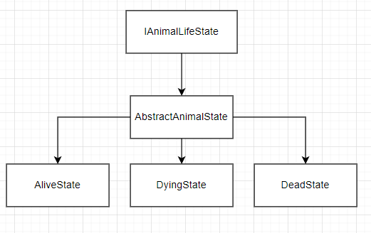
IAnimalLifeState:
IAnimalLifeState is the base interface for different life states of an animal in the zoo simulator. This interface serves as a marker for life states such as Alive, Dying, and Dead. Specific state classes will implement this interface to define state-specific behaviours.
AbstractAnimalState:
AbstractAnimalState is an abstract class that implements IAnimalLifeState. It serves as a base for all specific animal life states, providing a common foundation for state-related functionalities.
AliveState:
AliveState represents the alive state of an animal in the zoo simulator. It signifies that the animal is currently healthy and active.
DyingState:
DyingState represents the dying state of an animal in the zoo simulator. This class is intentionally left empty to allow for future extensions.
DeadState:
DeadState represents the dead state of an animal in the zoo simulator. This class is intentionally left empty to allow for future extensions.
Detailed Workflow:
- State Initialization: When an animal is created, its initial state is set to AliveState.
- Health Monitoring: As the animal's health changes, the IHealthMonitorService evaluates whether a state transition is necessary.
- State Transitions:
  - From Alive to Dying: If the animal's health falls below the DeathThreshold, the state transitions to DyingState.
  - From Dying to Dead: If the animal's health does not recover above the DeathThreshold, the state transitions to DeadState.
  - From Dying to Alive: If the animal's health recovers above the DeathThreshold during the DyingState, it can transition back to AliveState.
- Behavioral Changes: Each state can define specific behaviors or restrictions. For example, an animal in the DeadState cannot perform actions like walking.
Advantages:
- Flexibility: Easily add or modify states without affecting the animal's core functionalities.
- Maintainability: Isolates state-specific logic, making the system easier to understand and maintain.
- Scalability: Facilitates the addition of new states or modifications to existing ones as the simulator evolves.

Factory Pattern:
AnimalGenerator:
AnimalGenerator is a utility class responsible for asynchronously generating collections of animals within the Zoo Simulator. It provides methods to create specified numbers of different animal types, facilitating the initialization of the zoo environment with diverse animal populations.
Key Features:
- Asynchronous Generation: Utilizes asynchronous programming to generate animal instances without blocking the main thread, enhancing the application's responsiveness and performance.
- Generic Method Implementation: Employs generic methods to create collections of various animal types (Monkey, Elephant, Giraffe), promoting code reusability and scalability.
- Collection Management: Returns instances wrapped in ObservableRangeCollection<IAnimal>, allowing for efficient data binding and dynamic collection updates within the simulator's user interface.
Design Pattern Highlight:
Factory Method Pattern:
The AnimalGenerator class exemplifies the Factory Method Pattern by providing a flexible and reusable interface for creating objects without specifying their concrete classes. Specifically:
- Encapsulation of Object Creation: The generic methods GenerateAnimalAsync<A> and GenerateAnimal<A> encapsulate the instantiation logic for different animal types, allowing the simulator to generate various animals dynamically based on the specified type parameter.
- Promoting Scalability: By leveraging generics and type constraints (where A : IAnimal, new()), the factory methods can easily accommodate new animal types in the future without modifying existing code, adhering to the Open/Closed Principle.
- Simplifying Object Management: The GenerateZooAsync method orchestrates the creation of multiple animal collections concurrently, streamlining the setup process for initializing the zoo with diverse animal groups.

The Observer Pattern:
StageChangedEventHandler is a delegate that defines the signature for handling events when an animal's life state changes. It follows the standard .NET event pattern, accepting the event sender and event data as parameters.
GameEndedEventHandler is a delegate that defines the signature for handling events when the game ends. It follows the standard .NET event pattern, accepting the event sender and event data as parameters.

