1.void test(int sum)
{
int x;
scanf("%d",&x);
if (x==0)
sum=0;
else
{
do
{
sum+=x;
scanf("%d",&x);

}while (x!=0);

}
printf("%d ",sum);

}
2.
队列初始化
struct node * initQueue(struct node * rear) //队列初始化
{
rear=(struct node *)malloc(sizeof(Node)); //定义尾指针
if(!rear)
return 0;
else
{
rear->next=rear; //使队列循环
}
return rear;
}
入队列
struct node * enQueue(struct node * rear,ElemType e) //入队列
{
struct node * p=(struct node *)malloc(sizeof(Node));
p->data=e;
p->next=rear->next;
rear->next=p;
rear=p; //现在尾指针指向p
count++;
return rear;
}
出队列
struct node * deQueue(struct node * rear) //出队列
{
int e;
struct node * p;
if(rear==rear->next)
printf("队列为空");
else{
p=rear->next->next;
e=p->data;
rear->next->next=p->next;
if(rear==p)
{
rear=rear->next;
}
free(p);
}
printf("%d",e);
count--;
return rear;
}
程序运行截图
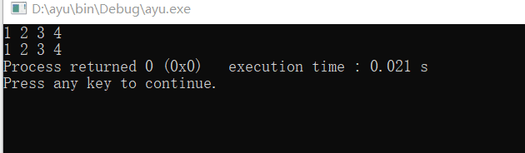
源代码
#include <stdio.h>
#include <malloc.h>
int count=0;
typedef int ElemType;
typedef struct node{
ElemType data;
struct node *next;
}Node;
struct node * initQueue(struct node * rear) //队列初始化
{
rear=(struct node *)malloc(sizeof(Node)); //定义尾指针
if(!rear)
return 0;
else
{
rear->next=rear; //使队列循环
}
return rear;
}

struct node * enQueue(struct node * rear,ElemType e) //入队列
{
struct node * p=(struct node *)malloc(sizeof(Node));
p->data=e;
p->next=rear->next;
rear->next=p;
rear=p; //现在尾指针指向p
count++;
return rear;
}

struct node * deQueue(struct node * rear) //出队列
{
int e;
struct node * p;
if(rear==rear->next)
printf("队列为空");
else{
p=rear->next->next;
e=p->data;
rear->next->next=p->next;
if(rear==p)
{
rear=rear->next;
}
free(p);
}
printf("%d",e);
count--;
return rear;
}

int main()
{
struct node * rear=initQueue(rear);
struct node *p;
struct node *q;
int i;
for(i=0;i<4;i++)
{
rear=enQueue(rear,i+1);
}
p=rear->next->next;
for(i=0;i<4;i++)
{
printf("%d ",p->data);
p=p->next;
}
printf("\n");
q=rear->next->next;
for(i=0;i<4;i++)
{
printf("%d ",q->data);
q=q->next;
}
return 0;
}

