2.对数据按类进行划分，用折线图分别对每个属性数据值画图

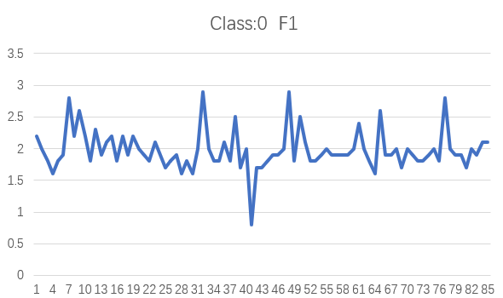

变化幅度较大，在31，48左右达到了顶峰。42出出现了最低值。

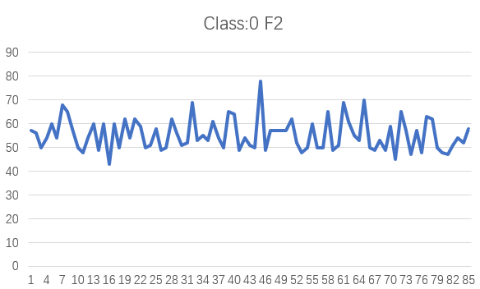

Y轴值整体集中在50以上，各个点间起伏大。

相比类0中F1平稳且比其值整体高，也集中分布在4以上。

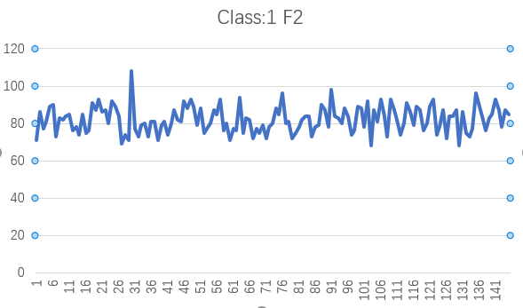

相比其它三图非常平稳，集中分布在80左右，31左右出现了顶峰。

3.对每个属性值分别计算出它的maximum, minmum, mean, 和standard deviation。

分别使用以下公式求得

=max(b2:b231) F0最大值5.5

=max(c2:c231) F1最大值108

=min(b2:b231) F0最小值0.8

=min(c2:c231) F1最小值43

=average(b2:b231) F0平均值3.487391

=average(c2:c231) F1平均值72.15652

=stdevp(b2:b231) F1标准差1.214251

=stdevp(c2:c231) F2标准差14.57878

4.用散点图画出F1 和 F2分别作横纵坐标的图

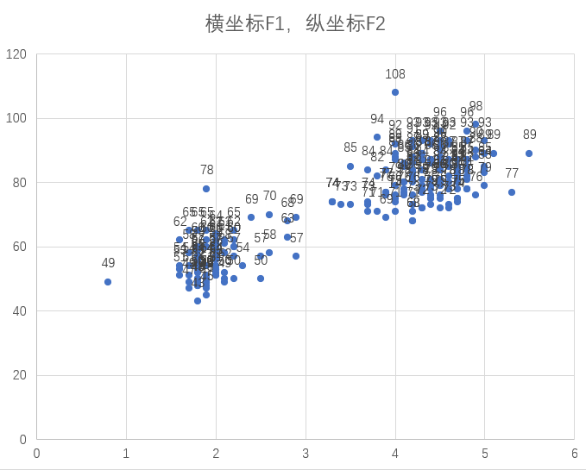

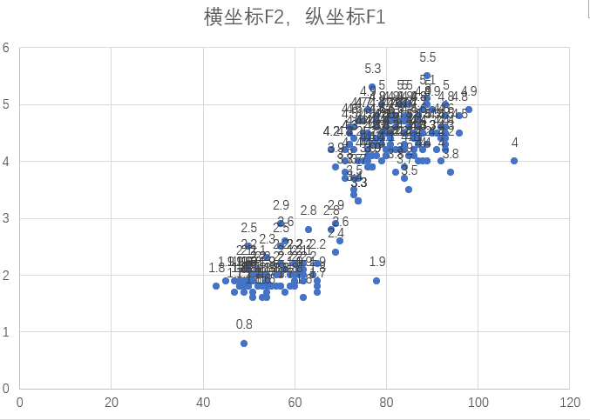

由散点图看出数据大致分布在一条直线附近，数据是相关的。

5.基于散点图手动观察找出5个离群点（outlier），用红色的圆圈将离群点标识出来

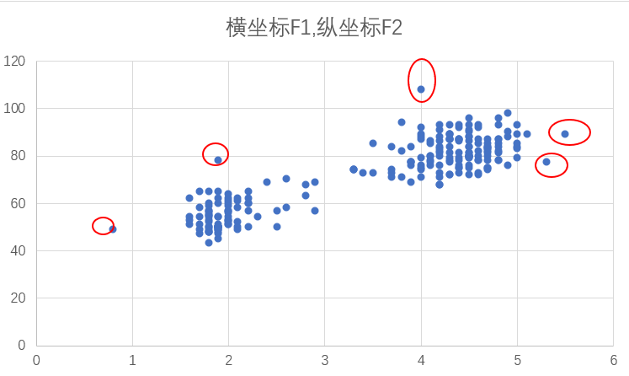

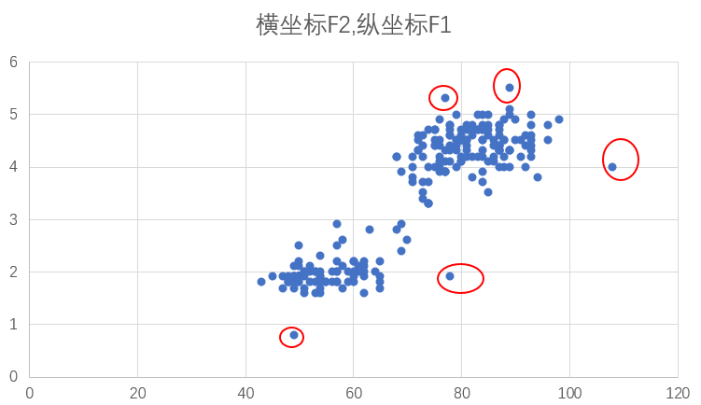

6.分别为每个类产生一个属性的相关矩阵

使用以下公式求得相关矩阵 =CORREL(B2:B86,C2:C86)

=CORREL(B87:B231,C87:C231)

|  |  |  |
| --- | --- | --- |
| Class0 | F1 | F2 |
| F1 | 1 | 0.410291 |
| F2 | 0.410291 | 1 |

|  |  |  |
| --- | --- | --- |
| Class1 | F1 | F2 |
| F1 | 1 | 0.288095 |
| F2 | 0.288095 | 1 |

可以看出类0中数据相关度相比类1更高

7.将属性规范到[0,1]之间

根据公式(x-min)(max-min)规范化一个值，拖动即可

F1 F2 Class

|  |  |  |  |  |  |  |  |  |  |  |  |  |  |  |  |  |  |  |  |  |  |  |  |  |  |  |  |  |  |  |  |  |  |  |  |  |  |  |  |  |  |  |  |  |  |  |  |  |  |  |  |  |  |  |  |  |  |  |  |  |  |  |  |  |  |  |  |  |  |  |  |  |  |  |  |  |  |  |  |  |  |  |  |  |  |  |  |  |  |  |  |  |  |  |  |  |  |  |  |  |  |  |  |  |  |  |  |  |  |  |  |  |  |  |  |  |  |  |  |  |  |  |  |  |  |  |  |  |  |  |  |  |  |  |  |  |  |  |  |  |  |  |  |  |  |  |  |  |  |  |  |  |  |  |  |  |  |  |  |  |  |  |  |  |  |  |  |  |  |  |  |  |  |  |  |  |  |  |  |  |  |  |  |  |  |  |  |  |  |  |  |  |  |  |  |  |  |  |  |  |  |  |  |  |  |  |  |  |  |  |  |  |  |  |  |  |  |  |  |  |  |  |  |  |  |  |  |  |  |  |  |  |  |  |  |  |  |  |  |  |  |  |  |  |  |  |  |  |  |  |  |  |  |  |  |  |  |  |  |  |  |  |  |  |  |  |  |  |  |  |  |  |  |  |  |  |  |  |  |  |  |  |  |  |  |  |  |  |  |  |  |  |  |  |  |  |  |  |  |  |  |  |  |  |  |  |  |  |  |  |  |  |  |  |  |  |  |  |  |  |  |  |  |  |  |  |  |  |  |  |  |  |  |  |  |  |  |  |  |  |  |  |  |  |  |  |  |  |  |  |  |  |  |  |  |  |  |  |  |  |  |  |  |  |  |  |  |  |  |  |  |  |  |  |  |  |  |  |  |  |  |  |  |  |  |  |  |  |  |  |  |  |  |  |  |  |  |  |  |  |  |  |  |  |  |  |  |  |  |  |  |  |  |  |  |  |  |  |  |  |  |  |  |  |  |  |  |  |  |  |  |  |  |  |  |  |  |  |  |  |  |  |  |  |  |  |  |  |  |  |  |  |  |  |  |  |  |  |  |  |  |  |  |  |  |  |  |  |  |  |  |  |  |  |  |  |  |  |  |  |  |  |  |  |  |  |  |  |  |  |  |  |  |  |  |  |  |  |  |  |  |  |  |  |  |  |  |  |  |  |  |  |  |  |  |  |  |  |  |  |  |  |  |  |  |  |  |  |  |  |  |  |  |  |  |  |  |  |  |  |  |  |  |  |  |  |  |  |  |  |  |  |  |  |  |  |  |  |  |  |  |  |  |  |  |  |  |  |  |  |  |  |  |  |  |  |  |  |  |  |  |  |  |  |  |  |  |  |  |  |  |  |  |  |  |  |  |  |  |  |  |  |  |  |  |  |  |  |  |  |  |  |  |  |  |  |  |  |  |  |  |  |  |  |  |  |  |  |  |  |  |  |  |  |  |  |  |  |  |  |  |  |  |  |  |  |  |  |  |  |  |  |  |  |  |  |  |  |  |  |  |  |  |  |  |  |  |  |  |  |  |  |  |  |  |  |  |  |  |  |  |  |  |  |  |  |  |  |  |  |  |  |
| --- | --- | --- | --- | --- | --- | --- | --- | --- | --- | --- | --- | --- | --- | --- | --- | --- | --- | --- | --- | --- | --- | --- | --- | --- | --- | --- | --- | --- | --- | --- | --- | --- | --- | --- | --- | --- | --- | --- | --- | --- | --- | --- | --- | --- | --- | --- | --- | --- | --- | --- | --- | --- | --- | --- | --- | --- | --- | --- | --- | --- | --- | --- | --- | --- | --- | --- | --- | --- | --- | --- | --- | --- | --- | --- | --- | --- | --- | --- | --- | --- | --- | --- | --- | --- | --- | --- | --- | --- | --- | --- | --- | --- | --- | --- | --- | --- | --- | --- | --- | --- | --- | --- | --- | --- | --- | --- | --- | --- | --- | --- | --- | --- | --- | --- | --- | --- | --- | --- | --- | --- | --- | --- | --- | --- | --- | --- | --- | --- | --- | --- | --- | --- | --- | --- | --- | --- | --- | --- | --- | --- | --- | --- | --- | --- | --- | --- | --- | --- | --- | --- | --- | --- | --- | --- | --- | --- | --- | --- | --- | --- | --- | --- | --- | --- | --- | --- | --- | --- | --- | --- | --- | --- | --- | --- | --- | --- | --- | --- | --- | --- | --- | --- | --- | --- | --- | --- | --- | --- | --- | --- | --- | --- | --- | --- | --- | --- | --- | --- | --- | --- | --- | --- | --- | --- | --- | --- | --- | --- | --- | --- | --- | --- | --- | --- | --- | --- | --- | --- | --- | --- | --- | --- | --- | --- | --- | --- | --- | --- | --- | --- | --- | --- | --- | --- | --- | --- | --- | --- | --- | --- | --- | --- | --- | --- | --- | --- | --- | --- | --- | --- | --- | --- | --- | --- | --- | --- | --- | --- | --- | --- | --- | --- | --- | --- | --- | --- | --- | --- | --- | --- | --- | --- | --- | --- | --- | --- | --- | --- | --- | --- | --- | --- | --- | --- | --- | --- | --- | --- | --- | --- | --- | --- | --- | --- | --- | --- | --- | --- | --- | --- | --- | --- | --- | --- | --- | --- | --- | --- | --- | --- | --- | --- | --- | --- | --- | --- | --- | --- | --- | --- | --- | --- | --- | --- | --- | --- | --- | --- | --- | --- | --- | --- | --- | --- | --- | --- | --- | --- | --- | --- | --- | --- | --- | --- | --- | --- | --- | --- | --- | --- | --- | --- | --- | --- | --- | --- | --- | --- | --- | --- | --- | --- | --- | --- | --- | --- | --- | --- | --- | --- | --- | --- | --- | --- | --- | --- | --- | --- | --- | --- | --- | --- | --- | --- | --- | --- | --- | --- | --- | --- | --- | --- | --- | --- | --- | --- | --- | --- | --- | --- | --- | --- | --- | --- | --- | --- | --- | --- | --- | --- | --- | --- | --- | --- | --- | --- | --- | --- | --- | --- | --- | --- | --- | --- | --- | --- | --- | --- | --- | --- | --- | --- | --- | --- | --- | --- | --- | --- | --- | --- | --- | --- | --- | --- | --- | --- | --- | --- | --- | --- | --- | --- | --- | --- | --- | --- | --- | --- | --- | --- | --- | --- | --- | --- | --- | --- | --- | --- | --- | --- | --- | --- | --- | --- | --- | --- | --- | --- | --- | --- | --- | --- | --- | --- | --- | --- | --- | --- | --- | --- | --- | --- | --- | --- | --- | --- | --- | --- | --- | --- | --- | --- | --- | --- | --- | --- | --- | --- | --- | --- | --- | --- | --- | --- | --- | --- | --- | --- | --- | --- | --- | --- | --- | --- | --- | --- | --- | --- | --- | --- | --- | --- | --- | --- | --- | --- | --- | --- | --- | --- | --- | --- | --- | --- | --- | --- | --- | --- | --- | --- | --- | --- | --- | --- | --- | --- | --- | --- | --- | --- | --- | --- | --- | --- | --- | --- | --- | --- | --- | --- | --- | --- | --- | --- | --- | --- | --- | --- | --- | --- | --- | --- | --- | --- | --- | --- | --- | --- | --- | --- | --- | --- | --- | --- | --- | --- | --- | --- | --- | --- | --- | --- | --- | --- | --- | --- | --- | --- | --- | --- | --- | --- | --- | --- | --- | --- | --- | --- | --- | --- | --- | --- | --- | --- | --- | --- | --- | --- | --- | --- | --- | --- | --- | --- | --- | --- | --- | --- | --- | --- | --- | --- | --- | --- | --- | --- | --- | --- | --- | --- | --- | --- | --- | --- | --- | --- | --- | --- | --- | --- | --- | --- | --- | --- | --- | --- | --- | --- | --- | --- | --- | --- | --- | --- | --- | --- | --- | --- | --- | --- | --- | --- | --- | --- | --- | --- | --- | --- | --- | --- | --- | --- |
| |  |  |  | | --- | --- | --- | | 0.297872 | 0.215385 | 0 | | 0.255319 | 0.2 | 0 | | 0.212766 | 0.107692 | 0 | | 0.170213 | 0.169231 | 0 | | 0.212766 | 0.261538 | 0 | | 0.234043 | 0.169231 | 0 | | 0.425532 | 0.384615 | 0 | | 0.297872 | 0.338462 | 0 | | 0.382979 | 0.230769 | 0 | | 0.297872 | 0.107692 | 0 | | 0.212766 | 0.076923 | 0 | | 0.319149 | 0.169231 | 0 | | 0.234043 | 0.261538 | 0 | | 0.276596 | 0.092308 | 0 | | 0.297872 | 0.261538 | 0 | | 0.212766 | 0 | 0 | | 0.297872 | 0.261538 | 0 | | 0.234043 | 0.107692 | 0 | | 0.297872 | 0.292308 | 0 | | 0.255319 | 0.169231 | 0 | | 0.234043 | 0.292308 | 0 | | 0.212766 | 0.246154 | 0 | | 0.276596 | 0.107692 | 0 | | 0.234043 | 0.123077 | 0 | | 0.191489 | 0.230769 | 0 | | 0.212766 | 0.092308 | 0 | | 0.234043 | 0.107692 | 0 | | 0.170213 | 0.292308 | 0 | | 0.212766 | 0.2 | 0 | | 0.170213 | 0.123077 | 0 | | 0.255319 | 0.138462 | 0 | | 0.446809 | 0.4 | 0 | | 0.255319 | 0.153846 | 0 | | 0.212766 | 0.184615 | 0 | | 0.212766 | 0.153846 | 0 | | 0.276596 | 0.276923 | 0 | | 0.212766 | 0.169231 | 0 | | 0.361702 | 0.107692 | 0 | | 0.191489 | 0.338462 | 0 | | 0.255319 | 0.323077 | 0 | | 0 | 0.092308 | 0 | | 0.191489 | 0.169231 | 0 | | 0.191489 | 0.123077 | 0 | | 0.212766 | 0.107692 | 0 | | 0.234043 | 0.538462 | 0 | | 0.234043 | 0.092308 | 0 | | 0.255319 | 0.215385 | 0 | | 0.446809 | 0.215385 | 0 | | 0.212766 | 0.215385 | 0 | | 0.361702 | 0.215385 | 0 | | 0.276596 | 0.292308 | 0 | | 0.212766 | 0.138462 | 0 | | 0.212766 | 0.076923 | 0 | | 0.234043 | 0.107692 | 0 | | 0.255319 | 0.261538 | 0 | | 0.234043 | 0.107692 | 0 | | 0.234043 | 0.107692 | 0 | | 0.234043 | 0.338462 | 0 | | 0.234043 | 0.092308 | 0 | | 0.255319 | 0.123077 | 0 | | 0.340426 | 0.4 | 0 | | 0.255319 | 0.276923 | 0 | | 0.212766 | 0.184615 | 0 | | 0.170213 | 0.153846 | 0 | | 0.382979 | 0.415385 | 0 | | 0.234043 | 0.107692 | 0 | | 0.234043 | 0.092308 | 0 | | 0.255319 | 0.153846 | 0 | | 0.191489 | 0.092308 | 0 | | 0.255319 | 0.246154 | 0 | | 0.234043 | 0.030769 | 0 | | 0.212766 | 0.338462 | 0 | | 0.212766 | 0.215385 | 0 | | 0.234043 | 0.061538 | 0 | | 0.255319 | 0.215385 | 0 | | 0.212766 | 0.076923 | 0 | | 0.425532 | 0.307692 | 0 | | 0.255319 | 0.292308 | 0 | | 0.234043 | 0.107692 | 0 | | 0.234043 | 0.076923 | 0 | | 0.191489 | 0.061538 | 0 | | 0.255319 | 0.123077 | 0 | | 0.234043 | 0.169231 | 0 | | 0.276596 | 0.138462 | 0 | | 0.276596 | 0.230769 | 0 | | 0.680851 | 0.430769 | 1 | | 0.765957 | 0.661538 | 1 | | 0.744681 | 0.523077 | 1 | | 0.851064 | 0.584615 | 1 | | 1 | 0.707692 | 1 | | 0.87234 | 0.723077 | 1 | | 0.765957 | 0.461538 | 1 | | 0.829787 | 0.615385 | 1 | | 0.851064 | 0.6 | 1 | | 0.723404 | 0.630769 | 1 | | 0.893617 | 0.646154 | 1 | | 0.787234 | 0.507692 | 1 | | 0.702128 | 0.538462 | 1 | | 0.617021 | 0.476923 | 1 | | 0.574468 | 0.646154 | 1 | | 0.787234 | 0.492308 | 1 | | 0.87234 | 0.507692 | 1 | | 0.723404 | 0.738462 | 1 | | 0.851064 | 0.676923 | 1 | | 0.808511 | 0.769231 | 1 | | 0.702128 | 0.661538 | 1 | | 0.744681 | 0.676923 | 1 | | 0.787234 | 0.569231 | 1 | | 0.680851 | 0.753846 | 1 | | 0.744681 | 0.707692 | 1 | | 0.787234 | 0.630769 | 1 | | 0.659574 | 0.4 | 1 | | 0.531915 | 0.476923 | 1 | | 0.617021 | 0.430769 | 1 | | 0.680851 | 1 | 1 | | 0.957447 | 0.523077 | 1 | | 0.574468 | 0.461538 | 1 | | 0.787234 | 0.553846 | 1 | | 0.723404 | 0.569231 | 1 | | 0.723404 | 0.461538 | 1 | | 0.744681 | 0.584615 | 1 | | 0.829787 | 0.584615 | 1 | | 0.638298 | 0.430769 | 1 | | 0.680851 | 0.553846 | 1 | | 0.723404 | 0.584615 | 1 | | 0.829787 | 0.476923 | 1 | | 0.787234 | 0.569231 | 1 | | 0.744681 | 0.676923 | 1 | | 0.829787 | 0.6 | 1 | | 0.765957 | 0.584615 | 1 | | 0.808511 | 0.753846 | 1 | | 0.787234 | 0.692308 | 1 | | 0.893617 | 0.769231 | 1 | | 0.914894 | 0.707692 | 1 | | 0.744681 | 0.553846 | 1 | | 0.787234 | 0.692308 | 1 | | 0.829787 | 0.492308 | 1 | | 0.659574 | 0.523077 | 1 | | 0.702128 | 0.569231 | 1 | | 0.829787 | 0.676923 | 1 | | 0.829787 | 0.646154 | 1 | | 0.851064 | 0.769231 | 1 | | 0.702128 | 0.507692 | 1 | | 0.829787 | 0.569231 | 1 | | 0.723404 | 0.430769 | 1 | | 0.702128 | 0.523077 | 1 | | 0.659574 | 0.507692 | 1 | | 0.638298 | 0.784615 | 1 | | 0.765957 | 0.492308 | 1 | | 0.723404 | 0.615385 | 1 | | 0.638298 | 0.6 | 1 | | 0.744681 | 0.446154 | 1 | | 0.659574 | 0.523077 | 1 | | 0.829787 | 0.492308 | 1 | | 0.893617 | 0.553846 | 1 | | 0.744681 | 0.446154 | 1 | | 0.808511 | 0.538462 | 1 | | 0.808511 | 0.569231 | 1 | | 0.87234 | 0.692308 | 1 | | 0.808511 | 0.646154 | 1 | | 0.851064 | 0.815385 | 1 | | 0.787234 | 0.569231 | 1 | | 0.787234 | 0.584615 | 1 | | 0.787234 | 0.446154 | 1 | | 0.680851 | 0.492308 | 1 | | 0.851064 | 0.538462 | 1 | | 0.808511 | 0.6 | 1 | | 0.617021 | 0.630769 | 1 | | 0.851064 | 0.630769 | 1 | | 0.553191 | 0.461538 | 1 | | 0.765957 | 0.538462 | 1 | | 0.765957 | 0.553846 | 1 | | 0.787234 | 0.723077 | 1 | | 0.744681 | 0.676923 | 1 | | 0.744681 | 0.538462 | 1 | | 0.87234 | 0.846154 | 1 | | 0.659574 | 0.630769 | 1 | | 0.829787 | 0.615385 | 1 | | 0.787234 | 0.569231 | 1 | | 0.723404 | 0.692308 | 1 | | 0.744681 | 0.630769 | 1 | | 0.531915 | 0.476923 | 1 | | 0.723404 | 0.507692 | 1 | | 0.893617 | 0.707692 | 1 | | 0.680851 | 0.692308 | 1 | | 0.851064 | 0.538462 | 1 | | 0.765957 | 0.753846 | 1 | | 0.723404 | 0.384615 | 1 | | 0.765957 | 0.676923 | 1 | | 0.787234 | 0.584615 | 1 | | 0.787234 | 0.769231 | 1 | | 0.829787 | 0.630769 | 1 | | 0.617021 | 0.461538 | 1 | | 0.723404 | 0.769231 | 1 | | 0.765957 | 0.676923 | 1 | | 0.723404 | 0.6 | 1 | | 0.680851 | 0.476923 | 1 | | 0.702128 | 0.569231 | 1 | | 0.787234 | 0.738462 | 1 | | 0.723404 | 0.661538 | 1 | | 0.787234 | 0.553846 | 1 | | 0.744681 | 0.707692 | 1 | | 0.680851 | 0.676923 | 1 | | 0.765957 | 0.507692 | 1 | | 0.787234 | 0.569231 | 1 | | 0.744681 | 0.707692 | 1 | | 0.765957 | 0.769231 | 1 | | 0.531915 | 0.476923 | 1 | | 0.808511 | 0.538462 | 1 | | 0.808511 | 0.676923 | 1 | | 0.808511 | 0.446154 | 1 | | 0.787234 | 0.630769 | 1 | | 0.893617 | 0.630769 | 1 | | 0.744681 | 0.676923 | 1 | | 0.723404 | 0.384615 | 1 | | 0.787234 | 0.661538 | 1 | | 0.765957 | 0.492308 | 1 | | 0.808511 | 0.461538 | 1 | | 0.659574 | 0.523077 | 1 | | 0.787234 | 0.815385 | 1 | | 0.680851 | 0.707692 | 1 | | 0.829787 | 0.630769 | 1 | | 0.680851 | 0.507692 | 1 | | 0.893617 | 0.615385 | 1 | | 0.851064 | 0.646154 | 1 | | 0.744681 | 0.769231 | 1 | | 0.851064 | 0.676923 | 1 | | 0.829787 | 0.538462 | 1 | | 0.765957 | 0.676923 | 1 | | 0.702128 | 0.646154 | 1 |   8. |  |  |

|  |  |  |
| --- | --- | --- |
| Class0 | F1 | F2 |
| F1 | 1 | 0.410291 |
| F2 | 0.410291 | 1 |

|  |  |  |
| --- | --- | --- |
| Class1 | F1 | F2 |
| F1 | 1 | 0.288095 |
| F2 | 0.288095 | 1 |

仍然使用题6中的公式求出相关系数，发现值未改变，也即是规范化操作并不会影响数据的相关系数矩阵。