# Overview

## VESevo is an innovative device conceived with the aim to analyse the tires tread viscoelasticity, overcoming the usual issues related to the need to remove samples to test, making the whole tires then unusable.

### Figure - Vesevo Device

## The VESevo bases its functioning on the principle of lifting and freely dropping an indenter mass, the motion of which will describe rebounds that are captured by the optical sensor.

## Additionally, an IR temperature sensor collects information about the temperature of the test material.

# Digital Twin

## In general, a digital twin offers a real-time, comprehensive virtual representation of a product or system, enabling a better understanding, monitoring, and management of the product, reducing costs, improving efficiency, and supporting continuous innovation.

## A digital twin model of a product can be useful in various ways and at different stages of the product lifecycle. Here are some of the most common applications:

## Design and Development:

## Virtual simulation and prototyping: A digital twin model allows for simulating the product's behavior in various scenarios before physical production, enabling the identification and correction of issues more cost-effectively and rapidly.

## Team collaboration: It provides a virtual space where design, engineering, and production teams can collaborate and share real-time information.

## Production:

## Real-time monitoring: A digital twin can be used to monitor production processes in real-time, detecting potential issues or inefficiencies.

## Preventive maintenance: By monitoring the product's real-time behavior, it's possible to predict when maintenance will be required and plan preventive interventions to avoid costly downtime.

## Product Use:

## Performance optimization: Data collected from the digital twin can be used to optimize product performance during use, such as adjusting parameters based on real conditions.

## Training support: A digital twin can be used to train operators or users on the correct use and maintenance of the product.

## 

## After-sales Support:

## Remote technical support: It enables diagnosing and resolving customer issues more efficiently, sometimes without the need for physical intervention.

## Updates and enhancements: The digital twin can be used to test new product updates or enhancements before implementing them physically.

## Recycling and Disposal:

## Lifecycle management: It helps track the entire product lifecycle, facilitating recycling and sustainable materials management.

# Current Status

## At the current state, the following models are available:

## CAD model of the entire device: solidworks or Neutral file (Step,IGES ecc)

## CAM model for part production

## SimMechanics model for mass-material contact: Matlab/Simulink

# Next steps

## The next steps, the project objectives, will be:

## Redesign the actuation system for automated installations.

## Design of the digital twin model of the entire system (including the electromagnet).

## Hardware in the loop (HIL): Communication between the VESevo board (firmware) and the digital twin."

# Redesign the actuation system for automated installations

## For industrial applications of VESevo, there is a need to automate the lifting system:

### Figure 3- Automated trigger:dc motor

### Figure 2- Manual Trigger

## Figure 3 shows an example of an automated trigger using a direct current linear actuator (Actuonix P16-50-22-12-P).

## Another actuation example could be to use a stepper motor as indicated in Figure 4.

Figure 4 – Automated trigger: Stepper motor

## Goal: **The objective is to design the actuation system by choosing the most suitable option from the various possibilities.**

# Design of the digital twin model of the entire system (including the electromagnet).

## The current SimMechanics model considers only the indenter subsystem in contact with a viscoelastic material:

### Figure 6 – SimMechanics model

### Figure5 – Cad model

## Goal: **The goal is to incorporate the automatic lifting and electromagnet components into the model.**

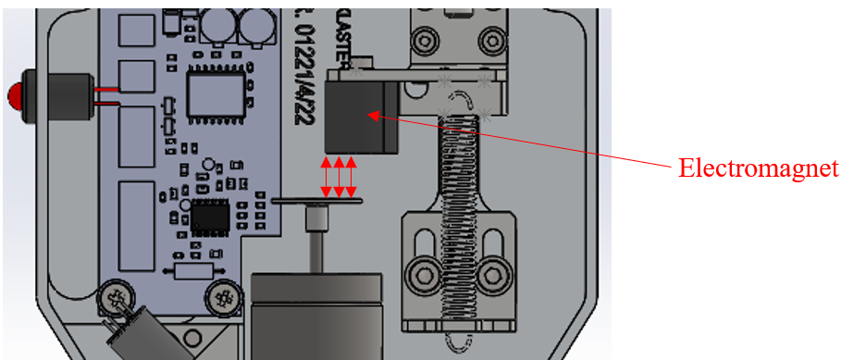

# Hardware in the loop (HIL): Communication between the VESevo board (firmware) and the digital twin.

## After building the digital twin model, the objective is to interface it with the electronic board of the device according to a Hardware in the Loop logic:

Digital twin

Elecrtonic board:Firmware

## The digital twin must include:

## 1) External communication for the simulation of the displacement sensor

## 2) External communication for temperature sensor simulation

## 3) External communication for activation/deactivation of the electromagnet

## 4) External communication for trigger management