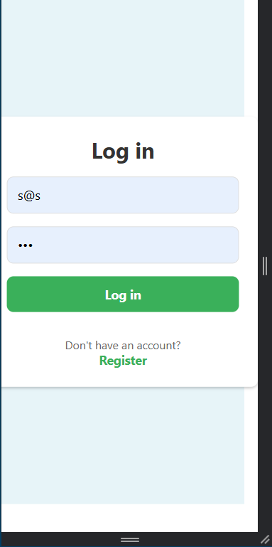

1. Login scren where user can log in their account.

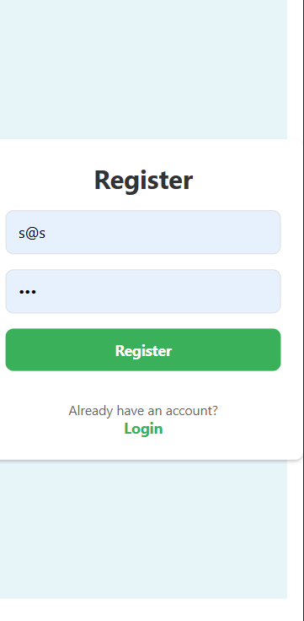

1. User can register their account

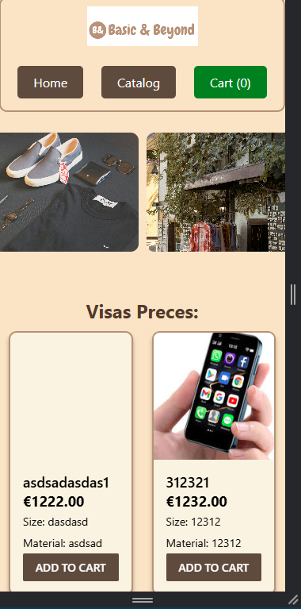

1. Main page where all products are displayed in interval of 2 , and have buttons to look through the products.

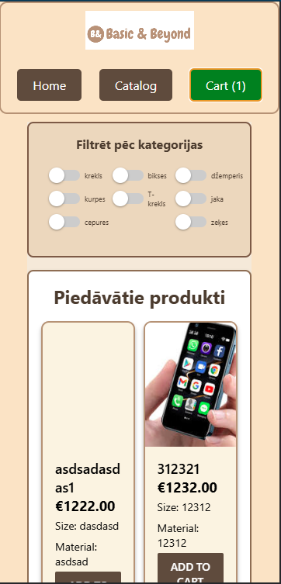

1. Catalog page where is displayed all products in 2 coloums and working filters and buttons that will bring to catalog page or home page.

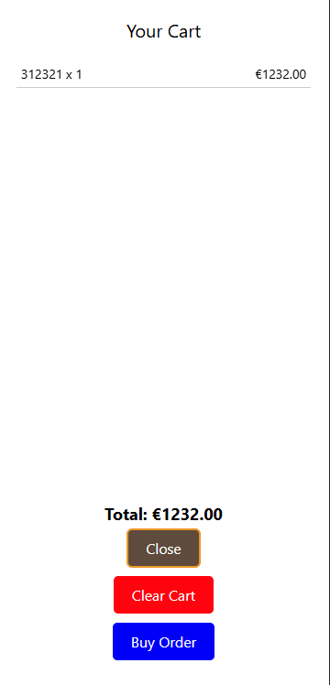

1. Cart where the all added products are displayed with the total, and user is able to clear a cart , or send email to company that they want to buy them

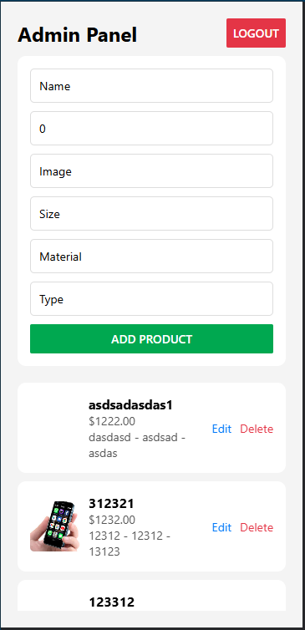

1. Admin panel where admin can add products update or delete them.