# Task: The page is splatted into two sections, header and body**.**

1. Fetch data from API Server with the following structure:

[

{

‘languages’: []

}

]

1. The buttons need to generates to match the requested languages.
2. The logo needs to fit the box, and requested from the internet (Choose any pic you want).
3. Using whatever stream method you want, check the internet connectively and change the color of the Wi-Fi icon:
   1. **Black** for no connect
   2. **Red** for no Internet
   3. **Green** for OK

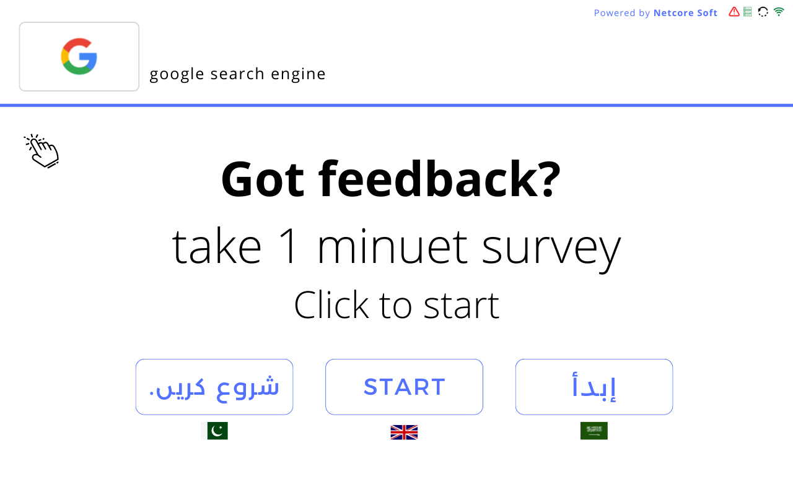

# Note:

1. The rest of the icons doesn’t do anything.
2. Upload the code on GitHub.
3. Send the APK on WhatsApp.