Personal Cloud Storage with AI Based File Organization

PROJECT SYNOPSIS
OF MINOR PROJECT
6th Semester
BACHELOR OF TECHNOLOGY
COMPUTER SCIENCE AND ENGINEERING (AI)

SUBMITTED BY

Salwi Kumari - 301311323114
Rishika Mahore - 301311323102
Manish Patel - 301311323060
Madhuri Verma - 301311323059

Session 2025-2026


RUNGTA COLLEGE OF ENGINEERING AND TECHNOLOGY BHILAI (C.G)

Department of CSE -AI

Table of Contents

S.No. | Title | Page No.
1. | Introduction | 03
2. | Rational Behind the Study | 04-06
3. | Literature Review | 07-08
4. | Research Objective | 09
5. | Feasibility Study | 10
6. | Flow Chart | 11
7. | Methodology/Planning of work | 12-15
8. | Expected Outcomes | 16
9. | References | 17

Under The Guidance of
Dr. Padmavati Shivastava
Head of
Department of CSE (AI/AIML)

Suggestions by the guide:
Consent of Guide

B. Tech Project Synopsis

Introduction:

In the modern digital era, the amount of data generated and stored by individuals is increasing rapidly. People use multiple devices such as smartphones, laptops, and tablets to create and store files including documents, images, videos, and other digital content. Managing this large volume of data efficiently has become a major challenge. Traditional storage methods, including physical storage devices and basic cloud storage systems, often require manual organization, which can be time-consuming and inefficient.

Personal Cloud Storage with AI-Based File Organization is an advanced system designed to address these challenges by providing a smarter and more efficient way to manage digital files. This system allows users to securely store, manage, and access their files over the internet from anywhere at any time. Unlike conventional cloud storage platforms, which rely heavily on manual folder creation and file arrangement, this system incorporates Artificial Intelligence (AI) to automate the process of file organization.

The integration of AI enables the system to analyse files based on their content, type, metadata, and user interaction patterns. Using techniques such as Machine Learning (ML), Natural Language Processing (NLP), and data analysis, the system can automatically classify files into meaningful categories such as documents, images, audio, and videos. It can also learn from user behaviour over time to improve its accuracy and provide personalized organization.

Furthermore, the system enhances the overall user experience by enabling faster and more efficient file search and retrieval. Instead of manually browsing through folders, users can locate files using keywords, tags, or even content-based queries. This significantly reduces the time and effort required to manage large datasets.

In addition to intelligent organization, the system also focuses on data security and privacy. It implements secure authentication mechanisms and data protection techniques to ensure that user information remains safe from unauthorized access.

Overall, this project aims to combine the capabilities of cloud computing and artificial intelligence to create a modern, intelligent, and user-friendly storage solution that simplifies file management and improves productivity.

Rationale Behind the Study:

In today’s digital world, the volume of data generated by individuals is growing at an unprecedented rate. From academic documents and personal photos to videos and application files, users are constantly storing and accessing large amounts of information across multiple platforms. While cloud storage services such as Google Drive and Dropbox have made data storage more convenient and accessible, they still rely heavily on manual organization. This often leads to cluttered storage spaces, misplaced files, and increased difficulty in retrieving important data when needed.

Managing files manually becomes not only time-consuming but also inefficient, especially as the amount of stored data continues to grow exponentially. Users frequently struggle to remember file locations, names, or folder structures, which results in wasted time and reduced productivity. As digital dependency increases, the need for a smarter, more efficient solution becomes essential.

This study is driven by the necessity to overcome these limitations by introducing automation and intelligence into file management systems. By leveraging Artificial Intelligence (AI), it is possible to transform traditional cloud storage into a more dynamic and user-centric platform. AI techniques such as machine learning and pattern recognition can analyse file content, usage behaviour, and user preferences to automatically organize and categorize files in a meaningful way.

The importance of this study lies in addressing several key challenges:

. Reducing manual effort: Eliminating the need for users to organize files manually

. Improving accessibility: Enabling faster and more accurate file search and retrieval

. Handling data growth: Managing the continuously increasing volume of digital data efficiently

. Enhancing user experience: Providing a smarter, personalized storage system

By developing an intelligent personal cloud storage system, this project aims to create a solution that not only simplifies file management but also adapts to user behaviour over time. The system will automatically organize files, suggest relevant content, and improve overall efficiency, making digital storage more intuitive and effective.

Ultimately, this study contributes to the advancement of smart storage technologies by combining cloud computing with artificial intelligence, paving the way for more automated and intelligent data management systems in the future.

Key Reasons for Conducting the Study:

The need for this study arises from the growing challenges associated with managing digital data in an efficient and intelligent manner. As technology continues to evolve, users are increasingly dependent on cloud storage platforms such as Google Drive and Dropbox for storing and accessing their files. However, despite their convenience, these systems lack advanced automation and intelligence, making file management a complex and time-consuming task.

One of the primary reasons for conducting this study is the rapid growth of digital data. Users generate a large volume of files daily, including documents, images, videos, and other digital content. Managing such vast amounts of data manually becomes inefficient and often leads to disorganization and confusion.

Another important reason is the inefficiency of traditional file management systems. Existing cloud storage solutions require users to manually create folders, rename files, and organize data. This not only consumes time but also increases the chances of errors, such as misplacing or losing important files.

The study is also motivated by the need to improve file retrieval and accessibility. Many users face difficulty in locating files quickly, especially when storage is unorganized. Delays in finding important files can negatively impact productivity and workflow efficiency.

Furthermore, there is a growing demand for automation and intelligent systems. With advancements in Artificial Intelligence, it has become possible to develop systems that can learn from user behaviour, analyse data patterns, and make intelligent decisions. Integrating AI into cloud storage can significantly enhance its functionality by enabling automatic file classification, smart search, and personalized recommendations.

Another key reason is to ensure better user experience and convenience. Modern users expect systems that are simple, fast, and efficient. An AI-based file organization system can provide a more intuitive interface, reduce complexity and make file management easier for users of all technical levels.

Lastly, the study focuses on enhancing data security and privacy. As users store sensitive and personal data on cloud platforms, ensuring secure access and protection against unauthorized use becomes essential. This project aims to incorporate security measures that safeguard user data while maintaining ease of access.

In conclusion, this study is conducted to bridge the gap between traditional cloud storage systems and modern intelligent solutions by introducing automation, improving efficiency, and enhancing overall user experience through the use of Artificial Intelligence.

LITERATURE REVIEW:

S.No | Author’s Name | Title | Source | Year | Methodology | Findings | Gaps
1 | Sharma et al. | Intelligent Personal Storage Systems | IEEE | 2023 | Developed a hybrid AI-based system combining supervised learning for file classification and rule-based techniques for modeling user preferences. The system analyzes file metadata and user behavior patterns to automatically organize and recommend files. | Enables personalized file organization and improves retrieval efficiency through intelligent recommendations. | Lacks integration with a dedicated personal cloud storage platform;  limited implementation of advanced AI-based file classification;  absence of an effective file recommendation system based on dynamic user behavior.
2 | Chen et al. | AI-Driven Data Organization Systems | ACM | 2023 | Implemented a reinforcement learning-based framework where an agent learns optimal file organization strategies through continuous interaction and feedback from user actions. | Achieves adaptive and self-improving file organization without manual intervention. | High computational complexity and training cost; requires extensive user interaction data; lacks practical deployment in personal cloud environments.
3 | Gupta & Verma | Smart File Retrieval Systems | Elsevier | 2024 | Utilized AI-based semantic search with NLP techniques to interpret user queries and match them with file content using indexing and ranking mechanisms. | Provides faster and more accurate file retrieval compared to traditional systems. | Focuses only on retrieval rather than complete file management; lacks automated classification and recommendation features.
4 | Lee & Park | AI-based Multimedia File Management | Springer | 2024 | Combined NLP for text processing and computer vision techniques for multimedia file classification, enabling handling of heterogeneous data formats. | Efficient management of multimedia and textual data with improved classification accuracy. | Requires high processing power; lacks integration with cloud-based storage systems; not optimized for lightweight personal use.
5 | Kumar et al. | Next-Gen Cloud Storage with AI Automation | IEEE | 2025 | Integrated machine learning models within cloud storage systems for automated file organization, duplication detection, and user-based recommendations. | Enhances automation and improves storage efficiency in cloud environments. | Limited real-time intelligent recommendations; insufficient personalization based on detailed user behavior patterns.
6 | Wang & Liu | Deep Learning for Cloud File Organization | Elsevier | 2025 | Applied deep learning models such as CNNs and Transformers for feature extraction and contextual classification of files. | Achieves high accuracy in file classification and organization. | Requires large datasets and high computational resources; lacks efficient implementation for real-time personal storage systems.

Objectives of the Project:

The main objective of this project is to design and develop an advanced personal cloud storage system integrated with Artificial Intelligence to enhance file management and user experience. The system aims to provide efficient, secure, and intelligent storage solutions by combining cloud technologies with machine learning techniques.

1. To Develop a Personal Cloud Storage System

The primary objective is to create a cloud-based platform where users can upload, store, and access their files anytime and from anywhere. This system will act as a centralized storage solution, allowing users to manage their digital data efficiently without depending on physical storage devices.

2. To Implement AI-Based File Classification

The project aims to integrate Artificial Intelligence techniques to automatically classify files into different categories such as documents, images, videos, and others. This classification will be based on file content, type, and metadata, reducing the need for manual organization and improving accuracy.

Feasibility Study:

A feasibility study is conducted to evaluate whether the proposed system is practical, cost-effective, and easy to implement. It examines the project from technical, economic, and operational perspectives to ensure successful development and deployment.

1. Technical Feasibility

The proposed system can be developed using modern and widely available technologies. Python will be used for backend development along with FastAPI to build efficient APIs. For the frontend, React can be used to create an interactive user interface. The system will also utilize Cloud APIs to enable secure file storage and access.

For implementing AI features, libraries such as TensorFlow and Scikit-learn will be used to develop machine learning models for file classification and organization. Data storage can be handled using databases like MongoDB or MySQL.

All these tools are open-source, well-documented, and widely used, making development easier. Therefore, the project is technically feasible.

2. Economic Feasibility

The project is cost-effective as it relies mainly on open-source technologies, which eliminates the need for expensive software licenses. Tools such as Python, TensorFlow, and MongoDB are freely available.

The hardware requirements are minimal, and a standard computer system is sufficient for development. If cloud services are used, free or low-cost plans can be utilized. Hence, the overall cost of development and implementation remains low.

3. Operational Feasibility

The system is designed to be user-friendly and easy to operate. Users can upload, organize, and retrieve files without requiring advanced technical skills. AI-based automation will reduce manual effort by automatically categorizing files.

The system requires minimal user training and offers features like smart search and automatic organization, improving usability and efficiency.

Conclusion

Based on technical, economic, and operational analysis, the proposed system is feasible. It can

be developed using available tools, requires low cost, and provides an efficient and user-friendly solution for file management.

Flowchart

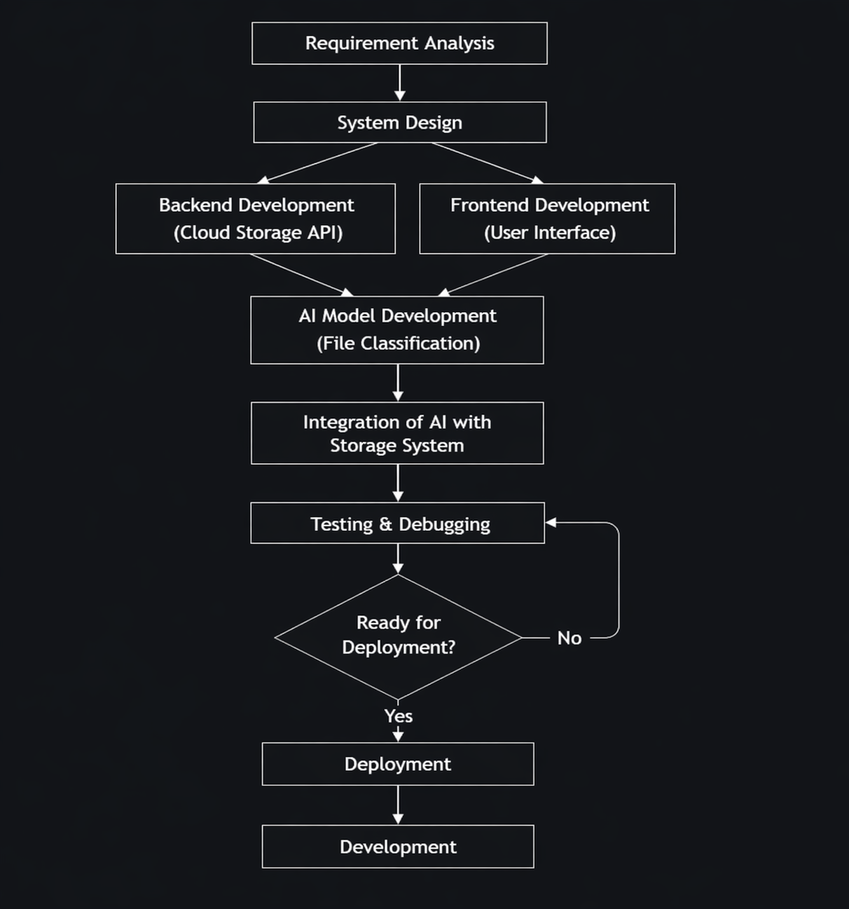

Methodology/ Planning of work:

Overview of the System

The proposed system, Personal Cloud Storage with AI-Based File Organization, is designed to provide secure storage along with intelligent file management. The system uses cloud technology combined with Artificial Intelligence (AI) to automatically organize files based on their type, content, and usage patterns.

The methodology focuses on developing a structured workflow that includes file upload, storage, processing, classification, and retrieval. The system is divided into multiple modules, each responsible for a specific task.

System Architecture

The system follows a client-server architecture:

Frontend (Client Side):

User interface developed using HTML, CSS, and JavaScript

Allows users to upload, view, and manage files

Backend (Server Side):

Developed using Python (Flask/Django)

Handles file processing, authentication, and AI logic

Database:

Stores user data, file metadata, and classification results

Example: MySQL / MongoDB

Cloud Storage:

Stores actual files securely

Example: AWS S3 / Firebase Storage

Working Methodology

The system works in the following steps:

Step 1: User Registration and Login

Users create an account using email and password

Authentication ensures secure access

Session management is used to maintain login state

Step 2: File Upload

User uploads files such as documents, images, or videos

File is sent to the server through an API

Metadata (file name, size, type, date) is extracted

Step 3: File Storage

Files are stored in cloud storage

Unique ID is assigned to each file

Metadata is stored in the database

Step 4: AI-Based File Analysis

This is the core part of the system.

The AI module performs:

File Type Detection (PDF, image, video, etc.)

Content Analysis

Text extraction using OCR (for images/PDFs)

Keyword detection

Metadata Analysis

Date, size, usage frequency

Step 5: Automatic Classification

Files are automatically grouped into categories such as:

Documents

Images

Videos

Academic files

Personal files

AI model assigns tags based on content

Example:

Resume → “Career”

Notes → “Study”

Step 6: Smart Organization

Files are arranged into folders automatically

No need for manual sorting

System updates organization dynamically

Step 7: File Retrieval

User can search files using:

File name

Keywords

Tags

AI improves search results using:

Past user behavior

Frequently accessed files

AI Model Implementation

The system uses simple AI/ML techniques:

Techniques Used:

Natural Language Processing (NLP)

Keyword extraction

Text classification

Process:

Extract text from file

Clean and preprocess data

Apply classification model

Assign category and tags

Algorithm Used

File Classification Algorithm (Basic Steps):

Input file

Extract text/content

Identify keywords

Compare with predefined categories

Assign category label

Store result in database

Security Methodology

To ensure data safety:

Authentication:

Login system with encrypted passwords

Data Encryption:

Files stored securely in cloud

Access Control:

Only authorized users can access files

Tools and Technologies Used

Component

Technology Used

Frontend

HTML, CSS, JavaScript

Backend

Python (Flask/Django)

Database

MySQL / MongoDB

Cloud Storage

AWS / Firebase

AI/ML

Python Libraries (NLTK, Scikit-learn)

Advantages of Methodology

Reduces manual effort in file organization

Saves time using automation

Provides smart search functionality

Ensures secure file storage

Improves user experience

Limitations

Accuracy depends on AI model quality

Requires internet connection

Initial setup complexity

Future Enhancements

Voice-based file search

Advanced deep learning models

Integration with mobile apps

Real-time file suggestions

Expected outcomes:

1. To Develop a Personal Cloud Storage System (Local Cloud Based)

The project will result in the development of a local cloud-based storage system, where users can upload, store, and access their files through a web-based platform within a local network. Unlike public cloud systems, this platform will operate on a local server, providing faster access and better control over data.

Users will be able to upload files such as documents, images, PDFs, and other data through a simple and user-friendly website interface. All files will be stored securely in the local cloud along with their metadata like file name, type, size, and upload date.

This system will act as a centralized storage within the local environment, allowing users to manage all their data in one place without relying on external cloud services or physical storage devices. It will improve data accessibility, reduce dependency on internet-based storage, and ensure better privacy and security of user data.

2. To Implement AI-Based File Classification

The system will automatically classify uploaded files into different categories such as documents, images, PDFs, resumes, and others using Artificial Intelligence techniques. This classification will be based on file content, type, and metadata analysis.

After uploading, the system will analyze each file and place it into the appropriate category without requiring manual sorting. For example, image files will be grouped separately, PDFs will be categorized as documents, and resumes will be identified and stored in a specific category.

This automatic classification will reduce manual effort, improve accuracy, and maintain a well-organized storage system. It will also make file retrieval easier, as users can quickly find files based on categories or keywords. Overall, this feature will enhance efficiency and provide a smarter way to manage files.

References:

- A. Sharma, R. Singh, and P. Verma, “Intelligent Personal Storage Systems Using Hybrid AI Models,” IEEE Transactions on Cloud Computing, vol. 11, no. 2, pp. 145–156, 2023.
[2] L. Chen, Y. Zhang, and H. Wang, “AI-Driven Data Organization Systems Using Reinforcement Learning,” ACM Transactions on Information Systems, vol. 41, no. 3, pp. 1–20, 2023.
[3] S. Gupta and M. Verma, “Smart File Retrieval Systems Using AI-Based Search Algorithms,” Elsevier Journal of Information Systems, vol. 58, pp. 102–115, 2024.
[4] J. Lee and S. Park, “AI-Based Multimedia File Management Using NLP and Computer Vision,” Springer Journal of Multimedia Tools and Applications, vol. 83, pp. 2105–2120, 2024.
[5] R. Kumar, A. Patel, and N. Sharma, “Next-Generation Cloud Storage Systems with AI Automation,” IEEE Access, vol. 13, pp. 55678–55690, 2025.
[6] X. Wang and T. Liu, “Deep Learning-Based Cloud File Organization Using CNN and Transformers,” Elsevier Journal of Big Data Research, vol. 30, pp. 100–112, 2025.

