A screenshot of a computer screen

Description generated with very high confidence

***Game Design Document***

***‘The ultimate survival game!*** – Samuel Akinmulero

|  |  |  |
| --- | --- | --- |
| Table of Contents  [1 Game Overview](https://n-xovwktmtjsnaxyc2mwes2xu7pohqedmdm6zjw5q-2lu-script.googleusercontent.com/userCodeAppPanel)  [2 High Concept](https://n-xovwktmtjsnaxyc2mwes2xu7pohqedmdm6zjw5q-2lu-script.googleusercontent.com/userCodeAppPanel)  [3 Synopsis](https://n-xovwktmtjsnaxyc2mwes2xu7pohqedmdm6zjw5q-2lu-script.googleusercontent.com/userCodeAppPanel)  [4 Game Objectives](https://n-xovwktmtjsnaxyc2mwes2xu7pohqedmdm6zjw5q-2lu-script.googleusercontent.com/userCodeAppPanel)  [5 Game Rules](https://n-xovwktmtjsnaxyc2mwes2xu7pohqedmdm6zjw5q-2lu-script.googleusercontent.com/userCodeAppPanel)  [6 Game Play](https://n-xovwktmtjsnaxyc2mwes2xu7pohqedmdm6zjw5q-2lu-script.googleusercontent.com/userCodeAppPanel)  [6.1 Game Controls](https://n-xovwktmtjsnaxyc2mwes2xu7pohqedmdm6zjw5q-2lu-script.googleusercontent.com/userCodeAppPanel)  [6.2 Maps](https://n-xovwktmtjsnaxyc2mwes2xu7pohqedmdm6zjw5q-2lu-script.googleusercontent.com/userCodeAppPanel)/Level Design  [7 Players](https://n-xovwktmtjsnaxyc2mwes2xu7pohqedmdm6zjw5q-2lu-script.googleusercontent.com/userCodeAppPanel)  [7.1 Characters](https://n-xovwktmtjsnaxyc2mwes2xu7pohqedmdm6zjw5q-2lu-script.googleusercontent.com/userCodeAppPanel)  [8 NPC](https://n-xovwktmtjsnaxyc2mwes2xu7pohqedmdm6zjw5q-2lu-script.googleusercontent.com/userCodeAppPanel)  [8.1 Enemies](https://n-xovwktmtjsnaxyc2mwes2xu7pohqedmdm6zjw5q-2lu-script.googleusercontent.com/userCodeAppPanel)  [9 Art](https://n-xovwktmtjsnaxyc2mwes2xu7pohqedmdm6zjw5q-2lu-script.googleusercontent.com/userCodeAppPanel)  [9.1 Setting](https://n-xovwktmtjsnaxyc2mwes2xu7pohqedmdm6zjw5q-2lu-script.googleusercontent.com/userCodeAppPanel)  [9.2 Audio](https://n-xovwktmtjsnaxyc2mwes2xu7pohqedmdm6zjw5q-2lu-script.googleusercontent.com/userCodeAppPanel)  9.3 What you Developed   |  | | --- | |  | | Game Development Team Members    PRODUCER  Samuel Akinmulero  PRODUCTION MANAGER  Samuel Akinmulero  PRODUCTION COORDINATOR  Samuel Akinmulero  GAME DESIGNERS  Samuel Akinmulero  SYSTEMS/IT COORDINATOR  Samuel Akinmulero  PROGRAMMERS  Samuel Akinmulero  TECHNICAL ARTISTS  Samuel Akinmulero  AUDIO ENGINEERS  Samuel Akinmulero  UX TESTERS  Samuel Akinmulero |

|  |
| --- |
|  |

# Game Overview

Title: Dodge Mesh 2: The Rise of Flocking

Platform: PC Standalone

Genre: Survival

Rating: (10+) ESRB

Target: Casual gamer (age 6+)

Release date: March 22, 2018

Publisher: Akinmulero Industries

Dodge Mesh 2: The Rise of Flocking is the sequel to the highly acclaimed Dodge Mesh. This sequel is a third-person, high paced, survival game. The story takes place in a post apocalyptic world where the “Boids” have taken over the Earth with their flocking behaviors! Their maneuverability is breathtaking to look at; however, they will not hesitate to destroy anything in their path…including YOU! Are you ready to take on this role?!

High Concept

Dodge Mesh 2 allows the player to traverse an open map whilst visualizing the beauty of the flocking behaviors. However, the most important aspect is to avoid the Boids that are trying to end your life! Forewarning: it is difficult to distinguished who will attack you and who will not.

Synopsis

The Boids have destroyed the Earth and you are the only survivor. You must avoid the Boids no matter what!

Game Objectives

The objective of this game is to survive without being annihilated by the Boids.

Game Rules

The player maneuvers a car and must not get hit 300 times, otherwise it is GAME OVER!

Game Play

Game Controls

Up Arrow – Moves player forwards

Down Arrow – Moves player backwards

Left Arrow – Moves player to the left

Right Arrow – Moves player to the right

R key – Resets the level

Mouse – Moves camera

A screen shot of a computer

Description generated with very high confidenceMaps/Level Design

A screenshot of a computer screen

Description generated with very high confidencePlayers

Characters

This is the vehicle that the main character drives to dodge the Boids in the game.

NPC

Enemies

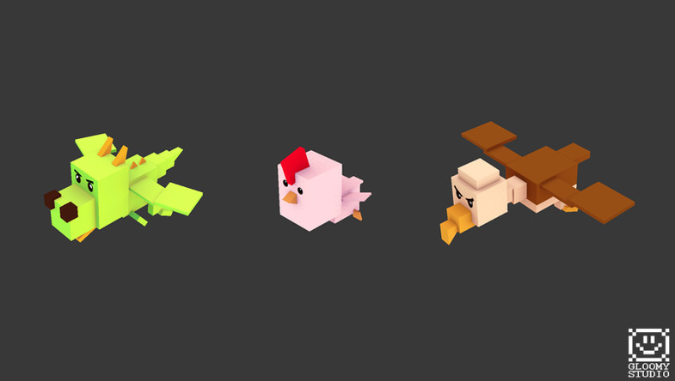

These are the “Boids” that attack the main character in the game.

A screenshot of a computer screen

Description generated with very high confidenceSetting

Audio

|  |  |  |
| --- | --- | --- |
| Name | Category | Description |
| DoThatIsh! Instrumental | Background Music | Plays during Start Menu |
| Big Shot Instrumental | Background Music | Plays during Instructions Scene |
| Look Alive Instrumental | Background Music | Plays during Main Game Scene |
| Walk it Talk It Instrumental | Background Music | Plays during End Scene |

What you Developed

MOSTLY EVERYTHING! Cited what I did not develop.