
AMERICAN INTERNATIONAL UNIVERSITY–BANGLADESH (AIUB)
Dept. of Computer Science
Faculty of Science and Technology
CSC2210: OBJECT ORIENTED PROGRAMMING 2
Spring 2024-2025
Section: [K]
Project Report On
StockPro: Integrated Warehouse Logistics & Payment Management System
Supervised By
DR. MD. IFTEKHARUL MOBIN
Submitted By:
Name | ID
Taseen Ahmed | 24-58252-2
Samira Sultana | 24-58264-2

CO2: Display and verify the mean of a real-life Project using the concepts of C# Graphical User Interface based environment with database integration to depict a desktop-based application.
Assessment  Criteria | Not Attended/ Incorrect (0) | Inadequate  (1-2) | Average  (3) | Good  (4) | Excellent  (5)
Evaluation Criteria | Evaluation Definition |  |  |  | Total =
Requirement fulfillment | Properly demonstrate a real-life scenario-based project with proper functional requirement identification for the Object-Oriented Programming project development activities.
Validation | Ensuring the ability of students’ proper demonstration on validation forms in their system in terms of dealing with the data.
Verification | Identifying if the students can verify the system data along with proper functional requirements in terms of data flow.

Topics | Pages
Title | 3
Introduction | 3
Case Study | 3
Functional Requirements | 3
Database Schema | 4
Database Query | 4
ER Diagram | 6
Table Of Contents
Normalization & Finalization | 6
Transition | 9
Future Scope | 12
Conclusion | 12

1.Title
StockPro: Integrated Warehouse Logistics & Payment Management System.

2. Introduction
In a modern industrial landscape, managing large-scale storage facilities requires more than just simple item tracking; it demands a robust, integrated logistics solution. Moving away from the localized needs of a retail mart, StockPro: Integrated Warehouse Logistics & Payment Management System is designed to handle the complexities of a high-volume distribution center.
3.Case Study
Apex Central Warehouse currently relies on a manual, paper-based ledger to track its growing inventory of thousands of bulk products. This system is highly inefficient and prone to human error, often resulting in "stock-outs" where the manager is unaware a bulk item is missing until a critical outbound shipment is delayed .Because there is no real-time tracking, staff must spend hours performing manual counts, which often leads to mistakes in the records and a general lack of accountability regarding who updated the stock .Furthermore, without any form of automated notification, integrated billing, or quality tracking, the warehouse frequently loses revenue because essential goods are not reordered in time, order payments are delayed, and unreliable suppliers go unchecked.
The StockPro system solves these challenges by providing a robust desktop application built with C# and SQL Server to manage all complex warehouse operations. Instead of writing in a notebook, the Inventory Manager enters new bulk shipments directly into the application, which instantly updates the database and ensures every item is accounted for..
The system eliminates the need for manual guesswork by providing a real-time view of current stock levels through a user-friendly dashboard. To address the financial and quality control bottlenecks, the application now includes an integrated payment gateway for processing outbound sales directly on the desktop, alongside a supplier review system to rate and track the quality of incoming goods. Most importantly, the application retains a powerful "Low Stock Alert" feature that automatically highlights items when they fall below a specific quantity, allowing the manager to restock proactively and keep the warehouse running smoothly at all times.

4.Functional Requirements
Admin (Warehouse Director):
-Create, update, or remove accounts for Inventory Managers and Logistics Staff.
-System Configuration: Define the "Low Stock Threshold" (example: alert when a bulk item falls below 10 pallets).
-Supplier Directory & Reviews: Add or edit supplier contact information and monitor their overall performance ratings.
-Financial Oversight: View completed transactions and payment histories processed through the integrated gateway.
-Stock Oversight: View a master list of all inventory across all categories and warehouse zones.

Inventory Manager:
-Product Entry: Add new bulk products with details like Name, Category, and Unit Price.
-Stock Adjustment: Manually update quantities when new shipments arrive or when items are audited.
-Category Management: Organize products into groups such as "Electronics," "Raw Materials," or "Packaging" for easier searching.

-Supplier Evaluation: Submit 1-to-5-star ratings and written reviews for suppliers based on the quality and punctuality of their deliveries.
-Alert Monitoring: Access a dedicated view that filters for all products currently below the low-stock limit.

Logistics/Sales Staff:
-Outbound Orders: Create dispatch records for goods leaving the warehouse.
-Payment Gateway Processing: Securely process client payments for outbound orders directly within the desktop application.

Common Features (All Users):
-Authentication: Secure login and logout functionality based on assigned roles.
-Search & Filter: A real-time search bar to find products, orders, or suppliers by name, ID, or category.

5.DATABASE SCHEMA

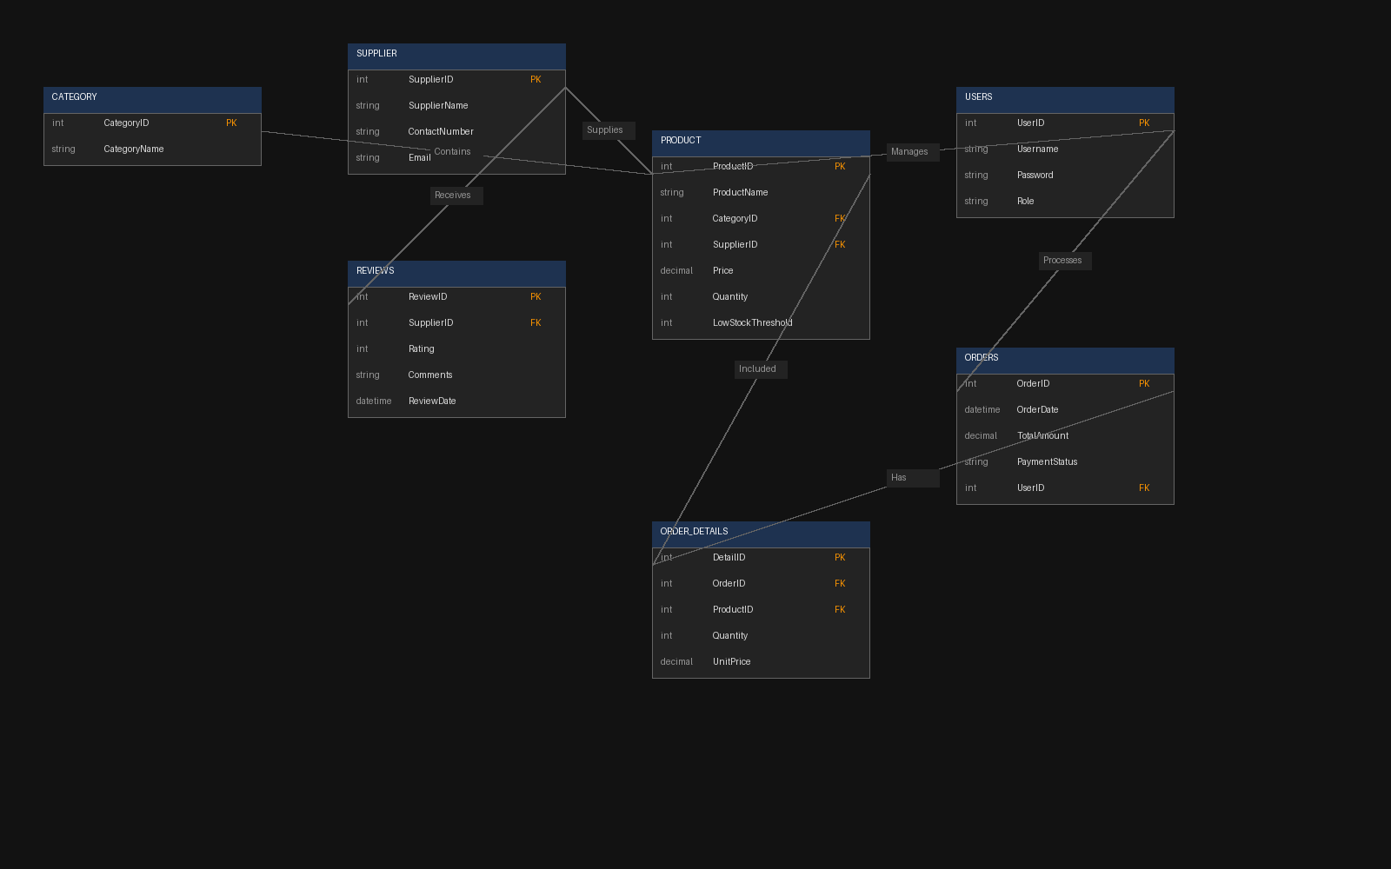

6.DATABASE QUERY
-- 1. USERS TABLE
CREATE TABLE Users (
UserID INT PRIMARY KEY IDENTITY(1,1),
Username VARCHAR(50) NOT NULL,
Password VARCHAR(255) NOT NULL,
Role VARCHAR(20) NOT NULL -- Admin, Manager, Logistics
);
-- 2. CATEGORY TABLE
CREATE TABLE Category (
CategoryID INT PRIMARY KEY IDENTITY(1,1),
CategoryName VARCHAR(100) NOT NULL
);

-- 3. SUPPLIER TABLE
CREATE TABLE Supplier (
SupplierID INT PRIMARY KEY IDENTITY(1,1),
SupplierName VARCHAR(100) NOT NULL,
ContactNumber VARCHAR(15),
Email VARCHAR(100)
);

-- 4. PRODUCT TABLE
CREATE TABLE Product (
ProductID INT PRIMARY KEY IDENTITY(1,1),
ProductName VARCHAR(100) NOT NULL,
CategoryID INT FOREIGN KEY REFERENCES Category(CategoryID),
SupplierID INT FOREIGN KEY REFERENCES Supplier(SupplierID),
Price DECIMAL(18, 2),
Quantity INT,
LowStockThreshold INT
);

-- 5. ORDERS TABLE
CREATE TABLE Orders (
OrderID INT PRIMARY KEY IDENTITY(1,1),
OrderDate DATETIME DEFAULT GETDATE(),
TotalAmount DECIMAL(18, 2),
PaymentStatus VARCHAR(20),
UserID INT FOREIGN KEY REFERENCES Users(UserID)
);

-- 6. ORDER_DETAILS TABLE
CREATE TABLE Order_Details (
DetailID INT PRIMARY KEY IDENTITY(1,1),
OrderID INT FOREIGN KEY REFERENCES Orders(OrderID),
ProductID INT FOREIGN KEY REFERENCES Product(ProductID),
Quantity INT,
UnitPrice DECIMAL(18, 2)
);

-- 7. REVIEWS TABLE
CREATE TABLE Reviews (
ReviewID INT PRIMARY KEY IDENTITY(1,1),
SupplierID INT FOREIGN KEY REFERENCES Supplier(SupplierID),
Rating INT CHECK (Rating >= 1 AND Rating <= 5),
Comments TEXT,
ReviewDate DATETIME DEFAULT GETDATE()
);
7.ER Diagram

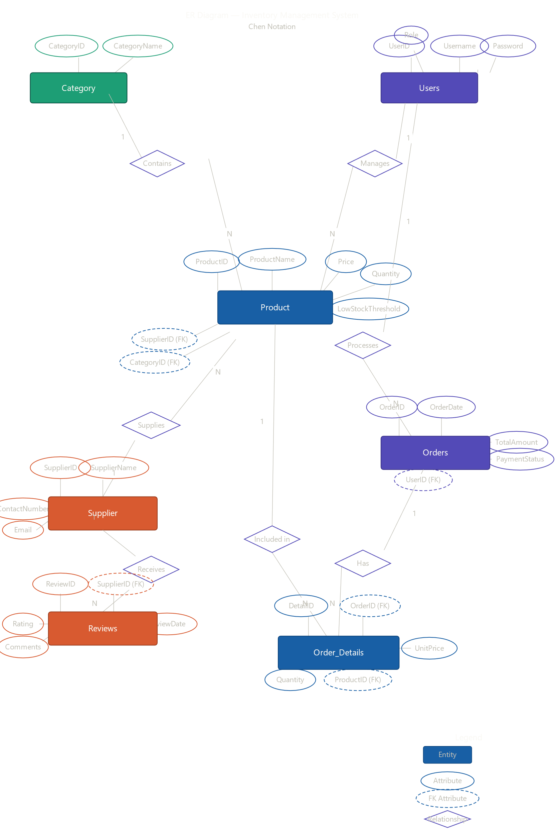

8. Normalization & Finalization
Normalization
Contains (Category → Product): one to many relationship
UNF:
CategoryID, CategoryName, ProductID, ProductName, Price, Quantity, LowStockThreshold
1NF:
CategoryID, CategoryName, ProductID, ProductName, Price, Quantity, LowStockThreshold
2NF:
CategoryID, CategoryName
ProductID, ProductName, Price, Quantity, LowStockThreshold, CategoryID (FK)
3NF:
Same as 2NF.

Supplies (Supplier → Product): one to many relationship
UNF:
SupplierID, SupplierName, ContactNumber, Email, ProductID, ProductName, Price, Quantity
1NF:
SupplierID, SupplierName, ContactNumber, Email, ProductID, ProductName, Price, Quantity
2NF:
SupplierID, SupplierName, ContactNumber, Email
ProductID, ProductName, Price, Quantity, SupplierID (FK)
3NF:
Same as 2NF.

Manages (Users → Product): one to many relationship
UNF:
UserID, Username, Password, Role, ProductID, ProductName, Price, Quantity
1NF:
UserID, Username, Password, Role, ProductID, ProductName, Price, Quantity
2NF:
UserID, Username, Password, Role
ProductID, ProductName, Price, Quantity, UserID (FK)
3NF:
Same as 2NF.

Processes (Users → Orders): one to many relationship
UNF:
UserID, Username, Role, OrderID, OrderDate, TotalAmount, PaymentStatus
1NF:
UserID, Username, Role, OrderID, OrderDate, TotalAmount, PaymentStatus
2NF:
UserID, Username, Role
OrderID, OrderDate, TotalAmount, PaymentStatus, UserID (FK)
3NF:
Same as 2NF.

Has (Orders → Order_Details): one to many relationship
UNF:
OrderID, OrderDate, DetailID, Quantity, UnitPrice, ProductID
1NF:
OrderID, OrderDate, DetailID, Quantity, UnitPrice, ProductID
2NF:
OrderID, OrderDate
DetailID, Quantity, UnitPrice, ProductID, OrderID (FK)
3NF:
Same as 2NF.

Included In (Product → Order_Details): one to many relationship
UNF:
ProductID, ProductName, Price, DetailID, Quantity, UnitPrice

1NF:
ProductID, ProductName, Price, DetailID, Quantity, UnitPrice
2NF:
ProductID, ProductName, Price
DetailID, Quantity, UnitPrice, ProductID (FK)
3NF:
Same as 2NF.

Receives (Product → Reviews): one to many relationship
UNF:
ProductID, ProductName, ReviewID, CustomerName, Rating, ReviewDate
1NF:
ProductID, ProductName, ReviewID, CustomerName, Rating, ReviewDate
2NF:
ProductID, ProductName
ReviewID, CustomerName, Rating, ReviewDate, ProductID (FK)
3NF:
Same as 2NF.

Finalization
Category:
CategoryID, CategoryName
Supplier:
SupplierID, SupplierName, ContactNumber, Email
Users:
UserID, Username, Password, Role
Product:
ProductID, ProductName, Price, Quantity, LowStockThreshold, CategoryID (FK), SupplierID (FK), UserID (FK)
Orders:
OrderID, OrderDate, TotalAmount, PaymentStatus, UserID (FK)
Order_Details:
DetailID, Quantity, UnitPrice, OrderID (FK), ProductID (FK)
Reviews:
ReviewID, CustomerName, Rating, ReviewDate, ProductID (FK)

9.Transition
*create account page
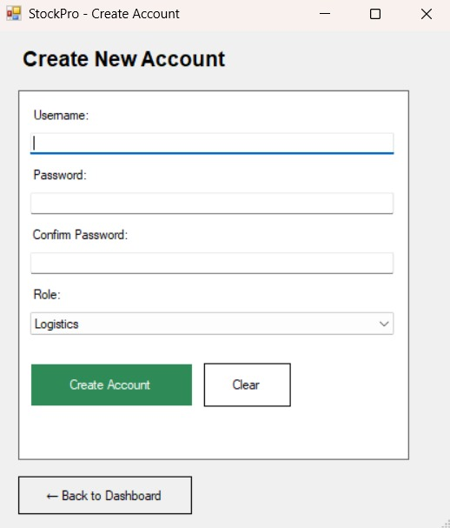
*Log in page
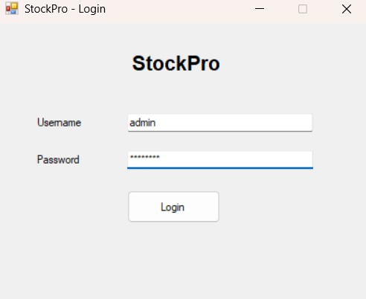
* Admin dashboard
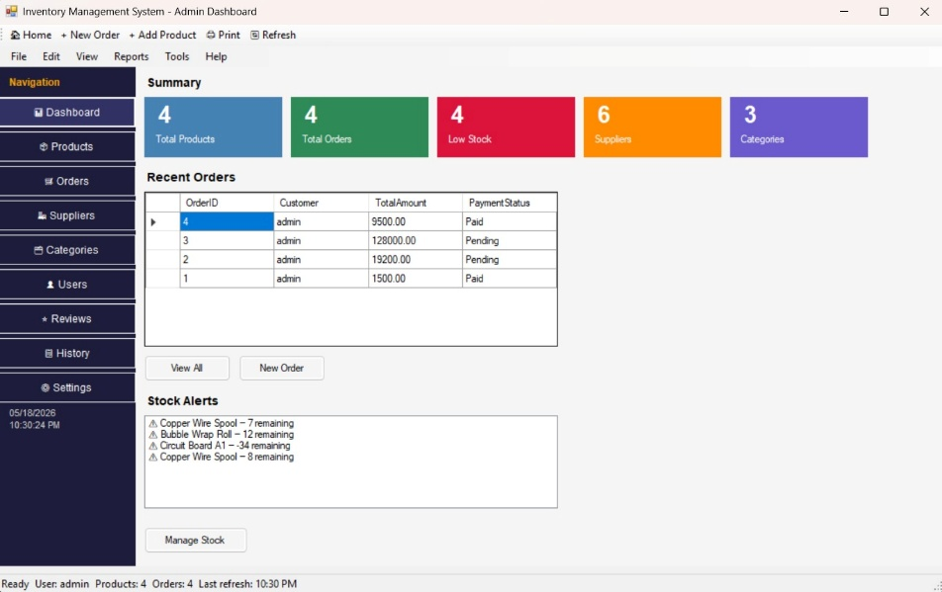
* Product management page
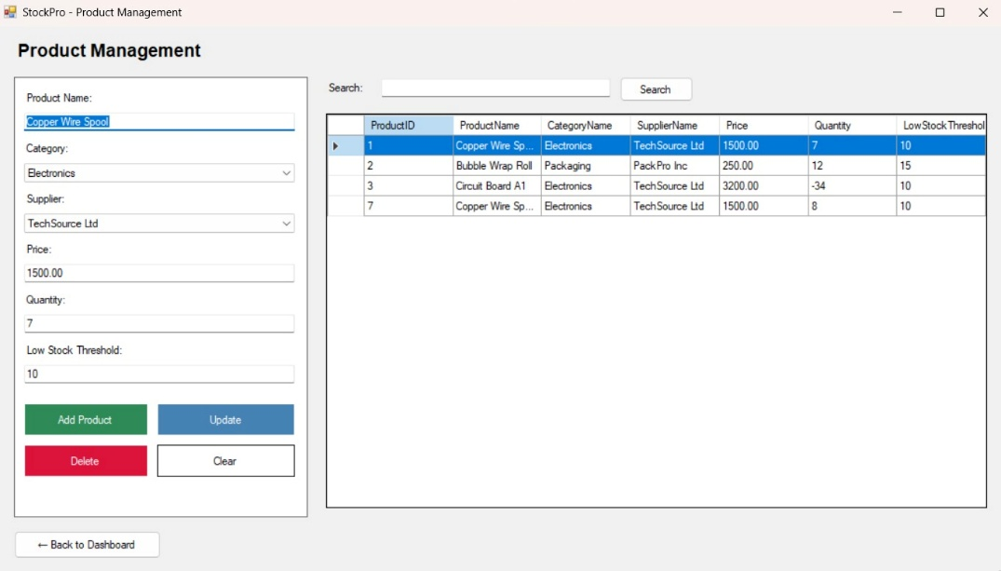
* Category management
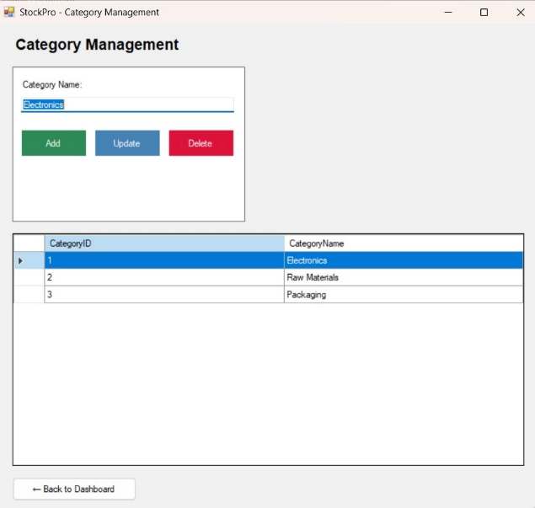
* Supplier management
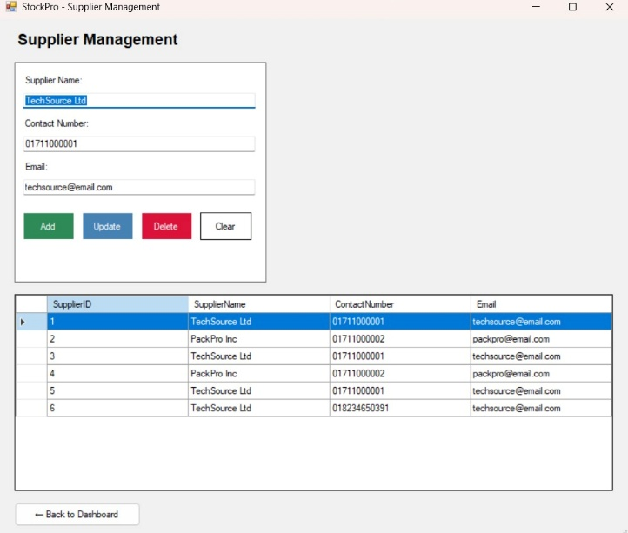
*Review system page
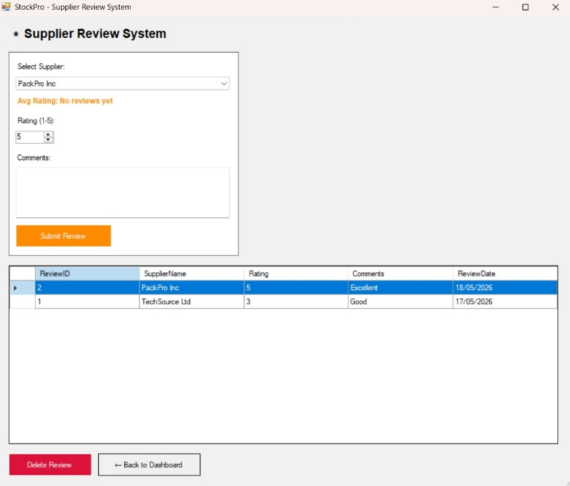
*Payment Gateway page
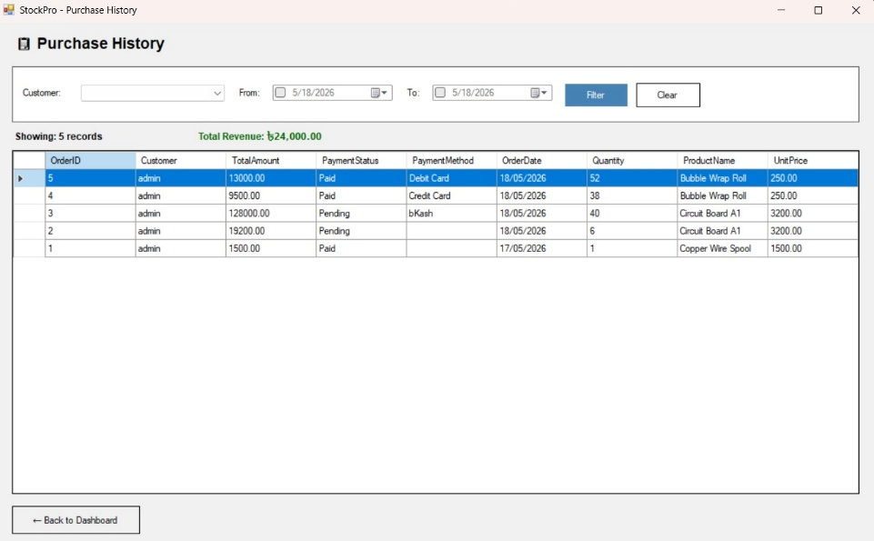
*Payment Processing page
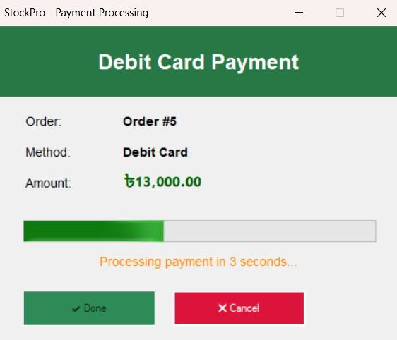

10.Future Scope
The future scope of this warehouse management system focuses on intelligent automation and cross-platform accessibility. A primary advancement involves integrating IoT and RFID technology, enabling real-time, hands-free tracking of bulk items to eliminate manual audit errors. Furthermore, implementing AI-driven predictive analytics will allow the system to forecast demand using seasonal trends rather than static thresholds, optimizing replenishment cycles automatically.
To improve mobility, a dedicated Mobile Companion Application can be developed, allowing warehouse floor staff to scan barcodes and process dispatches via handheld devices. Additionally, migrating the local SQL Server database to a Cloud-based environment will enable multi-warehouse synchronization, providing a centralized dashboard for global operations. Finally, expanding the payment module to support multi-currency transactions and automated tax reporting will transform the application into a full-scale Enterprise Resource Planning (ERP) tool, offering deeper financial insights and ensuring the system remains competitive in a modern industrial landscape.

11.Conclusion
The StockPro: Integrated Warehouse Logistics & Payment Management System successfully transitions manual, paper-based logistics into a streamlined and high-performance digital environment. By leveraging C# Windows Forms and SQL Server, the application provides a robust desktop platform for managing complex inventory levels, processing secure financial transactions, and auditing supplier performance.
This project demonstrates the practical application of Object-Oriented Programming (OOP) principles, particularly through the design of a normalized 7-table database and a role-based user interface. The integration of a payment gateway and a supplier review system addresses modern industrial challenges, ensuring both financial accountability and supply chain reliability. Furthermore, the Low Stock Alert feature remains a core component, enabling proactive replenishment and minimizing operational downtime. Ultimately, this system enhances organizational efficiency, ensures data integrity, and offers a scalable, professional solution for modern warehouse management.

