- Policy

Pangasinan State University (PSU) plans for the effective implementation and improvement of the EOMS. The organization considers the issues and requirements and determines the risks and opportunities that need to be addressed through the conduct of planning sessions.

PSU follows a seven-step strategic planning process as shown:

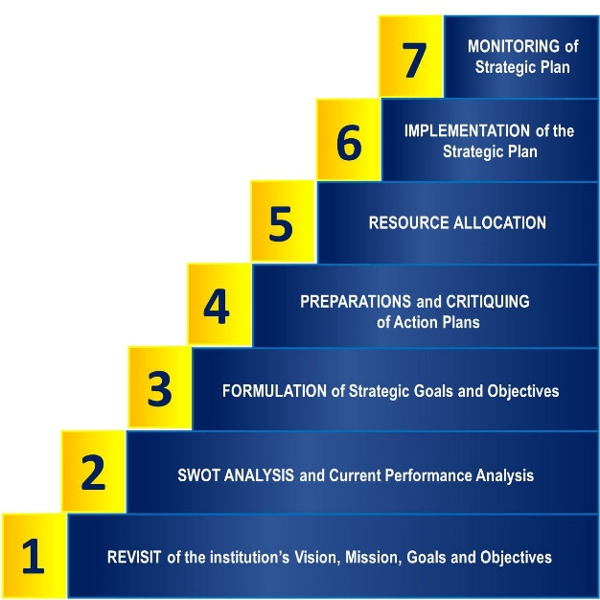

The above cycle is used in determining the necessary changes to the EOMS, such as policy statements and EOMS objectives, and relevant steps of documented procedures. In addition, PSU evaluates the effectiveness of these actions during planning meetings and during the management review.

Risk Assessment Process

The Risk Assessment process is a process under the Office of the Vice President for Quality Assurance. This process starts with the establishment of the operating context by preparing the table of criteria on severity and likelihood and the setting of risk tolerance and risk appetite of the University. After which, risks are identified and analyzed using the risk register. A risk management plan is then implemented to address the concerns, and another round of post-evaluation is conducted to come up with an updated risk assessment report, which again serves as the input for the next cycle of the Risk Assessment process.

Refer to procedure PM-PSU-02-OP-01

- Application

All departments

- References

- Vision
- Mission
- Core Values
- EOMS Policy
- EOMS Objectives: Strategic Plans and Operational Plans
- SWOT Analysis
- Process Risk Assessment Matrix
- Management Review Minutes

