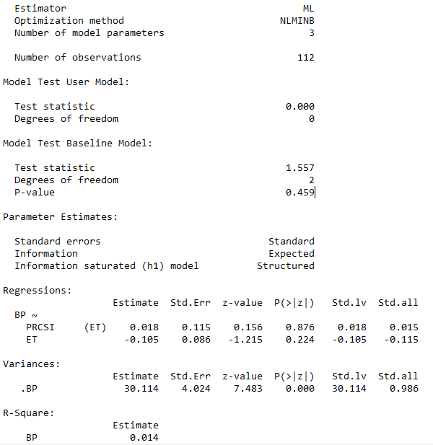Impact of **process space innovation** on profitability

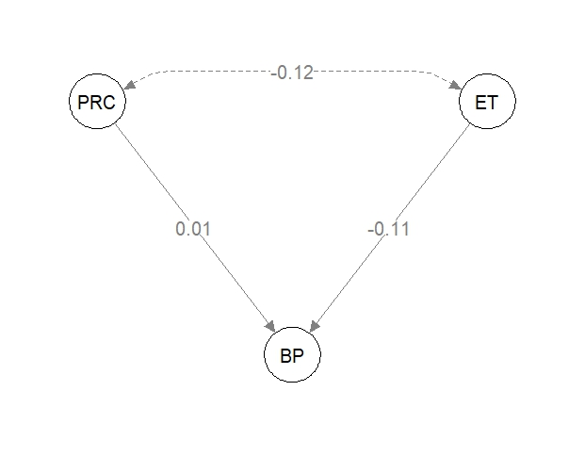

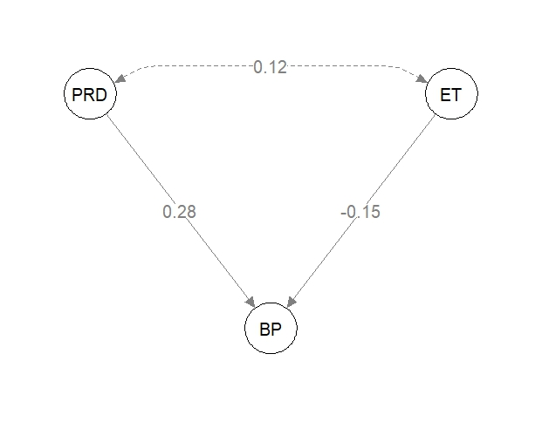Impact of **product space innovation** on profitability

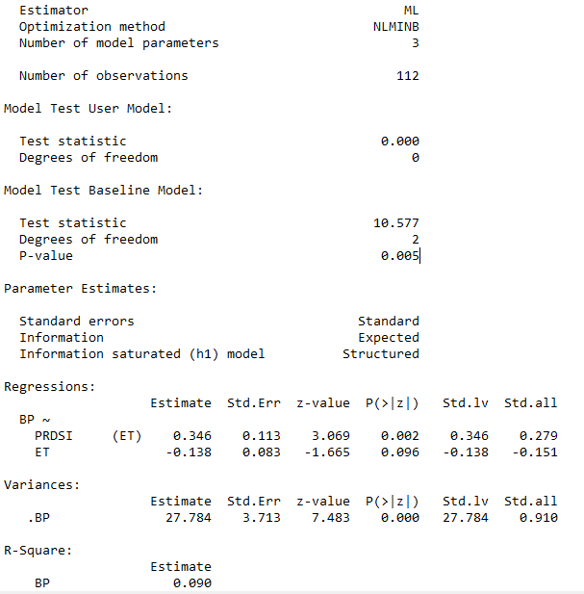

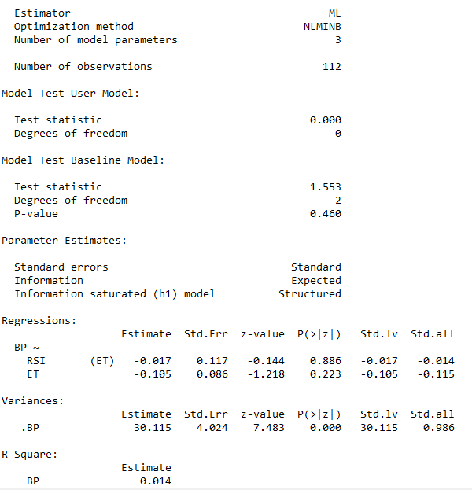Impact of **Relational Space Innovation** on profitability

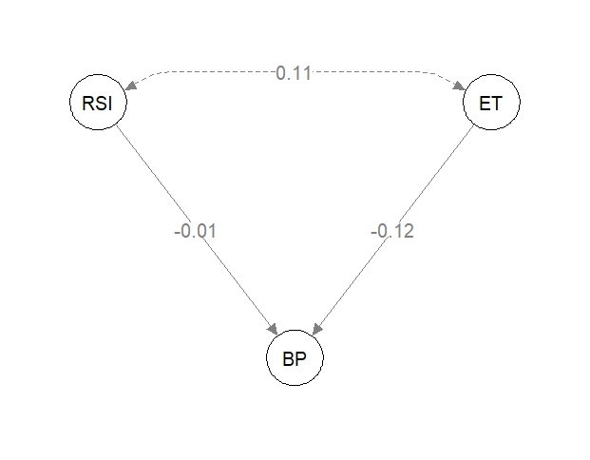

**Notes:**

Path coefficients are standardized versions of linear regression weights which can be used in examining the possible causal linkage between statistical variables in the structural equation modellings approach. The standardization involves multiplying the ordinary regression coefficient by the standard deviations of the corresponding explanatory variable: these can then be compared to assess the relative effects of the variables within the fitted regression model.