The following files are located on the lab ftp server:

- the handout:
/data/Multipath_Reading/Fading_sims/readme.doc

References are there too:
fading_model_Jeruchim.doc
fading_model_Jakes.doc

- Matlab fading simulator:
/data/Multipath_Reading/Fading_sims/example_codes

- Video clips (lectures):
/data/Multipath_Reading/Fading_sims/20191008老師講解Fading錄影

==

[Task I] Reading Assignment:

The following documents introduce the method of generating the Rayleigh fading channel with a specified channel coherence time. This is known as the Jakes model.

- fading_model_Jeruchim.doc: p382-385 (This doc also shows you how to simulate MULTIPATH channels.)
The Matlab code is /Multipath_Reading/Fading_sims/example_codes
is a fading simulator based on the description that was boxed in red on p383-384. (You need to cross-check the codes with the doc. What are the differences? Why?)
- [optional] fading_model_Jakes.doc: p70-72

[Task II] Simulate Fading Channels

After reading these documents, play with the fading simulator (Matlab code given in this folder) to generate fading channels. (NOTEL: 程式中參數如sampling rate等是以北美之2G系統IS-95 spec設定。你應根據GSM系統參數設定相關變數值。)

- Plot the fading coefficients (for many many symbols) for the following scenarios.

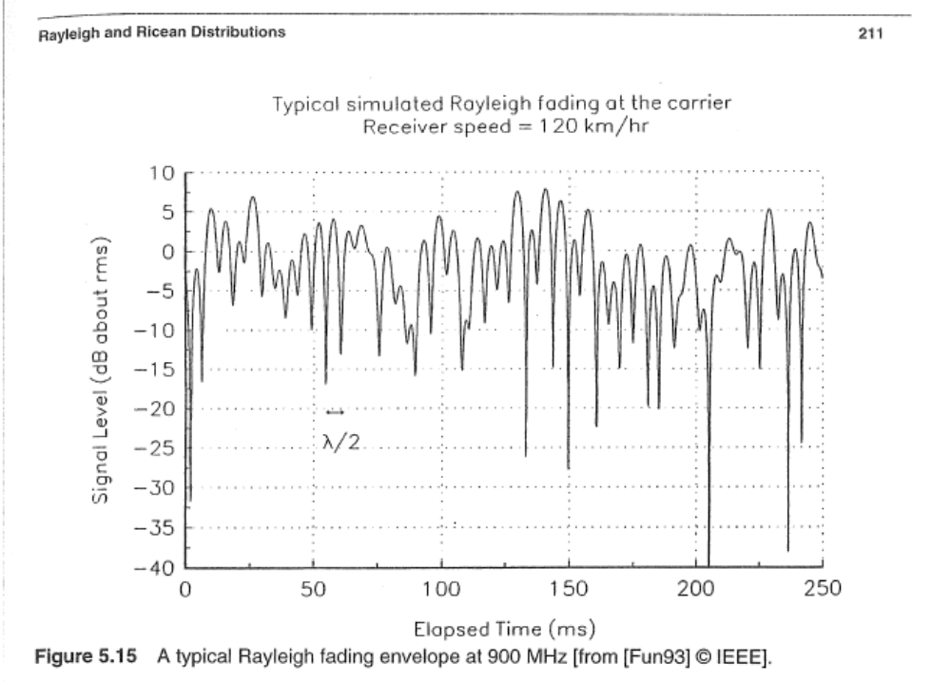

  - Suppose you want to look at the fading experienced by the GSM symbols.
Can you assume the channel is constant during a GSM symbol when vehicle velocity = 30 km/hr, 90 km/hr, and 120 km/hr? [What is the GSM symbol rate (check it out from the books in the lab)?] Plot the fading coefficients for different vehicle velocities. Which one fades faster?
  - Compute the Doppler shift (and channel coherence time) for each case. Is it fast or slow fading in each of the three cases above?
  - Plot the histograms of the fading coefficients for each case. Compare the histograms with the Gaussian pdf and Rayleigh pdf. In addition, compute the statistics of the fading coefficients. Do they match what you expected?

Think about these questions:
- How would you verify that what you generated is correct? Come up with as many ways as possible.

- What you generated was for single-path fading channel. How would you generate a multipath fading channel? [Hint: Use what you have done as the building block.]

- Are the fading coefficients that you generate real-valued or complex-valued?

- A Rayleigh distributed random variable can be view as the magnitude of random variable Z with Z=X+jY where X and Y are i.i.d. Gaussian random variable and j=sqrt(-1). [Review this!] Why don’t we use this approach to generate Rayleigh fading channels? (It seems that this latter approach is easier…)

Appendix: Important Distributions Related to Fading Channels
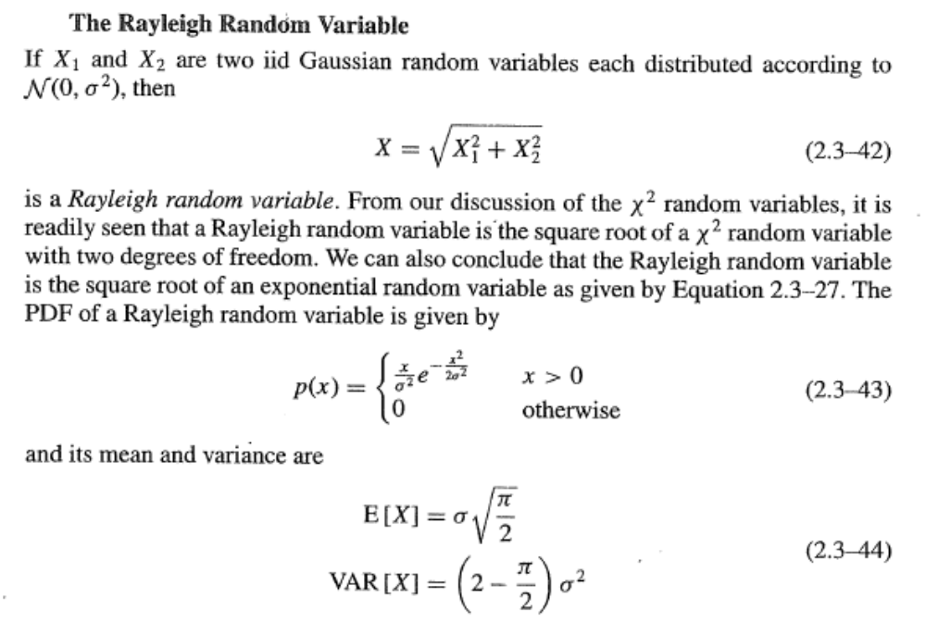

Questions: Find E(X²). What’s the physical meaning of E(X²)?
Hint:
Suppose that h is the Rayleigh channel gain, and s is the transmitted BPSK symbol. The received signal is modeled as r = h s + w where w is the Gaussian noise. Then what is the power of the desired component of the received signal (that is ‘hs’)?

