EviTrack
A tamper-evident chain-of-custody manager for digital evidence
Final project documentation
BSc Cybersecurity and Digital Forensics, Year 2 capstone project
Author: Sam Kariuki
Institution: Open University of Kenya
Module and supervisor: Programming Project 1 (Dr Edna Milgo, Dr Dennis Kikete, Dr Beth Kiratu)
Date: October 2026
Repository: https://github.com/Sam-Kariuki/evitrack
Live system: https://samkariuki.pythonanywhere.com

Table of contents
Table of contents 2
Abstract 4
1. Introduction 5
1.1 Background 5
1.2 Motivation 5
1.3 Document structure 5
2. Problem statement 6
3. Aim and objectives 7
4. Scope 8
4.1 In scope 8
4.2 Out of scope 8
4.3 Users 8
5. Requirements 9
6. Methodology and design 10
6.1 Development method 10
6.2 Technology 10
6.3 Architecture 11
6.4 Data model and hash chain 11
7. Implementation 12
7.1 Delivery steps 12
7.2 Authentication and roles 12
7.3 Cases 12
7.4 Evidence upload and hashing 12
7.5 Custody log 13
7.6 Integrity verification 13
7.7 Case report 15
8. Security design 18
8.1 Controls by area 18
8.2 Login lockout 18
8.3 Security headers 19
8.4 Residual risks 20
9. Testing and quality assurance 21
9.1 Automated tests 21
9.2 Manual testing 21
9.3 Continuous integration 21
10. Deployment 22
11. Results and evaluation 24
11.1 What worked well 24
11.2 Problems and lessons 24
12. Limitations 25
13. Future work 26
14. Ethical, legal and professional considerations 27
15. Conclusion 28
References 29
Appendix A: Threat model 30
Appendix B: Database schema summary 33
Appendix C: Configuration 33
Appendix D: Custody log action types 33

Abstract
Digital evidence is easy to change and hard to defend. A file can be altered without a visible trace, and handling records kept in ordinary logs or spreadsheets can be edited later. This project designed, built, tested and deployed EviTrack, a web application that records a SHA-256 hash of every evidence file at upload and writes each action on it to an append-only, hash-chained custody log.
EviTrack lets an investigator verify a file at any time and refuses to serve a file whose hash no longer matches. It produces a printable case report that shows PASS or FAIL for each file, the status of the custody chain and the latest log hash for offline comparison. The application is built with Python, Flask and SQLite and was developed in small tracked steps guided by a living threat model of 36 threats.
The last full test run passed 119 automated tests with 99% statement coverage. The system is deployed over HTTPS with security headers, login lockout and closed registration. The main limit is that deleting the newest custody entries cannot be detected from inside the database, so the latest entry hash is printed on each report as an offline anchor.

1. Introduction

1.1 Background
Chain of custody is the documented record of who handled a piece of evidence, when, and what they did. In digital forensics its value depends on two things: showing that the evidence has not changed since collection, and showing who accessed it. A hash function such as SHA-256 gives a short fingerprint of a file; any change to the file changes the fingerprint. A custody log gives the handling record. EviTrack combines the two and makes the log itself tamper-evident.

1.2 Motivation
The project is the end-of-year 2 capstone for the BSc Cybersecurity and Digital Forensics course. It was chosen because it applies programming, web security and forensic practice together: the same skills needed to build the system are those needed to attack and defend it.

1.3 Document structure
Section 2 states the problem and Section 3 the aim and objectives. Sections 4 and 5 give scope and requirements. Sections 6 to 8 describe the method, design and implementation. Sections 9 to 12 cover security, testing, deployment and evaluation. The remaining sections give limitations, future work, ethics and conclusions. Appendices hold the full threat model, the database schema, configuration and further evidence.

2. Problem statement
Three weaknesses make ordinary file handling a poor basis for evidence:
- Silent change. A file can be altered or swapped and nothing shows it. A copy that looks the same may not be the same.
- Editable records. Handling notes kept in spreadsheets or ordinary logs can be edited later without anyone noticing.
- Unclear handling. Who opened, copied or checked an item, and when, is often unrecorded or hard to reconstruct.
Without proof of integrity and proof of handling, evidence can be challenged. The problem addressed here is how to build a system that makes any change to evidence, or to its handling record, detectable.

3. Aim and objectives
Aim: design, build, test and deploy a web-based evidence tracker whose records can show when evidence has been tampered with.
Table 1: Objectives and how each was met
# | Objective | Where it is met
O1 | Store evidence with a SHA-256 hash taken at upload | Section 7.4; streamed hashing at upload
O2 | Record every action in an append-only, hash-chained log | Sections 6.4 and 7.5; triggers and verify_chain()
O3 | Verify integrity on demand and before every download | Section 7.6; verify and blocked download
O4 | Produce a printable case report with PASS or FAIL | Section 7.7; case report
O5 | Defend against common web attacks, guided by a threat model | Section 8 and Appendix A
O6 | Test automatically, deploy online and document it all | Sections 9, 10 and this document

4. Scope

4.1 In scope
- Accounts with investigator and administrator roles
- Case management with open and closed status
- Evidence upload with validation and SHA-256 hashing
- An append-only, hash-chained custody log
- Integrity checks that block altered downloads
- A printable case report with chain status
- Security hardening, automated tests, continuous integration and a live deployment

4.2 Out of scope
- Forensic analysis of file contents, and disk imaging or acquisition
- Password reset by email or single sign-on
- Administrator screens to disable or manage accounts (listed as future work)
- Scheduled background integrity checks
- Certification for real casework

4.3 Users
- Investigator: creates and owns cases, uploads, verifies and downloads evidence and generates reports. Sees only their own cases.
- Administrator: created from the command line; can see every case.
- Report reader: receives the printed or PDF report and compares its latest log hash with the system. Has no account.

5. Requirements
Table 2: Functional requirements
ID | Requirement
FR1 | Accounts with hashed passwords and two roles
FR2 | Create, edit, close and reopen cases
FR3 | Upload evidence; reject disallowed types, empty files and oversized files
FR4 | Hash every file with SHA-256 at upload
FR5 | Log upload, view, download and verification automatically
FR6 | Verify integrity on demand; block altered downloads
FR7 | Detect tampering with the custody log itself
FR8 | Generate a printable case report

Table 3: Non-functional requirements
ID | Requirement
NFR1 | Security: common web threats are handled and documented
NFR2 | Integrity: custody log entries cannot be edited through the application
NFR3 | Testability: automated tests with a 90% or higher coverage target
NFR4 | Usability: clear PASS or FAIL results and chain status
NFR5 | Deployability: free host, HTTPS, secrets kept out of the code

6. Methodology and design

6.1 Development method
Work was organised in small vertical steps. Each step followed the same loop: a GitHub issue, a branch, build and test, a manual check in the browser, a pull request, then merge and documentation. Nothing was committed straight to main. After each step a development log entry, screenshots and a threat-model update were written.
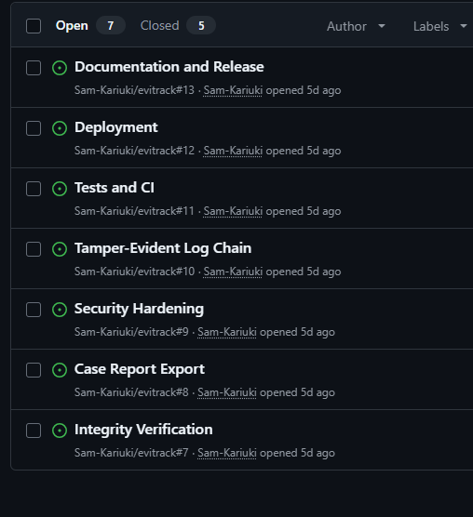
Figure 1: GitHub issues list for the project, one issue per step (issues 7 to 13 shown open).
The project started on about 1 October 2026 with a 14-day target. Twelve GitHub issues tracked the work and pull requests were used to merge each step.

6.2 Technology
Table 4: Technology choices
Technology | Reason
Python 3.13 | Readable language used throughout the course
Flask 3.1 | Small web framework with explicit routes and sessions
Flask-WTF | CSRF protection on every POST route
Jinja2 | Templates that escape output by default
SQLite | Embedded database; triggers make the custody log append-only
pytest and pytest-cov | Fast tests and a measured coverage figure
GitHub Actions | Runs the tests and a secrets check on every push and pull request
PythonAnywhere | Free HTTPS hosting with a persistent disk

6.3 Architecture
EviTrack is a Flask application organised into three blueprints (authentication, cases and evidence) plus modules for the custody log, login lockout and security headers. Pages are rendered with Jinja templates and static CSS. Data is held in a SQLite database. Evidence files are stored in a separate folder outside the static directory so they are never served directly.
The browser talks to the application over HTTPS. The session cookie is HttpOnly and SameSite=Lax, and every POST form carries a CSRF token.

6.4 Data model and hash chain
The database has five tables: users, cases, evidence, custody_log and login_attempts. A case has many evidence items and an evidence item has many custody entries. The full schema is in Appendix B.
Each custody entry stores the hash of the entry before it. The entry hash is SHA-256 over the compact JSON list [prev_hash, evidence_id, user_id, action, notes, timestamp]. The first entry uses a previous hash of 64 zeros. Changing any past entry changes its hash, which no longer matches the previous-hash value stored in the next entry, so verify_chain() reports the chain as broken.
Two further controls protect the log. Database triggers abort any UPDATE or DELETE on custody_log. log_action() uses BEGIN IMMEDIATE so writers take turns and the chain cannot fork, and the evidence row and its log entry commit in the same transaction.

7. Implementation

7.1 Delivery steps
Table 5: Build steps and test growth
Step | Work delivered | Tests passing
2 | Project foundation and authentication | 3
4 | Case management | 31
5 | Evidence upload and hashing | 47
6 | Chain-of-custody log | 58
7 | Integrity verification | 71
8 | Case report | 80
9 | Security hardening | 104
10 to 11 | Deployment changes and production setup | 109
12 | Edge-case tests and continuous integration | 119 (99% coverage)
Counts are the verified totals recorded at the end of each step.

7.2 Authentication and roles
Users register or are created from the command line. Passwords are stored as salted hashes. Two roles exist, investigator and administrator, and access checks run on the server. On login the session is cleared and given an 8-hour lifetime. A login failure gives the same message whether the username exists or not.

7.3 Cases
Investigators create, edit and close cases. Every case route checks ownership and returns a 404 page for another user's case so that its existence is not revealed. A closed case rejects edits and evidence uploads; only an administrator can reopen it.

7.4 Evidence upload and hashing
Uploads are checked against an extension allowlist and passed through secure_filename. The file is stored under a random 32-character hexadecimal name outside the web root and its SHA-256 is computed while it is streamed to disk. Empty files are rejected and the size limit (MAX_UPLOAD_MB, default 10) returns a custom 413 page. A failed upload leaves no row, no log entry and no file behind.
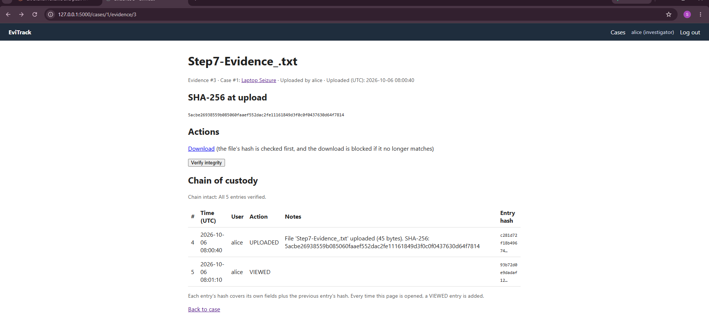
Figure 2: Evidence page after upload: SHA-256 at upload and the custody history. The banner reads "Chain intact: All 5 entries verified."

7.5 Custody log
Every upload, view, download and verification adds an entry with the user, UTC time, action and notes. Entries are written through log_action() in the same transaction as the action. The evidence page shows the history and the chain status.
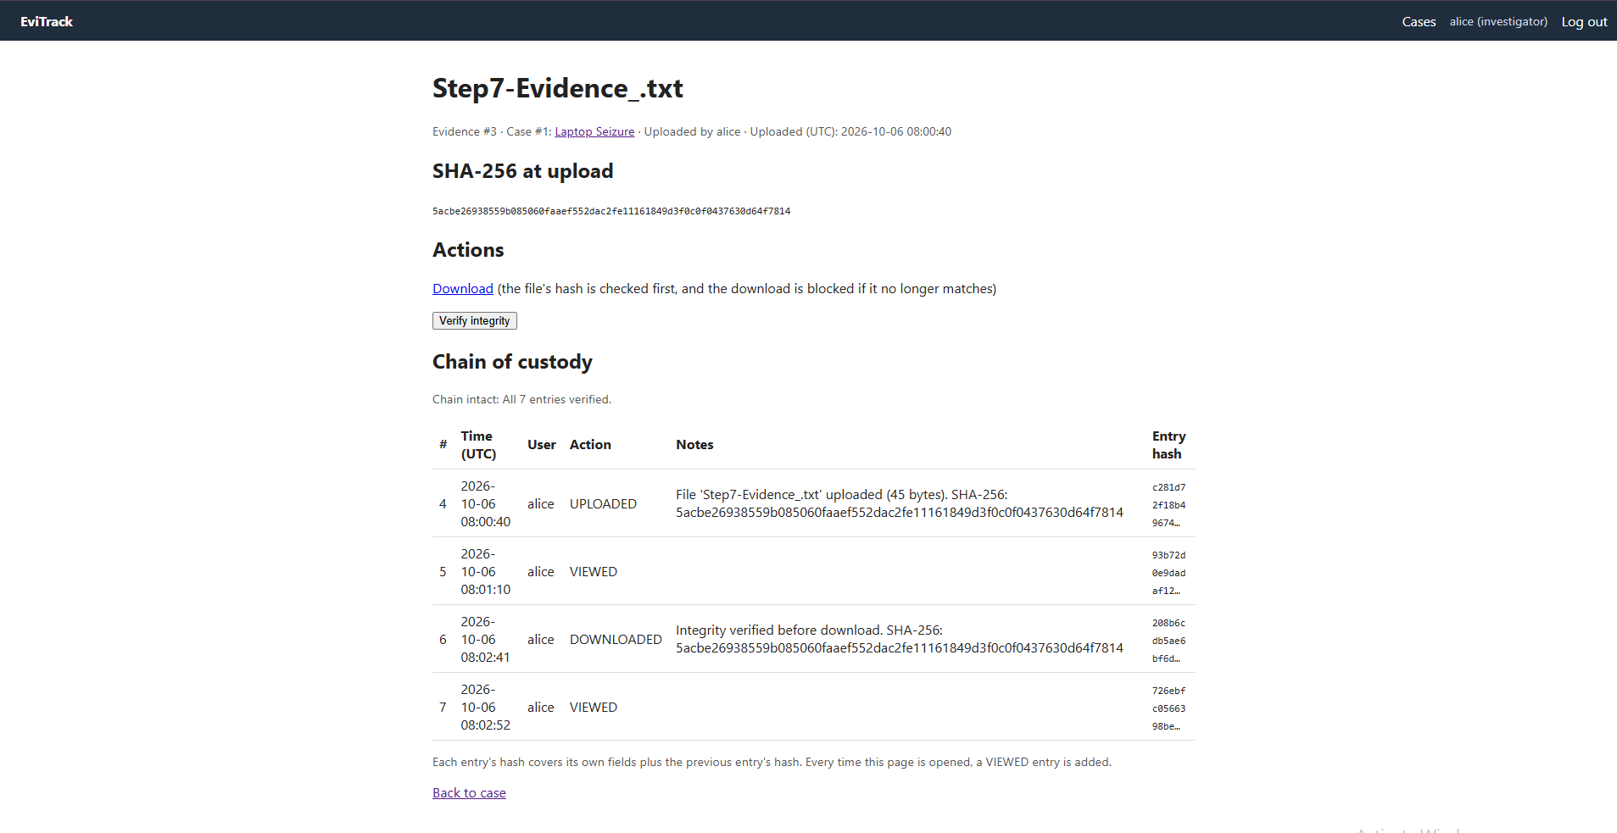
Figure 3: A DOWNLOADED entry added to the history after a successful verified download (7 entries, chain intact).

7.6 Integrity verification
The stored file is rehashed on demand and before every download. If the hash matches, the file is sent and a DOWNLOADED entry is written. If it does not match, or the file is missing, a HASH_VERIFIED FAIL entry is written and the download is blocked. The verify button is a POST protected by a CSRF token.
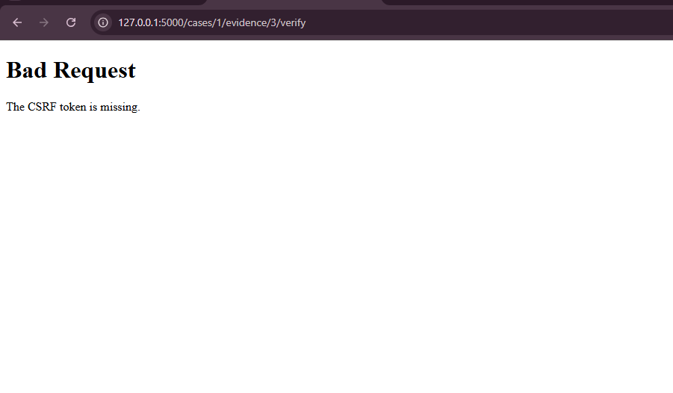
Figure 4: A verify request without a CSRF token is rejected with "Bad Request: The CSRF token is missing."
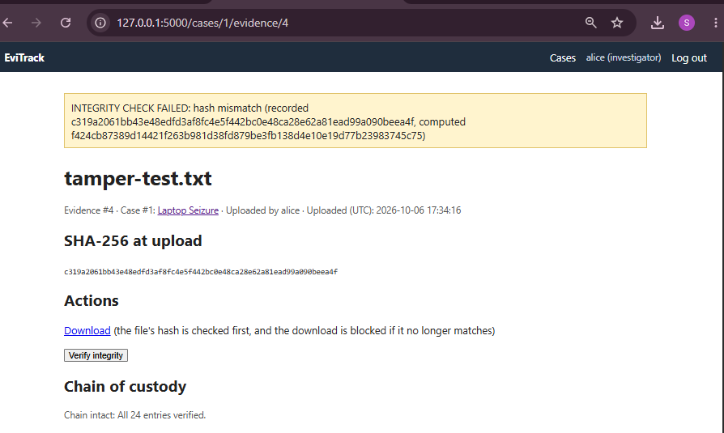
Figure 5: Tamper test: a stored file was modified and the integrity check shows INTEGRITY CHECK FAILED with the expected and actual hashes.
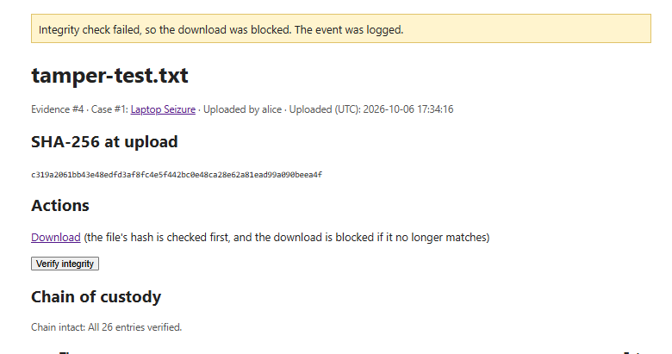
Figure 6: The download of the modified file is blocked and the user is told why.
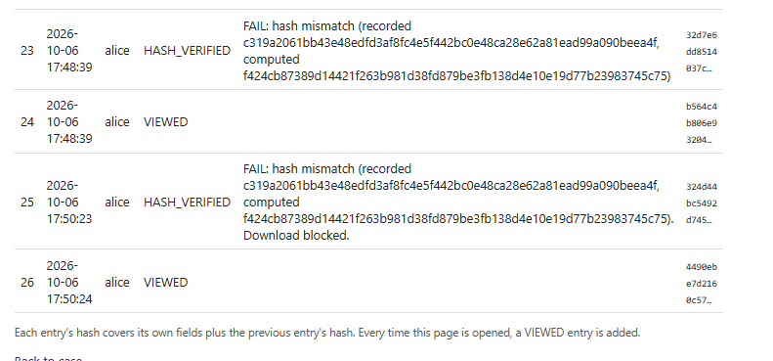
Figure 7: Custody entries 23 to 26: a FAIL, a VIEWED, a FAIL with "Download blocked." and a VIEWED. The failed checks and blocked download are recorded.

7.7 Case report
The report is generated by a POST request to the case. Every file is rehashed at that moment and shown as PASS, FAIL or "stored file is missing", with the generation time and the user who ran it. Each check is logged as a HASH_VERIFIED entry prefixed "Case report:". The report also shows the chain status and prints the latest entry number and hash so that a copy kept outside the system can be compared later. Report generation was changed from GET to POST in Step 9 so that a forged cross-site request cannot trigger it.
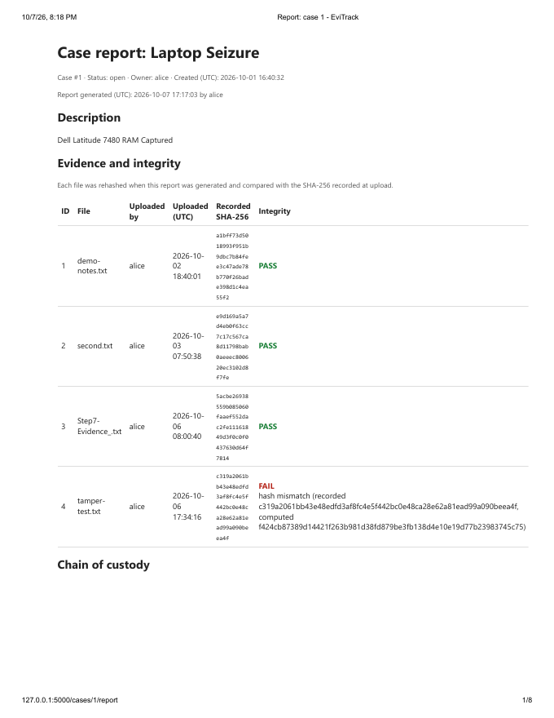
Figure 8: First page of the case report from the development system (Laptop Seizure), showing per-file PASS and FAIL results.
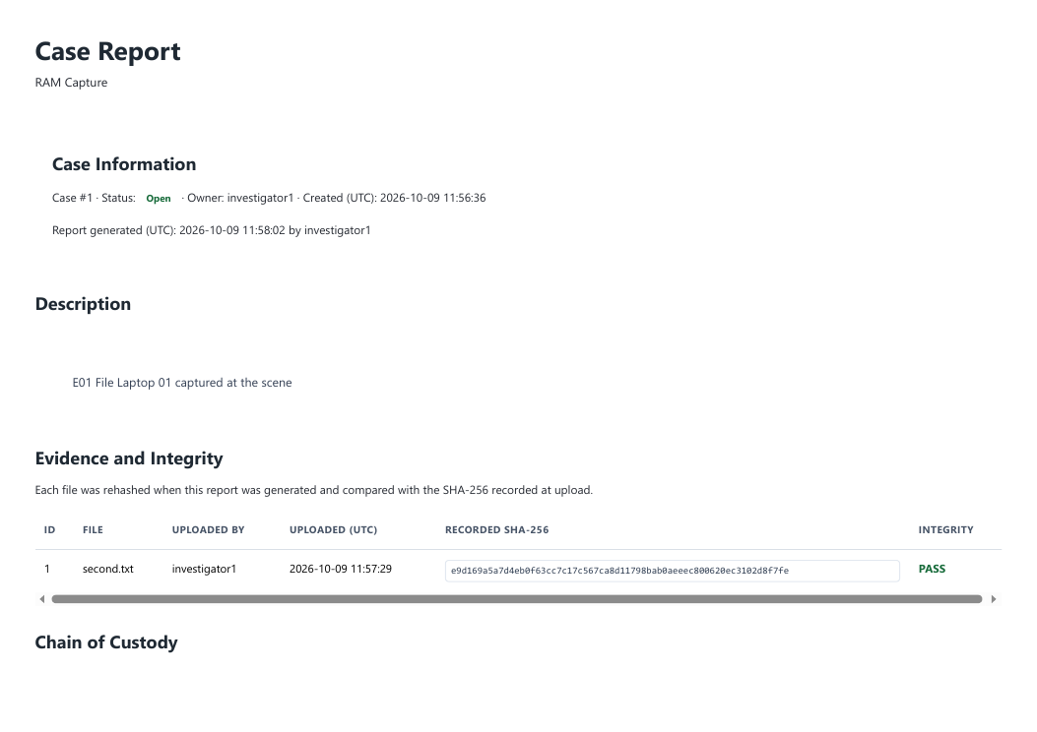
Figure 9: Case report generated on the live system (RAM Capture): one file PASS, chain intact with 2 entries.
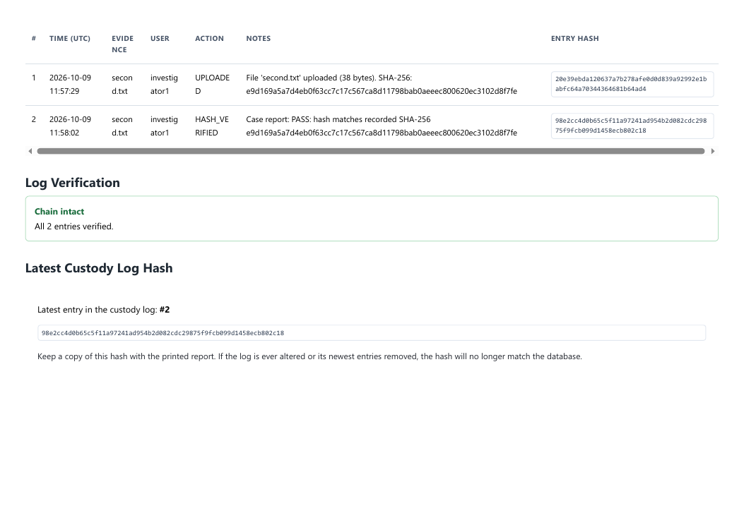
Figure 10: Second page of the live report: custody history and the latest entry hash printed as an offline anchor.

8. Security design
Security work was guided by a threat model that records each threat with its asset, mitigation and status. It grew from 26 threats at the end of Step 8 to 36 after hardening and deployment. The full table is in Appendix A: 30 threats are done, 5 are partial and 1 is accepted.

8.1 Controls by area
Table 6: Main controls
Area | Controls
Injection | Parameterised queries on every database call; Jinja autoescaping with no use of |safe
Access control | Role checks on admin routes; ownership checks on cases, evidence and reports with 404 responses
Uploads | Extension allowlist, secure_filename, random stored names, size limit, streaming, no inline serving
Request forgery | CSRF token on every POST route; a test checks that every POST route rejects a missing token; report is POST only
Authentication | Salted hashes; per-username lockout after 5 failures in 10 minutes (HTTP 429); dummy hash for unknown users; session cleared on login
Secrets | Application refuses to start with a default or empty SECRET_KEY; production key lives in a git-ignored .env; CI scans for secrets
Browser protections | Content-Security-Policy, X-Frame-Options: DENY, nosniff, Referrer-Policy, Permissions-Policy, no-store caching, HSTS
Evidence and log integrity | SHA-256 per file, hash-chained log, append-only triggers, check before every download
Errors | Custom 413 and 500 pages with no internal details

8.2 Login lockout
Failed logins are recorded per username in the database. After five failures within ten minutes further attempts are refused with HTTP 429, even with the correct password, until the oldest failure is more than ten minutes old. Unknown usernames are throttled in the same way so that the response does not reveal which usernames exist. A successful login clears the count.
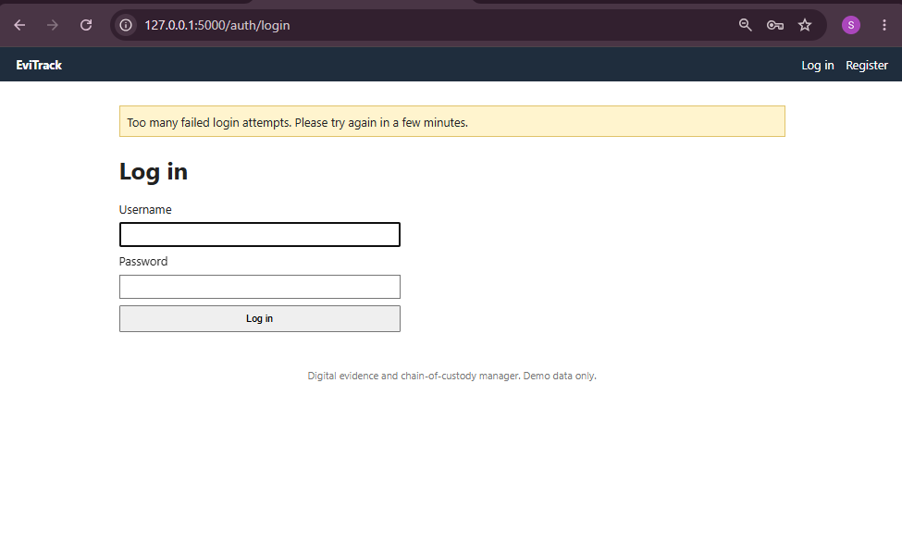
Figure 11: Lockout message on the development system after repeated failed logins.

8.3 Security headers
Headers are set on every response. The live site was checked with curl.exe -sI, which shows the Content-Security-Policy, X-Content-Type-Options, X-Frame-Options, Referrer-Policy, Permissions-Policy, HSTS and a session cookie marked Secure, HttpOnly and SameSite=Lax.
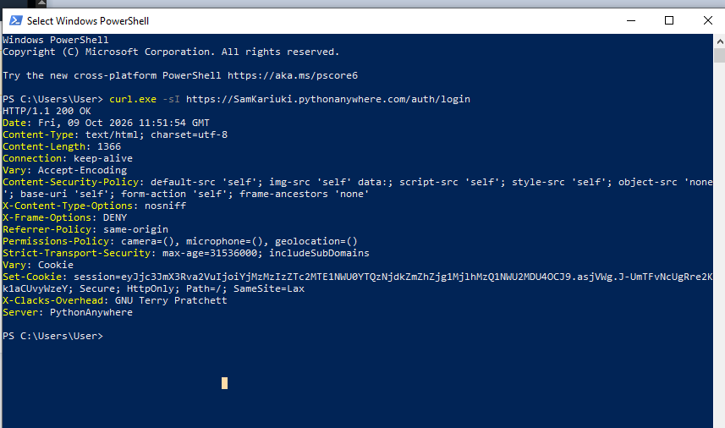
Figure 12: Response headers of the live site from `curl.exe -sI`.
Browser developer tools were also used. The page response shows Cache-Control: no-store and the session cookie. In that capture the Content-Security-Policy had been modified by the local antivirus software, which injects its own sources into the policy, so the curl output above is the reliable record of what the server sends. The stylesheet response shows the real policy and cacheable static files.
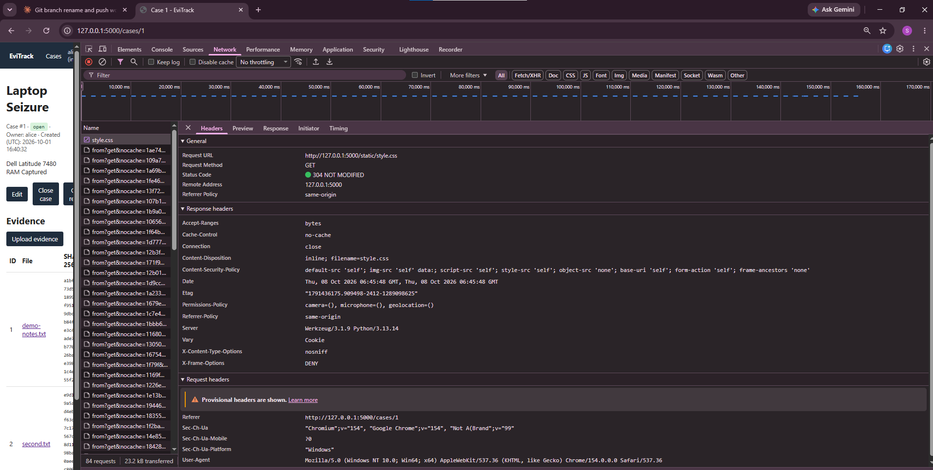
Figure 13: Developer tools, page response headers. The policy shown here was altered by local antivirus software; the server's own policy is in the `curl` output.
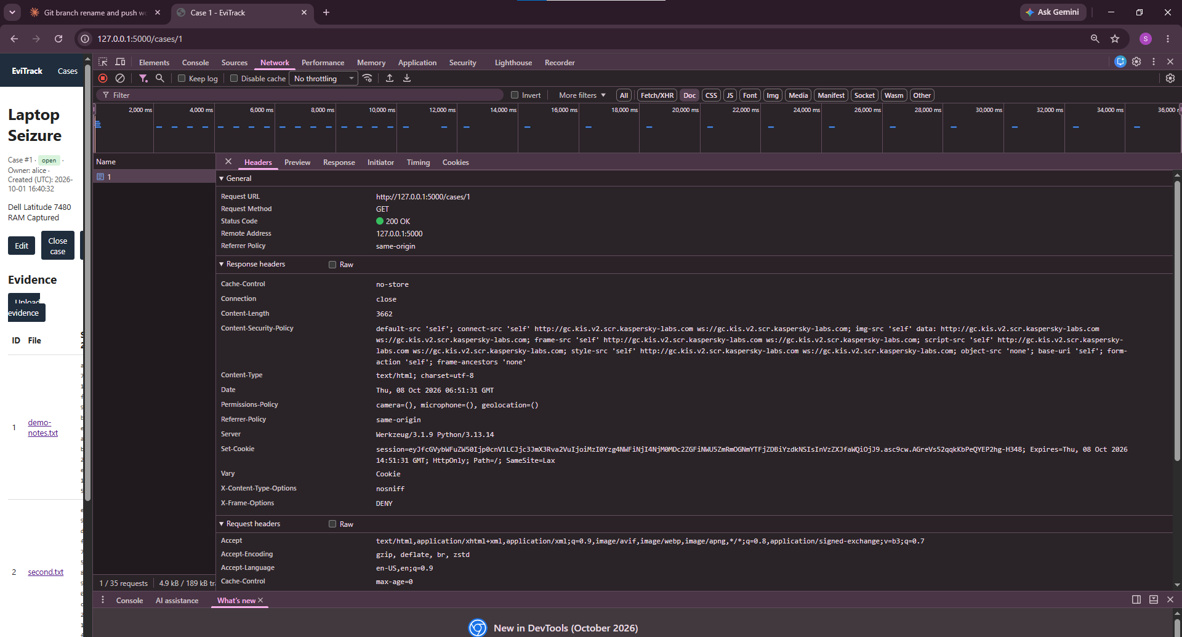
Figure 14: Developer tools, response headers for the stylesheet.

8.4 Residual risks
Some risks are accepted or only partly addressed. They are listed with their status in Appendix A and summarised in Section 12.

9. Testing and quality assurance

9.1 Automated tests
Tests use pytest with a fresh database and evidence folder per test. They cover authentication, case ownership, closed-case rules, upload validation, hashing, custody logging and chain verification, integrity checks, download blocking, report generation, lockout, security headers, the secret-key check and error pages.
Several tests tamper with the system on purpose: a stored file is modified or removed and the check must fail; a custody row is edited or removed and the chain must report a break; the append-only triggers must reject UPDATE and DELETE. One test builds the app with CSRF enabled and loops over the URL map, so any POST route added later is covered automatically.
Table 7: Test results
Measure | Result
Tests passing at last full run | 119
Statement coverage at last full run | 99%
Coverage threshold in CI | Fails below 95%
Two further tests (stale session handling and editing a closed case) were added after the last full run. Re-run `pytest --cov=app` for the final figure.

9.2 Manual testing
Each feature was walked through in a browser after it was built. The screenshots in Section 7 are from these checks, including the tamper test and the blocked download.

9.3 Continuous integration
A GitHub Actions workflow runs on every push to main and on pull requests. It first checks that no .env, database or instance/ folder is tracked and that no 64-character hexadecimal string appears in app/ or .env.example. It then runs the full test suite with a coverage threshold. The secrets check was added after a real secret key was pasted into the tracked example file during development; it was caught locally and the key was replaced and rotated.

10. Deployment
EviTrack is deployed on the PythonAnywhere free tier at https://samkariuki.pythonanywhere.com. The production configuration differs from development in these ways:
- ALLOW_REGISTRATION=0: the register route returns 404 and the links are hidden; accounts are created on the server with create-user and create-admin
- A production SECRET_KEY generated on the server in a git-ignored .env with restricted permissions
- SESSION_COOKIE_SECURE=1, which marks the session cookie Secure and enables HSTS
- A WSGI file that calls create_app(), and no static-files mapping so that security headers apply to static responses
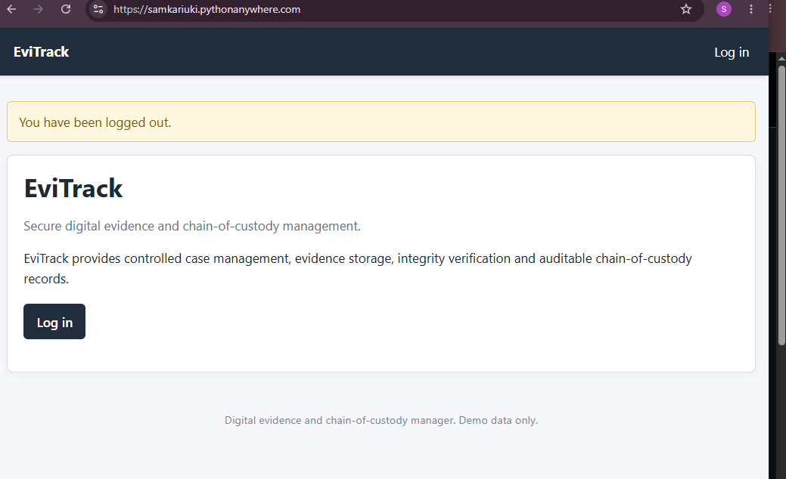
Figure 15: The live site home page after logout. Only a Log in link is shown because registration is closed.
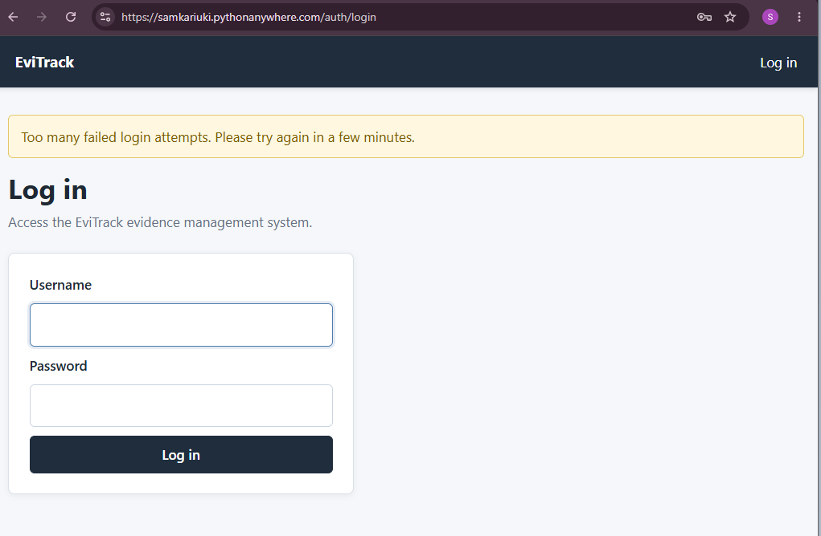
Figure 16: Login lockout message on the live site after repeated failed attempts.
Hosting limits were accepted for a demonstration system: one worker, no backups and a monthly expiry unless extended. Only demo data is stored.

11. Results and evaluation
Table 8: Success criteria
Criterion | Evidence
A modified file shows FAIL and its download is blocked | Figures in Section 7.6; tamper tests
An edited log row shows CHAIN BROKEN | Tamper tests on verify_chain()
Every POST route rejects a request without a CSRF token | Route-map test; Figure in Section 7.6
Five failed logins lock the account for ten minutes | Lockout tests; local and live screenshots
Coverage of 90% or more with CI passing | 99% at last run; CI result to be confirmed
HTTPS with security headers present | curl output of the live site
All six objectives in Section 3 were met in the application. The system detects a changed file, a missing file, an edited log row and a row removed from the middle of the log, and it records each failed check.

11.1 What worked well
- Small, tracked steps with tests kept regressions visible; the suite grew from 3 to 119 tests.
- Making the threat model a living document meant each step ended with a record of what was and was not covered.
- Deploying and checking headers on the live site found differences from development early.

11.2 Problems and lessons
- A template file was corrupted by an automatic edit; it was restored from main and fixed by hand. Lesson: commit before bulk edits.
- A real secret key was pasted into a tracked example file. It was caught before pushing, replaced and rotated, and a CI check now guards against it.
- A change was committed on main instead of a branch and a duplicate branch caused a conflict that closed one pull request. Lesson: check the branch before every commit.
- A browser extension and antivirus software altered response headers in developer tools, so header evidence was taken with curl instead.

12. Limitations
- Newest entries. Deleting the newest custody entries cannot be detected inside the database. The latest entry hash printed on each report must be kept outside the system for comparison.
- File content. Types are checked by extension only; there is no content inspection.
- Provenance. A hash shows a file is unchanged since upload, not that it was genuine when collected.
- Lockout. The lockout is per username, so a known user can be locked out for ten minutes; there is no per-IP limit or administrator unlock.
- Sessions. Sessions are stateless, so logout cannot revoke a copied cookie before it expires.
- Usernames. Registration, where open, reveals that a username is taken.
- Hosting. The free host has one worker, no backups and expires monthly unless extended.
- Certification. EviTrack is a learning project and is not certified forensic software.

13. Future work
- Administrator screens to list, disable and unlock accounts
- Automatic storage of the latest log hash outside the database
- Scheduled background integrity checks with alerts
- File content inspection and a per-user storage quota
- Server-side sessions so logout can revoke a session
- Per-IP rate limiting and backups of the database and evidence folder
- Tag the v1.0.0 release and add a short user guide

14. Ethical, legal and professional considerations
Only synthetic test data was used. No real casework or personal data is stored. The only personal data held is usernames and salted password hashes. The report and README state the limits of the system so that it is not mistaken for certified forensic software. Open-source libraries are used under their own licences.

15. Conclusion
EviTrack meets its aim. It records a hash of each evidence file at upload, keeps a hash-chained, append-only record of every action, checks integrity before any download and produces a report that states the result. The design was guided by a threat model, verified by 119 passing tests at 99% coverage, and deployed with security headers, lockout and closed registration.
The project also shows the limits of such a system. A hash chain makes tampering evident, not impossible, and the printed latest hash is what closes the gap for deleted newest entries. The remaining work is mainly operational: account management, off-database anchoring and backups.

References
National Institute of Standards and Technology (2015) FIPS PUB 180-4: Secure Hash Standard (SHS). Gaithersburg: NIST.
OWASP Foundation (2021) OWASP Top 10: 2021. Available at: https://owasp.org/Top10/
OWASP Foundation (n.d.) Cross-Site Request Forgery Prevention Cheat Sheet. Available at: https://cheatsheetseries.owasp.org/
Pallets Projects (n.d.) Flask documentation. Available at: https://flask.palletsprojects.com/
SQLite Consortium (n.d.) SQLite documentation: CREATE TRIGGER. Available at: https://www.sqlite.org/lang_createtrigger.html
Mozilla (n.d.) MDN Web Docs: Content-Security-Policy. Available at: https://developer.mozilla.org/
Add any course texts or standards required by the module, in the format the module specifies.

Appendix A: Threat model
Status key: Done means the control is implemented and tested. Partial means a control exists with a stated gap. Accepted means the risk is knowingly left in place.
Table 12: Threat model (36 threats: 30 done, 5 partial, 1 accepted)
# | Threat | Asset | Mitigation | Status
1 | SQL injection | Database | Parameterised queries on every database call | Done
2 | Weak password storage | User accounts | Salted password hashing; plain-text passwords are never stored | Done
3 | Unauthorised privilege escalation | Administrative functions | Role-based access control (investigator and admin roles) enforced on admin routes | Done
4 | Viewing or editing another investigator's case by changing the URL | Cases | Ownership check on every case route; returns 404 instead of 403 so the case's existence is not revealed | Done
5 | Reaching another case's evidence by changing the URL | Evidence | Case ownership check plus a check that the evidence belongs to the case in the URL; returns 404 | Done
6 | Altering a closed case | Case integrity | Server-side status check on edit and on evidence upload; only admins can reopen a case | Done
7 | Stored XSS through a case title, description or file name | Users' browsers | Jinja autoescaping with no use of |safe; covered by tests | Done
8 | Path traversal through a file name | Server filesystem | secure_filename, random stored names, and paths built on the server only | Done
9 | Executable or script upload | Server, other users | Extension allowlist; files stored under random names without an extension; never served inline or executed | Done (no content inspection)
10 | Oversized upload or disk exhaustion | Availability | MAX_CONTENT_LENGTH with a custom 413 page; files are streamed to disk in chunks | Done (no per-user quota)
11 | Evidence file altered after upload | Evidence files | SHA-256 recorded at upload; the file is rehashed on every download and manual verify; a mismatch is logged as HASH_VERIFIED (FAIL) | Done (no scheduled background check)
12 | Evidence file deleted or missing from storage | Evidence files | The integrity check reports "stored file is missing", logs a FAIL and blocks the download | Done (no backup or recovery)
13 | Serving a modified file as evidence | Evidence integrity | The integrity check runs before every download; the file is sent only if the hash matches; a blocked attempt is logged | Done
14 | Unlogged access to evidence | Evidence, custody log | UPLOADED, VIEWED, DOWNLOADED and HASH_VERIFIED entries are written automatically, in the same transaction as the action where one applies | Done
15 | Editing or deleting custody entries through SQL | Custody log | Append-only triggers abort any UPDATE or DELETE; the application only ever inserts | Done
16 | Edited or removed custody entries going unnoticed | Custody log | Each entry's hash covers the previous entry's hash; verify_chain() rechecks every link and hash, and the evidence page shows "Chain intact" or "CHAIN BROKEN"; tested by tampering with rows | Done (cannot detect deletion of the newest entries; see 25)
17 | Direct edit of the database file or dropping the triggers | Custody log | The hash chain detects edited rows and rows removed from the middle of the log; the latest entry hash is printed on each case report | Partial (not stored outside the database automatically)
18 | Concurrent writes forking the chain | Custody log | BEGIN IMMEDIATE takes the write lock before the last hash is read; the evidence row and its log entry commit together | Done
19 | Cross-site request forgery on state-changing actions | Evidence, cases, accounts | CSRF token on every POST form; a test builds the app with CSRF enabled and checks that every POST route in the URL map rejects a request without a token, so new routes are covered automatically | Done
20 | Brute-force login attempts | User accounts | Failures are recorded per username in the database; after 5 failures in 10 minutes further attempts get HTTP 429 until the oldest failure is more than 10 minutes old, even with the correct password; unknown usernames are throttled identically; a successful login clears the count | Done (no per-IP limit; see 31)
21 | Session hijacking, fixation or cookie theft | User sessions | HttpOnly and SameSite=Lax cookies; session cleared on login; 8-hour lifetime; Secure flag and HSTS active on the live site over HTTPS (verified with curl) | Done (a copied cookie stays valid until it expires; see 33)
22 | A report states stale or unverified file integrity | Case reports | Every file is rehashed when the report is generated; PASS, FAIL or "stored file is missing" is printed with the generation time and the user who ran it | Done
23 | Reading another investigator's case report | Case data, evidence metadata | Same ownership check as the case page; other users receive a 404; tested | Done
24 | Producing a report without a record | Custody log | Each integrity check made for a report is logged as HASH_VERIFIED with a "Case report:" prefix | Done (no case-level "report generated" entry, because custody_log.evidence_id is required)
25 | Newest custody entries deleted without detection | Custody log | Latest entry number and hash are printed on every report, so a kept copy can be compared with the database | Partial (comparison is manual; the printed hash must be stored outside the database)
26 | A forged cross-site request makes a logged-in user's browser generate a report and write log entries | Custody log | Report generation is a POST that needs a login and a CSRF token; a GET returns 405 | Done
27 | Forged sessions or CSRF tokens through a weak default secret key | All users | The app refuses to start with the default or an empty SECRET_KEY unless in debug or testing mode; tested | Done (key strength is the operator's responsibility)
28 | Clickjacking, MIME sniffing, injected scripts or styles | Users' browsers | Content-Security-Policy (default-src 'self', frame-ancestors 'none', object-src 'none'), X-Frame-Options: DENY, X-Content-Type-Options: nosniff, Referrer-Policy: same-origin; no inline scripts or styles in the templates | Done
29 | Stack traces or internal paths shown to users | Source code, server paths | Custom 500 page with no details; the error is logged server-side | Done (debug mode must stay off in deployment)
30 | Evidence pages or downloads read from the browser cache on a shared computer | Evidence, case data | Cache-Control: no-store on every page served to a logged-in user, including downloads | Done
31 | Deliberately locking a known user out of their account | Account availability | Lockout is per username and temporary (10 minutes); other accounts are unaffected | Partial (a persistent attacker can keep a known username locked; no admin unlock or per-IP limit)
32 | Finding valid usernames through login responses or timing | User accounts | Same message for unknown user and wrong password; unknown usernames run a dummy password hash and are throttled the same way | Partial (registration still reveals that a username is taken)
33 | Reuse of a stolen session cookie after the user logs out | User sessions | Signed cookie with an 8-hour lifetime; HttpOnly, SameSite=Lax and Secure at deployment | Partial (sessions are stateless, so logout cannot revoke a copied cookie before it expires)
34 | Strangers creating accounts and uploading files on the public site | Server storage, evidence data | ALLOW_REGISTRATION=0 in production: the register route returns 404 and the links are hidden; accounts are created with create-user and create-admin on the server | Done
35 | Secret key reuse or exposure between environments | Sessions, CSRF tokens | The production SECRET_KEY is generated on the server in a git-ignored .env (mode 600); .env.example holds placeholders; CI fails if a tracked .env, database or 64-character hex string is found | Done
36 | Loss of the database or evidence files on the host | Evidence, custody log | None beyond the host's persistent disk | Accepted (no backups on the free plan; demo data only; the web app expires monthly unless extended)

Appendix B: Database schema summary
Table 9: Tables and columns
Table | Columns
users | id (PK), username (unique), password_hash, role, created_at
cases | id (PK), title, description, status, created_by (FK users), created_at
evidence | id (PK), case_id (FK cases), original_name, stored_name (unique), sha256, uploaded_by (FK users), uploaded_at
custody_log | id (PK), evidence_id (FK evidence), user_id (FK users), action, notes, timestamp, prev_hash, entry_hash
login_attempts | id (PK), username, ip, attempted_at
Summary of the design. The authoritative definitions are in the repository schema file. `custody_log` carries triggers that abort any UPDATE or DELETE.

Appendix C: Configuration
Table 10: Environment variables
Variable | Purpose | Default
SECRET_KEY | Signs sessions and CSRF tokens; required outside debug and testing | none
MAX_UPLOAD_MB | Largest accepted upload | 10
ALLOW_REGISTRATION | Set to 0 to close public registration | open
SESSION_COOKIE_SECURE | Set to 1 over HTTPS; also enables HSTS | off

Appendix D: Custody log action types
Table 11: Actions recorded
Action | When it is written
UPLOADED | When evidence is stored, in the same transaction as the evidence row
VIEWED | Each time an evidence page is opened
DOWNLOADED | After a download passes the integrity check
HASH_VERIFIED | On a manual verify, a blocked download, or a case report check (PASS or FAIL)

